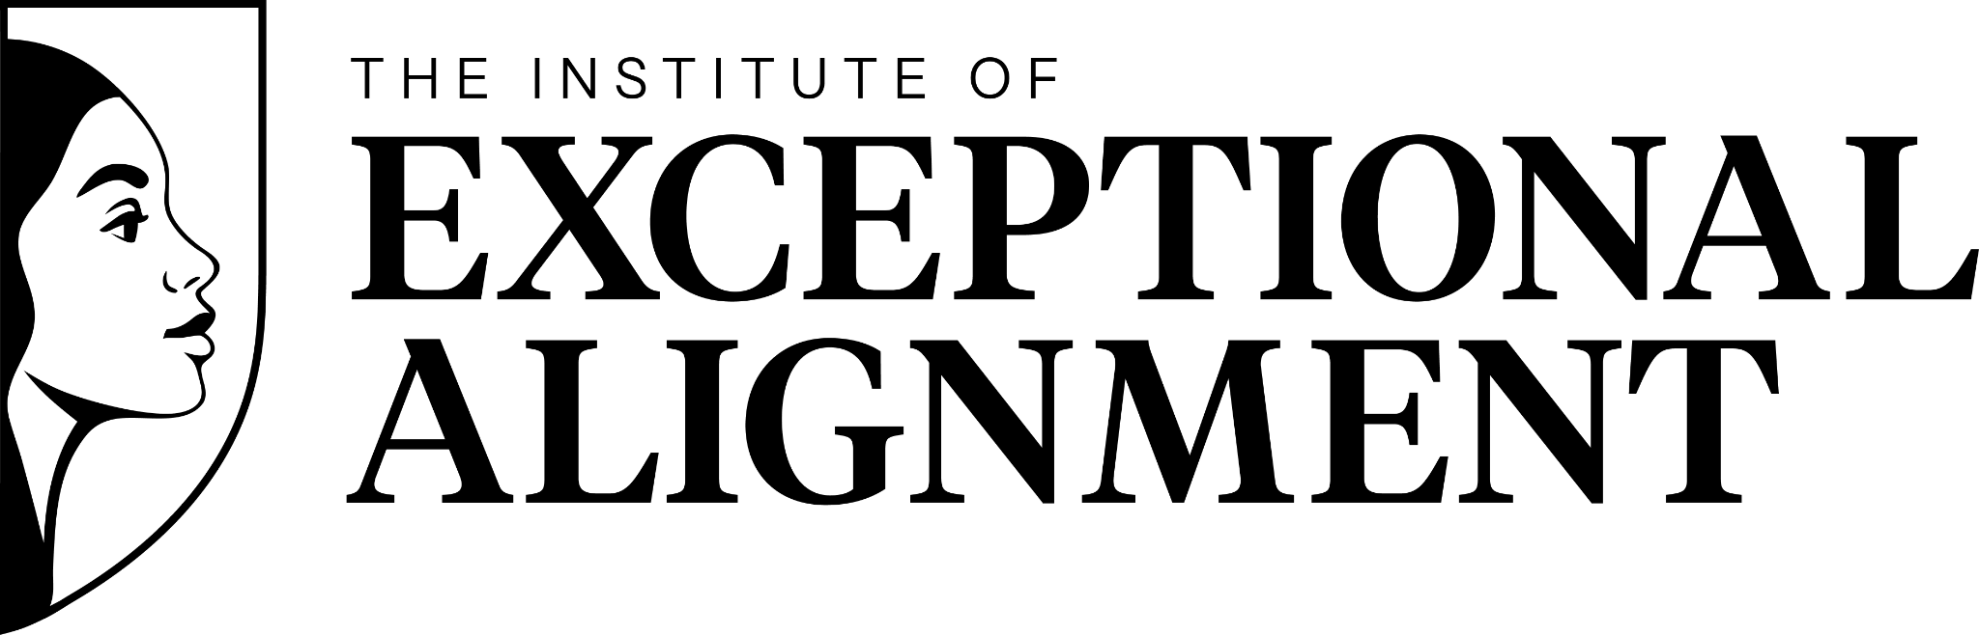
An Immersive Leadership Experience for High-Performing Women

Employer Sponsorship Request Kit

How To Use This Kit
This kit includes two template letters you can use to request employer sponsorship for your participation in The Institute of Exceptional Alignment™:
- Use the Align version if you are requesting sponsorship for the 6-month program
- Use the Advance version if you are requesting sponsorship for the 12-month elite track

Tips for A Strong Request
- Make the Opportunity section personal and specific. This is what moves a request from maybe to yes.
- Connect your growth directly to organizational impact. How will your team, your clients, or your leadership benefit from your development?
- Identify the right budget category before you submit. L&D, professional development, and ERG budgets are common pathways. Naming the source makes the ask easier to act on.
- Offer to connect your sponsor with the Institute team directly. Removing friction increases your chances of a yes.

Questions? Reach out to the Institute team at support@exceptionalalignment.com.

ALIGN | 6-Month Experience
Director to VP level – Our signature experience for building aligned, high-impact leaders.

Hi [[Sponsor Name]],

I'm requesting that [[Company]] sponsor my participation in the Institute of Exceptional Alignment, an immersive leadership development program built specifically for high-performing women at the Director to VP level. I believe this experience is the right investment at the right moment in my career, and I'd like to make the case for why it's also the right investment for this organization.

The Opportunity
[[This is your case in your own words. Where are you in your leadership right now? What are you navigating, and how does this experience connect to your role and your goals here? This is the part that makes the ask personal and specific, and it's often what moves it from a maybe to a yes.]]

Not sure where to start? Here's an example to get you thinking. Use it as inspiration, but make it yours:
I've spent the last few years consistently delivering at a high level, taking on expanded scope, and serving as a go-to leader for my team and for leadership. I'm ready to grow into the next chapter of my career with intention, and I'd like to invest our L&D budget in doing that well. The Institute of Exceptional Alignment is a leadership development program built specifically for women at my level, and I believe it will directly strengthen my ability to lead my team through complexity, make higher-stakes decisions with more clarity and confidence, and show up more strategically across the organization. The people I lead and the projects I'm responsible for will feel the difference, and so will the leaders I report to.

The Experience
The Institute of Exceptional Alignment was built on insights from hundreds of women leaders across industries, designed to address what traditional leadership development consistently gets wrong. The Align track is a 6-month immersive experience that combines 1:1 coaching, a research-backed curriculum, a peer community, and manager support, built to create a lasting shift in how I lead and how our team operates around me.

The Investment
The Align program is $9,997 for 6 months and includes:
- Six private executive coaching sessions
- Full curriculum access
- Peer cohort community
- Quarterly Vision Labs
- Bi-weekly office hours and monthly masterclasses
- Manager enablement support
- Quarterly benchmarking and progress reporting for organizations sponsoring three or more employees – so leadership sees the return throughout, not just at the end
[[IF APPLICABLE: I believe this could be covered through our [[L&D / Professional Development / ERG]] budget. If full sponsorship isn't possible, I'm open to discussing a partial contribution and covering the difference on my end.]]

For more information about the Institute and its corporate sponsorship options, visit the links below. If you have questions or would like to connect directly with the Institute team, please feel free to email them at support@exceptionalalignment.com.
- Partnerships Landing Page
- Partnership Opportunities - Fact Sheet

Thank you for considering this. I'm excited about what this experience will make possible, for me and for this team.

[[Your Name]]

ADVANCE | 12-Month Experience

VP and Above – For senior leaders positioned to define the next generation of leadership.

Hi [[Sponsor Name]],

I’m requesting that [[Company]] sponsor my participation in the Advance track at the Institute of Exceptional Alignment, a 12-month elite leadership development experience built specifically for senior women leaders. I'm committed to growing as a leader in a way that meaningfully contributes to this organization, and I'd like to make the case for why this is the right investment for both of us.

The Opportunity
[[This is your case in your own words. What is the scope and complexity of your role right now? What are you navigating, and what would leading with more clarity, confidence, and strategic authority make possible for you and for this organization? The more specific you are here, the stronger the ask. Consider: What’s at stake in your leadership right now? What becomes possible if you step into this next level?]]

Not sure where to start? Here's an example to get you thinking. Use it as inspiration, but make it yours:
I have spent the past several years leading at a level where my decisions, my presence, and the culture I model shape how this organization moves and grows. I'm ready to invest in that leadership deliberately and at the highest level, and I'd like to use our professional development budget to do it. This program will sharpen my strategic thinking, deepen how I develop and lead the people around me, and strengthen my ability to drive the kind of outcomes this organization is working toward. The growth I take away from this experience will extend beyond me, showing up in how I lead my team, how I contribute to our strategy, and the kind of leadership culture we build together.

The Strategic Case
Organizations that invest in their senior women leaders see measurable returns on team performance, pipeline strength, and profitability. Sponsoring my participation is both a commitment to my growth and a strategic investment in this organization's leadership capacity.

The Experience
The Institute of Exceptional Alignment was built on insights from hundreds of women leaders across industries, designed to address what traditional leadership development consistently gets wrong. The Advance track is a 12-month, high-touch experience designed to match the complexity and ambition of leadership at this level. It’s designed for leaders who are ready to move from reactive to strategic, from managing everything to leading with real authority, and who want an experience that meets them where they are and takes them further.

The Investment
The Advance program is $19,997 for 12 months and includes:
- 12 private executive coaching sessions
- Immersive in-person leadership retreat
- Monthly hot-seat coaching and faculty Q&A
- Integration labs
- Full curriculum access
- Peer cohort community
- Manager enablement support
- Quarterly benchmarking and progress reporting for organizations sponsoring three or more employees – so leadership sees the return throughout, not just at the end

[[IF APPLICABLE: I believe this could be covered through our [[L&D / Professional Development / ERG]] budget. If full sponsorship isn't possible, I'm open to discussing a partial contribution and covering the difference on my end.]]

For more information about the Institute and its corporate sponsorship options, visit the links below. If you have questions or would like to connect directly with the Institute team, please feel free to email them at support@exceptionalalignment.com.

- Partnerships Landing Page
- Partnership Opportunities - Fact Sheet
Thank you for your consideration. I’d welcome the chance to discuss it further.
[[Your Name]]

