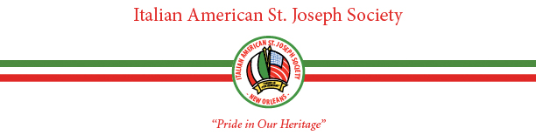
Italian American ST. JOSEPH SOCIETY MAID COMMITTEE

Dear Italian American Joseph Society Maid Candidate:

Our organization would greatly appreciate your support of the Italian community in the Greater New Orleans Area. Attached please find a Maid Application for your review and completion.

We promise that you will have a fantastic time during our St. Joseph’s Parade and our Maid Presentation at the St. Joseph’s Gala following the parade. As a Maid, you will also be included in various events such as the Maid Media Presentation and Party and the St. Joseph’s Pasta Party. These events are held each March.

At this time, we are assessing each Maid candidate a nominal registration fee of $100.00 in order to defray our costs. This fee must accompany the Maid Application. In order to be considered, each Maid candidate must submit the following by January 1st of each year:

- Completed Maid Application
- $100.00 Maid Registration Fee; and
- A Recent Photograph of the Maid Candidate.

We urge you to now assemble and forward these documents to our Maid Coordinator, Ms. Holly Javier, at:

Ms. Holly Javier
6372 Bellaire Drive
New Orleans, LA 70124
hjavier1@cox.net

Finally, if you have a friend between the ages of 5 and 24 who would like to participate in our organization as a Maid and whose father and/or grandfather is a current member or wishes to become a member of the Italian American St. Joseph Society, please contact Ms. Holly Javier at hjavier1@cox.net or (504) 723-3447.

With kindest regards,

Danté V. Maraldo Holly Javier
Board Member and Maid Chairman Maid Coordinator

ITALIAN AMERICAN ST. JOSEPH SOCIETY MAID APPLICATION

- Name:
(First) (Middle) (Last)
- Address:
- City: State: Zip:
3. E-mail:
4. Telephone: 5. Age: 6. Birth Date:
7. School or Employment:
8. Father’s Name: Grandfather’s Name:
9. Is Father or Grandfather and active member? __________Yes __________No
10. Mother’s Maiden Name:
11. Have you previously participated as a Maid of the Italian American St. Joseph Society?
__________Yes __________No If so, what years?
12. Why do you want to be a Maid in the Italian American St. Joseph Society?

13. Will your father/grandfather be able to escort you at the dance? (Must be a member of the I.A.S.J.S.)
Father ( ) Grandfather ( ) Other ( ) - Relationship:
14. Full Name of Escort:
15. If you have a friend or relative that will also be a Maid and you wish to ride with them, please list their names:

* Note: We will try to accommodate your float request to the best of our ability. Please understand that the
Maid’s age will also be a factor in the final float assignment.

Please mail this completed form, $100.00 registration fee, and recent photograph of the Maid candidate to:

ITALIAN AMERICAN ST. JOSEPH SOCIETY
c/o Holly Javier
6372 Bellaire Drive
New Orleans, LA 70124
hjavier1@cox.net

