

Contents
Executive Summary 4
Brief sector snapshot 4
Key challenges and pressures faced by the sector 4
Summary of workforce and training gaps 5
1 Introduction 6
1.1 Purpose of the functional analysis 6
1.2 Intended Audience 7
1.3 Project overview and scope 7
2 Methodology 9
2.1 Data sources 9
2.2 Analytical approach 9
3 Key findings 10
3.1 Workforce profile 10
3.1.1 Employment trends 10
3.1.2 Demographics and employment status 11
3.2 Job advertisement analysis 13
3.2.1 Snapshot overview 13
3.2.2 Roles archetypes 13
3.2.3 Generalised job descriptions 15
3.2.4 Overlapping functions 16
3.2.5 Regional and remote considerations 17
3.2.6 Cultural considerations 17
3.2.7 Context considerations 17
3.2.8 Additional insights 17
3.3 Employer feedback 18
3.3.1 Key themes from interviews and workshops 18
3.3.2 Specialised or emerging roles and service models 20
3.3.3 Sector reforms or innovations 20
3.3.4 Career pathways 22
3.4 Training and education 24
3.4.1 RTO delivery and challenges 25
3.4.2 Gaps in graduate readiness and other qualification-related insights 29
3.5 Functional mapping 31
3.5.1 Key roles and job types 31
3.5.2 Functions and subfunctions 36
Appendix A: Job advertisement data 57
Appendix B: Interview & survey questions 126
RTO Survey Question (SWOT Analysis) 126
Functional Analysis Interview Question 127
Appendix C: List of participating stakeholders 129
Appendix D: Enrolment and completion data 132
Program enrolments and completions 132
Unit enrolments and completions 134
Electives with high enrolments 138

Executive Summary
As part of the career development and employment services qualification review project, a functional analysis was conducted to define the roles, tasks, and skill requirements within the sector. This industry-informed approach used desktop research, job advertisement analysis, employer interviews, and workforce data to map CHC41115 Certificate IV in Employment Services, CHC41215 Certificate IV in Career Development, and CHC81315 Graduate Certificate in Career Development Practice to work practices.

Brief sector snapshot
The sector is currently characterised by distinct functional models, strong projected growth in career development, and a shift toward “inclusive support” in employment services.
- Workforce signals: The career development sector is predicting robust growth, with employment projected to rise from 34,200 (May 2024) to 44,100 (May 2034), a 29.1% increase. The workforce is currently female dominated (78%). It is also ageing (median age 47), signalling a future replacement gap. The employment services sector employs approximately 20,000 staff (as of 2022), split between frontline consultants and corporate/compliance roles.
- Functions & boundaries: Seven generic role classifications were identified to map the sector, setting clear in-scope/out-of-scope boundaries:
  - Career development: Operating on whole-school or employability models. Roles include career practitioners in schools (subject/pathway selection focus), tertiary institutions (graduate employability focus), independent (career transition, migrants, and other specific cohorts focus) and community (apprenticeship support and other government-driven focus).
  - Employment services: Operating on inclusive support or sales models. Roles include employment coaches (caseload management/barrier removal), employment brokers (employer sales/reverse marketing), in-work support officers (retention), and recruiters (HR functions).
Convergence: While boundaries exist, such as career development being developmental (future planning) and employment services being placement-focused (immediate entry), functional convergence is occurring. Both sectors increasingly rely on interpersonal skills coaching, barrier management, and digital literacy.

Key challenges and pressures faced by the sector
The research indicates a sector under pressure from rising client complexity, administrative burdens, and the need for digital adaptation.
- Client complexity vs. workforce capability: Employers in employment services report that the workforce is often unskilled regarding the complexity of current client needs. There is a sharp increase in clients with severe mental health issues, housing instability, and trauma. This has created an urgent pressure for staff to possess accidental counselling skills and trauma-informed practice capabilities, which are not currently standard in the Certificate IV in Employment Services.
- The compliance vs. care tension: Retention is a high issue in employment services. Staff face burnout risks due to the conflict between government contract compliance (audits, KPIs, mutual obligations) and the need for genuine, person-centred care. Employers explicitly screen for resilience in recruitment, acknowledging the high-stress environment.
- Digital & policy volatility: Digital literacy is the top emerging market signal. Staff are under pressure to navigate government systems in employment services or leverage AI and digital platforms in career development. Furthermore, policy shifts, such as the transition to Inclusive Employment Australia (IEA), are changing job roles expectations.
Credentialism: A disconnect exists in recruitment. Career development roles in schools often prioritise post-graduate qualifications, limiting recognition for certificate IV graduates. Conversely, employment services have low barriers to entry, often valuing attitude and life experience over formal Vocational Education and Training (VET) qualifications, leading to inconsistent service quality.

Summary of workforce and training gaps
The functional analysis identified specific skills gaps where current training products do not align with contemporary workplace requirements.
- The trauma gap (employment services): The most significant gap is the lack of core units addressing complex needs. The current Certificate IV in Employment Services is viewed as too generic for the reality of the role. For example, some graduates may be unprepared for domestic violence disclosures, psychosocial risk profiling, and mental health challenges.
- The currency gap (career development): There are gaps in knowledge regarding artificial intelligence, the gig economy, and modern digital recruitment platforms.
- Structural & delivery issues:
  - Content relevance: Some units are misaligned with practice (e.g., assessing skills in holding formal meetings when the industry facilitates appointments).
  - Content duplication: Significant duplication was reported across units, particularly regarding legal, ethical, and communication requirements. This repetition reduces learner engagement and training efficiency.

Introduction

Purpose of the functional analysis
Functional analysis plays a critical role in aligning industry demands with educational outcomes. The purpose of the process is to pinpoint the skills and knowledge required in the application of job role tasks, forming a framework for training product design to achieve the following:
- Understand the workforce and regulatory requirements to prepare individuals for the practical aspect of real-world jobs
- Identify skills and knowledge gaps in the current training products
- Analyse potential career progression pathways within the sector, and across related sectors
Examine design principles that will ensure the qualification meets the needs of industry and the workforce now and into the future
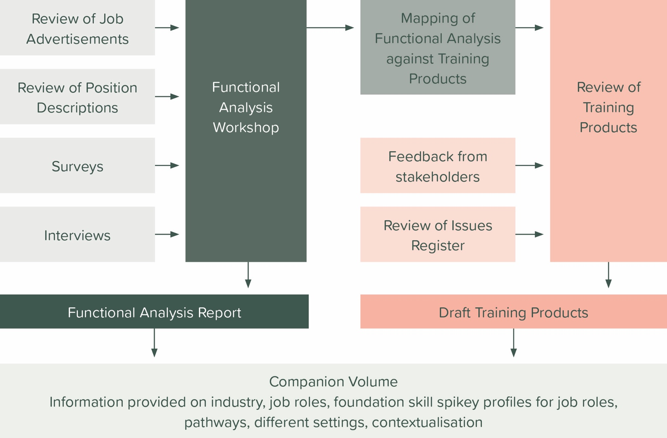
Figure 1: The functional analysis process

More specifically, the functional analysis process identifies:
- Functions that are universal across all contexts
- Training product gaps, duplications, and opportunities for improved clarity
- Opportunities to rationalise and streamline the training products
- The various contexts in which functions are performed, including:
- geographical settings, such as metropolitan versus regional areas
- client settings, involving work with individuals, families, groups, and communities
- specific client groups, including Aboriginal and Torres Strait Islander peoples, people from culturally and linguistically diverse (CALD) backgrounds, people who have disabilities and LGBTQIA+ communities

Intended Audience
This report is designed to communicate to industry stakeholders including, but not limited to:
- Skills Ministers
- The Department of Employment and Workplace Relations (DEWR)
- Industry representatives and stakeholders
- Peak bodies, relevant government departments and industry associations
- Registered Training Organisations (RTO) and Vocational Education and Training (VET) professionals
- HumanAbility
- Unions and the workforce

Project overview and scope
This functional analysis will assist in the review of the following:
Qualifications:
- CHC41115 Certificate IV in Employment Services ^{1,3}
- CHC41215 Certificate IV in Career Development ²
- CHC81315 Graduate Certificate in Career Development Practice ¹
1 Categorised as purpose 1: Qualification leading to a specific occupation.
2 Categorised as purpose 2: Qualification leading to multiple, related occupations.
3 Qualifications in community services, youth work, disability, and mental health can also serve the needs of workers in employment services, as per the findings of this functional analysis.
Skill Sets:
- CHCSS00108 Career Development Skill Set
- CHCSS00109 Employment Services Skill Set
CHCSS00065 Workforce Planning Skill Set
Units of Competency:
- CHCECD001 Analyse and apply information that supports employment and career development
- CHCECD002 Deliver and monitor contracted employment services
- CHCECD003 Promote job seekers to employers
- CHCECD005 Deliver employment services to employers
- CHCECD006 Develop and monitor employment plans
- CHCECD007 Maximise participation in work by people with disability
- CHCECD008 Deliver services consistent with a career development framework
- CHCECD009 Conduct career guidance interviews
- CHCECD010 Provide support to people in career transition
- CHCECD011 Manage quality in career development practice
CHCPRP006 Lead own professional development

Methodology
This functional analysis is based on multiple data collection methods and respondents across the industry.
Desktop research involved a 2-month review of public documents between October 2025 and November 2025 including job advertisements (n=67), position descriptions, industry standards, and reports to analyse workforce demand, skill requirements and employment trends. Key reports were sourced from government bodies, industry associations and research organisations.
Online surveys were conducted (n=28) to gather stakeholder feedback on workforce challenges and training needs.
Semi-structured interviews (n=24) were held with employers, employees, industry associations, and Registered Training Organisations (RTOs) to further explore industry needs and perspectives.
Online workshops (n=2) were held on 4th February 2026, engaging stakeholders in discussions on job functions, pathways, industry trends and training requirements. These workshops helped validate data collected through other methods, refine functional maps, and confirm essential competencies across the sector.

Data sources
- Job advertisements
- Sector reports, frameworks, and research papers
- National Centre for Vocational Education Research (NCVER) data
- Stakeholder interviews
- Industry workshops
- Surveys
- Cross-project research

Analytical approach
Roles were broken down into functions and subfunctions using data from job advertisements and employer interviews, and subsequently confirmed with industry stakeholders via online workshops. These were then mapped against the current training product components to identify misalignments, gaps, and areas for refinement.
Additional data such as RTO surveys, delivery data, and other information from interviews were used to complete the picture of the sector and extract actionable insights for the reviewed training products to match workforce needs.

Key findings

Workforce profile
The following section highlights the key information from desktop research about the career development and employment services workforce.

Employment trends

Career development
Counsellors (beyond career development) are predicted to experience strong projected growth over 10 years and will need continued workforce development and responsive vocational qualifications that align with changing labour market demands.
Baseline | Projected | Projected | 5-Year Change |  | 10-Year Change
May 2024 ('000) | May 2029 ('000) | May 2034 ('000) | Level  ('000) | % | Level  ('000) | %
34.2 | 39.4 | 44.1 | 5.2 | 15.3% | 10.0 | 29.1%
(Source: JSA, 2024, Employment Projections (May 2024-May 2034), produced by Victoria University for Jobs and Skills Australia, accessed 30 April 2025)

Employment services
According to a survey conducted by the National Employment Services Association (NESA), there were around 20,000 staff in the employment services sector in 2022. This included 12,000 frontline staff and 1,500 staff at the service delivery managerial level (such as regional and site managers). The remainder of the staff within the sector deliver corporate services (for example, HR and finance), or occupy customer service, quality assurance, claims processing, and compliance roles. The majority of staff in the sector have experience in related sectors, such as recruitment, education and training, health, youth work, and disability services.
(Source: National Employment Services Association, Submission to the Select Committee on Workforce Australia Employment Services (Attachment 1), pages 8, 12.)

Demographics and employment status
Careers Counsellor
ANZSCO | 272111
Employed | 2,300
Full-Time Share | 57%
Part-Time Share | 43%
Age Breakdown | 15–19 years: 0.2%  20–24 years: 2.6%  25–34 years: 14.6%  35–44 years: 24.4%  45–54 years: 30.7%  55–59 years: 11.5%  60–64 years: 9.1%  65+ years: 7.2%
Median Age | 47 years
Male Share | 22%
Female Share | 78%
(Source: Jobs and Skills Australia)

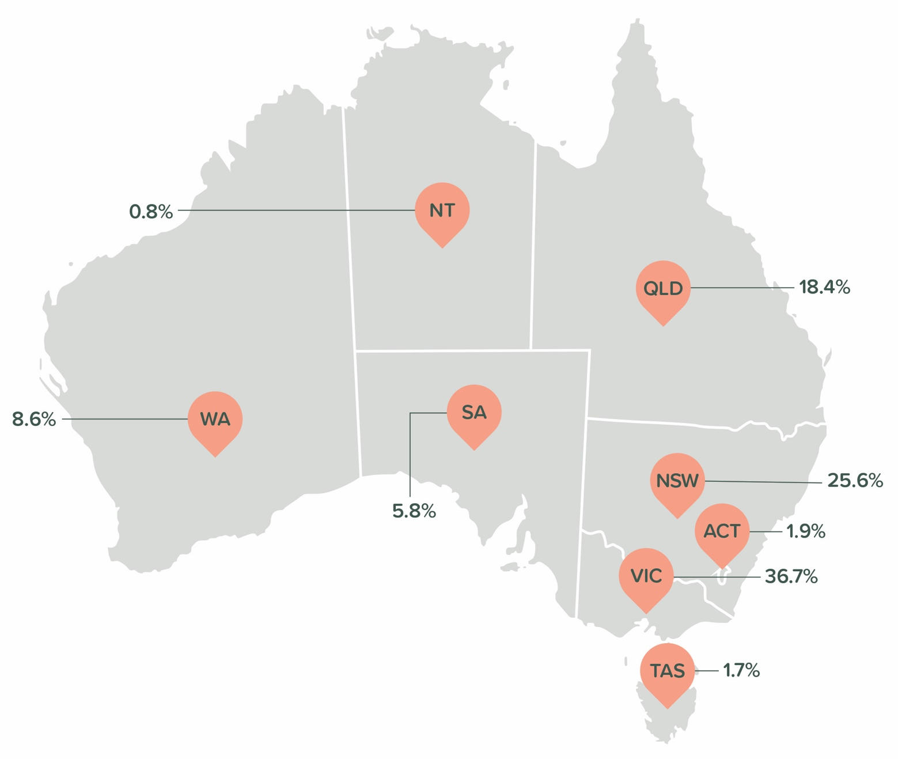
Percentages of workers in the sector for each state and territory are displayed below:
(Source: Jobs and Skills Australia)

Job advertisement analysis
The following section highlights the key information gathered from the desktop research of job advertisements and position descriptions in career development and employment services.

Snapshot overview
- Total advertisements reviewed: 61
- Sectors present: between Education/Schools (career development) and Social Services/Government Providers (employment services).
- Employer size: mix of small/medium/large employers, naturally skewed towards large employers.
- Job location: heavily concentrated in VIC, then QLD, with smaller numbers in NSW/SA/WA/NT/TAS (note: although job boards were searched nationally, geographic skew toward VIC may reflect bias in data outcomes).
- Location type: mostly Major City, then Inner/Outer regional, with a small number Remote/Very remote.
- Employment type: predominantly full-time, with a smaller mix of part-time and casual.
- Employment level: span from entry-level employment coaching to senior leadership in school career departments.
Bias: Although job boards were searched nationally, geographic skew toward VIC may reflect bias in data outcomes.

Roles archetypes
Rather than relying on job titles, which are often inconsistent, roles have been clustered by function into four archetypes.

The career practitioner
The primary context for this role is within schools (K–12), universities, and TAFEs, with the generic title of Student Pathways & Careers Counsellor. The core function focuses on holistic student development, academic advisement, and future pathway planning. Key responsibilities include providing one-on-one counselling for subject selection in Years 10–12 and tertiary admissions support such as VTAC/QTAC, managing specific tools including Morrisby Profile interviewing and “unpacking,” coordinating Work Experience programs and ensuring VET compliance, and liaising with parents and external tertiary providers. The role requires interpersonal skills such as high-level empathy, counselling capabilities, and the ability to build rapport with adolescents, as well as technical skills including knowledge of university admissions centres and the Australian school curriculum. Required qualifications and checks start at the Certificate IV in Career Development and include a Working with Children Check.

The employment mentor (inclusive/cultural support)
The primary context for this role sits within Workforce Australia, Disability Employment Services (DES), and Transition to Work (TtW), under the generic title of Inclusive Employment Mentor. The core function centres on providing intensive, person-centred support, often to specific cohorts such as Indigenous peoples, individuals with disability or National Disability Insurance Scheme (NDIS) participants, and culturally and linguistically diverse, migrant or refugee communities. Key responsibilities include ensuring cultural safety by delivering services that respect cultural protocols, such as working appropriately with Elders and Mob, providing holistic coaching that emphasises life skills, confidence building, and employability skills rather than solely job placement, and collaborating closely with stakeholders including NDIS providers, community elders, and social workers. The role requires interpersonal skills such as trauma-informed care, cultural awareness, patience, and advocacy, alongside hard skills including an understanding of NDIS frameworks and workplace inclusivity adjustments. Qualifications and checks commonly include lived experience or deep community ties, often within identified roles, and a Certificate IV in Mental Health, Youth Work, or Community Services.

The employment consultant (compliance & sales)
The primary context for this role is within Workforce Australia, DES, and TtW, with the generic title of Employment Outcomes Consultant. The core function is focused on placing unemployed individuals into sustainable work in order to meet government contract KPIs. Key responsibilities include reverse marketing by selling a candidate’s suitability to employers, managing large caseloads to monitor clients and ensure Mutual Obligation compliance, assessing and addressing non-vocational barriers such as housing or mental health through appropriate referrals to support services, and providing post-placement support by mentoring clients through the first six months of employment to reduce fall-out. The role requires interpersonal skills including resilience, a sales-oriented mindset, conflict resolution, and the ability to work under pressure, alongside hard skills such as KPI achievement, CRM and database management using ESS or Workforce Australia systems, and strong digital literacy. Required qualifications and checks include an AQF Level 4 qualification in Human Services, a Driver’s License, a Working with Children Check, a Police Check, and NDIS Screening.

The talent partner (recruitment & human resources)
The primary context for this role is within mid-to-large private enterprises and government organisations, with the generic title of Recruitment Officer or Talent Acquisition Specialist. The core function involves identifying, attracting, and securing high-calibre talent to drive business profitability and market growth, while ensuring strict adherence to legislative frameworks, industrial agreements, and safety credentialing. Key responsibilities include partnering with stakeholders by acting as a subject matter expert to advise hiring managers on selection strategies, interview best practices, and employer value proposition, managing regulatory compliance through rigorous pre-employment screening such as AHPRA registrations, NDIS Worker Screening, Blue and Yellow cards, and National Police Checks, and ensuring strong process governance by aligning all recruitment activities with Public Sector Acts, policies, or Health Service directives to maintain audit-ready records. The role also covers end-to-end coordination of the vacancy-to-offer lifecycle, including drafting contracts and letters of offer and coordinating large-scale intake programs such as Graduate Nurse Programs, as well as continuous improvement through identifying bottlenecks in the recruitment funnel and updating HRIS workflows to enhance both candidate and manager experience. Required skills, knowledge, and experience include interpersonal skills such as high-level stakeholder management, courageous communication, empathy for candidates, and the ability to remain calm in high-volume, high-pressure environments, alongside hard skills in advanced HRIS or ATS platforms such as Springboard, PageUp, or Workday, data integrity, legislative interpretation, and report writing, supported by domain expertise in contemporary attraction and retention strategies and awareness of industry salary trends and competitor offerings. Qualifications and checks include an AQF Level 3 or 4 qualification in Human Resources, Business, or a related field at Certificate III, Certificate IV, or Diploma level, mandatory checks such as a Police Check, Working with Children Check (Blue Card), and NDIS Worker Screening (Yellow Card), and a Driver’s License, particularly for regional or local council roles.

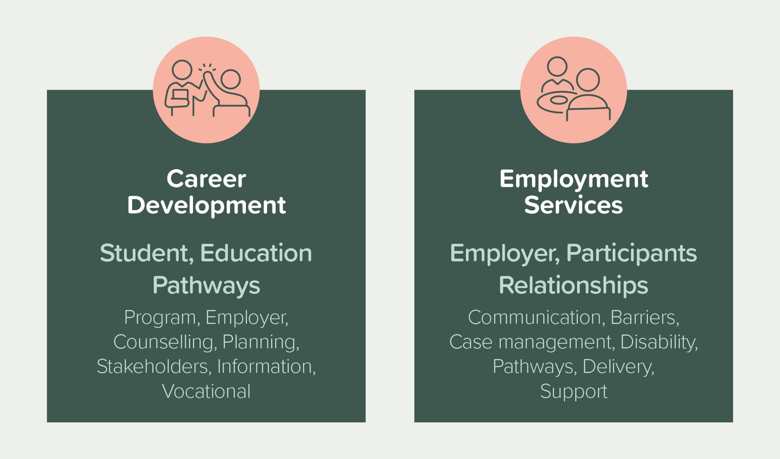
Generalised job descriptions

Career Development Practitioner
Sector: Education (Schools / Higher education / Vocational education), Independent / Community.
Focus: Holistic student development & future planning
Role summary: To provide expert career counselling and pathway planning for students, ensuring every student leaves with a viable destination. This role bridges the gap between academic curriculum, vocational training, and tertiary admissions, acting as the primary liaison between the school, parents, and VET and tertiary providers.
Core responsibilities:
- Counselling & advisory: conduct one-on-one pathways interviews with senior school students to discuss subject selection, ATAR projections, and tertiary admissions.
- Program management: Coordinate the delivery of the career education curriculum, including the administration and unpacking of psychometric tools (e.g., Morrisby profiles).
- VET & compliance (if required): Oversee VET enrolments, monitor student progress, and ensure compliance with RTO standards.
- Event management: Plan and execute major school events (e.g., careers expos, subject selection evenings) and coordinate guest speaker programs.
Stakeholder engagement: Build strong relationships with university admissions centres (VTAC/QTAC/UAC) to ensure accurate advice on SEAS (Special Entry Access Schemes) and scholarship applications.

Employment Services Consultant
Sector: Social services / government provider (Workforce Australia / DES)
Focus: Placement, retention & contract compliance
Role summary: To manage a caseload of job seekers, identifying barriers to employment and actively reversing them into sustainable work. This is a high-energy, target-driven role that combines social work principles with business development (sales) activity to meet strict government contract KPIs.
Core responsibilities:
- Caseload management: Monitor a high volume of participants to ensure they meet their mutual obligations (attendance, job search efforts) and maintain 100% file compliance for government audits.
- Reverse marketing (B2B sales): Proactively network with local employers to uncover hidden market vacancies and negotiate wage subsidies.
- Barrier resolution: Identify non-vocational barriers (housing, mental health, transport) and refer participants to internal specialists or external community partners.
Post-placement support: Provide ongoing mentoring to placed candidates (and their employers) for the first 26 weeks to ensure job retention and outcome payments.

Overlapping functions
While the career development and employment services sectors operate in different environments, there is a functional convergence between roles both within and across sectors:
Overlaps within sector: career development
- Career conversations + planning: goal setting, pathway planning, action plans.
- Education/work exposure: pathway knowledge and/or structured activities (work experience, employer links).
- Coaching micro-skills: rapport, motivation, confidence-building.
- Stakeholder engagement: parents/carers (student roles), employers and training providers (pathways roles).
Documentation: plans, records, monitoring progress.
Overlaps within sector: employment services
- Caseload + outcomes discipline: appointments, monitoring, targets/KPIs.
- Employer engagement + job matching: vacancy development, placement coordination.
- Barrier management + referrals: linking to training, supports, and services.
- Compliance and record-keeping: evidence quality and system accuracy.
Communication resilience: influencing, de-escalation, persistence.
Overlaps across sectors:
- Client-centred support: often explicitly person-centred/strengths-based
- Employability development: work readiness, confidence, job search skills
- Stakeholder engagement: employers, training providers, community services
- Outcome tracking + documentation: case management, documentation
Working with priority cohorts: students, disability, Aboriginal and/or Torres Strait Islander Peoples, CALD, parents/carers, regional/remote

Regional and remote considerations
Urban or regional and remote roles differ significantly in scope and focus. Urban roles are often more specialised, such as positions like Refugee Integration Coach, while remote roles in locations such as Wadeye or Kalgoorlie tend to be broader and more demanding. These remote positions emphasise independence and carry wider responsibilities, including case management, employer relations, community development, and adherence to cultural protocols.

Cultural considerations
Identified roles, such as Koori Employment Lead, place a stronger emphasis on cultural legitimacy and standing within the community than on formal academic qualifications. In these positions, responsibility shifts away from strict compliance requirements and towards trust-building, relationship development, and cultural authority.

Context considerations
Where cohorts are specified, students within career development and people with disability within employment services are the dominant focus groups. Cohort-based roles typically require a deeper capability in providing wraparound support to address complex and interconnected needs.

Additional insights
A clear sales pivot is evident across social and employment services, where roles are frequently framed using sales language despite being rooted in social work. Job descriptions commonly reference concepts such as reverse marketing, B2B sales, cold calling, and KPIs, signalling a strong commercial overlay.
Alongside this, burnout risk is strongly implied by the repeated use of terms like resilience, high-volume caseload, fast-paced, and pressure, suggesting high turnover and deliberate employer screening for candidates who can withstand sustained stress.
There is also a pronounced qualification gap between sectors. Career development roles typically present a high barrier to entry, with schools often requiring post-graduate qualifications such as a graduate certificate or diploma and, in many cases, teacher registration, which itself requires a minimum AQF 7 qualification. In contrast, employment services roles generally have a low barrier to entry, prioritising personal attributes like resilience and drive over formal qualifications, with the Certificate IV in Employment Services commonly listed as desirable rather than mandatory.
The repeated mention of the Morrisby profile in Victorian school role listings further indicates that psychometric assessment tools are technical imperatives for school-based career practitioners.
Digital transformation and compliance pressures are increasingly shaping role design across employment services. Frequent requirements for digital literacy, MyGov ID familiarity, and system compliance point to a shift toward hybrid service delivery, where practitioners must balance people-facing skills with data entry and digital adjudication.
Advertisements that heavily emphasise KPIs, compliance, evidence collection, and caseload management almost always align with employment services, while those referencing workplace adjustments, retention, person-centred support, and disability tend to cluster into inclusive employment roles.
Adding to the complexity, inconsistent job titles across the sector, such as Employment Consultant, Job Coach, Career Partner, or Talent Acquisition, obscure similar job functions and make effective job searching more difficult for candidates.

Employer feedback
The following section highlights the key feedback received from employers about the job roles in career development and employment services.

Key themes from interviews and workshops

Career development
Participants highlighted clear differences between career development and employment services. Employment services were described as focusing on supporting people into jobs, while career development was seen as broader and more holistic, involving working with individuals to understand their skills, interests, and abilities and how these can lead to training and employment. It should be noted that this perspective reflects the views of career development professionals rather than employment services professionals, who increasingly see their roles as closer to career development for priority cohorts rather than simply finding jobs for participants.
A tension was identified between credentialism and competency, with formal qualifications contrasted against the reality that many people enter the field through on-the-job pathways or teaching backgrounds. There was a sentiment that career development is “not really a sector” because of the lack of legislated qualification requirements (note that some professional memberships such as Career Industry Council of Australia (CICA) require qualifications).
The key skills identified for workers in the sector were empathy, active listening, resilience, and counselling, suggesting a significant psychological shift in the role. This points to career development remaining close to social work or psychology rather than being limited to providing career information, which may be an important consideration in reviewing the career development skill set.
There is evidence of role scope creep, with secondary practitioners functioning simultaneously as teachers, administrators, counsellors, event planners, and VET coordinators. The volume of administrative tasks identified in the data suggests a risk that administrative work is displacing time that could otherwise be spent on counselling.

Employment services
A recurring theme is the tension between contractual compliance requirements, such as administrative work and government systems, and the quality of service provided through human connection. The data suggests employment coaches spend around 60% of their time on administration and 40% on client work, although this varies by employer, and this imbalance is a major pain point. One participant described employment services workers as “admin workers for the government”, with successful roles being those that can streamline compliance to create more time for participants. There is repeated emphasis on relationship-based engagement, empathy, and trauma-informed approaches, alongside observations that mental health challenges among clients have “doubled in the past five years”, fundamentally changing the nature of the role (although this does not negate the purpose of employment services being to assist people to gain and keep sustainable employment rather than providing care or counselling).
Training and credentialing across the sector are inconsistent and are often learned on the job. The data repeatedly highlights the dominance of on-the-job learning, with formal qualifications described as preferred but not always required, and in-house training largely focused on contract compliance and program requirements. It should be noted that providers who do well and have lower turnover seem to train their staff more extensively and offer accredited training opportunities.
Clear distinctions were identified between youth and disability roles. Youth-focused roles prioritise mentoring and confidence building, while disability roles place greater emphasis on employer education and job carving.
The dataset shows a concentration of roles on the job-seeker side of pre-employment support, with fewer roles focused on employer-side pre-employment or post-placement support.
The most frequently mentioned core skills were communication, time management and multitasking, and empathy or client-centred practice. A smaller cluster of responses also highlighted relationship building, digital literacy, conflict resolution, and employer-sales capability.
Employment services roles are described as highly emotive, making self-care, peer support, and resilience critical for workforce retention. Burnout is a significant concern, reinforcing the importance of these factors in sustaining workers in the sector.

Specialised or emerging roles and service models

Career development
A human versus digital divide is evident from interviews, with AI and digital tools primarily viewed as mechanisms for improving efficiency rather than replacing core practice. The central value proposition remains trust and relationship building, particularly when working with adolescents and vulnerable groups.
There is noted overlap between career development and wellbeing support, including elements of counselling and addressing self-doubt. This points toward the emergence of a career wellbeing coach role, or, in school settings, a guidance officer role.

Employment services
There is a strong trend towards AI and automation taking on basic tasks such as resumes and cover letters, which shifts the human role towards higher-level behavioural coaching and emotional support.
Job carving is increasingly moving away from simply filling existing vacancies and towards co-designing roles with employers to align with a candidate’s specific capabilities, particularly in disability contexts.
There is a clear indication that the work should shift away from administrative processing and towards social work and mental health support. The data frequently references trauma-informed practice, mental health challenges, and the need for accidental counselling skills, highlighting that employers try to move away from administration and compliance where possible. This shift is captured by one participant’s statement that “meaningful work changes life: it is key to recovery”, which reflects the deeper purpose attributed to roles in the sector.
A more holistic approach is emerging in which employment services form one part of a broader suite of community supports, including housing and health services. This integration is also evident within employment services themselves, where some organisations divide the employment coach function across three or four distinct roles, with each role maintaining a strong understanding of the others.
The required capability mix is described as a combination of human services, sales, and operations. In organisations where employment coaches provide end-to-end support, the role blend is unusual compared to many industries, as coaches are expected to deliver counselling and coaching behaviours, manage stakeholder and employer relationships, maintain operational discipline through time management, multitasking, and documentation, undertake sales and job carving activities, and respond flexibly to whatever the job seeker requires, demanding high levels of problem-solving ability.

Sector reforms or innovations

Career development
Noting this dataset is qualitative and small, the innovation/reform directions implied that there is a push to embed career development within secondary and tertiary curriculum rather than treating it as an add-on service, with a shift away from ad-hoc advice towards embedding career development into coursework and leading curriculum development. This approach positions career skills as graded, academic outcomes rather than being only a supplementary support mechanism.
Mentions of the Australian Blueprint for Career Development being enforced into law and references to CICA guidelines indicate a broader push toward professionalisation and standardisation in the sector. However, these frameworks are not yet enforced by law.

Employment services
The Australian Government has an active employment services reform agenda (Workforce Australia) and has published ongoing reform updates. The Australian Government’s employment services reform aims to redesign Australia’s employment support system so it is more responsive, personalised, and effective at helping people find secure work while meeting employers’ workforce needs. It is guided by principles from the Working Future White Paper and recommendations from the Workforce Australia inquiry, with reforms including improved services, stronger integrity and complaints processes, and targeted programs for disadvantaged groups.
https://www.dewr.gov.au/employment-services-reform
The Parliamentary Library notes that the Budget includes measures continuing changes to Workforce Australia, with savings from these adjustments redirected to support the Australian Government’s broader employment services reform. These measures mainly relate to refining Workforce Australia program settings and funding while the government develops a redesigned employment services system.
https://www.aph.gov.au/About_Parliament/Parliamentary_departments/Parliamentary_Library/Research/Budget_Review/2024-25/EmploymentServices
Disability employment has undergone a major change: Inclusive Employment Australia replaced Disability Employment Services on 1 November 2025, which will directly affect job coach/disability-specialist role design, compliance settings, and employer engagement expectations.
https://www.dss.gov.au/inclusive-employment-australia
Government-facing integrity/compliance measures also influence frontline workflows (appointments, suspensions, re-engagement settings).
https://www.servicesaustralia.gov.au/sites/default/files/2024-05/budget-2024-25-work-3.pdf
Employment services roles can therefore expect continued pressure toward:
- better recognition of individual circumstances
- reduced “harmful compliance” approaches (debated in sector commentary)
stronger accountability for provider performance and service quality

Career pathways

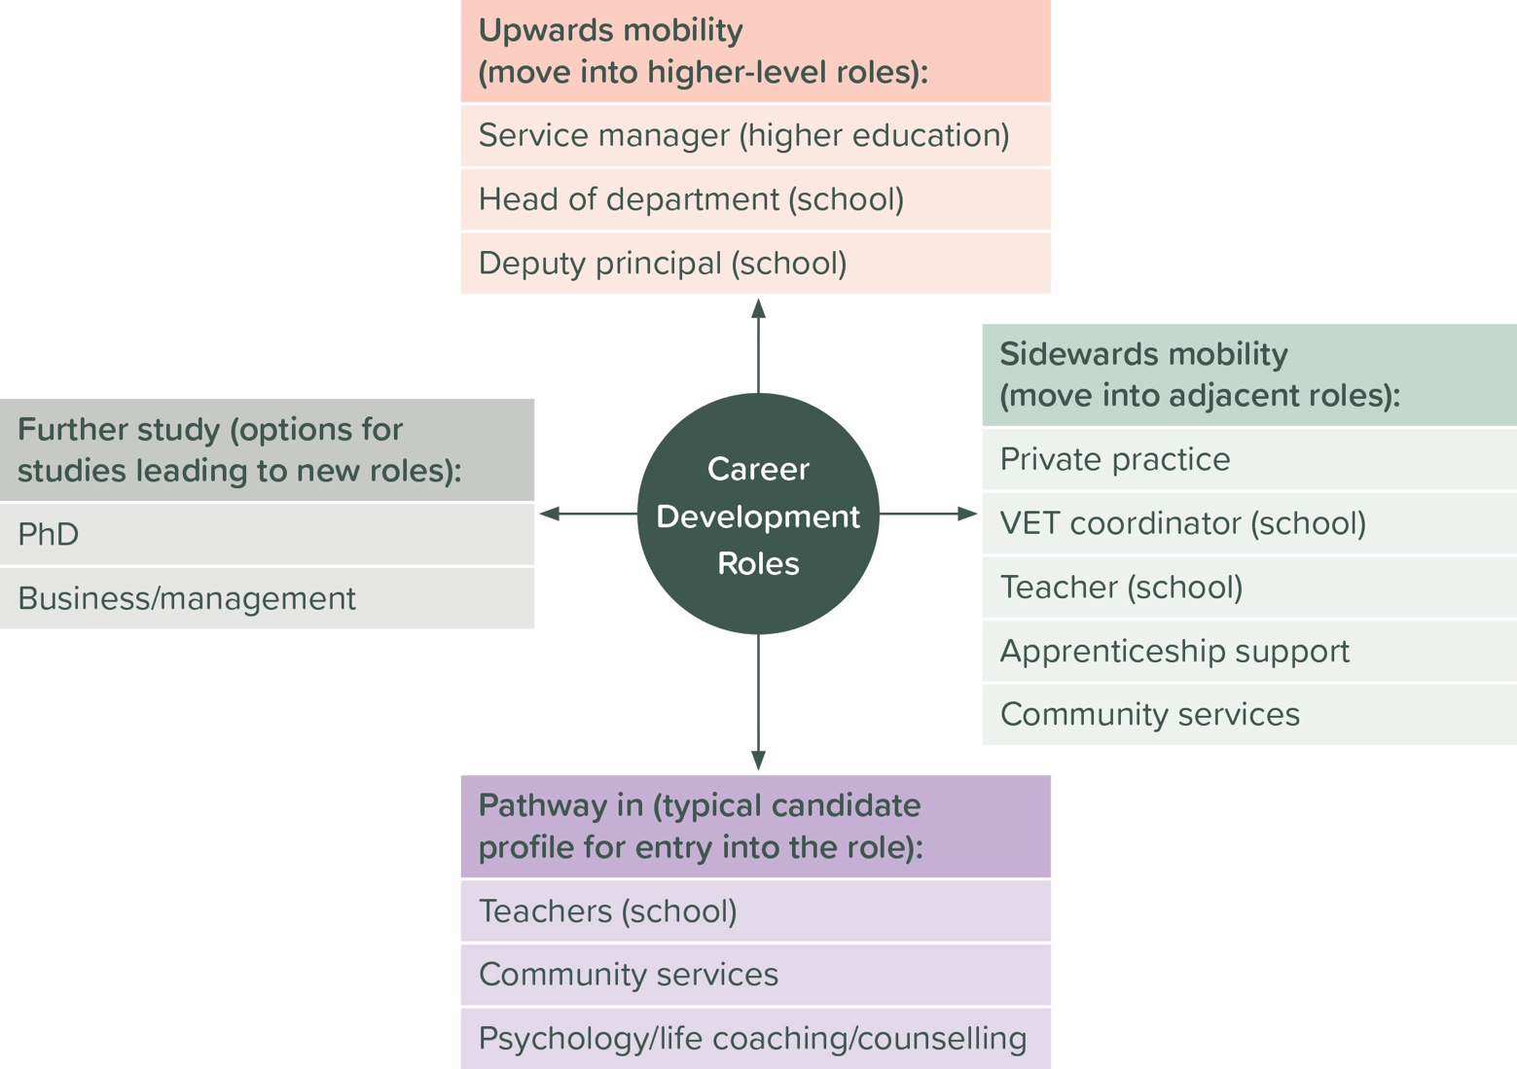
Career development

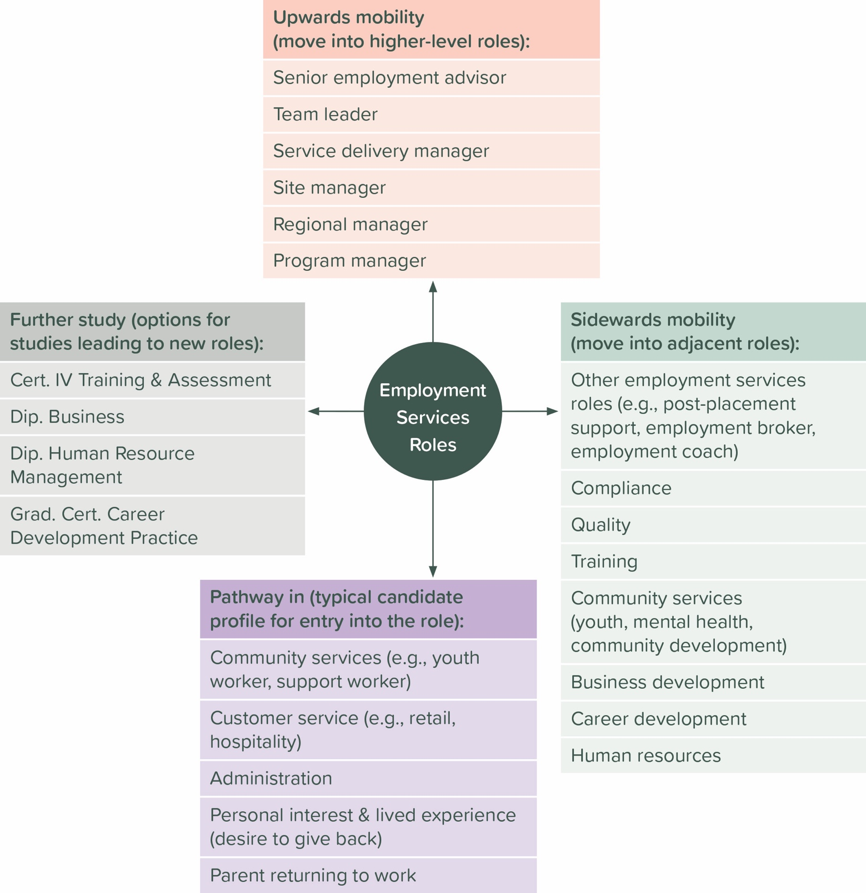
Employment services

Training and education
39 RTOs currently have the training products under review on scope. They are principally located in Victoria, New South Wales, south-east Queensland, and south-west Western Australia, with other locations spread around the country, as per the diagram below.
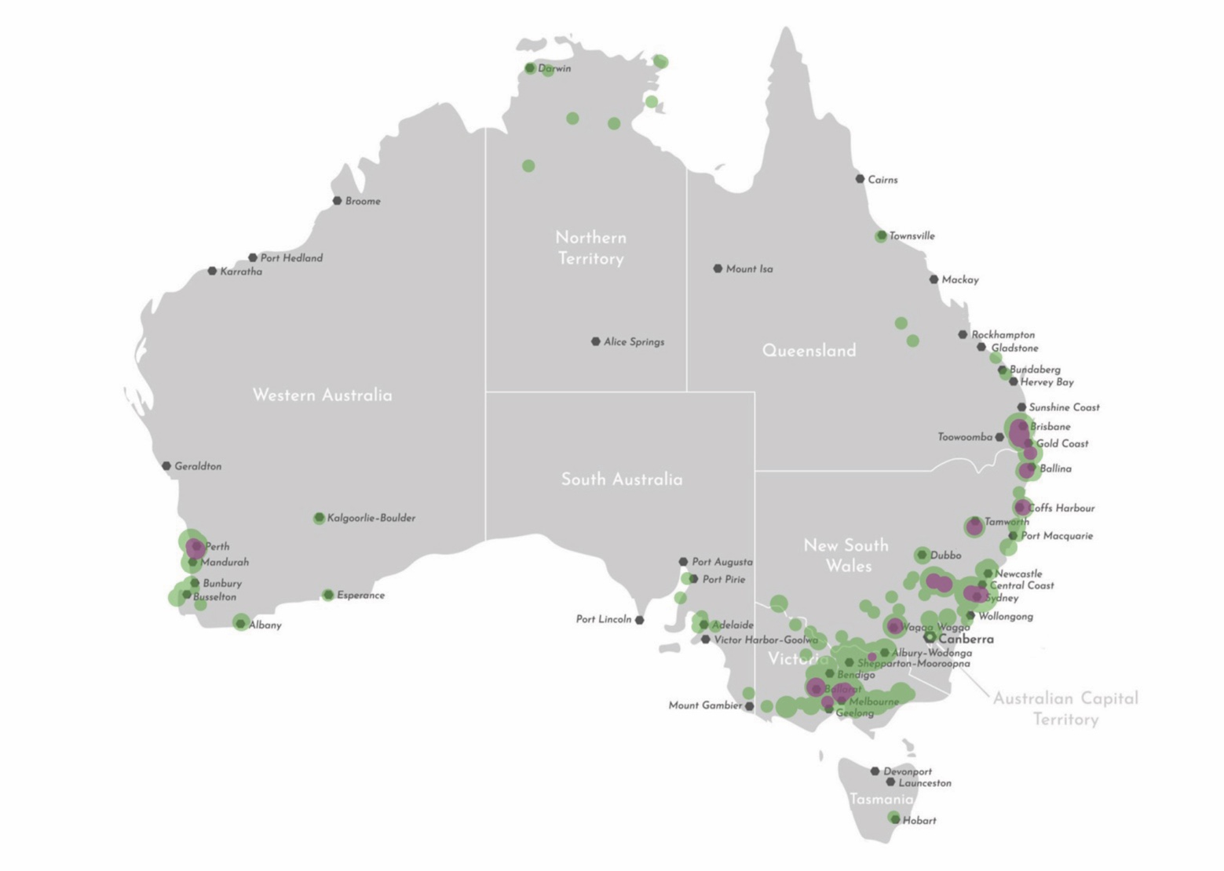
Note: purple indicates head office locations, green indicates additional delivery locations.
(Source: training.gov.au)
Enrolment and completion data for the training products under review is available in appendix D.

RTO delivery and challenges
The following section highlights the key feedback received from employers and RTOs about the training products under review.

CHC41115 Certificate IV in Employment Services

Strengths
The content is directly relevant to federally contracted employment services, including Workforce Australia, Transition to Work, and Inclusive Employment Australia, formerly DES. This alignment ensures the material reflects the operational and compliance realities of the sector. There is clear alignment with core functions such as client engagement, assessment, referrals, and labour market usage. The focus on how to build relationships in communities is highly engaging for students and provides a strong foundation in communication, documentation, and supporting people to use labour market information, with good inclusion of units addressing diversity and client needs. The qualification is differentiated from general community services qualifications, which are seen as including irrelevant topics such as infection control. It is relevant across a wide range of roles within the industry and adaptable to different delivery contexts, with course content described as directly applicable to the work and practically oriented in a way that makes sense to learners.
The competency-based structure supports practical skill development, with blended delivery models, scenario-based activities, and simulations working well. Traineeships delivered in the workplace are particularly effective, and workplace observations and question-and-answer approaches are viewed as strong assessment methods. Flexible packaging is seen as a strength, with good elective options and packaging rules that allow for meaningful customisation to suit different roles and contexts. The combination of Recognition of Prior Learning (RPL) and self-paced assessment works well for existing workers, allowing them to progress efficiently while recognising prior experience.
Employers also use the training as a staff retention tool, with staff often choosing to remain in their roles until they have completed the qualification before moving on.

Weaknesses
Some feedback describes the course content as overly generic and lacking relevance to real-world practice, with concerns that it is designed for “mainstream folks” rather than reflecting the needs of the actual client base. Respondents note that practitioners require skills to work effectively with people with disability, Aboriginal and Torres Strait Islander peoples, and individuals with complex needs. The requirement within CHCCOM002 Use communication to build relationships to hold a meeting is viewed as irrelevant, as the industry primarily facilitates appointments rather than formal meetings. There is a strong call for accidental counselling skills, reflecting the reality that staff are functioning more like case workers than recruitment consultants. CHCECD006 Develop and monitor employment plans is also questioned in terms of relevance, as job plans are now often generated or provided by the Department rather than created by the consultant, reducing the applicability of this unit. There is a noted lack of clarity between recruitment and employment services, with missing contextualisation for the recruitment industry, such as BSBHRM415 Coordinate recruitment and onboarding, leading to confusion among students and employers about the distinction between the two sectors. Digital literacy is identified as an important but uneven capability among learners, with varying skill levels affecting delivery despite digital competence being essential for workers in the sector. Significant duplication and crossover are reported across units, particularly in relation to legal and ethical requirements, communication, diversity, employer engagement, and knowledge evidence. Repetition of concepts and documentation requirements is seen as reducing learner engagement and overall efficiency. A major criticism is that the workforce is perceived as very unskilled relative to the complexity of the role, which often involves clients experiencing mental health challenges, housing instability, or foster care backgrounds. Respondents argue that current training lacks critical content in trauma-informed practice, domestic violence awareness, psychosocial risk profiling, and mental health first aid.

Opportunities
New product development opportunities include creating a specific skill set for employer engagement that treats the employer as the client and focuses on labour market navigation, developing a non-government contracted recruitment skill set, and introducing specialisations for post-placement and in-work support, potentially with a focus on breaking disability-related stigma with employers. There is also interest in developing leadership skill sets for experienced staff and digital capability and data administration skill sets, although both are noted as being out of scope for this project.
Proposed pathways include the creation of a lower-level entry qualification or short skill set for new entrants to the sector, as well as a dedicated pathway into the Certificate IV in Employment Services for remote workers who currently rely on the Certificate II/III in Community Services.
Updates to the electives list include reintroducing recruitment industry-focused electives, such as BSBHRM415 Coordinate recruitment and onboarding, and introducing new electives focused on sales and customer service skills.

Threats
The industry and regulatory environment is said to be characterised by significant policy volatility, with rapid and frequent changes to government contracts, funding models, and legislation threatening the ongoing relevance of training products. In addition, the qualification does not attract full traineeship incentives, which encourages employers to select less relevant qualifications, such as the Certificate IV in Community Services, purely to access funding, although this issue is noted as being out of scope for the project.
Work placement presents ongoing logistical challenges, with placement scarcity reported due to high demand for host organisations and the administrative burden placed on them. Privacy and confidentiality requirements within the sector further restrict opportunities for student placements, and there is limited workforce capacity to supervise students effectively. These challenges are compounded by Workforce Australia’s mandatory 8 to 12-week induction modules, which create a significant barrier to short-term placements and render many placement opportunities impractical.

CHC41215 Certificate IV in Career Development

Strengths
The three ECD core units, CHCECD008 Deliver services consistent with a career development framework, CHCECD009 Conduct career guidance interviews, and CHCECD010 Provide support to people in career transition, are described as providing a strong foundation for practice, with the training viewed as relevant, practical, informative, and up to date in terms of delivery ideas. The use of the Australian Blueprint for Career Development is cited as strong and effective, Morrisby testing is mentioned as a useful tool, and the Career Development Skill Set is praised as an excellent product, with an opportunity identified to promote it further as a pathway to a full qualification. The qualification is explicitly noted as being “very useful for employment services”, as it bridges the gap between career development theory and practical employment support across sectors.
The qualification allows for a flexible blended learning model that works well, with students valuing the wide range of delivery and assessment methods, including role plays, video reviews, presentations, infographics, and research tasks. Case studies are frequently cited as a particularly effective learning resource.

Weaknesses
The training package is viewed as outdated, with some units of competency referring to tools or organisations that no longer exist. Respondents identify content gaps, including the absence of material on artificial intelligence, priority industry areas, and practical guidance on school-specific processes such as apprenticeships and traineeships, VET in Schools, and subject selection. They also mentioned a lack of depth in content tailored to specific life stages, with feedback explicitly calling for specialisations focused on school and university transitions, career change contexts such as mid-life transitions or redundancy, and support for migrants and Aboriginal and/or Torres Strait Islander peoples.
The volume of the qualification, particularly the requirement to complete 13 units, is seen by some RTOs as a challenge and is reported to negatively impact learner retention.
Concerns are raised about the qualification hierarchy, with students able to bypass the practical foundations of the Certificate IV in Career Development and proceed directly to a graduate certificate. This is seen as producing practitioners who understand theory but lack the practical skills needed to effectively assist people.

Opportunities
The overlap in units is seen as creating a viable pathway to market a dual Certificate IV in employment services and career development, strengthening progression and flexibility for learners.
There is a recommendation to engage in consultation with peak bodies such as CICA and NESA to ensure industry perspectives and influence are embedded in any updates.
New product development ideas include creating a dedicated cross-cultural workplace skill set focused on adapting cultural elements to the workplace, although this is noted as potentially being out of scope for the project.

Threats
There are no mandated qualification requirements in the sector, which results in many practitioners being under-qualified for the roles they perform.
Although many students are already employed, work placement remains an issue in cases where placements are required by the RTO, with some learners unable to secure suitable opportunities due to limited availability.

CHC81315 Graduate Certificate in Career Development Practice

Strengths
The course is described as highly relevant to day-to-day practice, particularly for those already working in school settings, with narrative counselling and real-world practice sessions highlighted as especially useful. It provides a strong overview of career development theories, including the Australian Blueprint for Career Development, alongside counselling skills and techniques, and effectively builds capability in active listening, recognising strengths, career planning, and analysing organisational career plans.
The unit BSBLED809 Identify and communicate trends in career development is repeatedly praised as a highly valuable unit that supports career development language and emerging trends. Multiple respondents express strong concern about its replacement with BSBHRM611 Contribute to organisational performance development in the latest release removes essential knowledge related to labour market information and career development theories.
The qualification supports a flexible blended learning model that works well, with distance education improving access for regional students and allowing learners to progress at their own pace without disrupting school commitments. Assessments are often directly linked to the student’s current role, enhancing practicality, and a wide range of effective methods are used, including role plays, case studies, workplace observations, video-taped sessions, and research tasks.

Weaknesses
The training is sometimes seen as mismatched in context, being too general or adult-focused and lacking sufficient emphasis on teenagers and the specific regulatory and child protection requirements that apply within school environments. There are also identified content gaps and issues with outdated material, including the absence of training on artificial intelligence, modern career platforms, and practical data dashboarding skills, with some resources described as dated. While counselling skills are acknowledged as valuable, it is suggested they could be positioned as an elective, and the course is noted to lack critical content in lesson planning, resource design, and instructional design for those delivering career development education, as well as material addressing the rapid evolution of careers and how to identify new and emerging roles.

Opportunities
There is a call to create a stepping-stone qualification between the Certificate IV in Career Development and the Graduate Certificate in Career Development Practice to support smoother and more accessible upskilling pathways. There is also some demand from private practitioners for a new business and marketing skill set focused on marketing, business development, and product costing, although this is noted as being out of scope for the project.

Threats
Stakeholders stated that the absence of government mandates around qualification levels creates confusion about the value of undertaking Level 8 qualifications, with CICA registration often cited as the primary justification. At the same time, industry pressure to work at scale in many workplaces threatens the feasibility of the deep counselling models that are currently being taught.
Work placement also remains challenging, particularly for learners who are employed full time in other industries or those in regional areas where there are limited employer options available.

Gaps in graduate readiness and other qualification-related insights
The following section highlights the key feedback received from employers and RTOs about the gaps in graduate readiness for the training products under review.

Career development
Readiness to work effectively with priority groups, including people with disability and migrants, is commonly developed on the job rather than through initial training, indicating gaps in cultural and disability capability at entry to the sector.
Interview participants noted a distinction between higher education and VET pathways, observing that high-school teachers transitioning into career development typically undertake the higher education Graduate Certificate in Career Development Practice rather than the VET option, as they already hold a higher education bachelor qualification.
A perceived divide was also identified between Certificate IV in Career Development and Graduate Certificate in Career Development Practice, with the Certificate IV deemed to be more hands-on and aimed at frontline workers providing career advice (possibly under broad supervision), and the Graduate Certificate deemed more theoretical and aimed at managers, supervisors, and other career practitioners responsible for shaping strategic direction. One interview participant did suggest, however, that practitioners working in universities require the graduate certificate because “how can someone with a Cert. IV empathise with a university student?”

Employment services
There is a distinct preference for hiring staff with community services experience (e.g., youth work, mental health work, etc.) as they understand the context in which they are working. The most common readiness gaps implied by the role descriptions or explicitly stated by employers as a reason for not prioritising the Certificate IV in Employment Services as their preferred qualification:
- Complex client conversations (trauma, mental health, DFV, disability, housing instability)
- Case notes quality and compliance literacy (contracts, mutual obligations, audit-ready documentation)
- Time management under high caseloads (multi-tasking is repeatedly listed as top skill)
Systems navigation and stakeholder management (referral networks, service integration, employer liaison)
Considering this information and at times explicitly mentioned during interviews, practical job search craft (CV/cover letters, interview coaching, job matching logic), is viewed as secondary to the human touch.
Furthermore, it is important to invest in resilience training: The primary gap is dealing with trauma and aggression. Training must include vicarious trauma and de-escalation, not just sales, CV-building, etc.
The data also clearly indicated that career development professionals do not need employment services skills and knowledge. However, employment services professionals, especially those working with participants (i.e., employment coaches), clearly benefit from career development knowledge and skills.

Functional mapping
The following section highlights the key feedback received from employers and RTOs about the job roles in career development and employment services, and an analysis of their mapping to training products under review.

Key roles and job types

Career Development
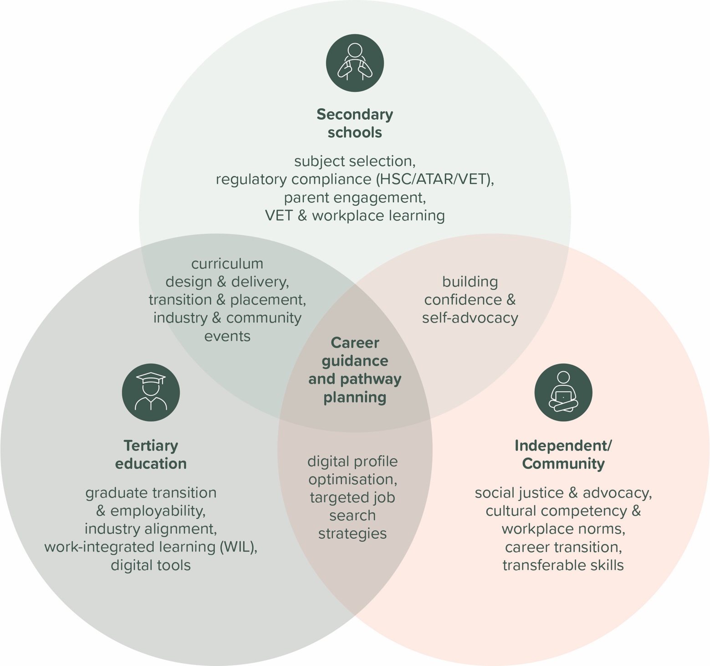
Based on an analysis of the role name, purpose, and detailed functions across the dataset, the roles can be effectively grouped into 3 generic classifications.

CD1: Career practitioner (secondary schools)
The job titles commonly used in this context include career advisor and career practitioner. The primary focus of the role includes developmental learning, career education, curriculum delivery, subject selection and pathway planning, transition support, regulatory compliance related to ATAR, HSC, and VET, VET coordination where a dedicated coordinator is not in place, and engagement with parents. The service model is based on a whole-school approach that combines formal teaching through timetabled lessons and Work Studies curriculum with one-on-one counselling. The role often includes elements of administrative gatekeeping, such as VET coordination, subject selection, and HSC or ATAR administration, as well as managing external providers like RTOs and work placement organisations, while acting as a central hub connecting parents, students, teachers, and external employers.

CD2: Career practitioner (tertiary education)
The job titles commonly associated with this role include career advisor and employability advisor. The primary focus is on employability skills, industry alignment, graduate transition, career counselling, industry and employer connection, and work-integrated learning where a dedicated WIL coordinator is not present. The service model follows an employability approach, with services often student-initiated or embedded within specific coursework. The role functions as a liaison between the institution and the labour market, translating degree outcomes into skills valued by employers, and relies heavily on resource development, workshops and events such as career expos, and the use of digital tools to deliver services at scale.

CD3: Career practitioner (independent/community)
The role is commonly titled career consultant. The primary focus is on social justice, removing barriers to employment, cultural competency, and providing holistic case management. The service model is an advocacy and integration approach that delivers high-touch, individualised support centred on lived experience and cultural safety. The service extends beyond career advice to include navigating Australian workplace culture, understanding rights at work, and building confidence.

Commonalities between roles
Although each role operates in a different context, there are common services delivered across all of them, which can often lead to roles that overlap contexts. For example, government-funded career counselling roles often overlap in functions between secondary and independent/community contexts. Similarly, apprenticeship support roles overlap between secondary schools and employment services contexts.
Other commonalities include guidance and casework provided through one-on-one or small group settings, encompassing career counselling, pathway planning, barrier and problem-solving support, confidence and self-doubt coaching, and work-readiness skill development. They also share responsibility for information provision and sector navigation, which involves maintaining resources, explaining pathways, costs, timelines, and entry requirements, and building labour market awareness. In addition, curriculum-embedded career education is a shared function, delivered through workshops, lessons, and employability skill-building activities integrated into learning.
Furthermore, education-based roles in both secondary and tertiary settings share responsibility for transition and placement activities, including coordinating work experience, structured workplace learning, apprenticeship and traineeship pathways, and work-integrated learning or internship opportunities. They also commonly focus on industry and community connection through activities such as career fairs, coordinating external speakers, mentoring programs, employer partnerships, events, and facilitating networking opportunities.
A note is made, however, about the difference between secondary and tertiary contexts. Secondary is constrained by curriculum and compliance (i.e., mandatory). Tertiary is driven by employability and strategy (i.e., voluntary). The implication is then that secondary practitioners need more regulatory knowledge (e.g., VTAC, school records) while tertiary practitioners need more sales/marketing/networking skills (e.g., AI, LinkedIn).

Employment Services
Based on an analysis of the role name, purpose and detailed functions across the dataset, the roles can be effectively grouped into 4 generic classifications: 3 specifically within the employment services sector, and 1 that is adjacent.
It should be noted that different organisations operate differently when it comes to job functions. For example, a job role in one organisation might include all of the first 3 generic classifications (ES1, ES2, ES3 below) for end-to-end case management, where another might have distinct positions for each, with the addition of intake officers for administrative processes, or even splitting the employment coach duties between getting the participant ready to start looking for work and dealing with work-ready participants only. This sort of overlap is especially important in remote organisations where many of the functions listed are not split across different roles as these providers generally operate with smaller caseloads and do not have the critical mass to employ separate staff for each function. Regardless of the job role distinctions, all participants interviewed indicated that a worker in any of these roles would normally have in-depth skills and knowledge of the other roles.

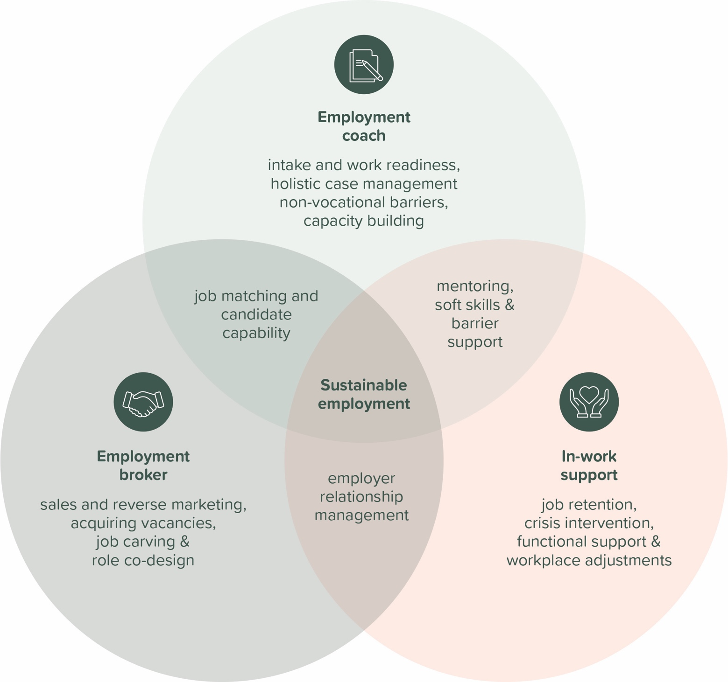

ES1: employment coach (job seeker side, pre-employment)
Common job titles in this area include employment consultant, employment advisor, employment coordinator, job coach, employment coach, youth mentor, employment support clinician, and link worker. The primary focus of these roles is on case management, compliance, overcoming barriers to employment, capacity building, and preparing candidates for participation in the labour market. The service model is a blend of case management and person-centred or therapeutic approaches and represents the core operational engine of the sector. Workers manage caseloads of approximately 30 to more than 40 participants, depending on contractual requirements, ensuring mutual obligations and government compliance are met while also identifying vocational and non-vocational barriers. Although the model is heavily administrative, it is shifting towards more relational, strengths-based work that emphasises coaching and mentoring, particularly within specific participant cohorts such as youth or people with disability, where barriers to employment are often psychological or systemic rather than purely skills-based.

ES2: Employment broker (employer side, pre-employment)
The job titles associated with this function include employment broker, recruitment broker, employer engagement officer, and business development consultant. The primary focus of the role is reverse marketing candidates, managing relationships with employers, acquiring job vacancies, and undertaking sales activities. The service model follows a sales and recruitment approach that operates largely independently from day-to-day job seeker management. It mirrors the structure of commercial recruitment agencies, where the employer is the client, and the objective is to sell the participant into a vacancy, requiring strong sales capability and extensive industry networking.

ES3: In-work support officer (both job seeker and employer side, post-placement)
The original titles used in the data for this function include post-placement support, in-work support person, and peer support. The primary focus of the role is on job retention, providing crisis intervention after placement, and mediating between employers and employees. The service model is a retention and crisis intervention approach that activates once a placement has occurred and is distinct due to the shift in power dynamics, as the participant becomes an employee. The focus is on sustaining employment by mediating between the employer and the new worker, with interventions often addressing interpersonal skill issues such as attendance, attitude, or anxiety rather than technical skill gaps.
Note: a role that is functionally similar to the employment broker and in-work support officer, but has stronger ties to the career development space is the apprenticeship support officer. They help identify and map school-based training opportunities within businesses and coordinate access to candidate pools. They also provide coaching and mentoring for ongoing support and successful outcomes.

ES4: Recruiter (employer side, pre- employment)
The original titles referenced in the data include recruitment officer, recruitment consultant, talent acquisition partner, talent acquisition specialist, and recruitment coordinator. The primary focus of this role is delivering end-to-end recruitment operations, ensuring legislative and policy compliance, advising internal hiring managers, and sourcing talent to meet organisational needs. The service model blends a sales and recruitment approach with an internal service and governance model and typically operates as a centralised function, such as within People & Culture or shared services teams, or in servicing external customers. This process- and quality-driven model aims to ensure merit-based selection, mitigate organisational risk, and strengthen the employer value proposition to attract talent over the long term, while also selling the vacancy to participants and requiring a combination of sales capability, industry networking, and human resources expertise.
Note: Recruiters, while having links to employment services roles (specifically to the employment broker as their role also operates on a sales & recruitment model), largely fall outside of the scope of this project as they more closely relate to human resources and business functions.

Functions and subfunctions

Career development

CD1: Career practitioner (secondary schools)
Function | Sub-functions
Provide one-to-one career counselling | Evaluate participant strengths to align with occupational pathways  (e.g., using career assessment tools) | Develop individual pathway (e.g., transition plans into VET, further study options, employment information) | Deliver individualised guidance on study options, entry, scholarships, government funding, cost, duration, and application processes | Develop long-term career self-management skills | Identify career-related health and wellbeing challenges, and refer students to appropriate support services
Develop career curriculum | Design structured career education | Design structured employability skill instruction (e.g., interpersonal skills, professional communication including résumés, cover letters, and interviewing) | Design (in collaboration with faculty) and integrate career development content within the curriculum | Maintain and update career information resources
Deliver career curriculum | Deliver structured career education | Deliver structured employability skill instruction (e.g., interpersonal skills, professional communication including résumés, cover letters, and interviewing) | Facilitate subject selection processes
Manage workplace learning & VET | Plan, approve, and monitor compliant workplace learning placements | Coordinate vocational pathways, apprenticeships, and external training programs
Engage and maintain stakeholder relationships | Establish and maintain employer partnerships to support opportunities | Plan and deliver career-related events, industry engagement, and exposure activities (e.g., career fairs, industry guest presentations) | Communicate post-school pathways and transition information to families
Develop professional practice | Analyse labour market data and employment trends | Maintain current knowledge of roles, training programs, and salaries
Support organisational strategy | Contribute career expertise to strategic planning (e.g., service improvement, employability strategies) | Monitor and report student engagement, pathway, and destination data | Maintain case notes and records of student interests & abilities

CD2: Career practitioner (tertiary education)
Function | Sub-functions
Provide one-to-one career counselling | Evaluate participant strengths to align with occupational pathways (e.g., using career assessment tools) | Develop individual pathway (e.g., further study options & cost & duration, employment information & remuneration) | Deliver individualised guidance on study options, scholarships, government funding, cost, duration, and application processes | Address confidence barriers and provide motivational coaching to support progress | Develop long-term career self-management skills
Develop career curriculum | Design structured career education | Design structured employability skill instruction (e.g., interpersonal skills, professional communication including résumés, cover letters, and interviewing) | Design (in collaboration with faculty) and integrate career development content within the curriculum | Maintain and update career information resources
Deliver career curriculum | Deliver structured career education | Deliver structured employability skill instruction (e.g., interpersonal skills, professional communication including résumés, cover letters, and interviewing) | Deliver targeted learning on industry trends and job search strategies | Build capability in digital recruitment platforms and technologies (e.g., profile optimisation, value proposition, platform consistency)
Manage Work-Integrated Learning | Coordinate (or support) WIL and employment programs
Engage and maintain stakeholder relationships | Establish and maintain employer partnerships to support opportunities | Plan and deliver career-related events, industry engagement, and exposure activities (e.g., career fairs, industry guest presentations) | Coordinate mentoring programs with alumni and industry professionals | Connect participants (e.g., students, alumni, client) with employment, internship, and graduate opportunities | Build participant networking skills
Develop professional practice | Analyse labour market data and employment trends | Maintain current knowledge of roles, training programs, and salaries
Support organisational strategy | Contribute career expertise to strategic planning (e.g., service improvement, employability strategies) | Monitor and report student engagement, pathway, and destination data

CD3: Career practitioner (independent/community)
Function | Sub-functions
Provide one-to-one career counselling | Evaluate participant strengths to align with occupational pathways (e.g., using career assessment tools) | Develop individual pathway (e.g., further study options & cost & duration, employment information & remuneration) | Develop structured short- to medium-term career plans | Assess capability gaps between current position and target roles | Identify and articulate transferable skills across industries
Develop career curriculum | Design structured employability skill instruction (e.g., interpersonal skills, professional communication including résumés, cover letters, and interviewing)
Deliver career curriculum | Deliver structured employability skill instruction (e.g., interpersonal skills, professional communication including résumés, cover letters, and interviewing) | Deliver targeted learning on industry trends and job search strategies (including hidden job market strategies and opportunity creation) | Build capability in digital recruitment platforms and technologies (e.g., profile optimisation, value proposition, platform consistency) | Build capability in emotional intelligence and personality type understanding
Engage and maintain stakeholder relationships | Establish and maintain employer partnerships to support opportunities | Build participant networking skills | Connect participants (e.g., students, alumni, client) with employment, internship, and graduate opportunities | Establish boundaries on responsibilities
Support career transition | Support individuals transitioning into new roles or industries (e.g., due to redundancy or organisational change) | Assist individuals re-entering employment after absence or disruption | Provide emotional support related to change management
Deliver cultural and workplace capability skills | Build understanding of Australian workplace norms and expectations (Explain standard workflows, systems, and performance expectations) | Build effective communication skills in diverse work environments (including self-advocacy, culturally safe workplace participation, professional workplace conflict resolution) | Build understanding of differences in religions, cultural thinking and practices and their impact on employment
Provide person-centred holistic case management | Establish trust and engagement using empathetic, participant-centred communication (including de-escalation and emotional regulation techniques to support engagement)

Employment services

ES1: Employment coach (job seeker side, pre-employment)
Function | Sub-functions
Provide intake services | Conduct intake and re-engagement appointments to explain services and obligations | Conduct skills and work readiness assessment (including vocational capacity and digital competency) | Identify employment history, goals, and suitable participation pathways | Complete eligibility checks, consent processes, and system registration | Develop and formalise Job Plans outlining participant and service requirements
Provide person-centred holistic case management | Establish trust and engagement using empathetic, participant-centred communication (including de-escalation and emotional regulation techniques to support engagement) | Identify non-vocational barriers and implement resolution strategies (e.g., coordinate referrals and external services to support participant stability, housing, safety, or basic needs) | Facilitate transport and logistical access to appointments and services | Monitor participation, address non-compliance, and adjust support plans.
Provide vocational and employment case management | Facilitate access to upskilling opportunities, required licences, credentials, and documentation | Match job-ready participants to suitable employment opportunities | Calculate pay details, manage employment expenditures, and access training funding
Deliver career curriculum | Deliver structured employability skill instruction (e.g., interpersonal skills, professional communication including résumés, cover letters, and interviewing) | Deliver finance skills guidance
Deliver cultural and workplace capability skills | Build understanding of Australian workplace norms and expectations (Explain standard workflows, systems, and performance expectations) | Build capability in digital platforms and technologies
Administer and comply with governmental requirements | Operate government and organisational systems to manage participant services | Maintain accurate, compliant case notes and participant records | Review job plans for contractual compliance | Undertake mandatory professional development

ES2: Employment broker (employer side, pre-employment)
Function | Sub-functions
Engage and maintain stakeholder relationships | Establish and maintain employer partnerships to support opportunities | Educate employers on candidates’ capability, support models, and workforce solutions | Co-design customised employment pathways and workforce solutions with employers (including job carving) | Develop and maintain customer relation management (CRM) database
Develop professional practice | Analyse labour market data and employment trends | Maintain knowledge of available financial incentives | Maintain knowledge of marketing and sales trends
Match and place participants | Analyse job roles, workplace requirements, and risk considerations to match relevant candidates | Market suitable candidates to employers (reverse marketing) | Prepare candidates for placement and communicate role expectations (including onboarding activities) | Facilitate productive working relationships between employers and candidates (including resolving placement issues through creative and practical solutions)
Provide vocational and employment case management | Facilitate access to upskilling opportunities, required licences, credentials, and documentation | Match job-ready participants to suitable employment opportunities | Calculate pay details, manage employment expenditures, and access training funding
Facilitate employer liaison & workplace adjustments | Educate and negotiate with employers on participant needs, functional impacts, and workplace adjustments
Administer and comply with governmental requirements | Operate government and organisational systems to manage participant services | Maintain accurate, compliant case notes and participant records

ES3: In-work support officer (both job seeker and employer side, post-placement)
Function | Sub-functions
Provide intake services | Conduct skills and work readiness assessment (including vocational capacity and digital competency)
Provide job-related support | Monitor job stability (including identifying in-work challenges and engagement) | Support day-to-day work readiness (including presentation, PPE, communication skills development, work-life balance). | Facilitate peer support to strengthen workplace engagement | Support career advancement and sustainable employment pathways (including coordination of internal role transitions to prevent job loss)
Provide emotional & functional support | Monitor and support symptom management impacting work performance (e.g., coordinate external health professionals to support work participation) | Provide emotional support and respond to in-work crises | Maintain contact with support network (e.g., family, support workers) for any impacts on social life | Maintain contact with participant through various means to monitor job satisfaction, symptoms, work performance and discuss management strategies
Facilitate employer liaison & workplace adjustments | Manage employer requests related to hours, duties, or certification | Identify functional and assistive technology needs, including workplace or home-based environment adjustments | Educate and negotiate with employers on participant needs, functional impacts, and workplace adjustments | Deliver person-centred support aligned to functional capacity (e.g., build adaptations for participants in the workplace) | Mediate performance and relationship issues to sustain employment
Administer and comply with governmental requirements | Secure and manage employment-related funding and supports (including NDIS access) | Monitor, coordinate and inform of processing of claims, subsidies, wage support payments, wage increases, wage/support assessments | Maintain accurate, compliant case notes and participant records | Monitor post-placement outcomes and report employer feedback

ES4: Recruiter (employer side, pre-placement)
Function | Sub-functions
Execute end-to-end recruitment operations | Manage approved vacancies from requisition through advertisement | Coordinate shortlisting, interviews, panels, and candidate communications | Advise managers on recruitment policy, process, and selection best practice | Prepare and issue offers, contracts, and outcome correspondence
Administer and comply with governmental requirements | Maintain accurate, compliant case notes and participant records | Ensure recruitment activity complies with legislation and industrial instruments | Manage sensitive candidate information in line with privacy requirements
Provide intake services | Complete eligibility checks, consent processes, and system registration
Drive talent attraction & sourcing strategy | Develop and promote the organisation’s employment value proposition | Source active and passive candidates | Build and maintain talent pools for current and future workforce needs
Engage and maintain stakeholder relationships | Plan and deliver career-related events, industry engagement, and exposure activities (e.g., career fairs, industry guest presentations)
Match and place participants | Analyse job roles, workplace requirements, and risk considerations to match relevant candidates | Market suitable candidates to employers (reverse marketing) | Prepare candidates for placement and communicate role expectations (including onboarding activities) | Facilitate productive working relationships between employers and candidates (including resolving placement issues through creative and practical solutions)
Facilitate employee lifecycle transitions | Manage recruitment-related exit and separation processes | Coordinate relocation, travel, or role-specific logistics where required
Support career transition | Support individuals transitioning into new roles or industries (e.g., due to redundancy or organisational change)
Support organisational strategy | Analyse recruitment metrics to inform workforce and performance decisions | Review and improve recruitment workflows and systems | Embed diversity and inclusion principles into recruitment practices
Develop professional practice | Analyse labour market data and employment trends
Provide job-related support | Support career advancement and sustainable employment pathways (including coordination of internal role transitions to prevent job loss)

Functional overlaps
The below table provides all functions and subfunctions of the job roles relevant to this project. This view helps identify the functional overlaps between job roles.
Note:
- CD1 = Career practitioner (secondary schools)
- CD2 = Career practitioner (tertiary education)
- CD3 = Career practitioner (independent/community)
- ES1 = Employment coach (job seeker side, pre-employment)
- ES2 = Employment broker (employer side, pre-employment)
- ES3 = In-work support officer (both job seeker and employer side, post-placement)
ES4 = Recruiter (employer side, pre-employment)
Functions and sub-functions | CD |  |  | ES
Functions and sub-functions | 1 | 2 | 3 | 1 | 2 | 3 | 4
Provide one-to-one career counselling
Evaluate participant strengths to align with occupational pathways (e.g., using career assessment tools) | ✔︎ | ✔︎ | ✔︎
Develop individual pathway (e.g., study options & cost & duration, employment information & remuneration) | ✔︎ | ✔︎ | ✔︎
Deliver individualised guidance on study options, entry, scholarships, government funding, cost, duration, and application processes | ✔︎ | ✔︎
Address confidence barriers and provide motivational coaching to support progress | ✔︎ | ✔︎
Identify career-related health and wellbeing challenges, and refer students to appropriate support services | ✔︎
Develop long-term career self-management skills |  | ✔︎
Develop structured short- to medium-term career plans |  |  | ✔︎
Assess capability gaps between current position and target roles |  |  | ✔︎
Identify and articulate transferable skills across industries |  |  | ✔︎
Develop career curriculum
Design structured career education | ✔︎ | ✔︎
Design structured employability skill instruction (e.g., interpersonal skills, professional communication including résumés, cover letters, and interviewing) | ✔︎ | ✔︎ | ✔︎
Design (in collaboration with faculty) and integrate career development content within the curriculum | ✔︎ | ✔︎
Maintain and update career information resources | ✔︎ | ✔︎
Deliver career curriculum
Deliver structured career education | ✔︎ | ✔︎
Deliver structured employability skill instruction (e.g., interpersonal skills, professional communication including résumés, cover letters, and interviewing) | ✔︎ | ✔︎ | ✔︎ | ✔︎
Facilitate subject selection processes | ✔︎
Deliver targeted learning on industry trends and job search strategies |  | ✔︎ | ✔︎
Build capability in digital recruitment platforms and technologies (e.g., profile optimisation, value proposition, platform consistency) |  | ✔︎ | ✔︎
Build capability in emotional intelligence and personality type understanding |  |  | ✔︎
Deliver finance skills guidance |  |  |  | ✔︎
Manage workplace learning & VET
Plan, approve, and monitor compliant workplace learning placements | ✔︎
Coordinate vocational pathways, apprenticeships, and external training programs | ✔︎
Manage Work-Integrated Learning
Coordinate (or support) WIL and employment programs |  | ✔︎
Engage and maintain stakeholder relationships
Establish and maintain employer partnerships to support opportunities | ✔︎ | ✔︎ | ✔︎ |  | ✔︎
Plan and deliver career-related events, industry engagement, and exposure activities (e.g., career fairs, industry guest presentations) | ✔︎ | ✔︎ |  |  |  |  | ✔︎
Communicate post-school pathways and transition information to families | ✔︎
Coordinate mentoring programs with alumni and industry professionals |  | ✔︎
Connect participants (e.g., students, alumni, client) with employment, internship, and graduate opportunities |  | ✔︎ | ✔︎
Build participant networking skills |  | ✔︎ | ✔︎
Establish boundaries on responsibilities |  |  | ✔︎
Educate employers on candidates’ capability, support models, and workforce solutions |  |  |  |  | ✔︎
Co-design customised employment pathways and workforce solutions with employers (including job carving) |  |  |  |  | ✔︎
Develop and maintain customer relation management (CRM) database |  |  |  |  | ✔︎
Develop professional practice
Analyse labour market data and employment trends | ✔︎ | ✔︎ |  |  | ✔︎ |  | ✔︎
Maintain current knowledge of roles, training programs, and salaries | ✔︎ | ✔︎
Maintain knowledge of available financial incentives |  |  |  |  | ✔︎
Maintain knowledge of marketing and sales trends |  |  |  |  | ✔︎
Support organisational strategy
Contribute career expertise to strategic planning (e.g., service improvement, employability strategies) | ✔︎ | ✔︎
Monitor and report student engagement, pathway, and destination data | ✔︎ | ✔︎
Maintain case notes and records of student interests & abilities | ✔︎
Analyse recruitment metrics to inform workforce and performance decisions |  |  |  |  |  |  | ✔︎
Review and improve recruitment workflows and systems |  |  |  |  |  |  | ✔︎
Embed diversity and inclusion principles into recruitment practices |  |  |  |  |  |  | ✔︎
Support career transition
Support individuals transitioning into new roles or industries (e.g., due to redundancy or organisational change) |  |  | ✔︎ |  |  |  | ✔︎
Assist individuals re-entering employment after absence or disruption |  |  | ✔︎
Provide emotional support related to change management |  |  | ✔︎
Deliver cultural and workplace capability skills
Build understanding of Australian workplace norms and expectations (Explain standard workflows, systems, and performance expectations) |  |  | ✔︎ | ✔︎
Build effective communication skills in diverse work environments (including self-advocacy, culturally safe workplace participation, professional workplace conflict resolution) |  |  | ✔︎
Build understanding of differences in religions, cultural thinking and practices and their impact on employment |  |  | ✔︎
Build capability in digital platforms and technologies |  |  |  | ✔︎
Provide intake services
Conduct intake and re-engagement appointments to explain services and obligations |  |  |  | ✔︎
Conduct skills and work readiness assessment (including vocational capacity and digital competency) |  |  |  | ✔︎ |  | ✔︎
Identify employment history, goals, and suitable participation pathways |  |  |  | ✔︎
Complete eligibility checks, consent processes, and system registration |  |  |  | ✔︎ |  |  | ✔︎
Develop and formalise Job Plans outlining participant and service requirements |  |  |  | ✔︎
Provide person-centred holistic case management
Establish trust and engagement using empathetic, participant-centred communication (including de-escalation and emotional regulation techniques to support engagement) |  |  | ✔︎ | ✔︎
Identify non-vocational barriers and implement resolution strategies (e.g., Coordinate referrals and external services to support participant stability, housing, safety, or basic needs) |  |  |  | ✔︎
Facilitate transport and logistical access to appointments and services |  |  |  | ✔︎
Monitor participation, address non-compliance, and adjust support plans. |  |  |  | ✔︎
Provide vocational and employment case management
Facilitate access to upskilling opportunities, required licences, credentials, and documentation |  |  |  | ✔︎ | ✔︎
Match job-ready participants to suitable employment opportunities |  |  |  | ✔︎ | ✔︎
Calculate pay details, manage employment expenditures, and access training funding |  |  |  | ✔︎ | ✔︎
Administer and comply with governmental requirements
Operate government and organisational systems to manage participant services |  |  |  | ✔︎ | ✔︎
Maintain accurate, compliant case notes and participant records |  |  |  | ✔︎ | ✔︎ | ✔︎ | ✔︎
Review job plans for contractual compliance |  |  |  | ✔︎
Undertake mandatory professional development |  |  |  | ✔︎
Secure and manage employment-related funding and supports (including NDIS access) |  |  |  |  |  | ✔︎
Monitor, coordinate and inform of processing of claims, subsidies, wage support payments, wage increases, wage/support assessments |  |  |  |  |  | ✔︎
Monitor post-placement outcomes and report employer feedback |  |  |  |  |  | ✔︎
Ensure recruitment activity complies with legislation and industrial instruments |  |  |  |  |  |  | ✔︎
Manage sensitive candidate information in line with privacy requirements |  |  |  |  |  |  | ✔︎
Match and place participants
Analyse job roles, workplace requirements, and risk considerations to match relevant candidates |  |  |  |  | ✔︎ |  | ✔︎
Market suitable candidates to employers (reverse marketing) |  |  |  |  | ✔︎ |  | ✔︎
Prepare candidates for placement and communicate role expectations (including onboarding activities) |  |  |  |  | ✔︎ |  | ✔︎
Facilitate productive working relationships between employers and candidates (including resolving placement issues through creative and practical solutions) |  |  |  |  | ✔︎ |  | ✔︎
Provide job-related support
Monitor job stability (including identifying in-work challenges and engagement) |  |  |  |  |  | ✔︎
Support day-to-day work readiness (including presentation, PPE, communication skills development, work-life balance). |  |  |  |  |  | ✔︎
Facilitate peer support to strengthen workplace engagement |  |  |  |  |  | ✔︎
Support career advancement and sustainable employment pathways (including coordination of internal role transitions to prevent job loss) |  |  |  |  |  | ✔︎ | ✔︎
Provide emotional & functional support
Monitor and support symptom management impacting work performance (e.g., coordinate external health professionals to support work participation) |  |  |  |  |  | ✔︎
Provide emotional support and respond to in-work crises |  |  |  |  |  | ✔︎
Maintain contact with support network (e.g., family, support workers) for any impacts on social life |  |  |  |  |  | ✔︎
Maintain contact with participant through various means to monitor job satisfaction, symptoms, work performance and discuss management strategies |  |  |  |  |  | ✔︎
Facilitate employer liaison & workplace adjustments
Manage employer requests related to hours, duties, or certification |  |  |  |  |  | ✔︎
Identify functional and assistive technology needs, including workplace or home-based environment adjustments |  |  |  |  |  | ✔︎
Educate and negotiate with employers on participant needs, functional impacts, and workplace adjustments |  |  |  |  | ✔︎ | ✔︎
Deliver individualised, person-centred support aligned to functional capacity (e.g., build adaptations for participants in the workplace) |  |  |  |  |  | ✔︎
Mediate performance and relationship issues to sustain employment |  |  |  |  |  | ✔︎
Execute end-to-end recruitment operations
Manage approved vacancies from requisition through advertisement |  |  |  |  |  |  | ✔︎
Coordinate shortlisting, interviews, panels, and candidate communications |  |  |  |  |  |  | ✔︎
Advise managers on recruitment policy, process, and selection best practice |  |  |  |  |  |  | ✔︎
Prepare and issue offers, contracts, and outcome correspondence |  |  |  |  |  |  | ✔︎
Drive talent attraction & sourcing strategy
Develop and promote the organisation’s employment value proposition |  |  |  |  |  |  | ✔︎
Source active and passive candidates |  |  |  |  |  |  | ✔︎
Build and maintain talent pools for current and future workforce needs |  |  |  |  |  |  | ✔︎
Facilitate employee lifecycle transitions
Manage recruitment-related exit and separation processes |  |  |  |  |  |  | ✔︎
Coordinate relocation, travel, or role-specific logistics where required |  |  |  |  |  |  | ✔

Appendix A: Job advertisement data
Job Title | Org. Name | Location | St. | FT  PT | Responsibilities | Skills, Knowledge, and Experience Requirements | Quals | Checks
Careers Pathways Advisor | Westminster School | Adelaide | SA | FT | - Coordination of the work experience program  - Provide counselling for Senior School students to support their identification of future pathways  - Promote and support the use of careers information and career preparation services by a broad range of students  - In conjunction with the Senior Career Pathways Advisor, interview Year 12, Year 11 and Year 10 students in relation to their post school pathways (2 per year)  - Assist students with work-related applications, resume construction and interview preparation  - Assist with the tertiary application process of Year 12 students, ensuring compliance with all requirements and procedures of relevant Australian and overseas Tertiary Admissions Centres and similar, liaising with the Head of Senior Students  - Assist students with tertiary admissions and scholarship applications  Broker School Based Apprenticeships and associated online learning  - Liaise with House Heads and Head of Senior Students with regard to student participation and progress in VET courses. | - Demonstrated effectiveness as a careers or work education teacher  - Broad knowledge of post-School pathways for students  - Previous experience of at least one of: designing and conducting careers education programs, designing and conducting work experience programs and coordinating Tertiary Admission processes within a school  - Previous experience of designing and conducting careers education programs, designing and conducting work experience programs and coordinating Tertiary Admission processes within a school is highly desirable. | AQF4 -  Cert. IV Career Development | Teacher's registration
Careers Counsellor | The Australian Centre for Career Education Ltd (Department of Education) | Ballarat | VIC | FT | - Provide additional support to help students with career exploration, identify pathways, and engage in employment readiness and work-based learning opportunities.  - Establishing and maintaining strong relationships with program stakeholders (such as school career, wellbeing and learning support staff) in select schools liaising with relevant department of education staff as required.  - Connecting to local industry and agencies to support opportunities for referred students and using the Morrisby profile to help students explore careers and pathway options.  - Conducting career counselling sessions with students including:  delivering the Morrisby Profile “unpacking” interviews  - discussing student interests and support needs  - discussing pathway options and work experience | - Trained to unpack the Morrisby Profile or willing to learn.  - Experience working with young people with a range of barriers such as disability, mental health issues, homelessness, and disengagement. | AQF8 - Grad. Cert. Career Development  AQF8 - Honours / Grad. Cert. / Grad. Dip. | Working with children check  Police check  Teacher's registration  Driver's license
Employment Consultant | AXIS Employment | Mildura | VIC | FT | Managing a caseload of participants, you will build rapport and trust with each person and work to create a plan that will see them achieving their employment goals. This will entail:  - Delivering pre-employment supports (job search, resume help, interview help)  - Addressing vocational and non-vocational barriers to build work readiness  - Build strong relationships with local employers and broker job opportunities  - Providing ongoing support to help clients maintain long-term employment  - Conducting assessments and develop personalised job plans  - Maintaining compliance and accurate documentation | - Experience in employment services, disability, community services, or related field  - Strong communication and stakeholder engagement skills  - Strong knowledge of vocational and non-vocational barriers to employment and strategies to address them  - Ability to motivate and support people with diverse needs |  | Working with children check  Police check  Driver's license  MyGov ID
Career Development Advisor | Endeavour Foundation | Cairns | QLD | FT | - Build relationships with local employers and identify job opportunities through networking, cold calling, and business development.  - Work one-on-one with participants to understand goals, address barriers, and develop employment pathways.  - Match participants to suitable roles and support them through recruitment, placement, and post-placement care.  - Maintain accurate case notes and documentation aligned with contractual and organisational standards.  - Meet performance targets and KPIs related to placements, customer satisfaction, and business development. | - Experience in employment services, recruitment, training, or community services.  - Proven success in a sales or target-driven environment.  - Strong stakeholder and relationship management skills  - Understanding of employer needs and the local labour market.  - Ability to work independently and in a dispersed team environment.  - Experience working with people with intellectual disability or other support needs (highly regarded).
Employment Mentor (Inclusive Employment Australia) | McLaren Vale Enterprises | Adelaide | SA | FT | - Connect with Jobseekers: Build strong partnerships to understand a participants employment goals, strengths and support needs, helping them navigate their career journey.  - Create Tailored Pathways: Design personalised and meaningful employment plans, that are supported by pre-employment coaching to build confidence and job-readiness.  - Partner with Employers: Collaborate with inclusive employers to uncover opportunities and match candidates in roles with long-term meaning.  - Support Long-Term Success: Provide ongoing post-placement coaching, mentoring and workplace support for both employees and employers.  - Ensure Workplace Inclusion: Address workplace adjustments, deliver training, and help foster inclusive, thriving workplaces.  - Commit to Quality and Compliance: Maintain accurate records and meet all IEA program requirement to ensure high-quality, accountable service delivery. | - Employment Services Knowledge: Previous experience in employment services or case management is highly valued.  - Relationship Building Skills: Proven ability to connect to participants, employers and community partners.  - Results-Driven Mindset: Demonstrated success in achieving targets and KPIs.  - Excellent Communicator: Strong interpersonal and communication skills.  - Problem Solver: Skilled in resolving challenges and managing conflict constructively.  - Tech Savvy: Confident with administration, computer systems with the ability to quickly learn new systems and processes.  - Resilient & Adaptable: Able to thrive in a dynamic, fast-paced, continuously changing environment. | AQF4 -  Cert. IV Employment Services  AQF4 -  Cert. IV Community Services | Working with children check  NDIS check  Police check  Driver's license
Careers Practitioner | Strathmore Secondary College | Melbourne | VIC | PT | - Assist Years 7 to 12 students to develop meaningful Career Action Plans.  - Provide information and advice to Years 9, 10 and 11 students about subject selection.  - Conduct pathway planning sessions with Year 12 students and help them to manage their VTAC preferences.  - Assist students with course-related documents (e.g., personal statements, SEAS applications, university applications, scholarship applications, enrolment forms etc.)  - Assist students to develop high-quality job applications and interview skills.  - Assist with the organisation and facilitation of group/class-based career education activities.  - Assist with the evaluation and improvement of the school’s career education services.  - Lead a culture of success for all students taking part in VET/SWL/SBATs within the VCE VM and VPC, and boost the profile of vocational learning across the school.  - Manage Work Experience including managing the school’s responsibilities for workplace visits and compliance with health and safety regulations in the workplace for our students.  - Manage My Career Insights (Morrisby) as part of the Careers and Pathways team.  - Publicise careers-related information to staff, students, and families (e.g., VTAC, Open Days, Scholarships, Industry programs etc.)  - Network with external education and training providers, employers, and community organisations to foster positive relationships.  - Work with the leadership team to design and deliver career development programs based as required.  - Participate in running school information nights  - Attend local Careers network meetings and some career practitioner briefings at TAFEs throughout the year  - Be a champion for One VCE through the engagement with Senior Secondary reforms across the school and wider community  - Other duties as reasonably directed by the Principal | The Careers and Pathways Practitioner supports the organisation and implementation of high-quality career education activities with a particular focus on coordinating the Work Experience and Morrisby programs. The Practitioner requires a sound understanding of young people's needs, detailed knowledge of education and employment pathways, and the capacity to work in a team and independently to meet the varied accountabilities of the role. | AQF4 - Cert. IV Career Development
Employment Consultant | Jobfind | Melbourne | VIC | FT | - Creating and sourcing employment opportunities for your clients  - Supporting and helping your clients identify their skills, abilities, and secure employment  - Providing and delivering a high level of customer service to our clients, employers, and stakeholders  - Building rapport and supporting our clients to increase their capacity to obtain sustainable employment through training and other support services  - Creating, tailoring, and implementing a partnered job plan with the client to support them during their employment journey and into sustainable employment  - Building sustainable and long-lasting relationships with local employers, registered training organisations and community organisations | - Passionate about working with our clients and local community networks  - Excellent communication skills and positive attitude  - Experience working in a performance driven environment |  | Working with Children Check  Police check  Driver's license
Employment Services Manager - Remote Area Employment Services | Thamarrurr Development Corporation | Wadeye | NT | FT | - leading staff and managing the RAES contract to ensure services meet client needs, program requirements, and employment targets for Wadeye and surrounding communities.  - develop strategies to support job seekers into employment, manage case management teams, oversee compliance and build strong partnerships with employers, training providers and community organisations. | - Strong leadership and staff management skills.  - Ability to develop effective strategies to achieve employment outcomes.  - Excellent communication, negotiation, and stakeholder engagement skills.  - High level of organisational and analytical ability.  - Strong understanding of compliance and government contract management.  - Cultural awareness and sensitivity when working in remote and indigenous communities.  - Experience in leading and managing staff teams in complex service delivery environments  - Proven ability to engage effectively with employers, training providers, and indigenous communities  - Knowledge of the RAES framework and transition from CDP (Desirable). | AQF4 - Cert. IV Employment Services  AQF4 - Cert. IV Community Services | Working with children check  Police check  Driver's license
Employment Coach | Workskil Australia | Melbourne | VIC | FT | - Assist diverse customers in overcoming personal and professional challenges  - Deliver coaching to improve employability skills, confidence and career planning  - Prepare quality resumes, cover letters and support job application processes  - Find suitable employment opportunities and advocate on behalf of customers  - Refer customers to housing, mental health and financial counselling support  - Provide mentoring and support during the first six months of employment  - Document customer information and progress accurately in Workskil and government systems | - Excellent communication and interpersonal skills  - Ability to work independently and as part of a team  - Demonstrated ability to achieve individual targets and KPIs  - Strong administration and IT skills including data entry, Word, Excel and Outlook  - Attention to detail and ability to work under pressure  - Minimum typing speed of 30 words per minute  - Employment services experience is highly regarded |  | Police check
Employment Consultant | Advanced Personnel Management | Bendigo | VIC | FT | - Identify and secure employment opportunities for participants with local employers  - Support participants to identify skills and become job ready  - Deliver quality service while adhering to contractual and compliance requirements  - Enhance participants' employability through training and referral to support services  - Develop personalised job plans outlining clear employment pathways  - Build and maintain positive relationships with local employers and community groups | - Driven, solution-focused and can-do attitude  - Empathetic and compassionate toward people with disability, injury or barriers to employment  - Excellent communication skills with composure and adaptability  - Transferable skills from sales, retail, call centre, hospitality or administration roles |  | Working with children check  Police check  Driver's license  MyGov ID
Koori Employment and Learning Lead | Court Services Victoria | Melbourne | VIC | FT | - Leading end-to-end recruitment for Elders and Respected Persons, including co-design of position descriptions, developing culturally appropriate recruitment tools, and conducting onboarding and induction programs tailored to their roles. Collaborating with the broader People Services teams to identify process improvements and operationalise service offerings, while contributing to other activities as required.  - Building strong relationships with CSV's Koori workforce including Elders and Respected Persons, supporting integration into court processes and ensuring a culturally safe workplace. Regularly consulting with Elders to ensure their needs are met and cultural protocols are upheld.  - Leading the co-design and implement jurisdiction-specific training programs by collaboratively designing, facilitating, and continually refining the Elders and Respected Persons training and First Peoples professional development package.  - Leading the development, management, facilitation and delivery of training and professional development for First Peoples including Elders and Respected Persons, that meets best practice principles.  - Regular travel, including overnight stay, is a mandatory requirement in this position. While every effort is made to plan travel in advance, instances where requests arise at short notice may occur. These are largely in relation to engagement with the Koori Staff Network, Elders and Respected Persons and includes attendance at DMDU events.  - Reviewing and making recommendations to support the continuous improvement of Koori recruitment processes, systems, metrics and reporting, and act as the subject matter expert on cultural recruitment and related processes. | - Demonstrated experience working with a First Peoples workforce throughout the employment life cycle, including recruitment, onboarding, engagement, and support.  - Tertiary qualifications and/or equivalent experience in Human Resources, or workplace training are highly desirable.  - Demonstrated knowledge understanding and experience in contemporary workforce learning and development. Knowledge of VPS, mobility, HR Policies and systems would be advantageous.
Employment Consultant | FindStaff Pty Ltd | Melbourne | VIC | FT | - Provide one-on-one support to job seekers to achieve sustainable employment  - Deliver individually tailored services to place people into sustainable employment with local employers  - Mentor clients, engage with the local community and liaise with employers to develop job opportunities  - Work primarily office-based with occasional field visits to employers and job seekers  - Manage a caseload to understand clients' needs and match them to the right employers | - Background in employment services or relevant industry/tertiary qualifications  - Knowledge of WFA & Job Ready (advantageous)  - Ability to communicate and build rapport with jobseekers and employers  - Strong communication skills and ability to work with diverse people  - Recruitment expertise in B2B sales and a drive to succeed  - Strong problem-solving skills and initiative  - Drive to achieve targets and results  - Strong organisation and administration skills; intermediate MS Office and database experience |  | Working with children check  Police check  Driver's license
Employment Specialist, Employment Pathways | Department of Justice and Community Safety | Melbourne | VIC | FT | - establish and maintain relationships with key stakeholders (such as employers, employment support service agencies, community and industry groups) to build sustainable post-release employment opportunities and facilitate transition into sustainable employment for people leaving prison  - engage directly with people in prison and immediately post release to assist and place them into jobs, employment pathways or further training as they transition back into the community  - oversee operational delivery of existing employment programs (VET Centre of Excellence and the Outside Jobs initiative) and services under EPT's operating model. | - Demonstrated knowledge of the employment sector at both State and Commonwealth levels  - Highly developed understanding of barriers faced by long term unemployed and marginalised job seekers.  - Experience working within a prison setting (desirable)  - An understanding of and/or experience of working with people with complex needs and applying a trauma informed approach in their work (highly regarded).  - Experience working in and/or with the employment sector is desirable | AQF3 -  Cert. III | Driver's license
Employment Coordinator | Echo Australia Inc | Melbourne | VIC | FT | - Identify and implement strategise to achieve sustainable employment outcomes for eligible jobseekers  - Engaging employers within the local community, networking and creating employment opportunities for our job seekers  - Ability to lead and develop a customer centric team and achieve common desired outcomes with relevant stakeholders, organisation and employers  - Ensure administration requirements and reports are accurate and up to date and provide reports and other information to management as required  - Work to achieve performance targets and relevant Department KPI's  - Build and maintain effective working relationships with key internal and external stakeholders to maximise client opportunities/outcomes, including to undertake relevant networking opportunities.  - Prepare and run information sessions for jobseekers  - Engaging job seekers, development of a career plan and placement into ongoing employment  - Meeting with job seekers to discuss their progress toward employment  - Assisting job seekers with identifying and moving towards vocational goals | - Demonstrated experience in Employment Services  - Demonstrated experience in leading mentoring and coaching a team to achieve high levels of work performance and compliance  - Case management or job seeker liaison experience including working with people who are Refugees and Asylum Seekers or are from a Culturally and Linguistically Diverse (CALD) background, and an understanding of the challenges they may face  - Proven ability to motivate job seekers, and advocate and negotiate on their behalf  - Excellent time management, communication and interpersonal skills  - Manage competing priorities and multitask in a fast pasted environment  - High level of admin skills, computer, written communication, report writing and time management skills  - Demonstrated ability to provide comprehensive job seeker assessment, identifying barriers to employment and preparing individual career plans  - A strong record of success in placement of job seeker into employment or experience in a similar role  - Demonstrated knowledge of current labour market trends  - Good level of organisational skills, including the ability to prioritise work and meet deadlines  - Demonstrated positive values of reliability, teamwork, and professionalism, committed to the quality of continuous improvement  - Ability to speak a second language will be highly regarded |  | Working with children check  Police check  Driver's license
Employment Skills Mentor | CVGT Employment | Bendigo | VIC | FT | - Caseload Management: Manage participant caseloads with care and efficiency, ensuring person-centred support throughout the employment journey.  - Engage & Coach: Support participants in identifying their strengths and barriers, while providing guidance and encouragement to help them stay focused on achieving their employment goals.  - Tailored Pathways: Facilitate group workshops and one-on-one mentoring. Connect participants with training, activities, and work experience pathways that suit their needs.  - Engage Community: Build strong partnerships with employers, training providers, and community organisations to expand opportunities and create employment pathways.  - Program Compliance: Maintain accurate records and uphold compliance standards to support high-quality contract-aligned outcomes and performance goals. | - Training & Facilitation: Experienced in designing and delivering engaging group workshops that build participants’ skills, confidence, and readiness for employment.  - Relationship Building: Skilled in building trust-based relationships and adapting communication styles with emotional intelligence, empathy, and professionalism.  - Organised & Adaptable: Manage competing priorities in a fast-paced, performance-driven environment, balancing administrative demands with people-centred service delivery.  - Tech Savvy: Confident with Microsoft Office, CRM systems, and digital tools. |  | Working with children check  NDIS check  Police check
Employment Partner (Workforce Australia) | WISE Employment | Melbourne | VIC | FT | - Developing strong rapport to understand your participants' needs, interests, skills and experience  - Assisting with participants’ resumes, job applications and interview preparation  - Identifying and assessing barriers towards employment and creating solutions to support them at work and ongoing  - Creating job plans with our participants to support clear pathways into sustainable employment  - Increasing our participants' employability through training and other support services  - Sourcing employment opportunities through networking and sales strategies  - Building and maintaining relationships with potential employers and community organisations | - Demonstrate the WISE attributes: Customer Centricity, Curiosity, Resilience, Adaptability, Creativity and a Growth Mindset  - Are passionate about making a difference, with a strong sense of empathy and compassion for people with employment barriers  - Have excellent communication skills and can maintain composure under pressure  - Have a background in customer service, sales, retail, call centres, hospitality, consulting, business development or administration  - Comprehensive training will be provided to equip you for success |  | Working with children check  Police check  Driver's license
Employment Coach | Sarina Russo Group | Melbourne | VIC | FT | - Achieving KPIs by placing job seekers into sustainable employment  - Designing tailored strategies and interventions to support job seekers find and maintain employment  - Delivering high-quality, timely recruitment and training services  - Building and maintaining strong relationships with employers and community partners  - Ensuring compliance with all contractual and procedural requirement | - A confident communicator with excellent relationship-building skills  - A team player who thrives in a fast-paced environment  - Someone who connects with people from all walks of life  - Digitally savvy with strong administrative capabilities  - Positive, energetic, and ready to challenge the status quo  - Ability to speak an additional language highly regarded |  | Police check
Guidance Officer | Department of Education and Training (Queensland) | Far North Queensland Region | QLD | Temp | - Advocate, provide counselling, psychoeducational assessment and individual student support, recommendations and advice to students, teachers and parents concerning educational, behavioural, career development, mental health and family issues  - Work as part of a multidisciplinary team and facilitate effective working relationships and partnerships with parents, school personnel and external support agencies to provide a comprehensive support, case management and referral service that optimises students’ access and engagement in educational programs  - Provide a counselling and referral service to assist students in decision making about critical educational, personal, social, emotional and career development, and provide ongoing support during the implementation phase of their decision  - Conduct activities such as student observation and psychoeducational assessment to determine the nature of student learning difficulties, disability, developmental levels or psychological and emotional status and make recommendations for educational adjustments and interventions  - Assist schools in the implementation of student protection, gifted and talented education, behaviour support policies and risk management processes, including developing individualised student plans (e.g. Educational Support Plans)  - Provide specific support in secondary schools including involvement in Senior Education and Training (SET) planning, career development and future pathway options counselling  - Balance the ethical issues of privacy and confidentiality for each student with the appropriateness of sharing information with others, and maintain a comprehensive and professional record keeping system compliant with policy and legal requirements of parental and legal access to records  - Participate in relevant professional development, and prepare and implement professional and personal skill development programs and in-service activities for administrators, teachers and parents  - Provide leadership and specialised support in response to student protection issues, critical incidents and emergencies, and the transition of students into alternative education programs, and their reintegration back into mainstream schooling | - A minimum of two (2) years full-time, or equivalent, teaching experience | AQF9 - Masters | Working with children check  Teacher's registration
Careers Counsellor | Holmesglen Institute | Melbourne | VIC | PT 0.4 | - Provide expert career counselling, aiding clients in career decisions, application processes, interview readiness, and effective job search strategies  - Enhance career opportunities and employment outcomes through tailored career education activities and employability programs  - Develop valuable career resources by staying abreast of the latest labour market trends and initiatives, ensuring clients have access to current job market insights | - Demonstrated knowledge of employment services, recruitment programs, and relevant businesses/agencies  - Ability to contribute to a collaborative team environment and adapt to changing client needs and policies  - Experience in educational environments, emphasising careers counselling and autonomous decision-making  - Understanding of government initiatives and policies related to job readiness and employment services, and familiarity with career development theory, individual career counselling, and the labour market  - Self-motivated with strong organisational skills, able to prioritise in demanding environments | AQF8 - Grad. Cert. Career Development | Driver's license
Development Coach - Economic Pathways to Refugee Integration | Brotherhood of St Laurence | Melbourne | VIC | FT | - Support implementation of an engagement plan for accessing the target group in the community and facilitate referrals into the EPRI program  - Deliver pre-employment training including formal, technical and industry-specific language development related to anticipated job pathways, occupational health and safety requirements, shared responsibilities (income, payslips, timesheets, tax, super) and ensure participants understand their remuneration, employment law, agreements, entitlements, and awards  - Manage a small cohort of program volunteers  - Establish relationships with employers and assist them to embrace diverse candidates, focusing on local industries with skills shortages and job opportunities  - Work in close collaboration with staff within the Broadmeadows Thrive Hub and across the Youth and Adult Transition program area to collectively achieve outcomes for all participants | - A strong track record of successfully supporting disadvantaged jobseekers into sustainable employment through pre-employment skill building, vocational guidance, social support and post-placement support  - Proven track record of engaging and influencing employers of various sizes to achieve employment outcomes for participants  - In-depth knowledge of the causes and consequences of CALD unemployment and successful strategies for helping people from CALD backgrounds follow pathways to work | AQF4 -  Cert. IV Community Services  AQF4 -  Cert. IV Community Development  AQF4 -  Cert. IV Training & Assessment | Working with children check  Police check
Career Coach | WISE Employment | Melbourne | VIC | FT | - Empower students’ career well-being through career coaching, workshops and initiatives  - Advance inclusivity and equality in the workplace by removing barriers to meaningful employment opportunities, making a lasting impact on students’ lives | - Background and ability to work effectively with people living with disabilities, injuries, illnesses, or mental health conditions  - Experience in coaching individuals and groups, helping them develop a portfolio of skills, knowledge, and experiences  - Excellent communication skills, enabling engagement with students, universities, industry partners, and external support providers  - Ability to collaborate in delivering career coaching programs, workshops and initiatives to bolster student employability in higher education  - Strong customer-centric approach, ensuring actions and decisions prioritize student impact and consistently deliver high-quality service with empathy and compassion  - Enthusiastic about promoting the GradWISE program and passionate about inclusivity and diversity
Employment Coach (Workforce Australia) | Workways Australia Limited | Traralgon | VIC | FT | - Ensuring that the customer understands program requirements and the expectation to be actively engaged in seeking work or preparing for work  - Identifying and coordinating assistance for customers to improve their employment prospects – building self-esteem, facilitating access to non-vocational and vocational interventions, engaging in on-site activities, and job matching  - Delivering and facilitating training to groups of customers to improve job search skills  - Developing and maintaining relationships with community organisations to ensure holistic support is provided  - Reviewing job plans regularly to ensure current activities and job search requirements are up to date | - Passionate about your community and connecting people to opportunities  - Results-driven but people-focused, always  - Well-developed interpersonal and communication skills, with the ability to negotiate, liaise and consult with a wide range of stakeholders  - Professional demeanor and strong customer service skills in supporting customers, including facilitating small groups  - Proficient in computer applications (Windows, MS Office suite)  - Ability to work within a contractually compliant environment | AQF4 -  Cert. IV Employment Services | Working with children check  Police check  Driver's license
Employment Consultant, Disability Employment Services | Advanced Personnel Management | Maryborough | QLD | FT | - Identify and secure employment opportunities for participants with local employers  - Support participants to identify skills to become job-ready  - Deliver quality service whilst adhering to all contractual and compliance requirements  - Enhance participants’ employability through training and referral to support services  - Develop personalised job plans for clear employment pathways  - Build and maintain positive relationships with local employers and community groups | - Driven and solution-focused with a can-do approach  - Demonstrates empathy and compassion towards people with disability, injury and/or other barriers to employment  - Motivated to go above and beyond for participants  - Excellent communication skills  - Composed and adaptable in day-to-day challenges  - Background in sales, retail, call centre, hospitality, consulting, business development, or administration (well suited to this role) |  | Working with children check  Police check  Driver's license  MyGov ID
Employment Consultant | Advanced Personnel Management | Wagga Wagga | NSW | FT | - Identify and secure employment opportunities for participants with local employers  - Support participants to identify skills to become job-ready  - Deliver quality service whilst adhering to all contractual and compliance requirements  - Enhance participants’ employability through training and referral to support services  - Develop personalised job plans for clear employment pathways  - Build and maintain positive relationships with local employers and community groups | - Driven and solution-focused with a can-do approach  - Demonstrates empathy and compassion towards people with disability, injury and/or barriers to employment  - Motivated to go above and beyond for participants  - Excellent communication skills  - Composed and adaptable in day-to-day challenges  - Background in sales, retail, call centre, hospitality, consulting, business development, or administration (well suited to this role) |  | Working with children check  Police check  Driver's license  MyGov ID
First Nations Employment Consultant (Identified Role) | Advanced Personnel Management | Ipswich | QLD | FT | - Work closely with Mob (Aboriginal and Torres Strait Islander participants), providing culturally safe and holistic services to help them overcome barriers and secure sustainable, ongoing employment  - Build and maintain positive relationships with local employers and community groups  - Develop tailored plans for Mob to create successful and culturally safe pathways for employment  - Empower Mob by developing and enhancing their employability skills to find meaningful employment, and provide support to employers and participants  - Deliver a quality service whilst adhering to all contractual and compliance requirements |  |  | Working with children check  Police check  Driver's license  MyGov ID
Employment Consultant (Workforce Australia) | Advanced Personnel Management | Brisbane | QLD | FT | - Establish and maintain strong relationships with job seekers to understand their goals, barriers and aspirations, while developing tailored Job Plans that meet individual needs and program requirements  - Conduct regular face-to-face appointments to monitor progress, provide motivation, and facilitate access to upskilling opportunities (accredited training, short courses)  - Deliver practical support including CV writing, interview preparation, and job search strategies, ensuring compliance with mutual obligation requirements and proper participation reporting  - Proactively engage employers (e.g. via cold calling and labour market insights) to uncover hidden job opportunities, present candidates’ strengths effectively, and negotiate job trials, placements, and wage subsidies  - Collaborate with internal teams to match candidates to suitable vacancies, and nurture employer relationships through regular follow-up and database management  - Ensure accurate and timely documentation for compliance, audits, and claims processing, while managing appointment scheduling, tracking KPIs, and responding to communications professionally  - Uphold program guidelines through diligent record-keeping and active participation in team meetings, training sessions, and continuous improvement initiatives | - Driven and solution-focused with a can-do approach  - Demonstrates empathy and compassion towards people with disability, injury and/or barriers to employment  - Motivated to go above and beyond for participants  - Excellent communication skills  - Composed and adaptable in day-to-day challenges  - Background in sales, retail, call centre, hospitality, consulting, business development, or administration (well suited to this role) |  | Working with children check  Police check  Driver's license  MyGov ID
Industry Training Consultant | Apprenticeship Support Australia | Hobart | TAS | FT | - Conduct the sign-up of apprentices and trainees face-to-face in the workplace, providing consistent and accurate information about their apprenticeship (conditions, rights, obligations under the Training Contract) and advice on appropriate qualifications and training providers  - Ensure apprenticeship arrangements are appropriate by determining the relevant qualification and assisting apprentices and employers to complete the Training Contract, and by helping them access support services to improve completion rates | - ‘In field’ experience and a sound understanding of the Australian Apprenticeship System (preferred)  - Proven ability to build rapport with the business community and stakeholders  - Demonstrated experience in client service  - Proven business development experience (highly regarded)  - Strong communication, liaison and networking capabilities  - Proficient with MS Office and able to use external database systems  - Ability to interpret Government guidelines and relevant VET legislation |  | Working with children check  Police check  Driver's license
Employment Engagement Officer (Workforce Australia) | CoAct | Brisbane | QLD | FT | - Building strong pipelines of job-ready candidates through active community engagement  - Creating and nurturing employer partnerships by networking, attending events, and visiting employers at their workplaces  - Promoting CoAct at networking events, industry forums, and community initiatives  - Translating employer hiring needs into tailored recruitment solutions  - Achieving sustainable job placements that meet performance targets while changing lives | - Resilient, optimistic, and able to remain solution-focused under pressure  - Proven ability to achieve KPIs and drive positive results  - Self-motivated and proactive, with a strong drive to meet and exceed goals  - Confident working independently while contributing effectively to a remote, collaborative team  - Creative thinker with strong problem-solving skills and a focus on outcomes  - Skilled at building authentic, professional relationships with candidates, employers, and colleagues  - Previous experience in Employment Services (DES, Workforce Australia) or similar customer-focused recruitment role (highly regarded) |  | Working with children check  NDIS check  Police check
Employment and Training Program Support Officer | Multicultural Families Organisation | Gold Coast | QLD | FT | - Support the Employment and Training team to deliver SQW training courses  - Recruit participants and assist them with enrolments  - Provide wraparound support to remove barriers to study  - Assist participants with resumes, cover letters, and job applications  - Maintain accurate student records and reporting databases  - Build strong connections with local businesses to create work placement and employment opportunities  - Develop referral pathways by engaging with local businesses, organisations, and community groups  - Work closely with RTOs, trainers, and students to ensure program success  - Contribute to promotional activities and community engagement | - People-focused, flexible, and committed to supporting others  - Strong communication and organisational skills  - Positive, “can-do” attitude and flexibility to adapt to changing needs | AQF3 -  Cert. III | Working with children check  Driver's license
Career Advisor | Islamic College of Sport | Melbourne | VIC | PT | - Conduct one-on-one and group sessions  - Administer and interpret career assessment tools  - Assist with researching and applying for universities, vocational programs, apprenticeships  - Design and deliver workshops on resume writing, interview skills, and career exploration  - Facilitate connections with local employers and community organisations  - Keep student records and monitor progress  - Collaborate with teachers to integrate career education into curriculum | - Strong interpersonal and communication skills  - Proficiency in career assessment tools  - Excellent organizational skills  - Knowledge of post-secondary pathways and scholarships  - Ability to foster a supportive environment | AQF7 - Bachelor  AQF8 - Grad. Cert. Career Development
Career Advisor | Wodonga Institute of TAFE | Wodonga | VIC | FT | - Support and guide clients with resumes, job applications, and job searches  - Provide excellent customer service  - Write case studies, prepare correspondence, maintain data  - Build networks and maintain relationships  - Work collaboratively in a team  - Develop and deliver tailored workshops  - Organise and manage workload effectively | - Alignment with values of Integrity, Respect, Community, Collaboration, Creativity, Innovation  - Ability to engage diverse clients  - Excellent communication and teamwork | AQF4 -  Cert. IV Career Development | Driver's license
Employment Support Consultant | Melbourne City Mission | Melbourne | VIC | FT | - Provide case management and client engagement  - Deliver tailored support for people with disability, injury, or health conditions  - Build rapport and foster motivation  - Assist job seekers within the Intensive Services Stream  - Maintain accurate records and compliance | - Organised, empathetic, adaptable, detail-oriented  - Strong communication and rapport building  - Problem-solving and solution-focused | AQF4 -  Cert. IV Employment Services  AQF4 -  Cert. IV Career Development  AQF4 -  Cert. IV Community Services  AQF4 -  Cert. IV Disability Support | Working with children check  Police check  Driver's license
Career Development Advisor | Endeavour Foundation | Adelaide | SA | FT | - Build relationships with local employers  - Work one-on-one with participants  - Match participants to suitable roles  - Maintain accurate case notes  - Meet performance targets | - Experience in employment services, recruitment, training, or community services  - Proven success in sales or target-driven environment  - Strong stakeholder and relationship management skills  - Understanding of employer needs and local labour market  - Experience with people with disability (highly regarded)
Careers & Pathways Advisor | Concordia College | Adelaide | SA | PT 0.5 | - Provide careers and pathways counselling  - Collaborate with parents, industry, and community  - Support transitions to post-secondary education/employment  - Work with Faculty Leader to deliver career development services  - Coordinate careers expos and work experience programs | - Dedicated and passionate professional  - Collaborative and student-focused approach  - Experience engaging with stakeholders and supporting students
Careers Practitioner | Swan Christian College | Perth | WA | PT 0.6 | - Provide personalised career counselling  - Plan and deliver career events and tertiary sessions  - Administer Morrisby Career Profile  - Develop and implement careers education program  - Liaise with Dean of Years 10–12 for guest speakers  - Stay informed on WACE, TAFE, university requirements | - Excellent communication, interpersonal, and time management skills  - Strong problem-solving skills  - Ability to make informed decisions under pressure  - Commitment to Christian ethos |  | Working with children check  Police check
Education Counsellor | KBA Global Pty Ltd | Sydney | NSW | FT | - Advise international students on course selection, applications, and visas  - Assist with enrolment and registration  - Provide ongoing support  - Conduct information sessions and workshops  - Maintain student records  - Collaborate across departments  - Provide administrative support | - Experience in student services or education counselling  - Strong understanding of Australian education system  - Excellent communication and interpersonal skills  - Problem-solving and time management  - Fluency in English + another language
Employment Consultant (Inclusive Employment Australia) | Sureway Employment and Training | Melbourne | VIC | FT | - Support people with disability into employment  - Develop partnerships with employers  - Provide in-employment support  - Achieve performance benchmarks  - Maintain compliance and records | - Passionate, motivated, and quality-focused  - Relationship builder with strong customer service  - Problem solver and tech-savvy |  | Police check  Driver's license
Advisor, Employment Programs | VIDA Roads (formerly Major Road Projects Victoria) | Melbourne | VIC | FT | - Coordinate recruitment and onboarding for graduate/intern programs  - Be the go-to contact for participants  - Support induction and learning journey  - Coordinate rotations and prepare reports  - Collaborate with stakeholders across VIDA Roads | - Organised, proactive, and relationship-oriented  - Experience in HR business partnering  - Ability to multitask and communicate effectively
Employment Mentor (Inclusive Employment Australia) | AMES Australia | Melbourne | VIC | FT | - Provide individualised support and guidance to job seekers from CALD backgrounds with a disability  - Negotiate, monitor, and review employment support services  - Case manage job seekers, reverse market candidates, deliver job search training, and support employers | - Case management or client liaison experience with CALD or refugee clients  - Knowledge of labour market trends and employment services  - Analytical, problem-solving, and communication skills  - Ability to motivate and advocate for clients  - Integrity, reliability, teamwork, professionalism |  | Working with children check  Driver's license
Employment Pathway Mentor | The Personnel Group | Melbourne | VIC | FT | - Manage a caseload of customers under IEA contract  - Develop and maintain support plans aligned with goals  - Deliver person-centred mentoring and inclusive servicing  - Collaborate with mentors and consultants  - Facilitate employment transitions and monitor progress  - Promote inclusive employment practices and maintain compliance | - Experience in mentoring, employment services, or disability support  - Strong understanding of inclusive and person-centred approaches  - Excellent communication and administrative skills  - Collaborative, empathetic, and digitally confident |  | Working with children check  NDIS check  Police check  Driver's license
Employment Pathways Officer | The BUSY Group | Brisbane | QLD | FT | - Support students with connections to industry leading to employment  - Advise on career pathways and training opportunities  - Establish and manage work experience programs  - Monitor placements and maintain records  - Collaborate with employers and education partners | - Ability to build stakeholder relationships  - Knowledge of vocational education pathways  - Excellent communication and promotion skills  - Organisational and case management ability | AQF3 -  Cert. III | Working with children check  Police check
Future Pathways Counsellor and Careers Practitioner | Scotch College | Melbourne | VIC | PT 0.8 | - Deliver one-on-one careers counselling and course advice  - Liaise with families, employers, and community services  - Support management of careers education events and programs | - Excellent written and verbal communication skills  - Experience in career counselling in education  - Knowledge of Australian and international education systems  - Organisational and relationship-building skills | AQF4 -  Cert. IV Career Development | Working with children check
Pathways Officer | Arethusa College | Brisbane | QLD | FT | - Deliver and manage pathways and career education program  - Provide career information, advice, and guidance  - Source and manage work experience placements  - Coordinate school-based apprenticeships and traineeships  - Liaise with employers, students, and parents  - Support career education and SET planning | - Professional, enthusiastic, detail-oriented, and adaptable  - Strong communication and interpersonal skills  - Ability to work independently and collaboratively  - Experience in VET and Work Experience programs | AQF4 -  Cert. IV Training & Assessment | Working with children check
Recruitment Partner | Youth Projects Ltd | Melbourne | VIC |  | - Develop and maintain employment pathways for young people under Transition to Work program  - Build relationships with clients and employers  - Coach and support participants to address barriers to work  - Achieve KPIs through outreach and networking | - Experience in Employment Services, Mentoring, or Recruitment  - Business development and stakeholder management skills  - Understanding of case management principles  - Strong administrative and multitasking ability | AQF4 -  Cert. IV Career Development  AQF4 -  Cert. IV Community Services  AQF4 -  Cert. IV Mental Health  AQF4 -  Cert. IV Youth Work | Working with children check  Police check
Employment Consultant | Advanced Personnel Management | Melbourne | VIC | FT | - Work with people who have a disability, injury, or health condition to help them find employment  - Provide tailored job plans and support services  - Engage employers to create job opportunities  - Maintain compliance and accurate case notes | - Passion for helping people achieve goals  - Ability to build rapport and manage multiple tasks  - Resilient and target-driven attitude |  | Working with children check  Police check  Driver's license
Employment Consultant | MAX Solutions | Townsville | QLD | FT | - Support job seekers to overcome barriers to employment  - Deliver tailored coaching and mentoring  - Liaise with employers to secure job opportunities  - Maintain compliance and accurate records | - Strong communication and relationship skills  - Experience in coaching, mentoring, or customer service  - Ability to work towards KPIs |  | Working with children check  Police check  Driver's license
Employment Consultant | genU | Melbourne | VIC | FT | - Help people with disability, injury, or mental health conditions into work  - Deliver employment programs and support services  - Liaise with employers and community partners  - Maintain participant records and meet outcomes | - Empathetic and professional approach  - Team player with problem-solving ability  - Comfortable with technology and compliance systems |  | Working with children check  Police check  Driver's license
Employment Consultant Support Officer (Inclusive Employment Australia) | atWork Australia | Melbourne | VIC | FT | - Provide administrative and customer support to Employment Consultants  - Assist with job seeker appointments, data entry, and documentation  - Support Inclusive Employment Australia projects | - Strong organisational and communication skills  - Attention to detail and ability to multitask  - Team-oriented and service-focused |  | Working with children check  Police check
Youth Mentor | Asuria | Melbourne | VIC | FT | - Engage and motivate job seekers towards sustainable employment  - Coach and guide participants, identifying transferable skills  - Support youth participants through mentoring and case management | - Experience in Employment Services or related industry  - Customer service or recruitment background  - Resilience and adaptability  - Excellent communication and organisational skills
Employment Consultant (Inclusive Employment Australia) | Impact Services Pty Ltd | Kalgoorlie | WA | FT | - Manage caseloads of participants providing support and guidance  - Take a solution-focused approach to supporting people with disability  - Build relationships with employers, training providers, and community partners  - Create meaningful employment pathways and celebrate milestones  - Maintain accurate documentation and compliance | - 1–3 years’ experience in similar role or industry  - Friendly, positive, and professional interactions  - Understanding of employment barriers and ability to develop effective strategies  - Strong communication and relationship-building skills | AQF3 - Cert. III | Working with children check  Police check  Driver's license
Career Coach (Inclusive Employment Australia) | Training Alliance Group | Kalgoorlie | WA | FT | - Manage caseloads and mentor participants to achieve employment goals  - Build rapport and develop tailored action plans  - Collaborate with employers to identify opportunities  - Support employers with inclusive practices  - Foster long-term, sustainable employment pathways | - Passion for supporting people  - Excellent interpersonal and communication skills  - Resilient, adaptable, proactive  - Organised, reliable, and outcomes-focused  - Prior experience in employment or community services highly regarded |  | Working with children check  Police check  MyGov ID
Mentor – Transition to Work | National Joblink | Rockhampton | QLD | FT | - Support young people (15–24) with employment or education goals  - Build rapport and advocate for participants  - Manage administration and participant engagement  - Build relationships with community organisations  - Balance reporting with client work | - Genuine desire to assist participants  - Strong local cohort knowledge  - Advocacy and stakeholder skills  - Excellent time management and digital literacy |  | Working with children check  Police check  Driver's license
Careers Advisor | Al-Taqwa College | Melbourne | VIC | FT | - Provide career advice and student guidance  - Plan and coordinate career expos and information sessions  - Support students with ATAR/VCE/VET and tertiary pathways  - Engage parents and staff to foster student motivation  - Maintain child safety and wellbeing standards | - Excellent written and spoken English  - Strong understanding of adolescent development  - ICT proficiency  - Organisational and leadership skills  - Commitment to restorative practice and student wellbeing | AQF4 -  Cert. IV Career Development | Teacher's registration
Career Coach | Skill Hire (GTO) | Albany | WA | FT | - Deliver career coaching and guidance to young people  - Help clients identify goals and interests  - Source local employment opportunities  - Build relationships with employers  - Travel to Mount Barker and Denmark as required | - Experience managing youth caseloads  - Excellent communication and interpersonal abilities  - Goal- and team-oriented mindset  - Confidentiality and administrative skill |  | Working with children check  Police check  Driver's license
Employment Consultant | The Salvation Army Employment Plus | Brisbane | QLD | FT | - Manage high-volume caseloads  - Assist job seekers to overcome barriers and find work  - Reverse market to employers  - Provide job readiness tools and confidence  - Maintain records and achieve outcomes | - Strong communication and interpersonal skills  - Resilient, adaptable, self-starter  - Experience achieving KPIs and targets  - Proficient in MS Office |  | Working with children check  Police check
Employment Coach | Aruma | Brisbane | QLD | Casual | - Facilitate learning sessions for people with disability  - Guide participants in achieving employment goals  - Deliver one-on-one and group coaching  - Coordinate external work experience placements  - Maintain documentation and records | - Experience supporting people with disability  - Facilitation and communication skills  - Organised, proactive, and inclusive  - Strong administrative and digital skills |  | Working with children check  NDIS check  Driver's license  First Aid Certificate
Youth Employment Consultant | VERTO | Muswellbrook | NSW | FT | - Support young people (15–24) into work or education  - Deliver pre-employment support and connect to training  - Engage employers and stakeholders  - Achieve KPIs and maintain administration  - Role model positive work ethic | - Ability to build rapport and show empathy  - Professional communication with youth and employers  - Administrative and teamwork skills  - Positive, non-judgemental attitude |  | Working with children check  Police check  Driver's license
Employment Coach (Inclusive Employment Australia) | SYC | Melbourne | VIC | FT | - Empower participants by helping them understand individual circumstances, build confidence and skills, and connect with tailored employment opportunities  - Work alongside clients, employers and partners to achieve positive outcomes  - Deliver a quality service supporting people with disability into meaningful employment  - Contribute to a positive team culture and community impact | - Passion for supporting people with disability  - Collaborative and people-focused  - Experience in support work, case management or employment services (highly regarded)  - Transferable skills from education, customer service, community services, sales or coaching are welcomed |  | NDIS check
Job Coach | Civic Disability Services Limited | Wollongong | NSW | FT | - Support individuals with disability to prepare for, secure, and sustain meaningful employment  - Conduct assessments and develop tailored job plans  - Provide career guidance and job-readiness coaching  - Collaborate with employers to match participants to roles  - Offer in-employment support and monitor outcomes  - Promote inclusive and sustainable employment practices | - Experience in customer service, job coaching, or disability support  - Knowledge of inclusive employment practices  - Strong relationship and communication skills  - Compassionate, tenacious, and goal-driven | AQF3 -  Cert. III  AQF4 -  Cert. IV Employment Services | Working with children check  NDIS check  Driver's license
Senior Parent Case Manager | Workskil Australia | Sydney | NSW | FT | - Provide person-centred case management to parents with young children  - Support parents experiencing complex issues (mental health, housing insecurity, addiction, FDV, trauma)  - Address vocational and non-vocational needs  - Engage with community organisations and referral partners  - Deliver calm, respectful, and child-friendly services  - Help parents set education and employment goals | - Empathy and understanding of parents experiencing disadvantage or trauma  - Ability to work effectively with culturally diverse families and stakeholders  - Excellent written and verbal communication  - Strong labour market knowledge | AQF5 - Diploma | Working with children check  Police check
Program Leader - Career Pathways | Mt St Michael's College | Brisbane | QLD | FT | - Articulating a vision of the Careers and Vocational Education programs to inform an operational plan.  - Providing leadership and the expertise necessary to ensure that all aspects of the Careers and Vocational Education Programs are aligned with the College mission, vision, values and educational objectives.  - Staying cognisant of the evolving educational landscape relevant to the role with a readiness to respond professionally through professional activity, membership with professional associations and ongoing professional development appropriate to the role.  - Collaborating with external stakeholders to develop effective and ongoing partnerships that strengthens the College.  - As a classroom teacher, modelling high levels of pedagogical expertise, collaboration and teamwork.  - Reflects on personal and professional actions in their leadership role in light of the College mission,  vision and values. | - a high level of knowledge about the diversity of career pathways  - capacity to develop, implement and evaluate career programs and events.
Recruitment Officer | Darling Downs Hospital and Health Service | Toowoomba | QLD | FT | - Embrace and model behaviours that reflect Darling Downs Health values.  - Assist in the management of functions within the recruitment and selection process ensuring a high level of processing accuracy is achieved, within designated timeframes.  - Support management of recruitment and selection documentation utilising confidentiality and privacy practices in the release and retention of relevant processes.  - Contribute to the quality improvement of recruitment practices by maintaining up to date knowledge of directives, Human Resource policies, procedures and guidelines.  - Provision of various administration supports within the recruitment process; conduct quality checks, follow-up with relevant stakeholders to finalise processes and preparation of appointment correspondence.  - Provide professional customer support, procedural advice and assistance relating to all aspects of vacancy processing, recruitment and appointment services.  - Work collaboratively with team members, prioritise workloads and meet deadlines in a team that processes high volumes of recruitment and appointment processes.  - Maintain up to date databases and spreadsheets with a high degree of accuracy.  - Process pre-employment checks, including accurately maintaining databases and liaising with key stakeholders. | - Knowledge of contemporary administrative practices and software systems.  - Ability to support the Recruitment and Attraction team to deliver customer focus services.  - Show resilience, courage and remain calm in times of uncertainty, communicating with the utmost respect to all people.  - Prioritise tasks and workloads appropriately.  - Courageous and welcome challenges, identifying opportunities to achieve improvements.  - Effective relationship builder and demonstrate empathy, patience and a positive attitude at all times. |  | Police check
Recruitment Officer | Gold Coast Hospital and Health Service | Gold Coast | QLD | FT | - Provision of administration support for the recruitment process; conducting audit processes, follow-up contact with relevant stakeholders to finalise processes.  - Provide professional customer/client support, procedural advice and assistance relating to all aspects of a recruitment process, recruitment systems and recruitment documentation.  - Work collaboratively with team members, prioritise workloads and meet deadlines, where required work autonomously in an area that processes high volumes of recruitment processes.  - Accurately complete data entry into relevant in-house recruitment systems and maintain systems integrity.  - Provide a high standard of customer service across all stakeholders to positively represent Attraction and Recruitment.  - Process and finalise selection processes for advertised and non-advertised positions including preparation of letters and starter packs.  - Provide advice to candidates and Hiring Managers regarding recruitment processes, rights and responsibilities.  - Ensure compliance and eligibility through HRIS systems including processing of Criminal History checks.  - Assist with continual process improvement initiatives.  - Utilise advanced computer skills in a variety of applications or the ability to rapidly develop these skills. | - Data entry and/or high-volume processing experience in a variety of systems would be advantageous.  - Previous recruitment experience would be highly regarded.  - Demonstrate written and oral communication skills including consultation and liaising.  - Proven strong work ethics, initiative and a positive attitude in a fast pace and busy environment. |  | Police check
Recruitment Consultant | Department of Education | Melbourne | VIC | FT | - Drive fair, high-quality and efficient recruitment processes.  - Resolve complex recruitment issues and support process changes to streamline processes and improve hiring manager experiences.  - Partner with hiring managers to provide high quality recruitment advice and help them confidently navigate recruitment processes and policies.  - Apply knowledge of departmental and VPS common policies, frameworks, and employment agreements to ensure fair and compliant recruitment outcomes.  - Proactively identify, investigate, and resolve complex recruitment issues using sound judgment, initiative, accountability and strategic problem solving.  - Utilise strong written and verbal communication to collaborate with the broader team to respond to a diverse range of recruitment requests and queries within a timely manner.  - Support leadership and the broader team by championing change and contributing to continuous process improvements. | - Knowledge and understanding of VPS policies, procedures, and practices is highly desirable.  - Demonstrated end-to-end recruitment experience in fast-paced, high-volume recruitment environments.  - High attention to detail, with strong written and verbal communication skills.  - Excellent relationship-building skills with the ability to influence, guide, and support hiring managers.  - Sound judgment and strong prioritisation skills to manage competing deadlines.  - Ability to interpret complex information, implement policy, and communicate advice clearly.  - Demonstrated capability in analysing issues and recommending evidence-based solutions.  - Agile mindset with experience supporting change initiatives or process improvements. |  | Police check
Talent Acquisition Partner | The Royal Children’s Hospital | Melbourne | VIC |  | - Provide advice, guidance and support to hiring managers and senior leaders in attraction and selection strategies.  - Conduct training sessions with managers on recruitment systems and best recruitment practices.  - Develop recruitment tools and guides to assist with selection, interview and offer stages.  - Lead and manage large-scale recruitment campaigns, including the annual Graduate Nurse Programs.  - Build and maintain strong talent pipelines through networking, talent pooling and marketing campaigns.  - Utilise talent platforms such as Seek and LinkedIn to attract qualified candidates.  - Develop and execute branding strategies including Employer Value Proposition.  - Ensure employment practices comply with RCH policies, procedures and legislation.  - Develop recruitment reports and liaise with payroll and stakeholders on recruitment matters.  - Maintain accurate recruitment systems and undertake credentialing checks. | - Strong understanding of Australian employment laws and regulations relating to recruitment.  - Proven experience providing recruitment advice, guidance and support across an organisation.  - Strong influencing, communication and stakeholder management skills.  - Demonstrated ability to interpret legislation, policies and procedures.  - Strong attention to detail and ability to manage conflicting priorities. | AQF3 -  Cert. III | Working with children check  Police check  Driver's license
Talent Acquisition Specialist | Possability | Melbourne | VIC |  | - Be a major contributor and driver of an organisational Talent Acquisition strategy including a comprehensive onboarding process.  - Influence and drive a culture of positivity around recruitment and onboarding activities.  - Ensure recruitment and onboarding experiences are positive, informative, and engaging.  - Lead and build a high performing recruitment & onboarding team.  - Provide operational leadership of end-to-end recruitment processes.  - Partner with organisational leaders to develop tailored recruitment campaigns.  - Lead proactive candidate sourcing and pipelining.  - Ensure recruitment processes promote workforce diversity.  - Provide advice, mentoring and training on recruitment and onboarding matters.  - Maintain accurate employee information within the HRIS. | - Contemporary knowledge and experience in talent acquisition and onboarding processes.  - Strong communication, engagement and influencing skills.  - Ability to build relationships at all levels to drive sustainable change.  - Experience in designing and implementing recruitment and onboarding processes.  - Highly developed organisational and project management skills. | AQF3 -  Cert. III | Working with children check  NDIS check  Police check  Driver's license
Recruitment Officer | Aurukun Shire Council | Aurukun | QLD | FT | - Support implementation of human resources management activities with particular emphasis on local recruitment and retention.  - Work closely with hiring managers to understand their staffing needs.  - Develop and implement recruitment strategies with a focus on attracting local talent.  - Post job openings on job boards, social media, and other platforms.  - Conduct initial screenings, coordinate interviews, and assess candidates’ qualifications and fit.  - Ensure a positive candidate experience through timely updates and feedback.  - Draft recruitment recommendations.  - Organise pre-employment police clearance checks.  - Assist employees with Blue Card and Yellow Card applications and tracking.  - Draft Letters of Offer and employment contracts.  - Support onboarding, probation and annual performance reviews.  - Maintain accurate recruitment records and ensure compliance with laws and regulations.  - Handle local employment termination processes.  - Provide HR information and reports to stakeholders. | - Experience in recruitment or a human resources generalist role.  - Understanding of employment related legislation.  - Excellent communication and stakeholder engagement skills.  - Strong written, oral, analytical and negotiation skills.  - Knowledge of modern approaches to human resources management.  - Experience working with Australian First Nations people. | AQF3 -  Cert. III | Working with children check  NDIS check  Police check

Appendix B: Interview & survey questions

RTO Survey Question (SWOT Analysis)

Strengths:
- Which aspects of the current training products work well?
What training and assessment methods/resources are effective for the training products?

Weaknesses:
- What are current challenges in delivering and assessing the training products?
- What aspects of the training products negatively impact student retention?
- Are there adequate opportunities to make reasonable adjustments to training and assessment?
- Are there duplications across the training products?
Is there anything missing from the training products (skills, knowledge, etc.)?

Opportunities:
Are there missing training products from the current suite (e.g., skill set, lower-level qualification, etc.)?

Threats:
- Are there challenges in finding work placements for students? (if your organisation uses work placement as part of the learning and teaching strategy)
Are industry or regulatory changes likely to affect the training products?

Open question:
Is there anything else you would like to say about the training products under review?

Functional Analysis Interview Question

Role-Specific Questions
- What is the name(s) used for this role?
What is the purpose of the role?

Hiring Information
- What are the qualification requirements? (Please specify preferred vs. minimum).
- What is the purpose of the qualification requirement?
- What checks and certifications are required?
- What is the typical candidate profile for entrants into this role?
What are the career pathways from this role? (Please specify upwards, sidewards, and further study options).

Work Environment
- What is the work location? (e.g., office, client site, roaming, other).
- Who does the worker report to? Who reports to the worker?
Who regularly interacts with the worker?

Tasks
- What does the worker do on a daily/weekly/monthly basis?
Do the tasks follow a particular order or are they independent?

Knowledge
- What must the worker know to do their job (e.g., procedures, regulation, etc.)?
How is this knowledge acquired?

Tools, Equipment, Technology, Resources
What tools, equipment, or software must the worker use to perform the role?

Foundation Skills
What must the worker learn, read, write, communicate, or calculate?

Top 5 Skills
What are the top 5 skills requirements for this role?

Emerging Requirements
How will this role evolve over the next 5 years?

Inclusivity
- What strategies ensure frontline staff are culturally competent?
How do you remove barriers to employment for people from priority groups?

Turnover & Capability
- What measures improve staff retention and wellbeing?
What professional development do you use to support workforce capability?

Compliance & Quality
- How do you manage administrative compliance vs service quality?
How do you evaluate the service quality and staff performance?

Pathways
- How do you partner with training organisations to create pathways?
How do you partner with employers to design pathways?

Appendix C: List of participating stakeholders
Organisation | Type | Location
Alkira Secondary College | Career Development provider | VIC
All At Once Consulting | Employment Services provider | QLD
Ambarvale high school | Secondary School | NSW
Amplify Alliance | Industry Association | National
Australian Government Department of Education | Commonwealth Government Department | National
BEST Employment | Employment Services provider | NSW, QLD
Betterlink Business Consultancy and Training Services Group | Private RTO | WA
Blacktown Girls High School | Secondary School | NSW
Brotherhood of St Lawrence | Employment Services provider | VIC
Careers Advisers Association of NSW & ACT | Career Development provider | NSW, ACT
CareerView | Career Development provider | WA
CEAV Institute (ACCE) | Private RTO | VIC
Centre for Disability Employment Research and Practice | Industry Association | VIC
CheckUP | Industry Association | QLD
Christian Brothers' High School | Secondary School | NSW
CoAct | Employment Services provider | National
CVGT Employment | Employment Services provider | TAS, VIC
Department of Education | Secondary School | NSW
Dubbo School of Distance Education | Secondary School | NSW
Education Services Australia | Career Development provider | QLD
Eighty9 | Employment Services provider | SA, WA
Hurlstone Agricultural High School | Secondary School | NSW
Jindabyne High School | Secondary School | NSW
Job Match Employment | Employment Services provider | QLD
Joblink Plus | Employment Services provider | NSW
Liverpool Boys High School | Secondary School | NSW
Migrant Talent Connector | Career Development provider | TAS
MS Plus | Employment Services provider | ACT, NSW, TAS, VIC
Murwillumbah High School | Secondary School | NSW
National Indigenous Employment and Training Alliance | Employment Services provider | National
National Joblink | Employment Services provider | QLD, TAS
NSW Department of Education | Secondary School | NSW
Opendoor | Employment Services provider | VIC
Opendoor Disability Services | Employment Services provider | VIC
Pacific Hills Christian School | Secondary School | NSW
Q.I.T.E. | Employment Services provider | QLD
Randwick High School | Secondary School | NSW
SAE University College | Tertiary Education provider | WA, NSW, QLD, VIC, SA
Sathya Sai College | Secondary School | NSW
South Grafton High school | Secondary School | NSW
St Pauls Catholic College Greystanes | Secondary School | NSW
The Riverina Anglican College | Secondary School | NSW
The Smith Family | Career Development provider | QLD
Tursa Employment & Training | Employment Services provider and Private RTO | NSW, QLD
Ulladulla High School | Secondary School | NSW
Ursula Frayne Catholic College - Victoria Park | Career Development provider | WA
WA Department of Education | State Government Department | WA

Appendix D: Enrolment and completion data

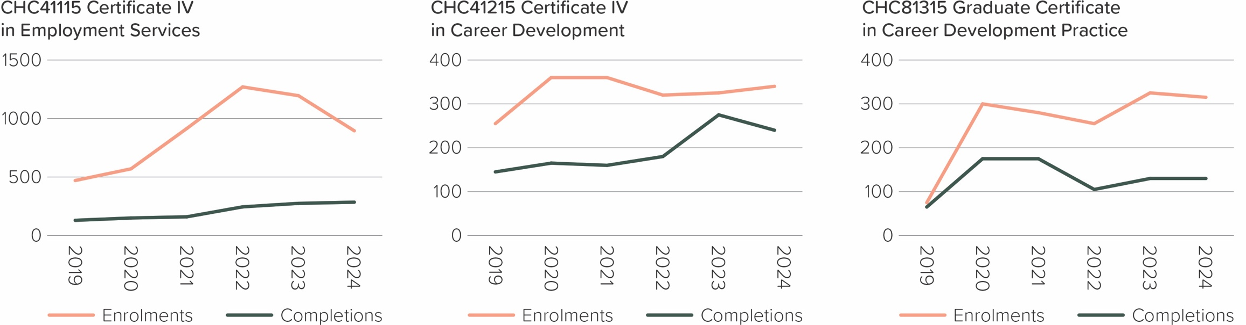
Program enrolments and completions

Program enrolments:
Code | Name | 2019 | 2020 | 2021 | 2022 | 2023 | 2024
CHC41115 | Certificate IV in Employment Services | 470 | 570 | 915 | 1,270 | 1,195 | 895
CHC41215 | Certificate IV in Career Development | 255 | 360 | 360 | 320 | 325 | 340
CHC81315 | Graduate Certificate in Career Development Practice | 75 | 300 | 280 | 255 | 325 | 315
CHCSS00108 | Career Development Skill Set | 10 | 5 | 15 | 20 | 15 | 15
CHCSS00109 | Employment Services Skill Set | - | - | - | - | - | -
CHCSS00065 | Workforce Planning Skill Set | - | - | - | - | - | -

Program completions:
Code | Name | 2019 | 2020 | 2021 | 2022 | 2023 | 2024
CHC41115 | Certificate IV in Employment Services | 130 | 150 | 160 | 245 | 275 | 285
CHC41215 | Certificate IV in Career Development | 145 | 165 | 160 | 180 | 275 | 240
CHC81315 | Graduate Certificate in Career Development Practice | 65 | 175 | 175 | 105 | 130 | 130
CHCSS00108 | Career Development Skill Set | - | 5 | - | - | - | 10
CHCSS00109 | Employment Services Skill Set | - | - | - | - | - | -
CHCSS00065 | Workforce Planning Skill Set | - | - | - | - | - | -
(Source: NCVER)

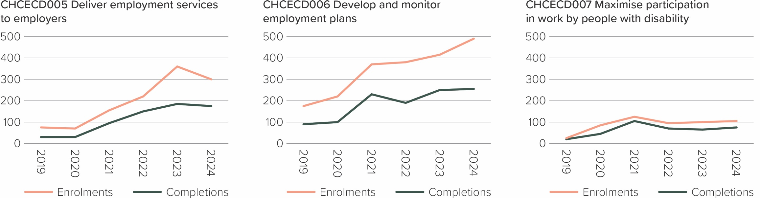
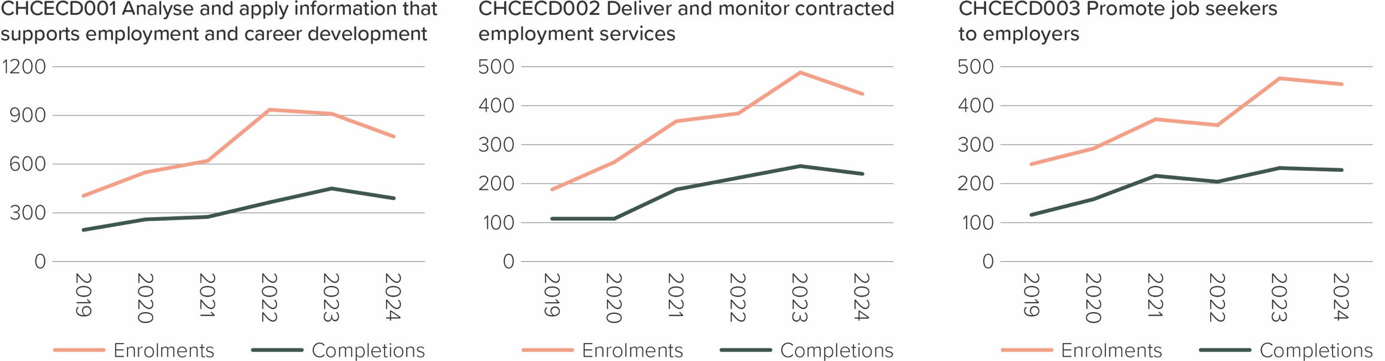
Unit enrolments and completions

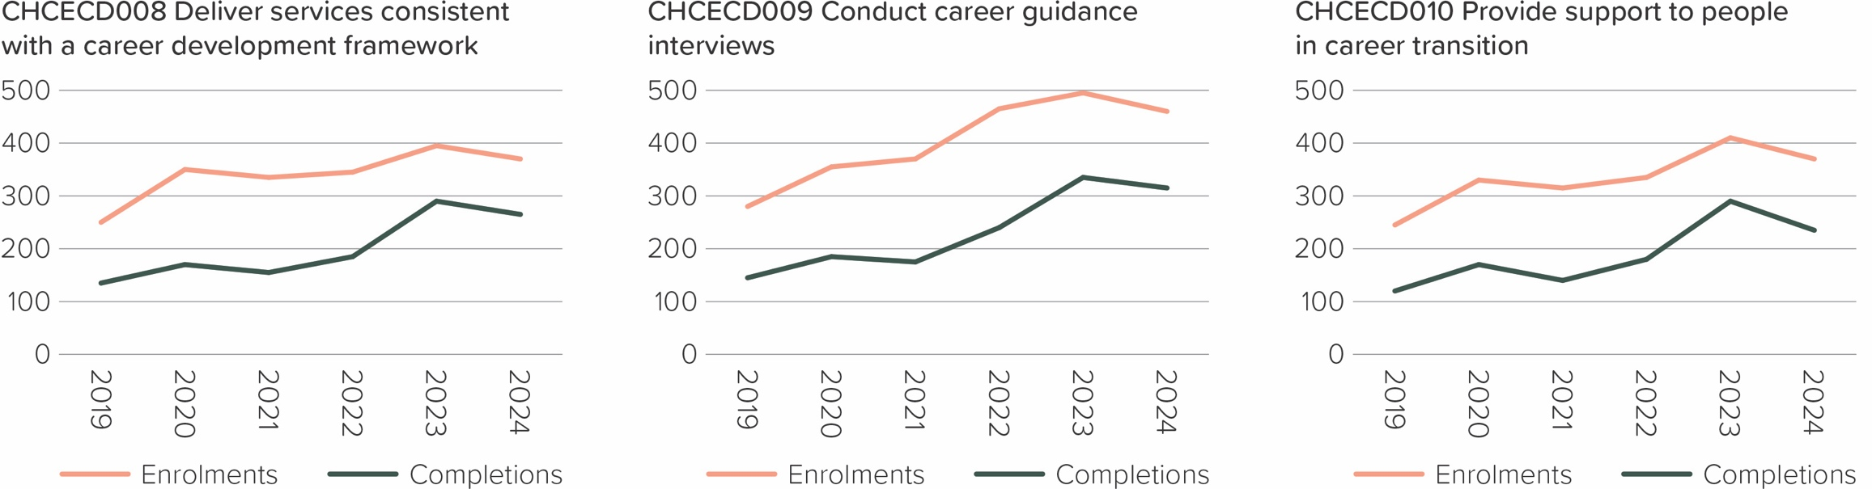

Unit enrolments:
Code | Name | 2019 | 2020 | 2021 | 2022 | 2023 | 2024
CHCECD001 | Analyse and apply information that supports employment and career development | 405 | 550 | 620 | 935 | 910 | 770
CHCECD002 | Deliver and monitor contracted employment services | 185 | 255 | 360 | 380 | 485 | 430
CHCECD003 | Promote job seekers to employers | 250 | 290 | 365 | 350 | 470 | 455
CHCECD005 | Deliver employment services to employers | 75 | 70 | 155 | 220 | 360 | 300
CHCECD006 | Develop and monitor employment plans | 175 | 220 | 370 | 380 | 415 | 490
CHCECD007 | Maximise participation in work by people with disability | 25 | 85 | 125 | 95 | 100 | 105
CHCECD008 | Deliver services consistent with a career development framework | 250 | 350 | 335 | 345 | 395 | 370
CHCECD009 | Conduct career guidance interviews | 280 | 355 | 370 | 465 | 495 | 460
CHCECD010 | Provide support to people in career transition | 245 | 330 | 315 | 335 | 410 | 370
CHCECD011 | Manage quality in career development practice | 70 | 250 | 220 | 200 | 235 | 230
CHCPRP006 | Lead own professional development | 70 | 290 | 195 | 150 | 235 | 230
(Source: NCVER)

Unit completions:
Code | Name | 2019 | 2020 | 2021 | 2022 | 2023 | 2024
CHCECD001 | Analyse and apply information that supports employment and career development | 195 | 260 | 275 | 365 | 450 | 390
CHCECD002 | Deliver and monitor contracted employment services | 110 | 110 | 185 | 215 | 245 | 225
CHCECD003 | Promote job seekers to employers | 120 | 160 | 220 | 205 | 240 | 235
CHCECD005 | Deliver employment services to employers | 30 | 30 | 95 | 150 | 185 | 175
CHCECD006 | Develop and monitor employment plans | 90 | 100 | 230 | 190 | 250 | 255
CHCECD007 | Maximise participation in work by people with disability | 20 | 45 | 105 | 70 | 65 | 75
CHCECD008 | Deliver services consistent with a career development framework | 135 | 170 | 155 | 185 | 290 | 265
CHCECD009 | Conduct career guidance interviews | 145 | 185 | 175 | 240 | 335 | 315
CHCECD010 | Provide support to people in career transition | 120 | 170 | 140 | 180 | 290 | 235
CHCECD011 | Manage quality in career development practice | 55 | 155 | 165 | 115 | 135 | 145
CHCPRP006 | Lead own professional development | 55 | 170 | 160 | 55 | 140 | 135
(Source: NCVER)

Electives with high enrolments
CHC41115 Certificate IV in Employment Services:
Unit Code | Unit Name | 2019 | 2020 | 2021 | 2022 | 2023 | 2024
CHCECD005 | Deliver employment services to employers | 75 | 70 | 155 | 220 | 360 | 300
CHCECD009 | Conduct career guidance interviews | 85 | 110 | 130 | 235 | 230 | 255
CHCMHS001 | Work with people with mental health issues | 50 | 70 | 270 | 170 | 180 | 185
CHCCCS004 | Assess co-existing needs | 30 | 30 | 50 | 115 | 225 | 220
CHCADV001 | Facilitate the interests and rights of clients | 115 | 120 | 110 | 105 | 115 | 90
CHCECD008 | Deliver services consistent with a career development framework ¹ | 45 | 55 | 75 | 110 | 155 | 135
CHCECD010 | Provide support to people in career transition ¹ | 45 | 60 | 85 | 115 | 155 | 140
CHCECD007 | Maximise participation in work by people with disability | 10 | 25 | 75 | 40 | 30 | 35
BSBPEF301 | Organise personal work priorities ¹ | - | - | - | 140 | 125 | 90
BSBPEF201 | Support personal wellbeing in the workplace ¹ | - | - | - | 130 | 135 | 100
(Source: NCVER)
¹ imported elective

CHC41215 Certificate IV in Career Development:
Unit Code | Unit Name | 2019 | 2020 | 2021 | 2022 | 2023 | 2024
CHCECD007 | Maximise participation in work by people with disability ¹ | 15 | 60 | 50 | 55 | 70 | 70
CHCPRP004 | Promote and represent the service | 100 | 120 | 65 | 10 | 90 | 85
CHCPRP003 | Reflect on and improve own professional practice ¹ | 40 | 25 | 65 | 75 | 120 | 120
CHCYTH003 | Support young people to create opportunities in their lives ¹ | 25 | 5 | 30 | 70 | 100 | 90
(Source: NCVER)
¹ imported elective
CHC81315 Graduate Certificate in Career Development Practice:
Unit Code | Unit Name | 2019 | 2020 | 2021 | 2022 | 2023 | 2024
CHCCSL002 | Apply specialist interpersonal and counselling interview skills | 55 | 240 | 205 | 140 | 215 | 180
BSBLED809 | Identify and communicate trends in career development ¹ | 45 | 265 | 145 | 135 | 165 | 170
(Source: NCVER)
¹ imported elective



