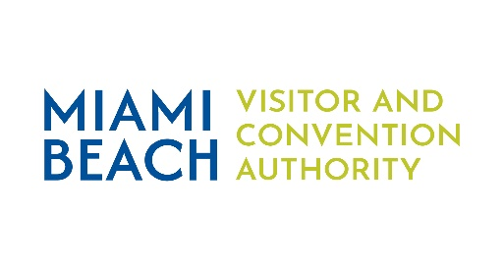

MBVCA Board Meeting

Thursday, May 21, 2026

Harold Rosen War Room
1701 Meridian Avenue, Suite 403
Miami Beach, Florida 33139

AGENDA

- Welcome - Mohan Koka, Chair 10:00 am – 10:10 am

II. Minutes Approval – April 24, 2026 10:10 am – 10:15 am

III. Administrative Update 10:15 am – 10:25 am
  - 2025/2026 Budget Review
  - Upcoming Events Calendar
  - Announcements/Discussion Items
  - Next Meeting Date

V. Private Label Marketing Update – Holly Winter 10:25 am – 10:45 am

VI. Forbes Travel Guide September Topic Review 10:45 am – 11:00 am

VII. Adjournment 11:00 am

