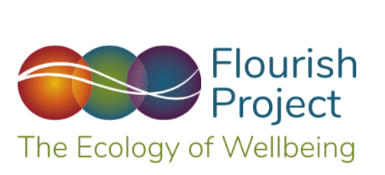

FLOURISH MODEL
MEASURES OF WELLBEING
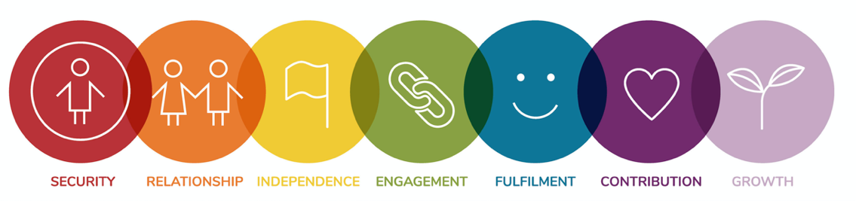

NURSERY SCHOOLS
The Flourish Model promotes the right of every child to be given the best possible start in life.
Level 1 Security
Children are safe and healthy
- The school takes all reasonable steps to keep children safe and well.
- The school is alert to any issues for concern in a child’s life and follows all appropriate safeguarding policies and procedures
- The school ensures the suitability of practitioners and other people who have regular contact with children
- The school ensures that all staff are sufficiently qualified and have the knowledge and understanding necessary for their role

- The school ensures that there is a named member of staff to build relationships with the child and parents in order to meet the child’s individual needs
- The school ensures that all children are adequately supervised at all times
- The school promotes the health of children and has implemented appropriate policies and procedures regarding illness, infection, food and drink, and accidents
- The school uses appropriate strategies to understand and manage unwanted behaviour
- The school ensures that both indoor and outdoor spaces are fit for purpose and suitable for the age of the children and the activities offered
- The school ensures that the necessary arrangements are in place to support children with SEN or disabilities in accordance with the SEND Code of Practice
- The school maintains the appropriate records and shares information with parents and professionals as appropriate to meet children’s needs
- The changing and dynamic nature of children’s home environments is both understood and monitored as a key contributor to children’s values, beliefs and behaviour.
- Parents are supported in providing stable and secure home environments for their children.
- The school environment is a safe and healthy place to be
- The school provides opportunities for children to be active and interactive, and to develop their co-ordination, control, and movement.
- Children are helped to understand the origins of food and are encouraged to make healthy nutritional choices
- Nursing and wellbeing services provide high levels of safeguarding to protect children’s physical health and wellbeing
- Nursing and wellbeing services provide advice and support to parents to optimise health and nutrition
Datasets
Fulfilment of EYFS Requirements
Levels of school security and safeguarding
Provision of policies and procedures
Qualifications of staff
Levels of regular and responsive contact with parents/carers
Number of reported incidents and accidents
Levels of food awareness and nutrition
Levels of child illness
Levels of obesity
Levels of child aggression
Levels of SEN
Number of children and young people needing additional support
Level 2 Relationship

Children feel loved and valued

- The school promotes the importance of high-quality adult interaction, which is sensitive and adaptive to the needs of individual children and capable of promoting learning
- Children are treated with affection and dignity
- Children are respected and valued as unique individuals
- Parents are respected as key contributors to their child’s learning and development
- Children and parents are supported in times of adverse or challenging home situations.
- The school provides learning experiences that contribute to the development of positive values and character traits and that promote positive group dynamics.
- Children are helped to develop the social and emotional skills that promote positive relationships and high levels of empathy and understanding.
- Children are helped to develop positive and respectful relationships with each other, their teachers and the community.
- Children are encouraged to talk about how they and others show feelings, to talk about their own and others’ behaviour and its consequences, and to understand why some behaviours are unacceptable
- Staff nurture professional relationships with children which are safe, respectful and supportive, and which help students to reach their full potential.
- Parents and carers are able to actively participate in school activities and are encouraged to support children as joyful and positive young learners.
Datasets
Fulfilment of EYFS Requirements
Teacher turnover
Teacher health and wellbeing
Levels of parental separation or divorce
Levels of parental illness or bereavement
Number of single parents
Number of children living in separated families
Levels of Adverse Childhood Experiences (ACES)
Levels of parental involvement
Levels of reported aggression
Levels of reported distress

Level 3 Independence

Children can develop as unique and joyful learners

- Children are recognised as biologically unique learners
- The school provides rich opportunities for children to initiate ideas and activities
- The school provides an environment that helps children to develop positive learning dispositions and a sense of mastery

- The school actively helps children to understand and increase their vocabulary

- The school recognises and supports children from families where English is not their first language

- The school provides lots of time and space for free and open-ended play

- The school provides regular and open access to the natural world

- The school gives children opportunities to speak and listen in a range of situations and to develop their confidence and skills in expressing themselves.

- The school provides and environment where children can demonstrate embedded learning and secure development without the need for overt adult support.
- Children have access to a rich learning environment where opportunities and conditions allow them to flourish in all aspects of their development
- The school values children’s efforts, interests and purposes as instrumental to successful learning

- Children are provided with environments that encourage them to be confident and resilient learners. They have positive self-esteem, stretch themselves and take risks in their learning.

- Children are encouraged to develop self-regulation and self-determination
- Children are encouraged to be self-aware and are helped to regulate their own emotions and behaviours
- Children develop the skills to reflect on and positively shape their behaviour
Children are self-directed, take initiative and grasp opportunity
- Children are encouraged to develop positive values and character traits that are reflected in their beliefs, behaviours and decision-making abilities
- Schools inform parents about their child’s development against the ELGs and the characteristics of their learning
- Schools use of assessment enables the planning relevant and motivating learning experiences for each child.

- Schools actively engage children, their parents and other adults who have significant interaction with the child in the assessment process.

Datasets
Fulfilment of EYFS Requirements
Quality of learning environments
Level of appropriate technology
Level of learning resources
Levels of play provision
Access to green spaces
Percentage of children with good level of development
Number of children needing social support
Levels of disability and special needs services
Level 4 Engagement

Children are able to match their skills and capacities with the challenges in the environment
- Children are provided with learning environments that honour their capacities and stretch their abilities
- Children are provided with meaningful, engaging and rewarding personalised learning experiences

- Children demonstrate clear levels of engagement

- Staff monitor the engagement levels of children and contribute to environments that deliver high quality and age-appropriate learning experiences

- Parents are actively involved in understanding and supporting the importance of positive learning dispositions

Datasets
Fulfilment of EYFS Requirements
Levels of neuro-motor maturity
Number of summer-born children
Quality of learning environment
Levels of engagement and concentration
Levels of free play
Levels of child-chosen/led activity
Levels of parental information and advice
Level 5 Fulfilment

Children are happy and have a clear sense of meaning and purpose

- Children are happy
- Children demonstrate clear and sustainable levels of engagement/flow
- Children reflect that they have a strong sense of meaning and purpose
- Children can identify, set and achieve their own meaningful goals
- Children are provided with opportunities to succeed and success is celebrated in a way that is meaningful to them
- Children are able to work on activities that fulfil them and give them a sense of personal achievement.
- Children are provided with ways of expressing and celebrating their individuality and unique potential

Datasets
Fulfilment of EYFS Requirements
Percentage of children demonstrating high levels of happiness
Percentage with good achievement before entering primary school

Level 6 Contribution

Children feel recognised and valued as important members of the school community
- Children are recognised and celebrated for their unique characters, talents and abilities
- Children feel comfortable and happy at school
- Children experience a sense of belonging and connectedness
- Children experience a sense of purpose and meaning
- Children are encouraged to develop empathy and a respect for diversity and identity
Datasets
Fulfilment of EYFS Requirements
Children are happy to come to school
Children actively collaborate with others
Children participate in the life of the school

Level 7 Growth

Children’s natural love of life and learning is honoured, protected and promoted.

- Children demonstrate passion and joy
- Staff provide caring and nurturing support for children struggling with external challenges and the demands of school life
- Children are encouraged to understand, celebrate and share their own cultural, religious and spiritual backgrounds
- Children are helped to understand and positively shape their own values, beliefs and mindsets
- Children are encouraged to learn about the natural world and the importance of the planet
- Children are able to experience aesthetics and beauty

Datasets
Fulfilment of EYFS Requirements
The school has a comprehensive and integrated strategy in place to support the physical, emotional, mental and spiritual wellbeing of young children in the context of quality teaching and learning.
The school has a comprehensive and integrated strategy in place to support the physical, emotional, mental and spiritual wellbeing of teachers and staff members in the context of their impact on the children in their care.
The school actively seeks to support parents and carers in understanding the impact of the home environment on young children’s health, wellbeing and levels of achievement.
The school acknowledges its role in helping to shape the values, beliefs, behaviours, attitudes and expectations of the children in its care.
The school acknowledges its role in developing children’s personal resilience and ability to cope with adversity.
The school promotes an understanding of child development, both the biological and cultural aspects, and its impact on how learning may best be supported
The school’s planning process ensures a relevant, motivating, flexible and interesting curriculum
The school acknowledges its role in shaping responsible, thoughtful and compassionate children who care about themselves, others and the wider world.
The school support a smooth transition to KS1 by ensuring a professional dialogue between EYFS and KS1 teachers
The school help year 1 teachers to plan an effective, responsive and appropriate curriculum that will meet the needs of all children

