IMDAC Global Forum 2026 Communications Page
Purpose – promote awareness and registration to the September 23, 2026 Global Forum
Social Media Campaign
- Person and organizational social channels – 8 times (note the dates below)
- For graphics – use these images on META; for LinkedIn, email imdac2030@gmail.com for images
- For captions, feel free to translate into your own language
Emails – Use any of this plus more information on IMDAC2030 website + Program at a Glance below
 | Week 1 – May 25 | Week 2 – June 15 | Week 3 – June 29 | Week 4 – July 20
Graphic | 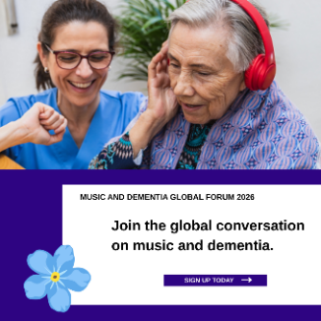 | 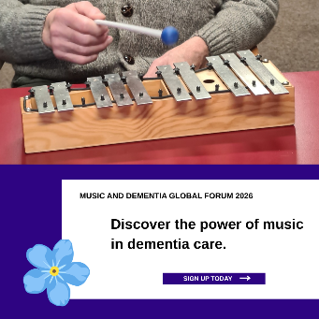 | 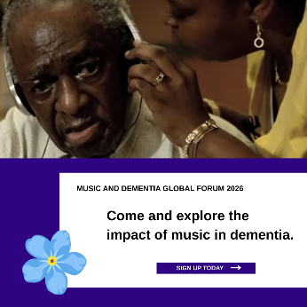 | 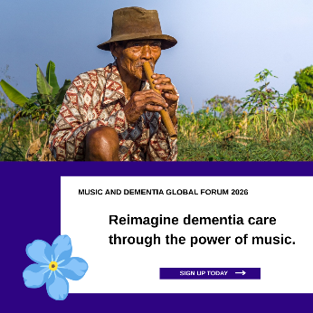
Caption | Join the first global gathering dedicated to advancing dementia care through music. This free virtual forum will bring together leaders, caregivers, researchers, and practitioners to explore how music can improve quality of life and well-being for people living with dementia.  September 23, 2026 | 9:00 AM–12:30 PM EST | Free Virtual Event | Sign up here #IMDAC2030 #MusicinDementia | How can we accelerate music access for all in dementia care? This international half-day event will explore advocacy, research, and practical approaches that support connection, well-being, and quality of life through music.  September 23, 2026 | 9:00 AM–12:30 PM EST | Free Virtual Event | Sign up here #IMDAC2030 #MusicinDementia | This global forum will spotlight voices from around the world working to expand the role of music in dementia care. Through presentations and live discussion, participants will explore policy change, evidence-based approaches, and promising care practices. September 23, 2026 | 9:00 AM–12:30 PM EST | Free Virtual Event | Sign up here  #IMDAC2030 #MusicinDementia | Designed for dementia care professionals, frontline providers, music practitioners, caregivers, and people living with dementia, this free virtual gathering creates space to share ideas, research, and practical solutions that support well-being through music. September 23, 2026 | 9:00 AM–12:30 PM EST | Free Virtual Event | Sign up here #IMDAC2030 #MusicinDementia

 | Week 5 – Aug 17 | Week 6 – Sept 2 | Week 7 – Sept 9 | Week 8 – Sept 16
Graphic | 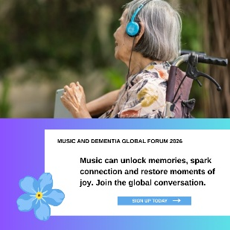 | 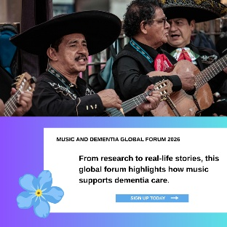 | 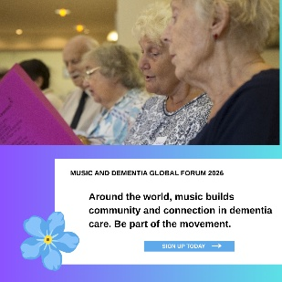 | 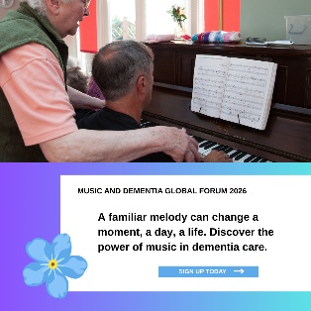
Caption | Discover how music is shaping the future of dementia care. This global gathering will focus on three key themes: influencing systems and policy, sharing evidence and lived experiences, and highlighting practical music-based programs for care settings worldwide. September 23, 2026 | 9:00 AM–12:30 PM EST | Free Virtual Event | Sign up here| #IMDAC2030 #MusicinDementia | Real stories. Research insights. Practical solutions. Join an international community exploring how music can support people living with dementia and strengthen care experiences across homes, communities, and healthcare settings. September 23, 2026 | 9:00 AM–12:30 PM EST | Free Virtual Event | Sign up here | #IMDAC2030 #MusicinDementia | Music has the power to connect, comfort, and support well-being in dementia care. This global forum will feature speakers from multiple countries sharing advocacy efforts, evidence, and promising practices that can inspire change across care systems. September 23, 2026 | 9:00 AM–12:30 PM EST | Free Virtual Event | Sign up here | #IMDAC2030 #MusicinDementia | Be part of a worldwide conversation on accelerating music access for people living with dementia. From policy leadership to practical programs, this free virtual event will showcase how music can create meaningful impact in dementia. September 23, 2026 | 9:00 AM–12:30 PM EST | Free Virtual Event | Sign up here #IMDAC2030 #MusicinDementia

PROGRAM AT A GLANCE
Synchronous Virtual
Time 9 am EST | 2 pm GMT | 6 am PST| 7:30 pm IST | 3 pm CET | 10 pm CST | 11 pm JST

Forum Host – Justine Schneider, England
1st hour – Research
Evidence and real-life stories showing the impact and value of music in dementia care

- Presenter 1 – Felicity Baker - MATCH – Australia
- Presenter 2 – Coming Soon
- Breakout Rooms – Moderated by Dr. Julene Johnson, US

2nd hour – Advocacy
Leaders and organizations sharing how they are influencing policy, funding, and system change

- Presenter 1 – Karoline Gjertsen - Sang I Eldreomsorgen - Norway
- Presenter 2 – Anite Shinde - Deloitte – North America
- Breakout Rooms – Moderated by Giles Wilmore - UK

3rd hour - Promising Practices
Practical musical programs and methods that can work in different care settings

- Presenter 1 – Sara Santini - Sound Project - Europe
- Presenter 2 – Elaine Fernandes Mateus - Musicalmente – Brazil
- Breakout Rooms – Moderated by Kristje Stedje- Norway

For those interested, there will be a 30 minute optional networking opportunity at the close of the 3rd hour.

