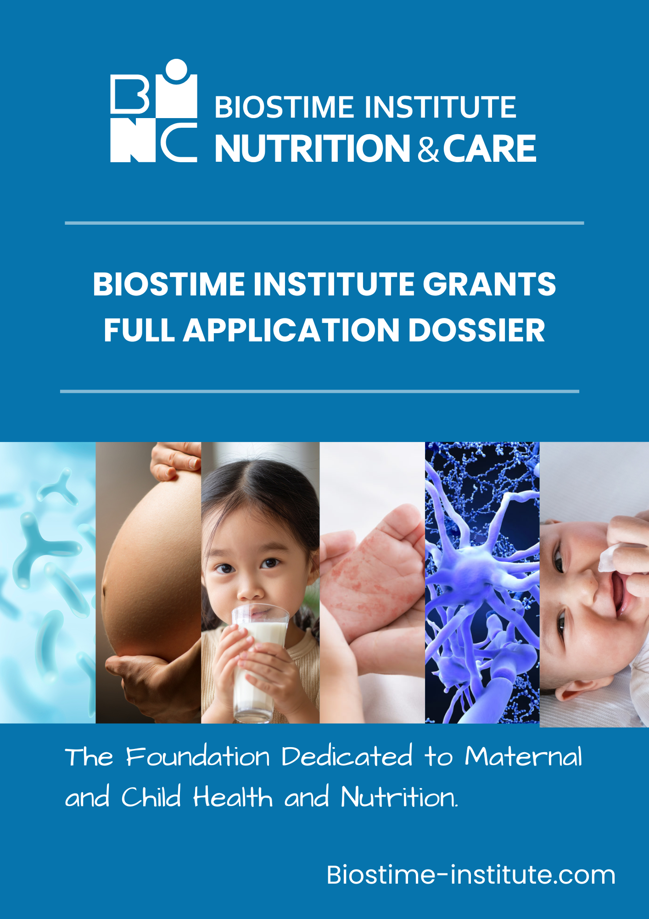

PROPOSAL FOR RESEARCH PROJECT (APPLICATION)

In the framework of the Biostime Institute for Nutrition & Care Research Partnership Program.

Date of the proposal:

2026 call topics | Please tick the appropriate topic to which this project is applicable (X)
Nutritional solutions in Infant Allergy
Nutritional Interventions Supporting Child Growth and Development
Postbiotic Solutions for Maternal, Infant, and Child Health

FIRST PART: GENERAL INFORMATION

- MAIN INFORMATION
Title of research project

Area of research
Total Project Cost
Start date / Duration  (18 – 24 months) | Start Date: | Duration:
The applicant
First name, Last name
Position
Title

Principle Investigator
First name, Last name
Position
Title

Grant Administrator
First name, Last name
Position
Title

Lead institution
Institution name
Address

Mandatory Attached Documents | - Curriculum Vitae of the applicant (including list of publications, awards, related referenced research articles, existing, related intellectual property)  - List of existing research facilities (allowing the execution of this research proposal)

The main applicant hereby confirms that all the data contained in both parts of the application file and in the attached files are accurate and that the files have been prepared with the consent of the persons involved.

Place, date: | Signature:
- INFORMATION RELATED TO THE APPLICANT

2.1. Principal Candidate

Name (First name, Last name)
Diplomas
Title & Position
Email

Laboratory/Service
Institution/Department
N°, street,
Postal code, Town
County
Phone (office)
Phone (mobile)

International Collaboration | ☐ yes ☐ no
If yes, with which persons / groups / institutions?

What will be their primary role on the project?

In which countries?

National Collaboration | ☐ yes ☐ no
If yes, with which persons / groups / Institutions?

What will be their primary role on the project?

- OTHER SUPPORT

Are there pending applications under review for this project? Is there existing support from an industry partner or any other funding organization? Is this project a sub-project under a larger project that has already obtained funding?
Other sources of funding | ☐ yes ☐ no
If yes, please precise

Subcontracting to a third party
Will you outsource some of this research to a third party?

☐ yes ☐ no
If yes, please precise

- FUNDING REQUESTED

4.1. Personnel and Staff recruited to the project (postgraduate, contract, etc.)

Salaries
(Salary and social charges of the scientific and technical staff * pro rata of its implication in the research project)
* Excluding salary and social charges of any professor involved in the research project

- First name, Last name
Degree
Role and time of work on the project (%)
Salary (pro rata to the time of work on the project)
Responsibilities in the project

- First name, Last name
Degree
Role and time of work on the project (%)
Salary (pro rata to the time of work on the project)
Responsibilities in the project

4.2. Budget details

Total

Application for research project

Date of application:

Signatures

SECOND PART: DETAILED PROPOSAL

- Summary of Research Proposal (one page maximum, in Arial at a font size of 10)
The content for this page should be written in Arial at a font size of 10.

- Project context
(rational of undertaking the research, the background of the research and relevance of the research to BINC Foundation’s 2026 call topics) (one page maximum, font Arial 10)

  - Supporting documentation
(include preliminary results when available) (one page maximum, font Arial 10)

- Project task(s) (description per task)
(Please manually duplicate the "Objective/Aim" box and "Description of methods" box for each separate project task)
Objective/Aim:

Description of methods and statistical analysis:

- Project planning overview – Gant Chart
(Mandatory to include a Gantt chart to show the schedule of the above project tasks)

- Project Impact

  - Explain the importance of the proposed research in the context of nutritional applications if they exist

- Describe the most important benefit (s) and the target population, as well as the possibility(s) of a practical application to the target population

  - Communication and/or Translational Science plan

- Communication of the results: describe the type (s) of communication of the results that you envision? (within 2 years maximum after project completion)

- Translational Science Plan of Research: describe any commercial, regulatory, sustainability, or other real-world impacts of the research

Application for research project

In the framework of the Biostime Institute for Nutrition and Care - Geneva (BINC- Foundation) funding programs (by submitting this application to BINC Foundation, the applicant agrees to accept the grant if it is successfully selected at the final Round):

Date of application:

Signatures

