Dear <first name>

As of <date>, <organization> has purchased Office Timeline Enterprise Licenses for new users and will replace any active Office Timeline product keys for existing users.

Office Timeline helps you create professional timelines quickly to communicate effectively, save time and impress your audience. Here are a few examples:

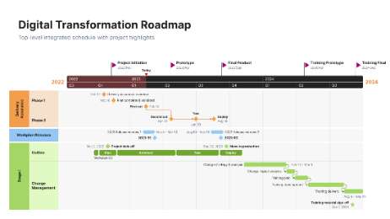 | 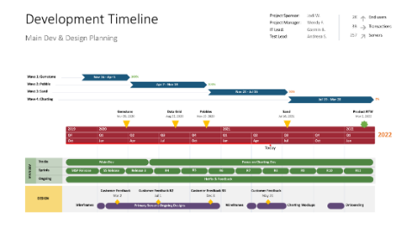 | 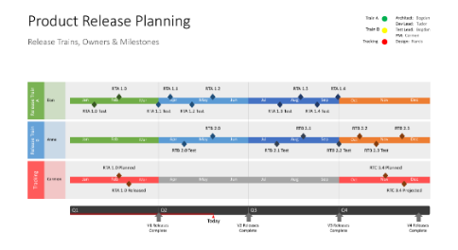

What’s the next step?

Download Office Timeline and enter product key <XXXX-XXXX-XXXX-XXXX-XXXX-XXXX-XXXX-XXXX>.

To update your product key to the active key, follow these simple steps outline in our support article how to update your Office Timeline license key.

For a quick refresher on how to use the software you can sign up for a weekly webinar at: https://www.officetimeline.com/webinars

Or check out some quick how to videos at: https://www.officetimeline.com/videos

Any questions please email us at: feedback@officetimeline.com or contact <organization’s> Technical Support.

Kind regards,
Office Timeline Enterprise team

