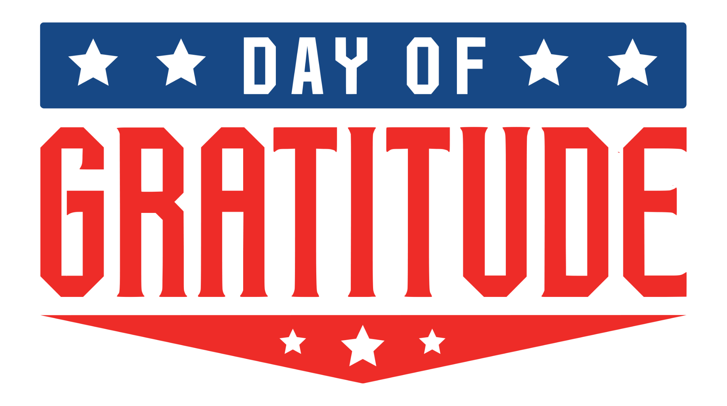

Contact
Press@JDAWorldwide.com
615.473.0794
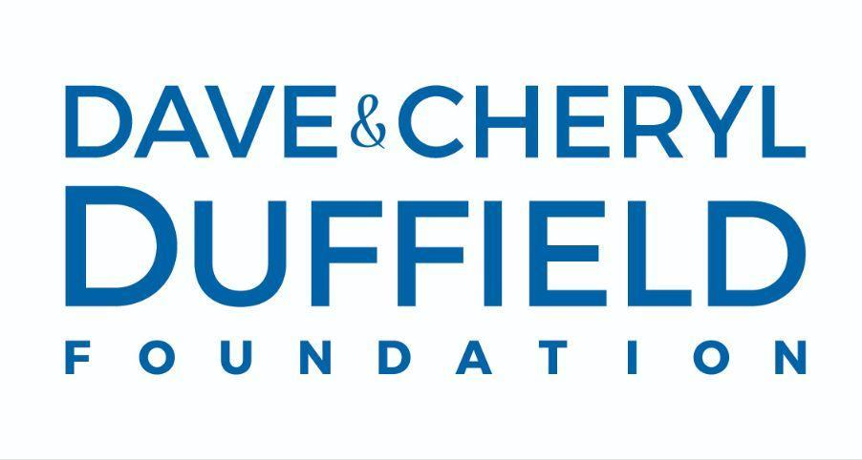
The Dave & Cheryl Duffield Foundation joins Day of Gratitude as Presenting Sponsor
Media Alert: JDA Worldwide for CityServe
March 4, 2026
LAS VEGAS, Nev. — CityServe, Voice of the Veteran, and Love Has No Limits is proud to welcome The Dave & Cheryl Duffield Foundation (DCDF) as the presenting sponsor of the 2026 Day of Gratitude, a unique event at Allegiant Stadium honoring and celebrating U.S. military heroes and their families.
“A significant objective of the Dave & Cheryl Duffield Foundation is to recognize and support our nation’s Veterans,” said Dave Duffield, co-founder and chairman of DCDF. “The Day of Gratitude is a wonderful opportunity for Veterans and their families to gather, feel appreciated, and learn more about support services. We’re very proud to be the presenting sponsor and to help make possible a special day for our heroes.”

The Dave & Cheryl Duffield Foundation, founded in 2016 in Incline Village, Nevada, funds transformational services and programs for Veterans, companion animals, and public service institutions. Their flagship initiative is Liberty Dogs, a national Service Dog training and placement program for U.S. military Veterans diagnosed with post-traumatic stress syndrome. Liberty Dogs is scheduled to open in Reno, Nevada in the Summer of 2026.

“Day of Gratitude is a natural extension of the incredible work already being done by the Duffield Foundation and Liberty Dogs,” said CityServe co-founder and CEO Wendell Vinson. “The individuals we recognize at Day of Gratitude have been overlooked and underserved for far too long. It’s partners like these that make our celebration so meaningful. We are incredibly honored to be able to serve American heroes alongside them in June.”
Day of Gratitude will be held at Allegiant Stadium, home of the Las Vegas Raiders, commemorating the 250th anniversary of the United States.
Day of Gratitude 2026 will include:
- A special awards ceremony
- Live music and entertainment
- Family friendly activities
- On-site access to vital support services and resources for veterans and military families
- Gratitude gifts during and following the event for every family
For more information, visit https://dayofgratitudeamerica.com/
Press inquiries may be sent to Press@JDAWorldwide.com.

###

CityServe is a collaborative network of churches and community leaders who help those in need live better lives. CityServe empowers the local church to fulfill its purpose to overcome despair and transform lives by resourcing them with tangible goods and capacity building. CityServe brings the church to the table to address community challenges by offering long-lasting relationships that lead to transformation and has been designated a “Community of Faith and Opportunity” by the U.S. Department of Agriculture.
Voice of the Veteran is a Nevada Veteran Operated Non-Profit 501(c)(3) Veterans Outreach Organization that is totally dedicated to the enhancement of the life and lifestyle of Veterans and their families. This is accomplished through their efforts and other trusted sources. The direction of these sources may be educational, Veterans helping Veterans or other programs that are beneficial with proven and positive results.
Love Has No Limits is uniting and activating millions of Good Neighbors to provide sustainable solutions to the greatest challenges facing our communities.
The Dave & Cheryl Duffield Foundation (DCDF) carries forward the Duffield family's legacy of supporting transformational programs and services in three core areas: pairing Veterans with Service Dogs, expanding access to care for companion animals, and strengthening local public service organizations. Founded in 2016, DCDF is part of the Duffield Foundation Family, which also includes Maddie’s Fund—a national leader in advancing the well-being of companion animals—and Liberty Dogs, a new Service Dog training facility dedicated to providing life-changing support for Military Veterans living with PTSD.

