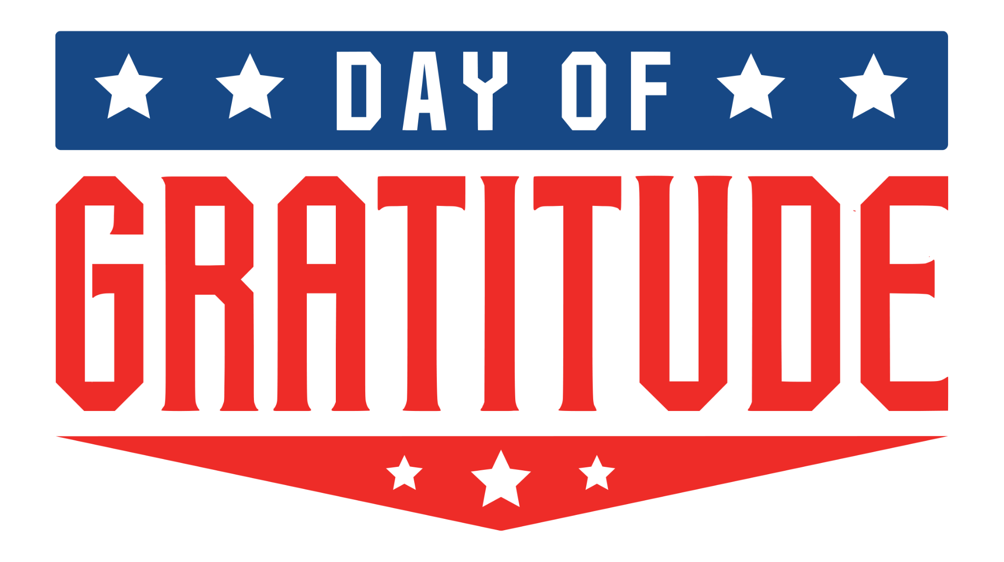
Contact
Press@JDAWorldwide.com
615.473.0794

Big & Rich to Headline National ‘Day of Gratitude’ Honoring Veterans on D-Day Anniversary at Allegiant Stadium
CityServe and other organizers announce multi-platinum country duo as featured entertainment for national tribute honoring veterans and military families on June 6, 2026

Media Alert: JDA Worldwide for CityServe
May 5th, 2026
LAS VEGAS, Nev. — Multi-platinum country duo Big & Rich will headline the 2026 Day of Gratitude on Saturday, June 6, 2026, at Allegiant Stadium, marking the 82nd anniversary of D-Day. Organizers expect thousands of veterans, service members, and military families nationwide for one of the largest tributes honoring America’s 250th anniversary.
Led by CityServe, Voice of the Veteran, and Love Has No Limits, and presented by The Dave & Cheryl Duffield Foundation, the event will be a unifying national moment to honor the courage and sacrifice of U.S. service members and their families.
Known for their high-energy performances and patriotic anthems, Big & Rich will take the stage as part of a program focused on celebrating and uplifting the military community.
“There's a reason Big & Rich's songs echo across small towns from coast to coast — their music speaks the language of the American soldier and the families standing behind them,” said Wendell Vinson, co-founder and CEO of CityServe. “We couldn't have asked for better musicians to help us say thank you. Their songs carry the very spirit of freedom and sacrifice that Day of Gratitude is all about."
Veterans, service members, and military families can reserve their free spot now at dayofgratitudeamerica.com. Organizers anticipate thousands of attendees, building on the momentum of the 2024 event, which drew one of the largest community gatherings ever held at Allegiant Stadium in honor of America’s heroes.
Day of Gratitude will provide veterans and military families with recognition, on-field tributes, resources, and meaningful support through a large, family-friendly experience.
Day of Gratitude 2026 will include:
- A special awards ceremony
- Live music and entertainment, featuring Big & Rich
- Family-friendly activities
- On-site access to vital support services and resources
- Gratitude gifts for every attending family
CityServe and its partners continue to expand Day of Gratitude into a nationwide movement, uniting communities across the country in honoring those who have served.
Press inquiries may be sent to Press@JDAWorldwide.com.

###

Day of Gratitude Presenting Sponsor:

The Dave & Cheryl Duffield Foundation(DCDF) carries forward the Duffield family's legacy of supporting transformational programs and services in three core areas: pairing Veterans with Service Dogs, expanding access to care for companion animals, and strengthening local public service organizations. Founded in 2016, DCDF is part of the Duffield Foundation Family, which also includes Maddie’s Fund—a national leader in advancing the well-being of companion animals—and Liberty Dogs, a new Service Dog training facility dedicated to providing life-changing support for Military Veterans living with PTSD.

Organizing Sponsors:

CityServe is a collaborative network of churches and community leaders who help those in need live better lives. CityServe empowers the local church to fulfill its purpose to overcome despair and transform lives by resourcing them with tangible goods and capacity building. CityServe brings the church to the table to address community challenges by offering long-lasting relationships that lead to transformation and has been designated a “Community of Faith and Opportunity” by the U.S. Department of Agriculture.
Voice of the Veteran is a Nevada Veteran Operated Non-Profit 501(c)(3) Veterans Outreach Organization that is totally dedicated to the enhancement of the life and lifestyle of Veterans and their families. This is accomplished through their efforts and other trusted sources. The direction of these sources may be educational, Veterans helping Veterans or other programs that are beneficial with proven and positive results.
Love Has No Limits is uniting and activating millions of Good Neighbors to provide sustainable solutions to the greatest challenges facing our communities.

