The Sample for the Abstract for your Presentation in Nd₂Cu₃O_{x}

*Taro Sanso¹, Hanako Sanso², and Kusuo Ken^{1,2} Please mark the speakers with *.
¹ National Institute of Advanced industrial Science and Technology, 1-1-1 Umezono Tsukuba, Ibaraki, 305-XXXX, Japan
² National Institute for Material Science, Sengen, Tsukuba, Ibaraki 305-xxxx, Japan

Abstract
It is our great pleasure and honor to welcome you to the 38th International Symposium on Superconductivity ISS2025, to be held in Nagasaki, Japan, from December 2 to 4, 2025. The ISS has been held annually since the first symposium in 1988, shortly after the discovery of high-temperature superconductivity, and we ae glad to have 38th symposium this year. Since then, the ISS has provided a unique opportunity of discussing the state of the arts of superconductivity research in all fields both in fundamental science and for applications to researchers all over the world; explicitly covering Physics and Chemistry (PC), Wires and Bulk (WB), Electronic Devices (ED), and Large-Scale Applications (AP). ISTEC completed its role and disbanded in 2016. We look forward to the continued support of researchers and engineers participating in the ISS. Superconducting technology requires long-term, continuous research and development activities. For this reason, it is also essential to develop young human resources who will lead the future. We would like to ask all of you for the active participation of industrial companies and academia related to the field of superconductivity. We look forward to your continued support. Please prepare the full abstract with an estimated length of 1-2 pages. The submission should be in PDF format.

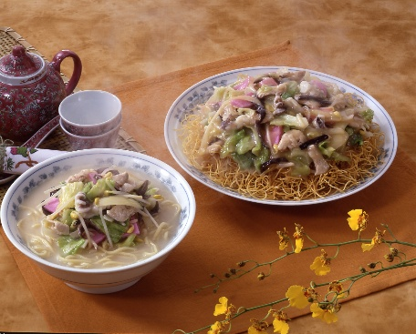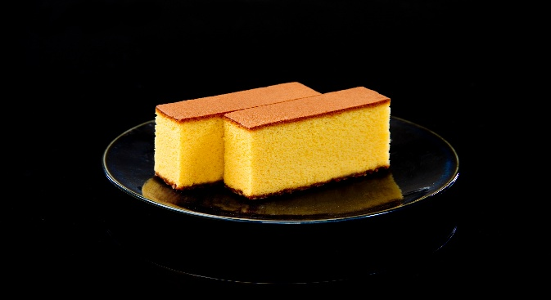
- (b)
Figure 1 Traditional Nagasaki Foods: a)Cyang-pong, b) Traditional Castera

References
1)H. Sanso et al. IEEE Trans Appl. Super. Vol 300, pp999, 2030
2)T. Sanso et al. Journal of Physics: Conf. Ser. Vol.110, p001, 2030

Keywaords: SQUID, REBCO, Fusion, Critical Current

