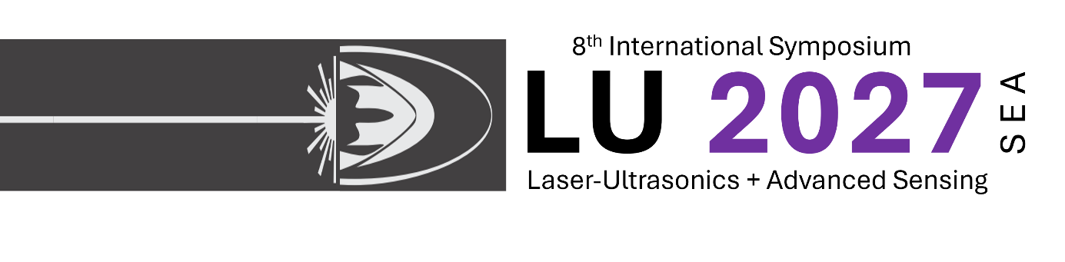Exhibitors’ Brochure 2027

University of Washington, Fishery Sciences bld.
1122 NE Boat Street, Seattle, WA 98195, USA

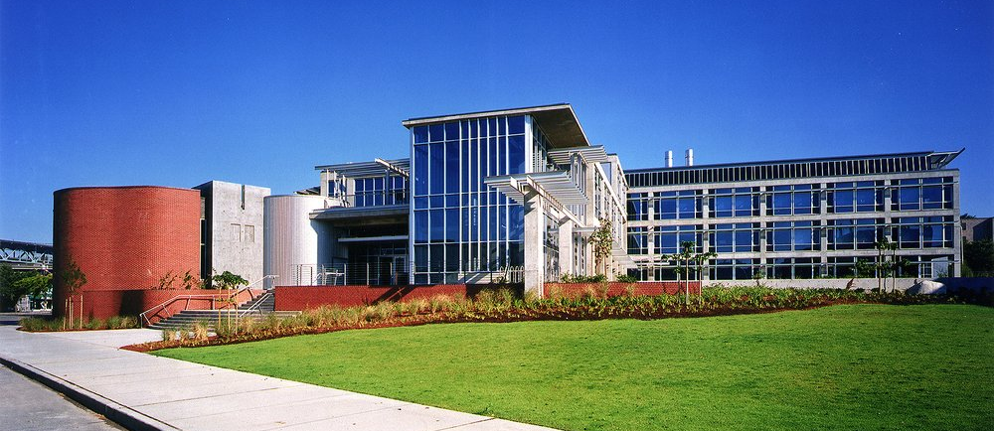
 | Bronze level | Silver level | Gold level
Complementary registered  representatives | 0 | 1 | 1
Floor space | No floor space | On-site premium exhibit space, with second tier priority on choice of  Location | On-site premium exhibit space, with first priority on choice of  location
Printed materials | ½ page, full color advertisement in program book (digital)  •  ½ page, full color advertisement in digital abstract book | ½ page, full color advertisement in program book (digital)  •  ½ page, full color advertisement in digital abstract book | Full page, full color advertisement in program book (digital)  •  Full page, full color advertisement in digital abstract book
On-site presentation during ‘industry day’ | No on-site presentation | 15 min on-site presentation | 30 min on-site presentation
Linked logo | Linked logo placement and acknowledgement on the ITEC  homepage
Cost | $1,000.00 | $2,000.00 | $3,000.00

Contacts
LU 2027 Chair
Dr. Vanya Pelivanov
Email: ivanp3@uw.edu

Exhibit Location
The exhibition will be held in the foyer of the Fishery Sciences building (1122 NE Boat Street, Seattle, WA 98195, USA) during all conference days.
If you are planning to ship your Exhibition devices/materials, please contact Dr. Ivan Pelivanov in advance and provide all information about the shipping items and FedEx/UPS tracking number.
Do not ship materials with DHL, which can induce large delays and improper handling.
Note that ITEC does not provide and support with Customs Clearence.

LU 2027 Conference & Exhibition Address:
1122 NE Boat Street, Seattle, WA 98195, USA
Fishery Sciences building

Shipping Address:
616 NE Northlake Place, Seattle, WA 98105, USA
Benjamin Hall bld., room 363
Attn: Ivan (Vanya) Pelivanov
Tel: +1 206 504-6609
Email: ivanp3@uw.edu

