This procedure describes the use of Plug’s shore power facilities in Bergen. The procedure is meant to function as a guide for the ship’s crew to ensure safe use for ship side and shore side.

Content of the Procedure
- General procedure for connecting and disconnecting of ships in accordance with IEC 80005-3.
- User guide of Zinus cable management system, ZPP215.
- How to start the PowerCon shore power system.
- Contact information for errors or questions

1. General procedure for connecting and disconnecting ships in accordance with IEC 80005-3

Use of Plug’s shore power systems is required to follow the IEC-standard IEC 80005-3 as shown in the picture below.
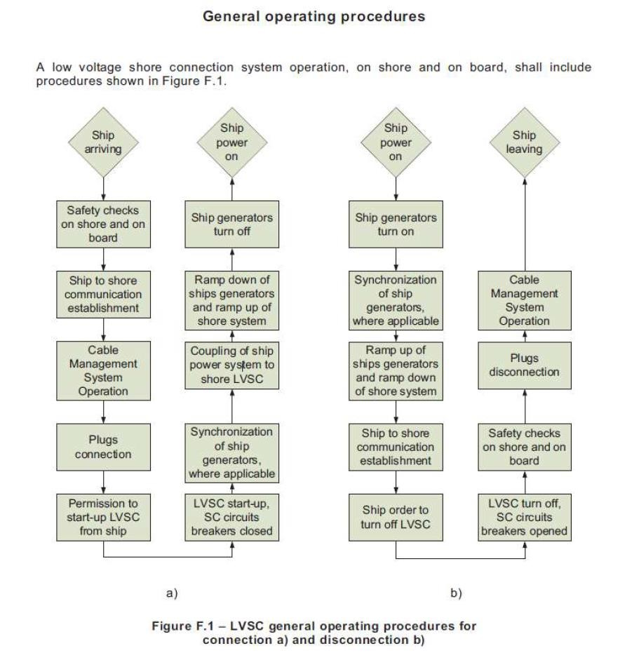

2. User guide of Zinus cable management system (CMS), ZPP215

Activation of the control panel
On the control panel there is a key switch that activates the control panel. When this is turned to «ON» the CMS is operational.
If the key switch is turned to «OFF» none of the other switches will be functional. However, the automatic security systems installed in the CMS is still operational with the key switch turned to off and the signal lamps will work as intended.
When the key switch is first turned from «OFF» to «ON» the signal lamps will be tested, and will switch between GREEN, YELLOW and RED for 8. Seconds. The CMS is functional during the lamp test.
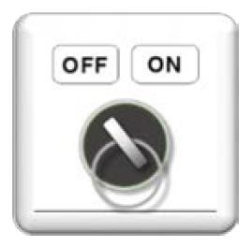

Emergency stop (EMS).
The EMS will immediately stop all operations. An indication that the CMS is non-operational is that all signal lamps will blink red, and will continue to blink red as long as the EMS is pressed.
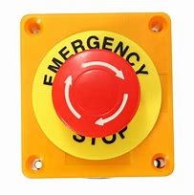

External signal status
WARNING
Automatically activated with less then 5m cable left on the CMS. (Indicated with yellow blinking light).
ALARM
This is activated in the event of an overload on cable tension and when only 3 meters remain on the drum. It is also activated if the emergency stop is triggered.

Safety functions

Emergency Stop (EMS)
If the emergency stop button is pressed, all operations and automatic functions will be deactivated. All signal lamps will start blinking RED. You can only pull out more cable if you override the brakes on the drum.

Cable operational functions
Manual operations
By operating the control panel, you can use the buttons to activate the cable drum spooling function.

Cable
ZPP215 operates through the control panel in the front. From this panel you can control the spooling function of the cables. Each cable can be individually spooled, or together.

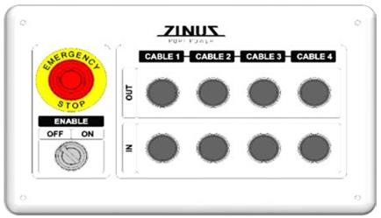

Manual operations
Trough assistance of the control panel, it is possible to spool each cable individually in or out to reach its destination. To be spooled back in after use.
Cable Spooling
To start spooling the cable, the key switch must be turned on. Then press the «OUT» button for the selected cable for a minimum of 5 seconds until the signal lamp starts to blink green. When the lamp is blinking green, the cable is ready to be spooled out. This can be done for one cable, or more simultaneously. There is a high and low limit for automatic spooling of the cable. By pulling the cable with a force above the highest limit, the drum engine will start spooling cable out, and gradually increase in speed, until the pulling force is below the highest limit. If the pulling force is below lowest limit, the speed will be reduced and if necessary, stop.

Only spool out enough cable for the vessel to be connected in a safe matter.
The cable drum must not, under any circumstances, be run empty of cable.

Cable Pulling
To pull the cable in, the key switch must be in the "ON" position, and the "IN" button for the selected cable must be held down. It is possible to pull all cables simultaneously if desired. The cable speed will decrease as it approaches the inner position.

Safety Features

Emergency Stop
If the emergency stop switch is activated, both automatic and manual operation will be disabled, and all cable pulling motors will stop.

Overload During Cable Pull
If the cable is pulled in and exceeds the maximum pulling force (>100kg), the motor will stop, and the overload indicator lamp will blink RED. As soon as the operator releases the button, the cable will automatically attempt to move out of the overload state. To prevent unwanted tension in the cable, it is monitored by a load cell. When the tension in the cable exceeds the setpoint, the brake on the drum drive gear will be released, allowing the cable to move "freely" out. If all cable is pulled off the drum, it will be detached from the drum via plugs in a dedicated emergency release system. This prevents the ZPP215 from being pulled out of position when the drum is empty.

Monitoring Cable Length on the Drum
The PLC reads the individual rotation of all cables and continuously calculates the number of meters of cable that have been pulled out.

End Position
To prevent the cable from being pulled out beyond its maximum length or pulled in when the cable is in the inner position, the length of the deployed cable is calculated continuously. The inner position is detected via a mechanical stopper on the cable. When the mechanical stopper reaches the mechanical end position, the counter is reset, ensuring that the calculation for cable deployment always has the correct reference point. If the cable is detected in the inner position, pulling it in will stop. When the cable exceeds the maximum deployed length, whether in manual or automatic mode, further deployment will stop. If the rotation sensor fails, a dedicated break loop will detect whether the entire cable has been pulled too far out, allowing the frequency converters to de-energize the system.

Description of Warning Lights
Each cable module has a warning light on the front that changes color depending on various detections, such as ready status, hazard, and alarm. Below is a description of the colors and corresponding actions:
Color | Indication | Description
Green | Steady light | Cable in the inner position
Green | Blinking | Cable is ready for unreeling
Yellow | Steady light | System is set to “service mode” (for service personnel only)
Yellow | Blinking | Warning: Limited cable remaining on the drum (reduced speed)  Cable approaching the inner position (reduced speed)
Red | Steady light | Emergency stop activated
Red | Blinking | Alarm: Out of cable  Excessive cable tension  System set to “Override Mode” (for service personnel only)

3. Starting the PowerCon Shore Power System

Login Screen

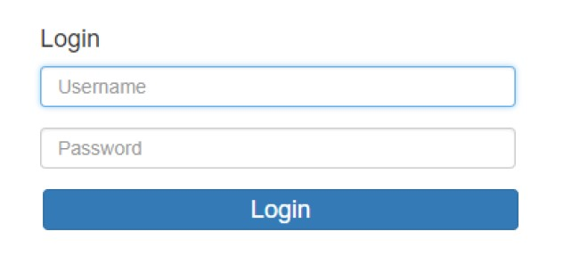

For username and password, contact the Harbor master’s office.

Screen for Entering Ship's Name and IMO Number, Voltage Selection, Frequency, Ground Fault Monitoring, Number of Cables, Phase Sequence, and Synchronization Method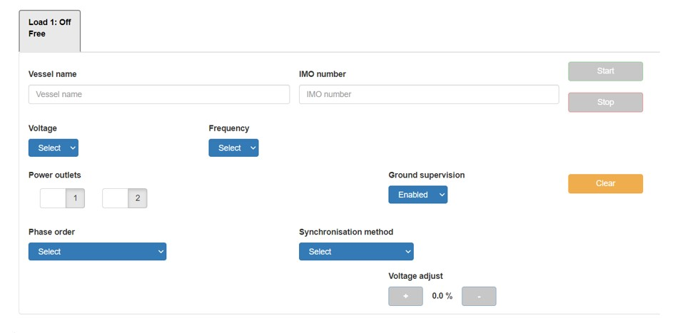
Normally, ground fault monitoring is set to disabled if the ship has its own ground fault monitoring. Failure to do so may result in blackouts.
The standard synchronization method is A1, where the ship synchronizes with the land-based system.

Screen for Starting Power Supply to the Ship
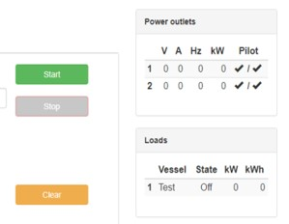
Once all selections have been entered and the start button lights green, the system is ready to start.
Note: Check for voltage on both pilot circuits.
If the start button does not light green, there are typically two reasons for this:
- A fault in the pilot circuit, which will display a triangle on the screen. The first triangle indicates a fault on the land side, while the second triangle indicates a fault on the ship side. The illustration below shows faults on both sides for demonstration purposes.
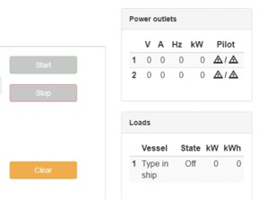
- Active alarms in the system. These must be deactivated before starting the system.

Screen for Displaying Active Alarms
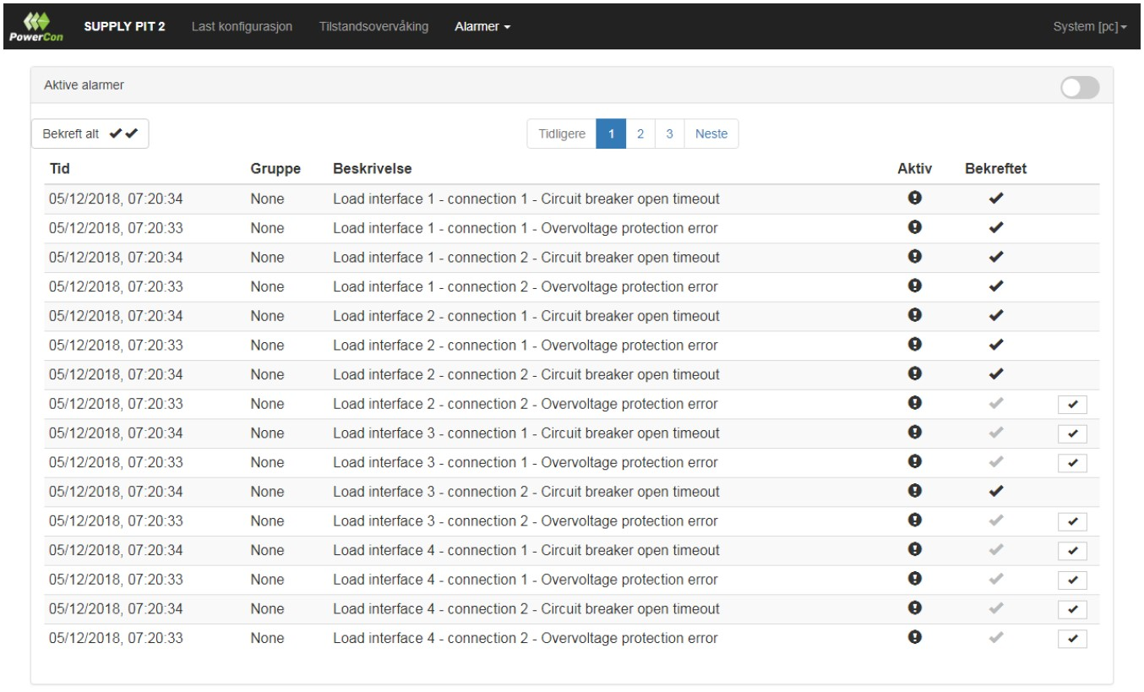

If the system has active alarms, they must be deactivated before the system can be started.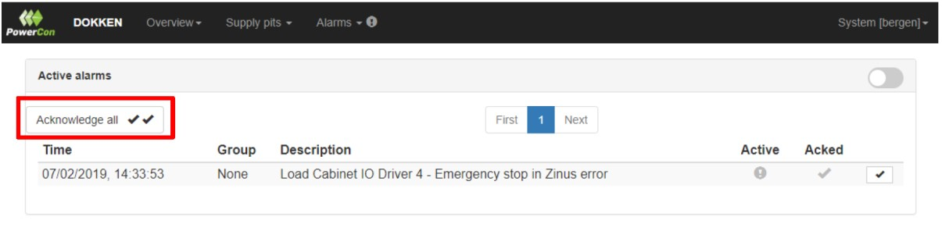
If the alarm does not disappear, it is still active. Contact authorized personnel to clear the alarm.
4. Contact Information for Issues or Questions
For system issues, report to:

Harbor Masters Office Bergen: +47 959 89 980
Plug Operations: +47 475 14 999 (Available 08:00–16:00 on weekdays)
For contact outside working hours, send an email to: Operations@Plugport.no

