OVERVIEW

Our Company was originally incorporated as ‘Swid Process Technologies Private Limited’ a private limited company under the Companies Act, 2013 at Pune, pursuant to a certificate of incorporation dated May 02, 2016, issued by the Registrar of Companies, Central Registration Centre. Subsequently, the name of our Company was further changed from ‘Swid Process Technologies Private Limited’ to ‘Swid Process Technologies Limited’, upon its conversion from Private Limited Company to Public Limited company, pursuant to a resolution passed by the members of our Company on August 30, 2024 and a fresh certificate of incorporation dated December 31, 2024, was issued by the Assistant Registrar of Companies/ Deputy Registrar of Companies/ Registrar of Companies, Central Processing Centre. Thereafter, name of our Company was changed from ‘Swid Process Technologies Limited’ to ‘Swid Renewables Limited’, pursuant to a resolution passed by the members of our Company on January 16, 2025 and a fresh certificate of incorporation dated February 22, 2025 was issued by the Assistant Registrar of Companies/ Deputy Registrar of Companies/ Registrar of Companies, Central Processing Centre.

We are an engineering, procurement and construction (EPC) company operating in the renewable energy sector with a primary focus on solar photovoltaic power projects. We provide end-to-end EPC solutions including site assessment, system design, procurement of key components, installation and commissioning of solar PV systems for residential, commercial and industrial customers. We operate under an asset-light model wherein the solar assets installed at the customer’s premises are typically owned by the customer, while we undertake the engineering, procurement and construction of such projects.

In recent years, we have increasingly focused on industrial solar installations, particularly within-premises solar power plants installed for captive consumption of electricity by commercial and industrial customers. As on FY26, 87% of our project portfolio is derived from industrial customers.

Solar PV plants may generally be classified based on project location and financial structure. Based on project location, installations may be categorized as within-premises solar plants and outside-premises solar plants (open access projects). Solar projects may also be structured under CAPEX or OPEX financial models. However, our operations are currently focused on within-premises solar PV installations executed under the CAPEX model. Under this model, we provide EPC services for design, procurement, installation and commissioning of solar PV systems while the ownership of the solar asset remains with the customer. We do not own solar power generation assets and operate primarily as an EPC service provider.

Our business primarily operates through three verticals:

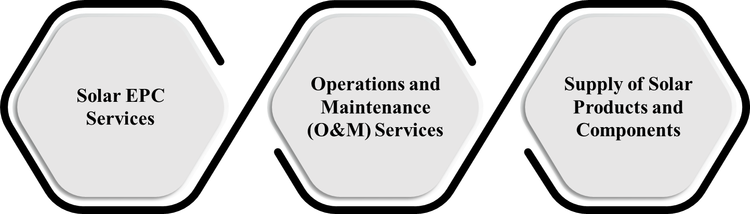

- Solar EPC Services
Our core business involves engineering, procurement and construction of solar PV plants including site feasibility assessment, design engineering, procurement of solar modules and inverters, installation, commissioning and grid integration.

- Operations and Maintenance (O&M) Services
We provide operations and maintenance services for solar PV plants including periodic inspection, module cleaning, performance monitoring and preventive maintenance to ensure optimal plant performance.

- Supply of Solar Products and Components
We also undertake limited supply of solar-related components and balance-of-system materials required for solar installations. However, this activity currently constitutes a relatively small portion of our overall operations and is generally undertaken in connection with our EPC projects.

As on FY26, we have executed 521 solar EPC projects with a cumulative installed capacity of 62.43 MWp across 43 cities in 8 states in India. Our installed project base includes 400+ active monitoring sites. A significant portion of our revenues is derived from repeat customers, with 33.64 % of our revenues generated from repeat clients.

Our operations are supported by an integrated team comprising engineering and design personnel, procurement professionals, execution and site supervision teams, safety and quality assurance teams, and regulatory coordination teams. Our company is led by our promoters, Mr. Ishan Vishnu Shahade, holds a Bachelor of Engineering degree in Petrochemical Engineering from the Maharashtra Institute of Technology, Pune (affiliated with Savitribai Phule Pune University), completed in June 2015.

Our revenues from operations for the financial years ended March 31, 2026, March 31, 2025, and March 31, 2024 were ₹ 79.23 crores, ₹ 70.37 crores ,and ₹ 46.55 crores respectively.

