EA PARTNERS

THE ULTIMATE
Cold Email Outreach
Playbook
The complete operating manual for building a predictable,
inbox-landing, reply-generating outbound machine.
Strategy · Infrastructure · Deliverability · Lists · Offers · Copy · Sequences · SOPs · Compliance · Scaling
Internal field guide and operating manual · Edition 2 · 2026

Contents

Introduction: Why This Playbook Exists 3
Part 1 — The Three Pillars 4
Part 2 — Technical Infrastructure 6
Part 3 — Deliverability: Staying Out of Spam 10
Part 4 — Building the List 13
Part 5 — The Offer 16
Part 6 — Copywriting That Reaches the Inbox and Earns Replies 18
Part 7 — Sequences and Testing 21
Part 8 — Managing Replies 23
Part 9 — Scaling the Machine 24
Part 10 — Beyond the Inbox 26
Part 11 — The 30-Day Implementation Roadmap 27
Part 12 — Standard Operating Procedures 29
Part 13 — Metrics, Diagnosis and Reporting 31
Part 14 — Compliance and Risk Controls 33
Part 15 — The Pre-Flight Checklist 35
Appendix A — Templates and Swipe Files 37
Appendix B — The Toolbox, by Job 39
Appendix C — Glossary 40

Introduction: Why This Playbook Exists

Cold email is the single highest-leverage channel in business-to-business growth. It is the cheapest, fastest and most controllable way to put an offer in front of a decision-maker who has never heard of you. You are not renting attention from an ad platform that can switch you off overnight. You own the relationship from the first touch. For a few pennies per contact you can reach the exact people who need what you sell, and you can turn the volume up or down at will.
This guide is the EA Partners operating manual for doing it properly. It is written to take someone from a blank page to a working system that lands in the inbox and generates qualified replies on autopilot, and to give an experienced operator a single reference for every moving part. Everything here is the current, working approach, not the way cold email was done three years ago. The channel changes constantly. Mailbox providers tighten their filters, spam traps move, and tactics that printed money in 2022 now route straight to junk. What follows is what works now.
A warning before you begin: cold email is not easy. No marketing channel worth running is. There are thousands of small things that can go wrong, and most people who declare cold email "dead" simply stopped keeping up. Done badly it burns your domain and annoys strangers. Done well it is the most profitable line item in the business. The difference is discipline. Follow the recipe, do not cut corners to save a few dollars, and respect the order of operations laid out in these pages.
How to read this guide
Work through it in order the first time. The chapters build on each other, exactly the way the system itself does: infrastructure first, then list, then offer and copy, then scale.
Come back to it as a reference. When deliverability dips or a campaign goes flat, the relevant chapter tells you exactly where to look.

Part 1 — The Three Pillars

Picture your cold email system as a structure resting on three pillars. If any one of them is weak, the whole thing comes down. Most failing campaigns fail because one pillar was neglected while effort was poured into another. The fix is almost always to find the weakest pillar and strengthen it, rather than to do more of what is already working.
The pillars also sit in a deliberate order, like a pyramid built from the ground up. The base has to be solid before anything above it can stand. Send the most beautifully written email in the world from a broken technical setup and it lands in spam, where its quality is irrelevant. Hit the inbox flawlessly but target the wrong people and you get reported, which destroys the very infrastructure you built. Get both right but write a weak offer and nobody replies.
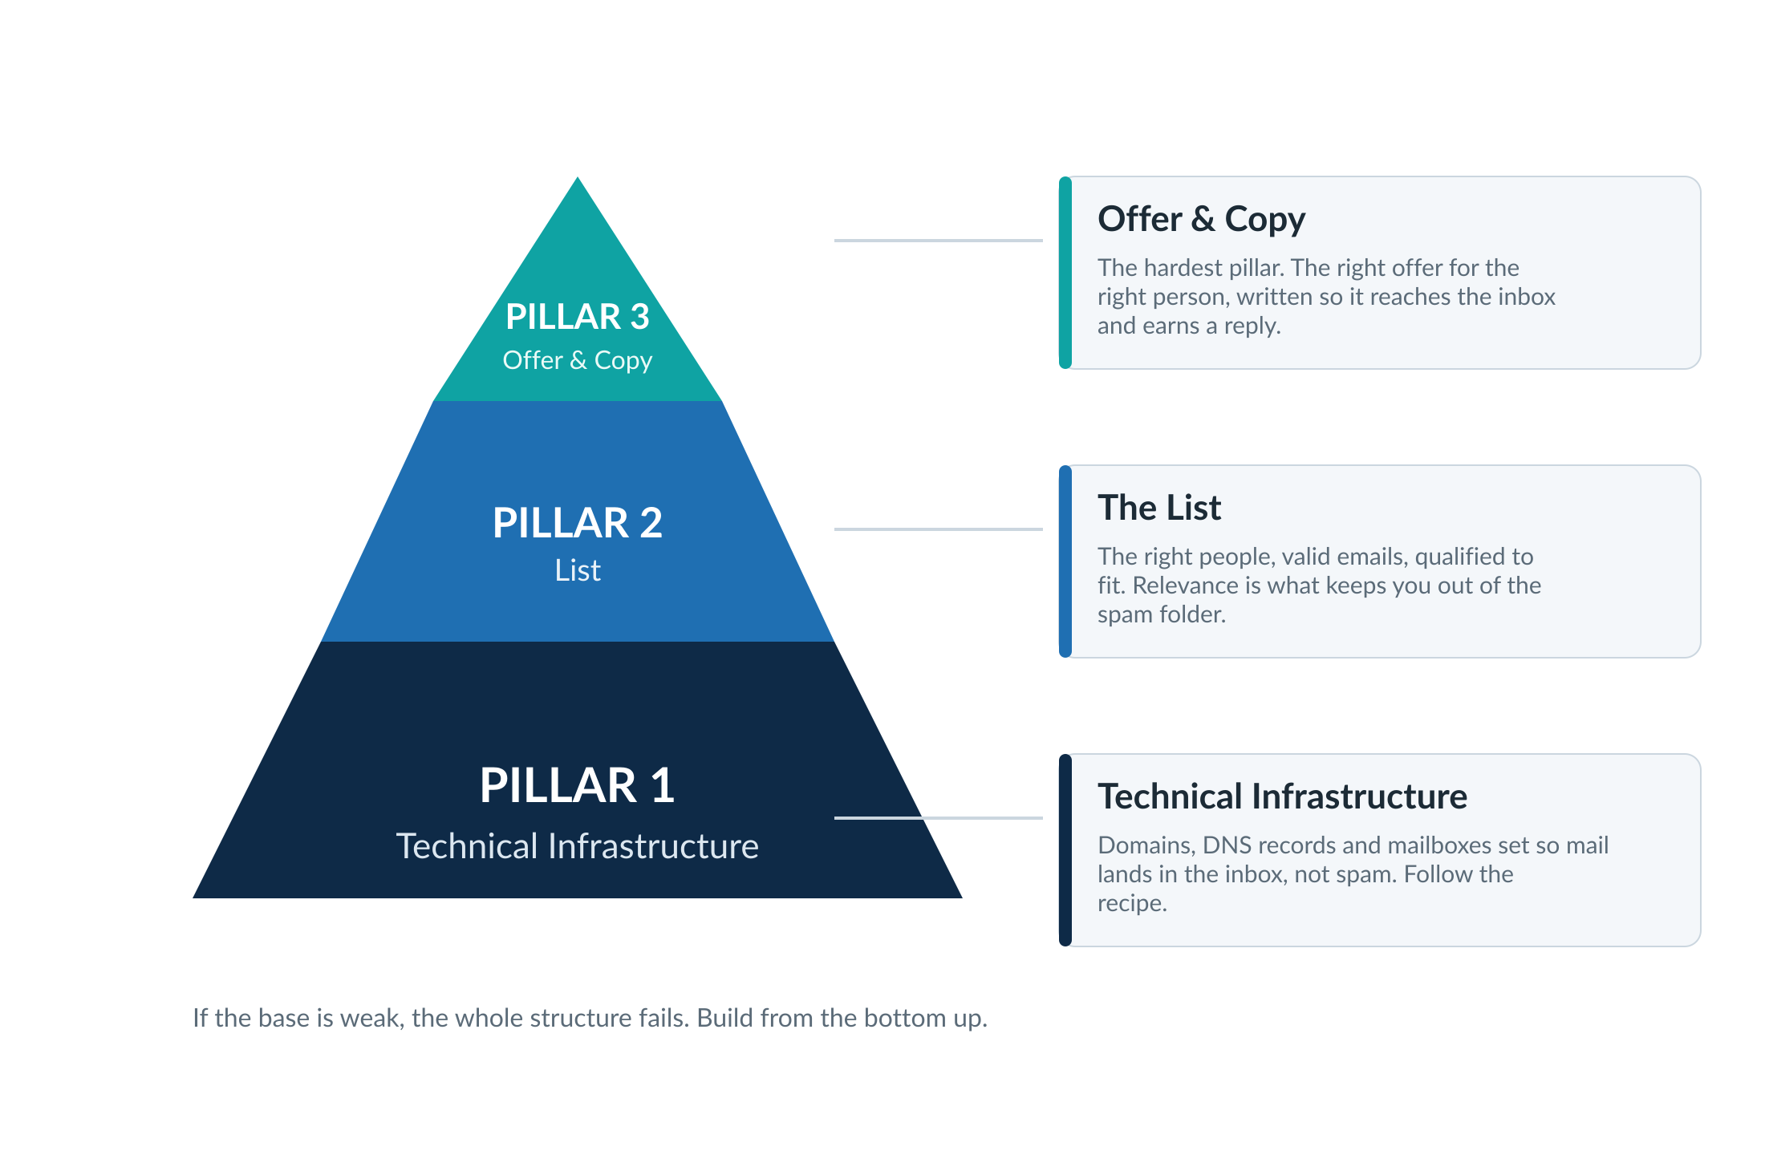
Figure. The three pillars of cold email, built bottom-up. Strengthen the weakest one.

Pillar 1 — Technical Infrastructure
This is the domains, DNS records and mailboxes that carry your mail to the inbox without being flagged. It is the "boring nerdy stuff" that scares beginners away, and it is also the easiest pillar to get right, because it is a recipe. Do this, then this, then this, and you land in the inbox. There is no creativity required and therefore no excuse for getting it wrong. The whole of Part 2 is dedicated to the recipe.

Pillar 2 — The List
This is who you actually email. The right people, with valid email addresses, qualified to make sure they genuinely fit your offer. The worst thing that can happen in cold email is being marked as spam, and the fastest route to being marked as spam is sending irrelevant offers to irrelevant people. Relevance is not a nicety, it is a deliverability mechanism. Part 4 covers building, verifying and qualifying the list.

Pillar 3 — Offer and Copy
This is the hardest pillar because there is no single template that fits everyone. Your offer is unique, your audience is unique, and the problem you solve is unique. This is where you get a stranger to open your email, trust you within seconds, and reply with interest. Parts 5 and 6 cover the offer and the copywriting that carries it.
A standing caution: fundamentals beat fancy
The most common mistake ambitious operators make is reaching for advanced AI personalisation, signal automations and clever tooling before the fundamentals are solid. This actively hurts results.
Master the three pillars first. A boring, well-targeted campaign with a clear offer beats a technically dazzling one every time. Add the fancy layer only once the basics are working.

Part 2 — Technical Infrastructure

Everything in this chapter exists to do one thing: get your email into the inbox of the right person, authenticated and trusted, without tripping a spam filter. Understand how the pieces connect and you will know exactly where to look when something breaks.

The Journey of a Cold Email
An email passes through a chain of components on its way from you to your prospect. Each one carries a reputation score that rises or falls based on how your mail is treated. A weak link anywhere in the chain can send you to spam.
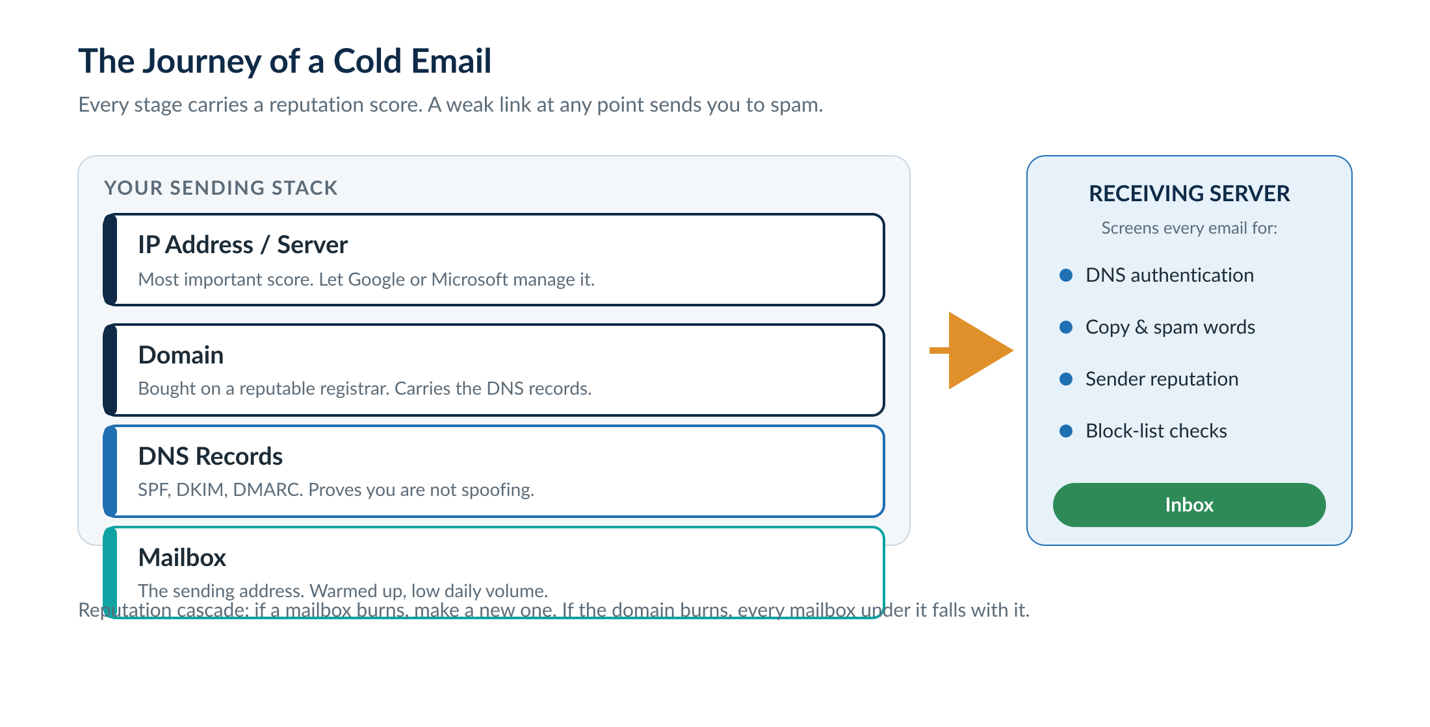
Figure. The components an email passes through, each with its own reputation score.
From most important to least, the sender side is the IP address (the server the mail leaves from), the domain, and then the individual mailbox. The reputation cascade matters enormously. If a single mailbox gets burned by spam complaints, you simply make a new one under the same domain. But if the domain itself lands on a blacklist, every mailbox beneath it falls with it. This is the single most important reason never to send cold email from your primary company domain. Your primary domain is sacred; one wrong list and your whole company’s email is affected.

Domains
Buy dedicated sending domains, never your main one. Use a reputable registrar that makes bulk buying and management easy and keeps renewal prices sane. Stick to .com extensions: they are cheaper and they instil trust faster than novelty extensions. A common, effective pattern is to take your brand name and wrap it in prefixes and suffixes (get-, try-, -hq, -mail) to find available variants in bulk.
Point every sending domain to forward to your real website with a simple redirect. A sending domain that resolves to a dead link is a red flag to receiving servers. Remember that DNS changes take time to propagate, usually minutes but occasionally hours, so be patient after making them.
Domain rules of thumb
Use .com only, bought in bulk from a reputable registrar.
Never send from your primary company domain. Use dedicated, redirecting sending domains.
Age every domain at least 30 days before sending; 60 to 90 days is better. Domain age is a major trust factor.

DNS Records: SPF, DKIM and DMARC
These three records are how a receiving server confirms your email genuinely comes from you and is not spoofed. They are non-negotiable. Without all three configured correctly, your mail does not stand a chance of reaching the inbox. They need to be not just present but correct.
Record | What it does | Note
SPF | Lists which servers are allowed to send for your domain | One per domain
DKIM | Cryptographically signs your mail so it cannot be tampered with | Generate via your mail provider
DMARC | Tells receivers what to do with mail that fails the above checks | Set a policy and a reporting address
Free generators make creating these records straightforward, and a good mailbox setup service will configure them perfectly for you. After setup, always scan the domain with a free DNS checker to confirm all three are valid before you send a single email.

A change worth noting: tracking domains
Custom tracking domains used to be standard. They are a CNAME record that lets the software track opens and clicks. We no longer track opens or clicks on cold email, because the tracking pixel and the shared CNAME pointing back to a sending platform are a fingerprint that filters use to identify cold email at scale. If you do not need to track, do not add a tracking domain at all. If you absolutely must track, a custom one is still better than the platform default, but the recommendation is to send clean.

Mailboxes: Google, Microsoft or SMTP
The mailbox provider determines the IP address your mail leaves from, and that IP reputation is the most important deliverability factor of all. There are three broad options, and choosing wrong is one of the fastest ways to end up in spam.
Option | Best for | The trade-off
Google Workspace | Almost everyone, especially beginners | Highest inbox placement today; trusted IPs Google keeps clean
Microsoft 365 | Diversification; enterprise targets | Strong, but currently delivers slightly worse than Google
Private / SMTP | Experienced senders scaling cheaply | You own the IP reputation; one mistake can burn the whole range
The current recommendation is to build primarily on Google, which has the highest inbox placement, and to use a setup service with negotiated reseller rates rather than paying full retail per mailbox. Private SMTP services are tempting because they are cheap and scale infinitely, but nobody is keeping that IP address clean except you. Until you have a proven system and very low spam complaint rates, avoid them.
Diversify as you scale
At scale, run at least three mailbox providers in your system. Deliverability for any one provider can drop overnight, and you never want a machine that depends on a single point of failure. Spreading mailboxes across providers is risk management, the same logic as not putting all your eggs in one basket.

Email Warm-Up
A brand new mailbox has no reputation. Warm-up is the process of building that reputation by automatically sending and receiving genuine-looking email back and forth within a trusted pool, so that providers learn the mailbox sends good mail. Every mailbox should be warming from the day it is created, and you should keep warm-up running even after you start sending. Use a tool with a clean, well-maintained warm-up pool; a bad pool will damage your reputation faster than almost anything else.

Sending Volume: Low and Slow
This is one of the highest-impact settings and one of the most commonly abused. Keeping volume low per mailbox keeps spam complaints down, keeps the domain safe, makes campaigns last longer and lifts deliverability. The numbers below are not published by Google or Microsoft; they are the current best-guess safe limits from extensive testing.
Lever | Target
Mailboxes per domain | About 5
Emails per day, per mailbox | 20 to 25 (up to 50 maximum, ramped slowly)
Emails per day, per domain | Around 100 total
Ramp | Slow ramp on; never jump from 0 to full volume
Domain age before sending | 30 days minimum
Lower is always safer. When you want to send more, you do not turn up the dial, you add more mailboxes. This is covered in full in Part 9.

A Trap to Avoid: Mailbox Forwarding
Domain forwarding (a sending domain redirecting to your website) is fine and expected. Mailbox forwarding, where replies auto-forward to a central inbox, is a trap. Once a prospect replies you have an open, trusted conversation in that thread. If you then reply from a different, central mailbox, the receiving server sees it as a brand new cold email from an unknown sender, and it is likely to be rejected. Always reply from inside your sending platform’s unified inbox, never via a forwarding rule.

Part 3 — Deliverability: Staying Out of Spam

Infrastructure gets you eligible for the inbox. Deliverability is the ongoing discipline of staying there. The single biggest cause of landing in spam is simple: people reporting your mail as spam. No technical trick replaces sending good emails to people who are a genuine fit. Everything in this chapter is downstream of that one truth.

How Filters Judge You
Receiving servers screen incoming mail on a handful of factors: whether the domain is authenticated (your SPF, DKIM and DMARC), the reputation of the IP, domain and mailbox, and the content of the copy itself. Google and Microsoft use increasingly sophisticated AI to read your words. If the copy looks like marketing, it gets treated like marketing.

Words, Phrases and Fingerprints
It is no longer enough to avoid obvious spam words like "free", "guarantee", "cash" or "100%". Entire phrases now get flagged, because when thousands of senders use the same phrasing and get reported, filters learn to associate that exact phrase with spam. It can be something as innocent as a stock company description or even the business address in your signature. The same copy with an address may go to spam while the same copy without it inboxes.
The two tools that solve repetitive copy
Spin tax is now mandatory, not optional. It rotates through hard-coded variations of each phrase so no two emails are identical, which prevents filters from pattern-matching your copy. Always preview the output: combinations can read badly or reintroduce spam words.
AI-generated unique copy goes further. For the specific phrases you suspect are risky, generate a genuinely original variation per prospect. Filters cannot blacklist a phrase that appears only once. You do not need to rewrite the whole email, only the lines most likely to be flagged.

Test Before and After You Send
Run inbox-placement and spam-score tests before launching any campaign, and again whenever deliverability dips. The essential checks are: warm-up health scores, DNS validity, a copy spam-score check, a blacklist check on your domains, and a seed-list inbox-placement test that shows how real Gmail, Outlook, Yahoo and other mailboxes receive your mail. Keep bounce and unsubscribe rates each under five percent; high bounce rates blacklist you faster than almost anything else.

The Spam Recovery Protocol
When your emails start landing in spam, do not panic and do not keep sending. Work the loop. The longer you have been in spam, the harder it is to climb out, so move fast, but move in order.
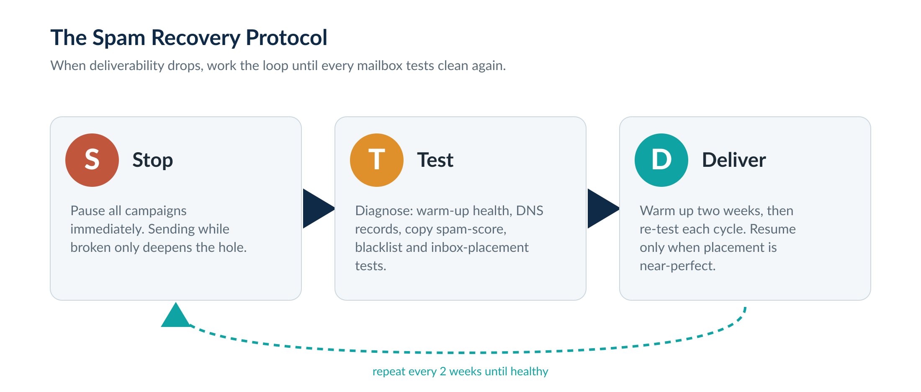
Figure. When deliverability drops, work the loop until every mailbox tests clean.
Stop every campaign immediately; sending while broken only deepens the hole. Test to diagnose the cause across the checks above. Deliver: warm the affected mailboxes for about two weeks, then re-test, and only resume sending from a mailbox once it tests near-perfect again. If a mailbox refuses to recover, retire it and spin up fresh mailboxes and domains on diversified infrastructure. No matter the precise diagnosis, the treatment is almost always the same: stop, warm, re-test.

Unsubscribe Links and Opt-Outs
From a pure deliverability standpoint, a literal "unsubscribe" link and the word itself can read as a marketing signal and are best kept out of the first email. The practical alternative is to give a plain-language way to opt out and to honour it instantly: configure automatic block-list triggers so that anyone replying with "stop", "remove me" or similar is suppressed at once. In a longer sequence, add gentle opt-out language such as "if I am barking up the wrong tree just say so and I will leave you be."
There is a real tension here between deliverability tactics and the law, and it must not be ignored. Providing a genuine, easy means to opt out and honouring it is a legal requirement, not optional, and high-volume senders face an explicit one-click unsubscribe rule. The full picture, including how this works for UK and EU recipients, is in Part 14 — Compliance and Risk Controls. Read it before you launch. The short version: you may avoid the clickable link in a low-volume B2B cold email, but you must always be identifiable, always offer a way out, and always suppress on request.
Hostile prospects
Modern sending platforms can flag prospects who are statistically likely to react badly or report spam, based on aggregated data. Switch these protections on: skip the hostile and unlikely-to-reply contacts entirely. You will email fewer people, but your engagement rate, and therefore your deliverability, climbs. The goal was never to email the most people; it is to get the highest engagement.

Part 4 — Building the List

Relevance is a deliverability mechanism, not just a courtesy. A perfectly written email to the wrong person still ends in spam. The job of this pillar is to assemble a list of people who are a genuine fit, with valid email addresses, and to strip out everyone who is not before you ever press send.

Start With the Ideal Customer Profile
Before sourcing a single contact, define exactly who you serve: the job titles that make decisions, the industries, the company sizes, the regions. For B2B this is usually a founder, owner or C-suite leader at a company in a specific industry and size band. Use a proxy like employee count for "revenue", since private companies do not disclose real revenue and database guesses are unreliable. The tighter and more honest your profile, the better everything downstream performs.

Three Ways to Source Contacts
Leads come from three broad places, and the right one depends on whether you have more time or more money to spend.
- Databases. B2B databases let you filter millions of contacts by title, industry, size and location. Always apply the verified-email filter. Then actually read a sample of the results, because filters routinely pull in wrong-fit companies; refine with included and excluded keywords until roughly nine in ten look right.
- Scraping. When your ideal customer is not well covered by a database (local businesses, certain professions, creators), scrape from sources like Google Maps or social platforms. The upside is that under-served niches are also less abused by other cold emailers, so you stand out. Always verify scraped data before using it.
- Signals. A signal is a recent, relevant event about a company: new funding, a key hire, rapid growth, an award, a new product. Reaching out right after a signal, while it is still fresh, dramatically lifts reply rates because you genuinely have a reason to be in touch. The catch is timeliness; signal data is only valuable if you are early, so source it from places that update in near real time, not from stale second-hand database fields.
The funnel below is the shape every good list passes through, from the whole addressable market down to a clean, qualified, send-ready file.
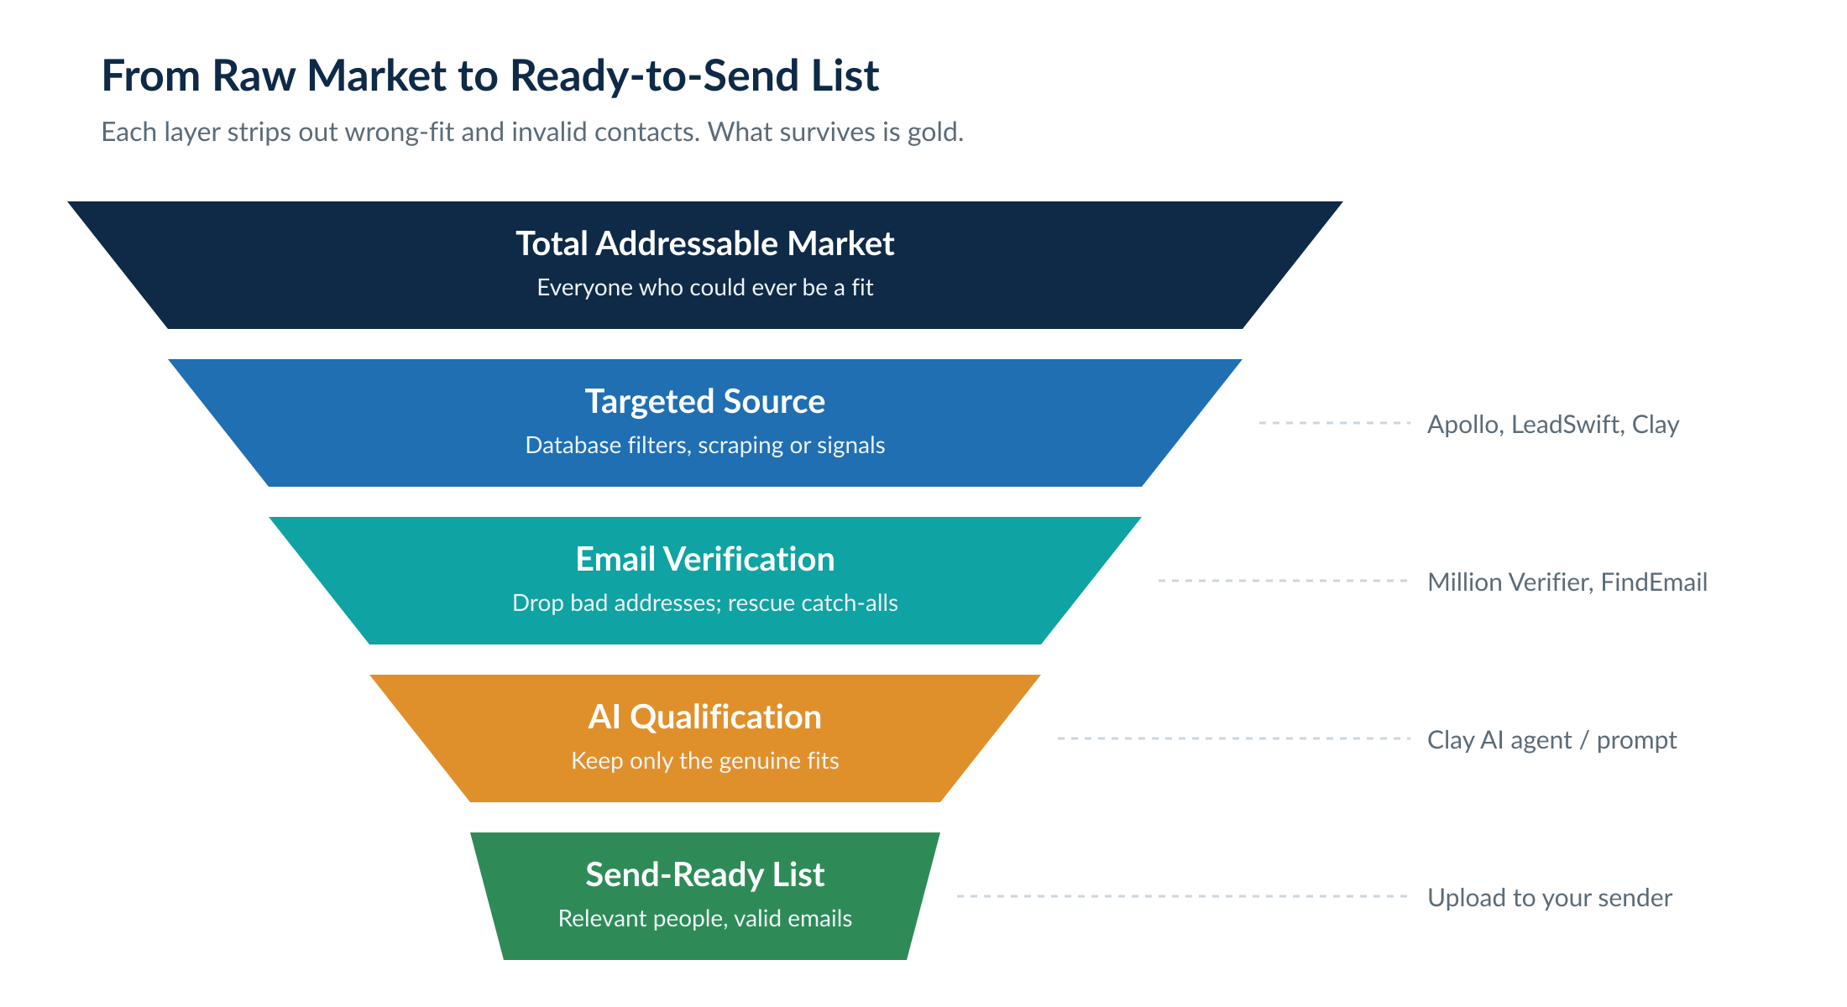
Figure. Every layer removes wrong-fit or invalid contacts. What survives is worth sending to.

Verification: Never Let an Email Bounce
High bounce rates blacklist your domain. Verification pings each address to label it good, risky or bad. Only ever send to "good". Run your list through a bulk verifier first; buy credits in bulk to keep the per-email cost low.
The overlooked opportunity is the "risky" bucket of catch-all and unknown addresses. About half of these are actually deliverable, and on a small total addressable market that data is precious. Run the risky addresses through a dedicated catch-all verification tool to rescue the deliverable half, rather than discarding them or, worse, blindly mailing them.
Never buy cheap, pre-built email lists
Old, bounced or simply wrong data is the fastest way to destroy a domain. Worse than a bounce is wrong information: emailing a contact you think is a marketing agency who is actually an automotive supplier gets you reported instantly. If you must use a sourced list, clean it hard and qualify it before sending.

AI Qualification: The Multiplier
Even a carefully filtered database list contains perhaps three in ten contacts who are not truly a fit. AI qualification reviews each lead and company against your offer and keeps only the genuine fits. Expect it to remove 30 to 50 percent of a list, and expect reply rates to two or three times as a result, because every remaining contact is relevant. Fewer emails, far better engagement, fewer spam complaints, happier replies.
A reusable qualification prompt
You are an expert sales assistant. Review the information about the following lead and their company and decide if they are a good fit for me to sell to. Use your knowledge of their industry and business model to judge whether they have a real use for my offer.
Here is my offer: [I help X do Y]. Here is the information about the lead’s company: [company description, industry, job title, and ideally scraped website or profile detail].
Output only one word, "yes" or "no", with no explanation or punctuation.

Part 5 — The Offer

No amount of clever copy rescues a weak offer. Before you write a word, you need to know exactly who you serve, understand their real problems and wants, and offer something that genuinely fits, expressed simply enough that a stranger understands it instantly. Remember the cold email mindset: the prospect is not searching for you, is not aware they have a problem you can solve, and even if they are a perfect fit they probably are not looking right now. The goal of the email is never to close the sale. It is to get them to raise their hand.

Offer Killers
Four things will sink an offer before the copy even matters.
- Boring. They have seen it a thousand times and nothing sparks interest.
- Competitive. It is indistinguishable from everyone else in the space, so you compete only on price.
- Absurd. Wild guarantees with no credibility or mechanism behind them ("six figures in 30 days") read as a scam and trigger the spam button.
- Complex. If a stranger cannot understand what you do in seconds, they will not invest effort to find out.

The Best Solution: a Genuinely Strong Offer
If you can offer something proven, unique and clearly desirable, that is a "blue ocean", you do not need tricks. You focus on their problem and your distinct solution and the rest gets dramatically easier. Differentiate by repositioning a generic skill into something specific and currently in demand, or by serving a moneyed segment that everyone else ignores. Spend real time here: the better the offer, the easier lead generation, sales and delivery all become.

When the Offer Is Boring or Competitive: Get a Foot in the Door
Most operators are selling something both boring and competitive. The play then is not to win the whole deal in the cold email, but to get the door open with a front-end offer, earn trust by over-delivering, and upsell the real, recurring offer afterwards. Three reliable mechanisms:
Mechanism | How it works
Loss leader | Offer something they really want and assume is expensive, at a shockingly low (near-cost) price. You make nothing on it, but it opens the relationship and the back-end pays for it.
Trojan horse | Frame the first contact as something other than a sales pitch, a partnership, a piece of research, a journalist’s request, so the prospect engages, then transition smoothly to the offer.
Lead magnet | Give a genuinely useful resource or mini-service related to your core offer, good enough that they would have paid for it.

Lead Magnets and Reverse Lead Magnets
The old lead magnet, a generic PDF or webinar the prospect has to consume, barely works any more. The rule that still holds: the more time the prospect believes you personally spent on them, the higher the perceived value, and the more effort it requires of them, the lower it. Tiered, the weakest magnets are generic templates and white papers; the strongest are usable data, free software, or an actual sample of your service done for them.
The current evolution is the reverse lead magnet. Instead of giving them something to implement, you give them something already implemented: a small, purpose-built deliverable or tool that solves a real problem for their specific business with zero effort on their part. The cold email does not say "download my guide"; it says "would it be okay if I spent some time building something for you?" That framing, the impression of bespoke effort, is what cracks reply rates in even the hardest niches. Modern AI tooling lets you produce these at scale, roughly one build per vertical that then serves every lead in that vertical.
Why the reverse lead magnet converts
Reciprocity: you did something meaningful for them, so booking a call feels natural rather than forced.
Proof over claims: instead of saying you are good, you show them. The deliverable is your portfolio.
It doubles as your retargeting asset: the page it lives on can carry your pixels, so even non-repliers can be retargeted.

Part 6 — Copywriting That Reaches the Inbox and Earns Replies

Cold email copywriting is not normal copywriting. Using the wrong word does not just lose a sale, it lands you in spam. And your goal is not to sell; it is to find out whether the prospect has a problem you can solve. Throughout, the email should read like a message to a friend, not a sales pitch. Keep it short, simple, and human.

The Triple Tap
Every cold email asks the prospect to take three separate actions. Break your copy into these three chunks, and test each one independently. If any tap fails, the whole email fails.
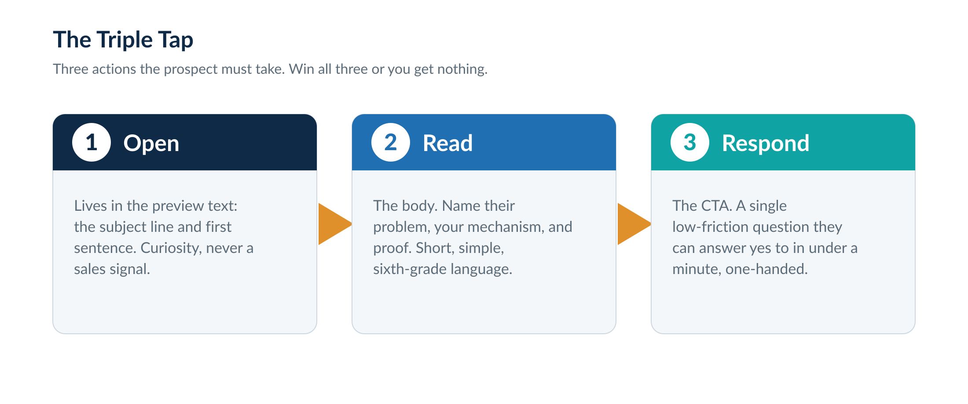
Figure. Three actions, three chunks of copy to test independently.
Open. This is won in the preview text, the subject line and first sentence, the only things visible before the decision to open. It must spark curiosity without ever signalling a sale. The moment a prospect can tell you are about to pitch, they archive or report you. Questions work well, because human nature is to want to answer them. Read. This happens in the body and must do two things: name their problem and your mechanism for solving it, and build genuine, non-boastful credibility. Respond. This is the call to action, and the bar is simple: can they reply with a single word, one-handed, in under a minute?

The Anatomy of the Email
A reliable structure is subject, compliment, case study, call to action, signature, one sentence each. Follow it and the email is automatically short enough to read on a phone without scrolling, which is exactly where the best cold emails are read.
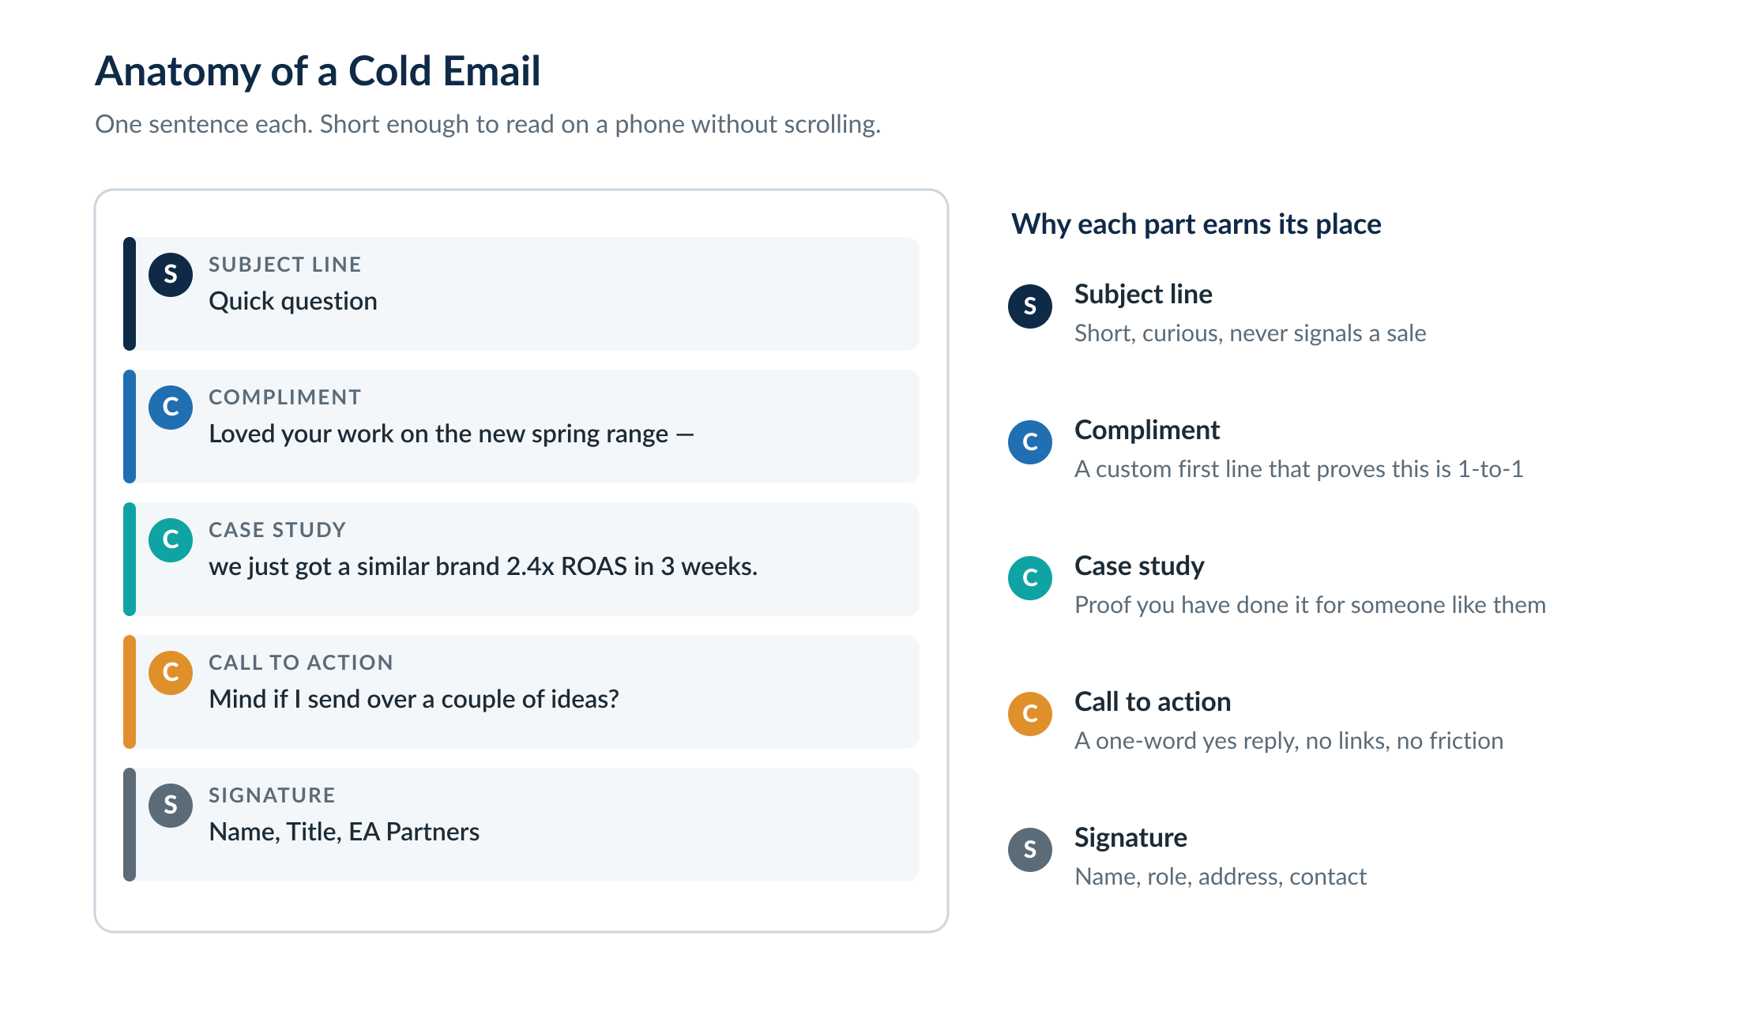
Figure. Five parts, one sentence each. Built to be read on a phone.

Subject line and preview text
The subject and first sentence are a single unit working together. They should make the prospect think the email could be from a client, a vendor or a partner, anything but a pitch. A few patterns that consistently earn opens:
- The (fake) referral. "Found you through [name]." A name the prospect recognises is the strongest possible opener. If you have no mutual contact, an interview or podcast they appeared on can serve the same role honestly.
- The news item. "Congrats on the funding round." Reference a genuine, recent event, and make sure the first line of the body picks the thread up so it does not feel like bait.
- Generic-but-customised. "[First name], about [company]." Easy to send at scale and reliable, provided your data is clean. This is the workhorse for large sends.
- Curiosity questions. "Sending cold emails?" framed so it could plausibly be an internal or vendor query, pulling the reader in to find out.

The body
Two or three sentences. Call out the problem and your specific mechanism, and establish credibility in an authentic way. Personalise both the problem and the proof to the audience: if you are emailing cold email agencies, the social proof that resonates is the big cold email agencies you have helped, not an unrelated client. If you have no case studies yet, credibility can come from a relevant piece of content, media coverage, or a social following, and it is often worth doing a piece of free work to earn an anchor case study.

The call to action
Low resistance is everything. No links, no asking them to click or think. The reply you want is "yes", "sure" or "send it". "Mind if I send over a couple of ideas?" is a model CTA: it asks only for a one-word hand-raise, and once they raise it, the rest is just sales.

Golden Rules
Do | Don’t
Keep it to six sentences maximum | Over-promise or use absurd guarantees
Write at a sixth-grade reading level | Be vague about what you do or how
Use the first name; it always works | Lean on company names or locations (often wrong, and a cold-email tell)
Match tone to the reader’s profile | Bait and switch between subject and body
Make one specific, mechanism-backed claim | Use promotional, salesy language

Personalisation, Done Right
More personalisation is not better. Every variable you add is another chance to be wrong or to look automated. The all-caps or "LLC"-suffixed company name is an instant cold-email tell that kills results. The one variable to always use is the first name. Beyond that, the highest-value personalisation is a single AI-written sentence, two to eight words, based on research that is not readily available on a profile: a recent partnership, an article they were featured in, a detail from their site. Done well this can lift replies sharply; done badly, and most people do it badly, it makes you look like a robot and tanks the campaign.

Part 7 — Sequences and Testing

The Sequence
A sequence is the series of emails a prospect receives over several days. The default is three emails, and the shorter the sequence the more total people you can reach with the same infrastructure. Email one is almost always the best performer, and every additional email slightly raises the odds of a spam complaint, which is why three is the practical maximum. For a very large addressable market, a one or two-email sequence reaching more people is often the best bet; reserve longer sequences for small markets where you genuinely need to work each contact, and only when every email carries new value.
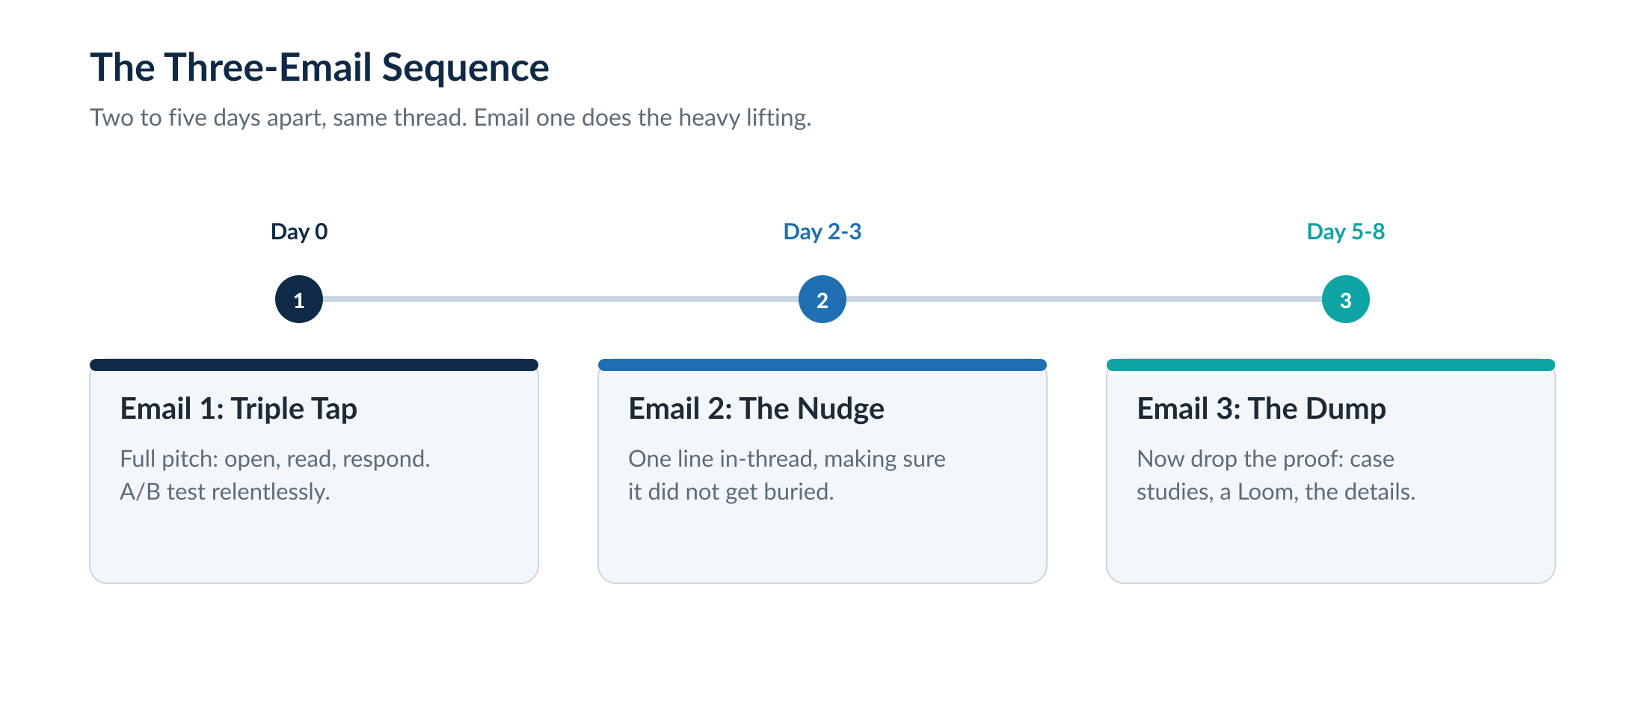
Figure. The default three-email sequence: same thread, two to five days apart.
Email one is the full Triple Tap. Email two, two to three days later and in the same thread, is a one-line nudge that simply lifts the original back to the top of the inbox. Email three is where you can finally dump the proof, because by now you are already in their inbox: case studies, a Loom or YouTube link, the supporting detail you deliberately withheld earlier. Once you are in the primary inbox, links to trusted, familiar domains (a calendar tool, a Loom, a YouTube video) are safe to send in emails two and three, though never in email one.

A/B Testing: the Engine of Improvement
Testing is how a campaign gets better, and the only rule that matters is to change one thing at a time. Test audiences (industries, company sizes) by running them as separate campaigns with identical copy, so a difference in result points cleanly to the audience. Test copy and offers as A/B variants within a campaign, working off the same list. Map your variants to the Triple Tap: test the preview text (subject and first line), then the body, then the CTA, each in isolation.
Reading results honestly
Reply rate is the working proxy for open rate, since we no longer track opens. But do not stop at reply rate, look at the opportunity rate, the share of replies that are genuinely interested. The two usually move together, but not always, and the opportunity rate is what actually pays.
Wait for statistical significance before declaring a winner. If a test between two variants shows little difference after a large send, they are not different enough, swap in a bigger change, such as an entirely different offer.

Part 8 — Managing Replies

A cold email system is not set-and-forget; it is a machine that needs tending. By far the most important job in running one is replying to interested prospects fast. This is where most operators drop the ball.

Speed Beats Polish
Reply within five to ten minutes wherever possible. Personalise if you can, actually read their message and look at their company, but if the choice is between a fast canned response and a slow bespoke one, speed wins. Keep notifications on and the mobile app installed so an interested reply never sits unattended.

Keep the Conversation in the Unified Inbox
The moment a prospect replies, the next message you send is no longer a cold email, it is a warm conversation in an open thread, and you can now send links, images, video and language you would never risk in a cold email. This is exactly why you reply from inside the sending platform’s unified inbox and never via mailbox forwarding: forward the conversation to another mailbox and you reset it to a cold email from an unknown sender, likely to bounce. Hold the conversation in the unibox until the prospect takes a concrete action, booking a call or filling a form, at which point an automation should move them into your real CRM and a nurture sequence.
The reply-handling SOP
One named person owns the unified inbox. Shared ownership means nobody does it.
Notifications on, app installed, target response time under ten minutes.
Keep the thread in the unibox until a call is booked or a form is filled, then hand off to the CRM via automation.

Part 9 — Scaling the Machine

Once a campaign is proven, scaling is mechanical. The cardinal rule: to send more, go wide, not loud. Never crank up the per-mailbox volume past safe limits. Instead, add more mailboxes, more domains and, as you grow, more providers.
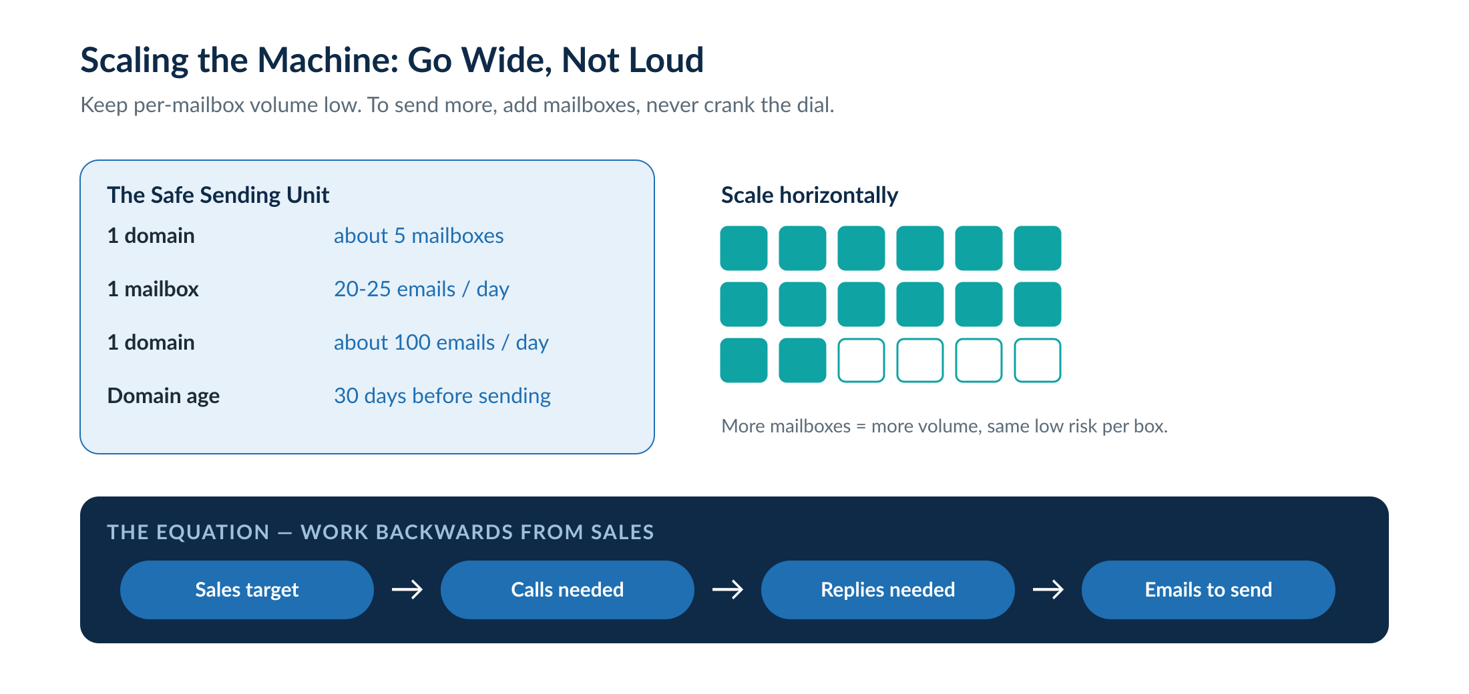
Figure. Scale horizontally by adding mailboxes; work volume backwards from your sales target.

Work the Equation Backwards
Unlike most channels, cold email volume is predictable. Start from the sales target, work back through how many calls that needs, how many replies produce a call, and how many emails produce a reply. That tells you precisely how many emails per day to send to keep the calendar full, and therefore how many mailboxes you need. A mature system on a large market might run between 500 and 1,000 mailboxes, which is still remarkably cheap relative to paid advertising.

Benchmarks to Scale On
Do not scale a campaign until the numbers justify it. As a rough guide, a campaign worth pouring money into is delivering a reply rate around two percent or better with a healthy share of genuine opportunities (roughly a one percent opportunity rate). Below that, fix the offer, the list or the copy before adding volume.
Metric | Healthy guide | What it tells you
Reply rate | 2%+ (5–20% on strong signal campaigns) | Whether copy and targeting are landing
Opportunity rate | ~1%+ | Whether the replies are real interest
Bounce rate | Under 5% | List quality and verification
Unsubscribe / negative | Under 5% | Relevance and spam-complaint risk

The Team Behind a Mature System
At a thousand mailboxes with hundreds of replies a week, one person cannot run it. A mature operation typically needs three roles: an operator who scrapes, verifies and loads new lists and prevents the system from running dry; a maintainer who checks metrics, mailbox health and inbox-placement daily; and a closer from the sales team who owns the unified inbox and converts replies into calls. Scale slowly and only when the team is ready; the most common failure is running the list dry or letting replies pile up because the people were not in place.
Common scaling failures to watch for
Reply build-up: if replies are not being worked fast enough, stop scaling until the team catches up.
List run-out: the most common issue of all. Make sure someone owns the constant flow of fresh, qualified leads.
Copy burnout: the more you send the same copy, the faster it gets flagged. Keep heavy spin tax and rotate whole offers.

Part 10 — Beyond the Inbox

Email is the core engine, but the highest-performing outbound surrounds the prospect across several channels. Multiple touches across email, LinkedIn, SMS, voicemail and retargeting raise the odds that a prospect sees you, and crucially build familiarity: someone who has already seen your email and your LinkedIn is far likelier to take your call. The principle is persistence with value, never harassment, and the instant someone asks you to stop, you stop.
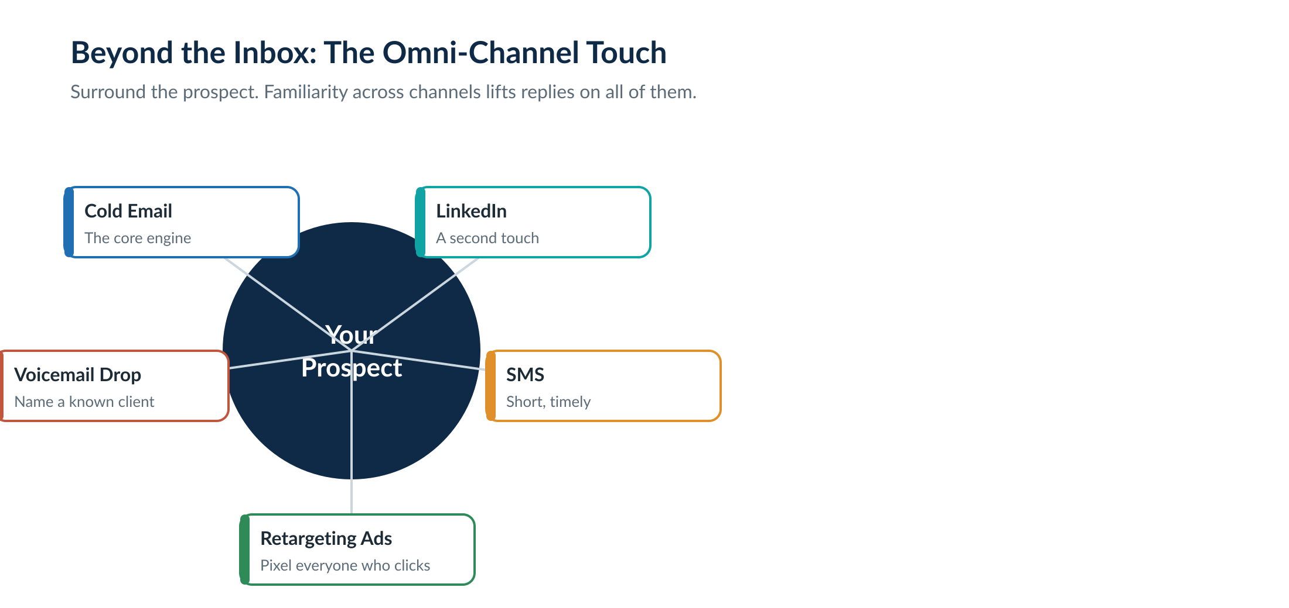
Figure. Email is the engine; surrounding channels build familiarity and lift replies everywhere.
The quiet powerhouse of the mix is retargeting. Anyone who clicks through to your page can be pixelled and served ads across platforms, so even prospects who never reply stay in front of you for pennies. A reverse lead magnet doubles as the perfect retargeting asset for exactly this reason. Voicemail drops work best when the script names a known client or competitor, and the whole stack can be wired together with automation so the sequence runs across channels on autopilot. Whatever you add, track it: tag every link so you know which channel and which campaign produced each booked call, because without that data you cannot tell what to scale.

Part 11 — The 30-Day Implementation Roadmap

A campaign should be built in controlled phases, not launched at full volume on day one. The goal of the first month is to build reputation, prove the offer, find the responsive segment, and only then scale what works. A campaign that fails at low volume only fails more expensively at high volume. Each phase below has an exit gate: do not move on until it is met.
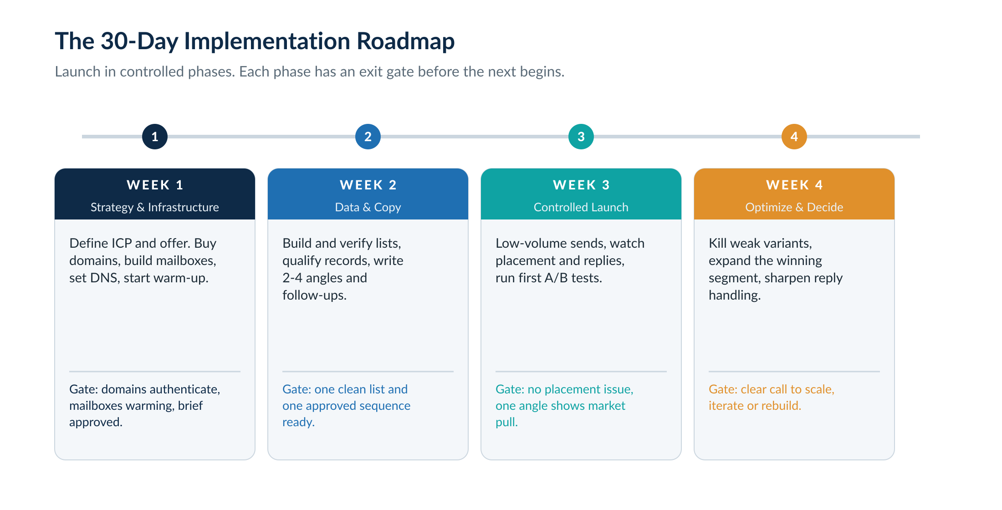
Figure. A staged four-week launch. Each phase has an exit gate before the next begins.

Week 1 — Strategy and Infrastructure
Define the ideal customer profile, the offer and the segments. Buy the secondary domains, build the mailboxes, set DNS, configure signatures and the suppression process, and switch warm-up on. Nothing sends this week. Exit gate: every domain authenticates correctly, mailboxes are connected and warming, and the campaign brief is approved.

Week 2 — Data and Copy
Build the first lead lists, verify the emails and qualify the records while the mailboxes keep warming. Write two to four copy angles, draft the follow-ups, and prepare reply macros for the common questions and objections. Exit gate: at least one clean lead batch and one approved sequence are ready for a live test.

Week 3 — Controlled Launch
Begin low-volume sends, monitor inbox placement closely, watch the replies, classify the objections, and run the first A/B tests across angles and segments. Exit gate: no major placement problem, and positive replies show that at least one angle has genuine market pull.

Week 4 — Optimise and Decide
Kill the weak variants, expand the winning segment, sharpen reply handling, and prepare the scale plan. Exit gate: a clear, evidence-based decision to scale, iterate, retarget or rebuild the audience or offer.
Launch-readiness checklist
Campaign brief approved by the strategy owner; the primary domain is not used for outbound.
Secondary domains have a real or redirected web presence and correct DNS; SPF, DKIM, DMARC and MX verified.
Mailboxes warming and not over-scheduled; Email 1 is plain text with no attachments, images or needless links.
Lead data cleaned, sampled, deduped and screened against the suppression list.
Reply ownership and response time assigned; opt-out and block-list process live before the first send.

Part 12 — Standard Operating Procedures

A system that depends on one person’s memory breaks the moment that person is unavailable. These procedures let anyone on the team launch a campaign safely and keep the machine running without relying on tribal knowledge. Assemble every campaign the same way, so mistakes are easy to spot.

Campaign Setup SOP
This assumes the strategy, infrastructure, list and copy are already approved. The builder does not improvise offer claims, add unapproved links, change targeting, or upload unverified data. If something is missing, stop and ask the campaign owner.
- Name the campaign clearly: market, offer, segment, date and version.
- Upload the list and map every field deliberately: first name, company, title, website, custom variables, owner and suppression fields.
- Check for duplicates inside the platform and against the master suppression list.
- Confirm the sender mailbox group is correct and daily limits are conservative.
- Paste Email 1, 2 and 3 using approved variables only.
- Preview at least twenty leads, including records with long names and missing optional variables.
- Send internal test emails to verify formatting, sender name, signature and reply routing.
- Run spam and content checks and a placement test on the live copy where possible.
- Set the schedule, timezone, stop conditions and reply-handling tags, then launch at controlled volume and watch day one closely.
Campaign QA checklist
Campaign name clearly identifies the segment and offer.
Every lead variable renders naturally; no all-caps or legal-suffix company names.
No stray formatting, rich HTML, hidden links or copied styling; no attachment or image in Email 1.
The CTA appears once and is easy to answer; the suppression list is applied; bounced leads stop automatically.

Daily Management
Daily work protects the machine. The point is to catch problems while they are small.
Daily task | Owner | Standard
Handle positive replies | Sales / operator | Respond same business day, ideally within minutes
Review bounces | Operator | Pause a list or segment if the bounce rate rises
Check placement and mailbox health | Operator | Pause or tag any mailbox with poor placement
Classify replies | Sales / operator | Interested, question, objection, referral, soft no, hard no, out of office
Update CRM / pipeline | Sales | Move opportunities by status and next step
Monitor hostile replies | Operator | Block-list hard negatives; review targeting if a pattern emerges

Weekly Management
Weekly work improves the machine. Review by audience, offer, variant, mailbox group, list source and reply category, then act.
Weekly task | Standard
Variant review | Compare positive reply rate, opportunity rate, call rate and quality
Audience review | Identify which industries, sizes, titles or signals produce qualified replies
Deliverability review | Check placement trends, domain reputation, mailbox pauses, bounces and complaints
List review | Audit sources, verification results, qualification pass rate and disqualification reasons
Reply review | Add new macros for common questions and objections
Scale decision | Increase volume only if placement and economics justify it

Part 13 — Metrics, Diagnosis and Reporting

Track the numbers that reveal pipeline health, not the vanity metrics that distract the team. A campaign dashboard should show the whole funnel, from leads uploaded through to revenue, so you can find the true bottleneck rather than guessing. Ignore open and click rates: open tracking is usually off for deliverability and is distorted by privacy systems, and in cold email the best first action is a reply, not a click.
The power of the funnel view is that each gap points to one cause. Read where the drop-off happens and you know what to fix.
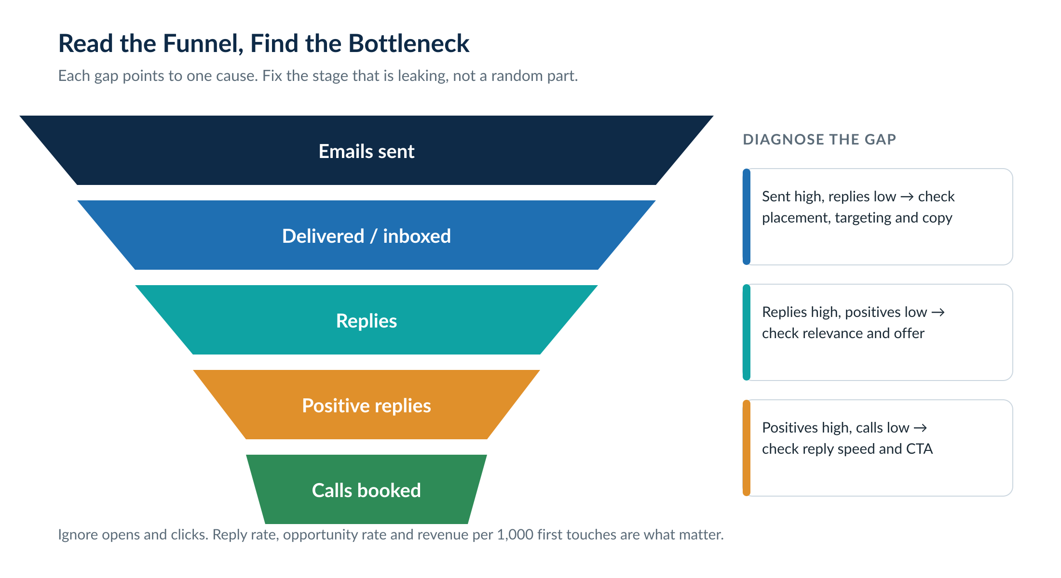
Figure. Each gap in the funnel points to a single likely cause. Fix the leaking stage.

The Metrics That Matter
Metric | What it reveals | Action if weak
Inbox placement | Whether emails are likely seen | Pause, diagnose, warm, rewrite or replace infrastructure
Bounce rate | Data quality and sender risk | Stop the list, re-verify, remove bad sources
Positive reply rate | Offer and market resonance | Test audience, offer and proof
Opportunity rate | Qualified interest per first touch | Improve ICP and qualification
Booked call rate | Reply handling and CTA strength | Improve speed, macros, objection handling
Revenue per 1,000 first touches | The economic value of the campaign | Use to decide scale, pause or rebuild

The Minimum Weekly Report
Even a lean operation should circulate a short weekly summary so decisions are based on data, not feel. At a minimum it covers:
- Campaigns active and paused, and leads added by source and segment.
- Emails sent and first touches sent.
- Bounce rate and placement status.
- Replies, positive replies and opportunity rate.
- Meetings booked and the resulting pipeline, with the scale-or-fix decision for the week.

Part 14 — Compliance and Risk Controls

Not legal advice
This section sets out sensible operating controls and a plain-English summary of the main rules as they stand in 2026. It is not legal advice. For decisions specific to your jurisdiction or a particular client, take qualified counsel.
Cold outreach lives inside legal, technical and reputational limits, and the safest posture is to treat compliance as part of the operating system rather than an afterthought. The universal habits cost nothing and protect everything: a truthful sender identity, a subject line that matches the body, genuinely relevant targeting, a valid way to opt out, prompt suppression of anyone who asks, accurate sender details, and a record of what you did.

The UK and EU: PECR and GDPR
For business-to-business outreach in the UK, the position is more permissive than many assume, but it is not a free-for-all. The PECR electronic-mail marketing rules do not apply to corporate subscribers, meaning you may email a limited company, LLP or public body without their prior consent. The important catch is who counts as corporate: sole traders and unincorporated partnerships are treated as individuals, so emailing them needs consent or a soft opt-in, exactly as it would for a private person.
Two duties apply regardless. You must not disguise or hide your identity, and you must give a valid address through which someone can opt out, then honour that opt-out promptly. Keep a do-not-contact suppression list and screen every new list against it. Separately, UK GDPR still applies whenever you process personal data, and a named person’s work email (jane@company.com) is personal data. In practice that means relying on legitimate interests as your lawful basis, being able to justify it, and honouring objections. The EU position is broadly similar but varies by member state and tends to be stricter, so treat consent as the safer default when emailing individuals there.

Gmail, Yahoo and Microsoft Sender Rules
Independent of the law, the mailbox providers set their own requirements, and these now have real teeth, with Gmail ramping up enforcement through late 2025. Authentication is mandatory: valid SPF, DKIM and DMARC with proper alignment. The complaint-rate ceiling is the one most cold emailers underestimate.
Provider requirement | The standard
Authentication | SPF, DKIM and DMARC configured and aligned to the sending domain
Spam-complaint rate | Stay below 0.3% as reported in provider tools; aim under 0.1%
One-click unsubscribe | Required for senders above 5,000 messages a day to Gmail; honour opt-outs within two days
Encryption | TLS for connections; valid reverse-DNS (PTR) on sending IPs
How this squares with the deliverability advice in Part 3: because a well-built cold email system keeps volume low and spread across many domains, you generally stay below the 5,000-a-day-to-Gmail threshold that triggers the one-click unsubscribe rule, which is why a reply-to-opt-out approach can be compliant for low-volume B2B sending. But the authentication and complaint-rate rules apply to everyone, always. Keep your spam complaints minuscule, your authentication perfect, and your suppression instant, and you satisfy both the providers and the law.
Compliance non-negotiables
Be identifiable. Real sender name, real company, no spoofing, no fake-reply subject lines.
Always offer a way out and honour it the moment it is asked, individual or corporate.
Maintain one master suppression list and screen every new list against it.
Keep SPF, DKIM and DMARC perfect and spam complaints far below 0.3%.
When emailing sole traders or individuals, especially in the EU, get consent or a soft opt-in.

Part 15 — The Pre-Flight Checklist

Run this before launching any campaign. It is the condensed discipline of the whole playbook, the points where operators most often go wrong.

Infrastructure and deliverability
- Dedicated sending domains, aged at least 30 days, redirecting to your real site.
- SPF, DKIM and DMARC present and validated on every domain.
- Mailboxes warming from day one, all showing healthy warm-up scores.
- Volume set low: roughly 20 to 25 per mailbox per day, slow ramp on.
- No mailbox forwarding; replies handled in the unified inbox.
- Copy run through a spam-word check and a seed-list inbox-placement test.

List and targeting
- Ideal customer profile defined by title, industry, size and region.
- List verified to "good"; risky catch-alls rescued, bad addresses removed.
- List AI-qualified so roughly nine in ten contacts are a genuine fit.
- Bounce and unsubscribe risk expected under five percent each.

Offer and copy
- A clear offer that solves a real problem, expressed simply.
- Each email passes the Triple Tap: open, read, respond.
- Six sentences maximum, sixth-grade reading level, no spam words.
- A single low-friction CTA that earns a one-word reply.
- Spin tax in place; first name the only guaranteed personalisation.
- A/B variants set up to test one element at a time.

Compliance and operations
- Sender identity is accurate; subject lines match the body; no spoofing or fake replies.
- A valid opt-out path exists and the master suppression list is applied.
- Sole traders and individuals handled to a consent standard; EU recipients treated cautiously.
- Reply owner assigned with a response-time target, and the daily and weekly SOPs are in place.

The one rule above all others
Send good emails to people who genuinely want to receive them. Every technical tactic in this guide is downstream of that. Get it right and cold email becomes the most predictable, profitable channel you run.

Appendix A — Templates and Swipe Files

Use these as starting points and adapt them to the specific ICP, offer and jurisdiction before sending. They are deliberately skeletal: the value is in the structure, not the words.

Campaign Brief Template
Campaign name: [Market] – [Offer] – [Segment] – [Month/Version]
Objective: [Booked calls / partnerships / demos / audits / referrals]
ICP: [Industry, geography, company size, revenue proxy, business model, exclusions]
Buyer: [Job titles, seniority, decision authority]
Problem: [The specific pain this segment already feels]
Mechanism: [How EA Partners solves it differently or better]
Proof: [Case study, benchmark, recognisable client type, media proof]
CTA: [The low-friction reply request]
Lead source: [Database / scraper / signal / referral / partner / event]
Compliance notes: [Jurisdiction, opt-out path, suppression requirements]
Success metric: [Positive reply rate, meetings booked, revenue per 1,000 first touches]

Cold Email Templates
Template 1 — Problem / mechanism
Subject: quick question
Hi [first name], noticed [relevant signal or context].
We help [ICP] fix [problem] by [mechanism], without [common frustration].
Worth sending over the short breakdown?
[signature]
Template 2 — Reverse lead magnet
Subject: [specific topic]
Hi [first name], I am putting together a quick [audit / benchmark / plan] for [company] around [problem].
It would show [the specific thing they would learn]. Okay if I spend some time on it and send it over?
[signature]
Template 3 — The nudge (Email 2, same thread)
Hi [first name], just making sure this did not get buried. Worth a look?

Reply Macros
Pre-write short, editable responses for the situations that recur, so speed never depends on inspiration. Keep them human and personalise the first line where you can.
- Interested: "Great, [first name]. Easiest is a quick 15 minutes. Does [day] or [day] suit, or send a couple of times that work?"
- Asks what it costs: "Fair question. It depends on [variable], so the honest answer is on a short call. Worth grabbing 15 minutes to see if it even fits?"
- Not now / timing: "Completely understood. Want me to check back in [timeframe]? Happy to send the short breakdown in the meantime."
- Wrong person: "Apologies, [first name]. Who would be the right person to speak to about [problem]? Happy to reach out directly."
- Opt-out: "No problem at all, [first name], I will take you off the list. All the best." (Then suppress immediately.)

Appendix B — The Toolbox, by Job

Tool names change; the jobs do not. Use this as a map of what to have in the stack, and choose current best-in-class tools for each role. Categories below describe the function so the playbook stays useful as specific products come and go.
Job in the system | What to look for
Domain registrar | Bulk buying and management, fair renewal pricing
Mailboxes | Google primary; Microsoft and managed SMTP for diversification
Setup / DNS | A service that configures SPF, DKIM, DMARC and warm-up correctly
Sending platform | Unified inbox, spin tax, warm-up pool, deliverability protections
Warm-up | A clean, well-maintained warm-up pool
Lead database | Deep B2B filtering with a reliable verified-email flag
Scraping | Google Maps and social sources for under-served niches
Signals | Near-real-time funding, hiring and growth data
Verification | Bulk verifier plus a dedicated catch-all checker
Qualification / personalisation | AI enrichment that can research each lead
Testing | Spam-score and seed-list inbox-placement tools
CRM | A separate home for warm leads, with nurture automation

Appendix C — Glossary

Shared language so anyone new to the system can read the rest of this guide without guessing.
Term | Meaning
Cold email | Outreach to someone who has not opted in and does not yet know the sender
ICP | Ideal Customer Profile: the precise definition of who you target
TAM | Total Addressable Market: everyone who could plausibly be a fit
Deliverability | The ongoing ability to land in the inbox rather than spam
Warm-up | Automated sending and receiving that builds a mailbox’s reputation
SPF / DKIM / DMARC | The DNS records that authenticate your mail and prevent spoofing
Placement | Where your mail actually lands: inbox, promotions or spam
Spin tax | Copy syntax that rotates word and phrase variations to avoid pattern detection
Catch-all | A domain set to accept all mail, so an address cannot be simply verified
Signal | A recent, relevant event about a company that justifies timely outreach
Reverse lead magnet | A pre-built deliverable or tool offered as the cold-email hook
Triple Tap | The three actions a cold email must win: open, read, respond
Opportunity rate | The share of replies that are genuine, qualified interest
Suppression list | The master do-not-contact list screened against every new list
Unibox | The unified inbox in the sending platform where replies are handled

EA PARTNERS
The Ultimate Cold Email Outreach Playbook · Operating Manual · Edition 2 · 2026

