EMPLOYEE BENEFITS
Working week Our full-time working week is 37.5 hours per week and applications for flexible working are considered. For Teachers, SNCT conditions apply.

Healthshield Seamab provides employees with a Level 1 health cash plan. This includes access to mywellness online tools and information, 24/7 counselling and support helpline, face to face counselling, mindfulness app and online health assessments.

Holidays The holiday year runs from 1st April to 31st March. Entitlement for new employees working full-time is 255 hours per annum, rising to 292.5 hours after 5 years’ continuous service. Pro rata for part-time and term-time working patterns.

Induction New employees are provided an induction plan, to support them joining our teams. We work over three locations, the Seamab School and Seamab Care Campus and our Home at Linlithgow.

Ongoing Learning Employees have access to the Charity Learning Consortium and additional opportunities are provided, related to development needs.

Pension Employees are eligible to join the Seamab Pension Scheme which is a standard ‘salary sacrifice’ scheme, provided by Legal & General (5.5% employee, 11% employer). Membership starts after 3-months service.

Probationary Period New employees are employed on a probationary period of five months.

Salaries Salaries are paid by bank transfer on the 28th of each month.

Sick Pay On satisfactory completion of 6-months service the Organisational Sick Pay is as follows:
Service at Commencement of Absence from Duty | Full Salary for a period of | Half Salary for a period of
Less than 26 weeks | SSP only | SSP only
26 weeks but less than 1 year | 2 weeks | 2 weeks
1 year but less than 2 years | 5 weeks | 5 weeks
2 years but less than 3 years | 9 weeks | 9 weeks
3 years but less than 5 years | 11 weeks | 11 weeks
5 years or more | 13 weeks | 13 weeks
Seamab Group Life Assurance Aviva Insurance provides death in service support, 4 times annual salary. Casual employee earnings are calculated over a 12-month period.
Our Mission

Seamab is a place where possibilities open up. A place where children can feel proud of who they are, and excited about who they might become. Here, every voice matters, and every individual is supported to live and learn in the way that works best for them. At Seamab, each day is filled with challenge and adventure – with opportunities to take risk safely, try new things, and create happy memories. Met with unconditional love, the children begin to build strong relationships, to trust and be trusted, to feel safe, and to have fun.

As they discover their interests and strengths, the young people take on responsibilities, grow in confidence, and learn to believe in themselves – to stand a little taller. Surrounded by rolling hills, fresh air, opportunities and belief, Seamab is the perfect place for resilience to take root, and ambition to stretch upwards. It’s also a pretty great place to build a den.

Our Values

- Nurturing – We all work with acceptance, love and care – supporting the children and each other to create a warm, nourishing place to live and learn.

- Ambitious – We believe in the children, and each other, and take pride in constantly raising expectations, pushing ambitions, and striving to do things
better.
- Playful – We approach each day with lightness, openness and a sense of fun – using our creativity to make sure the children enjoy their days, make
happy memories and build confidence.

- Courageous – Unconditional love and a tenacious spirit run through everything we do – we know how hard things can be at times, but we will never
give up.

The Sea Changers

For privacy reasons we can’t show the children’s or young people’s faces in promotional material to tell their specific stories which in turn made it difficult to engage with the outside world. The Sea Changers are a set of characters who give Seamab an endearing voice to tell their story.
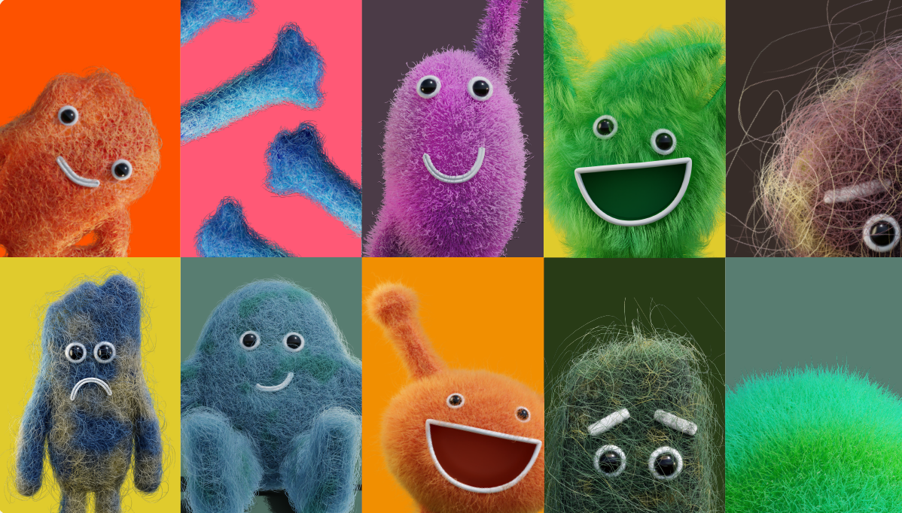
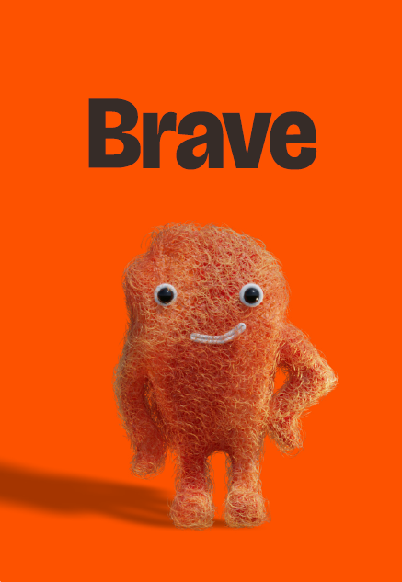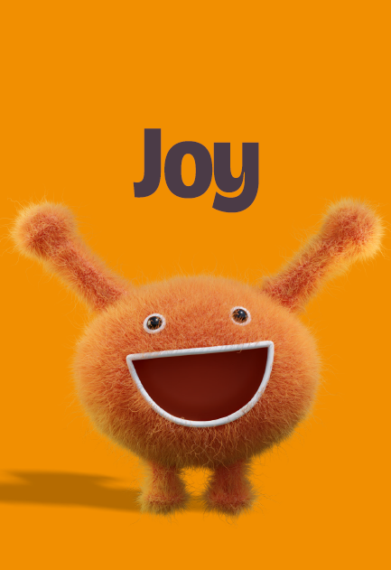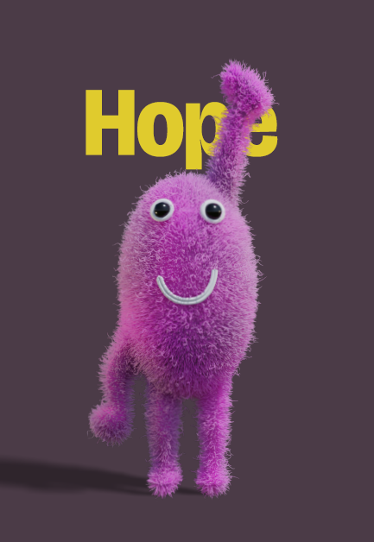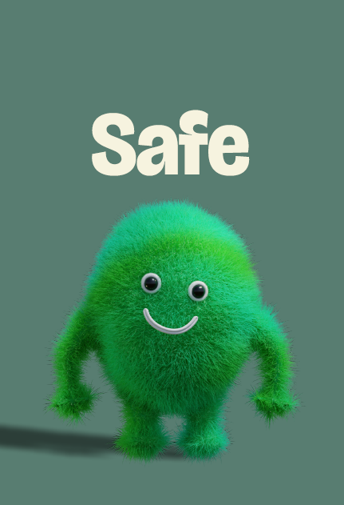
Free has lived at Seamab since forever  He loves climbing trees, running around and he’s the most confident lad you could ever meet. Some of the kids are afraid of Free at first.  They think Free could get them hurt again. They think they don’t deserve to know him. Every child deserves to know Free and with your help we can make them great friends. | Calm is an influential figure at Seamab  Sometimes it seems like Calm is never around, but when the children need him he’s always there for them. A lot of our kids had never met Calm until they came to Seamab – now they’re roommates, classmates and playmates. Calm can help our children to settle down and focus on a brighter future. You can help too. | Brave keeps a wonderful eye over Seamab  He always stands up for himself and everyone else and he loves to try new things. He really believes in himself and that’s something that rubs off on the kids. Of course, they’re scare of him at first – they don’t know you were even allowed to be so confident. Brace helps our kids to do anything they dream of. Help us to make their dreams a reality. | Hug’s always around at Seamab  He really cares and he just loves to help make the children smile. Some of the kids love Hug from day one and can barely let go of him.  Others are a bit shy if they’ve never met anyone so faring before so we give them time to learn to trust him and learn to smile. Hug can help out kids through some really tough times and so can you. | Joy has always lived at Seamab  When some kids arrive here, they can’t seem to find her. They’ve never met her before, and they don’t really know what she looks like. When they are introduced to her, they can be hostile at first – she is a stranger after all. Given enough time, care and attention, every one of our kids can get to know Joy. Help us to make that happen. | Hope is never lost at Seamab.  She’s lived here for a long time, and she knows the place like the back of her hand. She picks the kids up when they fall and she’s always showing them how good tomorrow could be. When the world seems really dark, Hope gives the kids a loan of her torch.  Without Hope our kids wouldn’t stand a chance. Help us to keep her around. | Safe lives happily at Seamab.  She’s warm and friendly and a great listener. She tucks the kids in at night and stays by their sides when they’re afraid. Some kids like to hold Safe’s hand, some like to hide behind her, and some are just so happy to know she’s there for them. Safe should be there for every child. Help us make sure she is.

…and the Unwelcome Visitors


Angry sometimes barges into Seamab  He can be unpredictable and mean. When he gets out of hand he makes a real mess and he makes people upset. It’s okay if Angry comes to visit now and again – we help out kids learn to understand him and how to calm him down. You can help too | Sad sometimes visits Seamab  Sometimes the new children carry him on their backs. Sometimes he sneaks in when nobody’s looking.We don’t ignore Sad, but we do help the kids to say goodbye to him. Sometimes it is hard to say goodbye. | Scared visits Seamab from time to time  She’s usually alone and some of the kids don’t even notice her. We find her hiding in the corners of rooms, curled up under tables, lying silently under the bed. Sometimes it’s good to listen to what she has to say, but sometimes she just wants to make trouble, especially when she gets together with Angry and Sad. Help us to stop them causing trouble.

Children and staff developed Sea Changers with StudioLR.

