HILLMAN GRAD MENTORSHIP LAB MARKS 100 MENTEES WITH LAUNCH OF SEASON 5 COHORT

Lena Waithe’s Flagship Talent Development Program Continues to Build Hollywood’s Next Generation of Diverse Storytellers

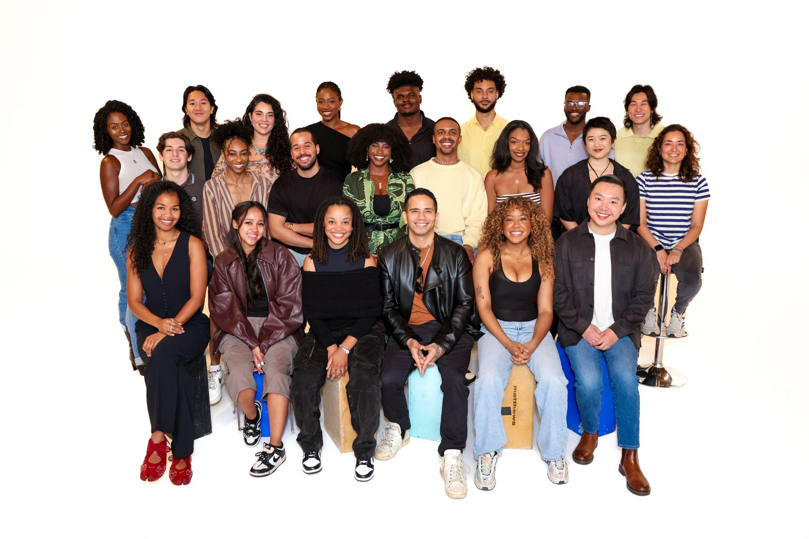

Lena Waithe’s Hillman Grad Foundation has unveiled the 22 creatives selected for the fifth season of its acclaimed Mentorship Lab–a milestone moment as the program surpasses 100 mentees served since its 2021 launch. The initiative continues its mission to expand access and opportunity for underrepresented voices in the entertainment industry.

Over the course of six months, participants will take part in hands-on workshops, speaker series, and networking opportunities geared towards enhancing their creative skillset. The mentees will receive personalized instruction from Michael Svoboda (Director of Writing Track), Behzad Dabu (Director of Acting Track), and Kyle Fong (Director of Executive Track).

The Season 5 cohort includes Arnold Setiadi, Ashley Deleon, Bre Jacobs, Cheyenne Washington, Heather Knobel, John Woods III, Kennedy Tolson, Marlon Alexander Vargas, Olamiju Obanikoro, and Symone Holmes in the acting track; Dylon Goris, Marisol Romero, Meredith Isom, Quincy Bell, Robert Chen, Sophia Lau, Teodorico Sajor, and Zoe Arscott in the writing track; Alia Wood, Diego Diaz, Joshua Kwan, and Matthew Threadgill in the executive track.

“Five seasons and more than 100 mentees is not just a number, it’s a commitment to doing the work. We set out to prove that diverse storytellers don’t need to be discovered; they need to be developed. The Mentorship Lab was built to do exactly that, and the careers our alumni are building speak for themselves. Hollywood is better when more voices are in the room, and we’re not slowing down.”

Since launching in 2021, the Hillman Grad Mentorship Lab has provided professional development for more than 100 mentees, becoming a vital pipeline for diverse talent with alumni landing representation, selling original projects, and securing jobs across the industry. Featured alumni include Juliana Aidén Martinez (GRISELDA; LAW & ORDER: SPECIAL VICTIMS UNIT; FBI), D.K. Uzoukwu (CLEAN SLATE), Tea Ho (THE SYMPATHIZER; WE WERE THE LUCKY ONES; POKER FACE), and Abigail C. Onwunali (JOE TURNER’S COME AND GONE; JAJA’S AFRICAN HAIR BRAIDING).

The Mentorship Lab is the Foundation’s flagship program, created and led by Justin Riley with the support of program coordinators Christine Murrain and Geralyn Smith. As a 501(c)(3) nonprofit, the Hillman Grad Foundation is propelled by the generous support of individuals, partners, and corporate sponsors to further its impact.

