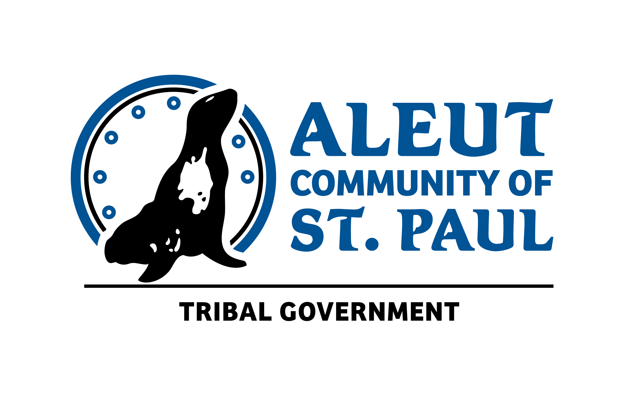 | Aleut Community of Saint Paul Island Tribal Government of St. Paul Island  Acknowledgment and Assumption of Risk, Release and Waiver of Liability  For 2024 Program Activities
THIS IS A LEGALLY BINDING AGREEMENT. BY SIGNING THIS DOCUMENT, YOU ARE WAIVING CERTAIN RIGHTS, INCLUDING THE RIGHT TO BRING A LAWSUIT TO RECOVER DAMAGES IF YOU OR YOUR CHILD ARE INJURED WHILE PARTICIPATING IN ACTIVITIES BY, HOSTED OR THE TRIBAL GOVERNMENT. PLEASE READ CAREFULLY BEFORE SIGNING.

PARTICPANT INFORMATION
First Name |  |  |  |  |  |  | Last Name |  |  |  |  |  |  |  |  |  |  |  |  |  |  |  | DOB
Physical Address
Mailing Address
City |  |  |  |  |  |  |  | State |  |  |  |  |  |  |  |  | Zip Code
Home Phone |  |  |  |  | Work Phone |  |  |  |  |  |  |  |  |  |  |  |  |  |  | Cell Phone
Email |  |  |  |  |  |  |  |  |  |  |  |  | ID # |  |  |  |  |  |  |  | Current Age
EMERGENCY CONTACTS
First Name |  |  |  |  |  |  |  |  |  |  | Last Name
Home Phone |  |  |  |  |  | Work Phone |  |  |  |  |  |  |  |  |  |  |  |  | Cell Phone
Email |  |  |  |  |  |  |  |  |  |  | Relation
First Name |  |  |  |  |  |  |  |  |  |  | Last Name
Home Phone |  |  |  |  |  | Work Phone |  |  |  |  |  |  |  |  |  |  |  |  | Cell Phone
Email |  |  |  |  |  |  |  |  |  |  | Relation:

In consideration of my or my child’s participation in Tribal Government activities, I acknowledge and willingly agree that:

- I am registering voluntarily and of my own free will for myself or my child to participate in Program Activities of various departments of the Tribal Government. Activities including, but not limited to, outdoor recreation such as paddle boarding, boating, walking, hiking, being near or around water; arts and crafts, meals, community, educational and scientific research, surfing, camping, sports, swimming, fishing, etc.

- I am or my child is physically able to participate in activities and know of no disability or prior injury which would prevent my or my child’s participation, or potentially lead to my or my child’s injury or the injury of another.

- I acknowledge and fully understand that activities potentially involve risk of injury, including serious and/or permanent physical injuries and death which might result not only from my own actions, inactions or negligence, but also the actions, inactions or negligence of others, including the Tribal Government, its officers, servants, agents, employees and volunteers, (hereafter referred to as “releasees”), the environmental conditions or the equipment used.
- I accept personal responsibility for the damages following such injury, permanent disability or death, including those resulting from the negligence of the releasees.

- I knowingly and freely assume all risks, both known and unknown, even those arising from the negligent acts or omission of others and assume full responsibility for my own or my child’s participation.

- I further hereby agree to indemnify and save and hold harmless the releasees, from any loss, liability, damage or costs they may incur due to my participation in activities, whether caused by the negligence of any or all of the releasees, or otherwise.

- I hereby release, waive, discharge and covenant not to sue the Tribal Government, its officers, servants, agents, employees and volunteers, from any and all liability, claims, demands, actions and causes of action whatsoever arising out of or relating to any loss, damage or injury, including death, that may be sustained by me, or to any property belonging to me, whether caused by the negligence of the releasees, or otherwise, while participating in activities.

- I consent to the Tribal Government and its legitimate program partners to record, display and/or reproduce my likeness and voice, to edit and otherwise modify and use such media at its discretion knowing I will not receive compensation.

- I know that I may not be available to authorize emergency medical care of my minor child and appoint any official of the Program Activity to act in my place, and in my absence and to give such authorization.

- It is my express intent that this agreement shall bind the members of my family and spouse, if I am alive, and my heirs, assigns and personal representative, if I am deceased,

In signing this Release, I acknowledge and represent that I have read the foregoing Release, fully understand it, and sign it voluntarily as my own free act and deed; that no oral representation, statements or inducements, apart from the foregoing written agreement, have been made; that I am at least eighteen (18) years of age and fully competent; and that I execute this Release for full, adequate and complete consideration fully intending to be bound by same.

_________________________________________ ___________
Signature of Participant Date

_________________________________________
Printed Name of Participant

CONSENT AND RELEASE OF PARENT OR LEGAL GUARDIAN
As parent or guardian of the below noted participant, on behalf of myself and said participant, I acknowledge that I have read this agreement, that I have executed this agreement voluntarily, and that this agreement is to be binding upon myself, my heirs, executors, administrators, and representatives in the event of my death or incapacity.

_________________________________________ _____________

Signature of Parent or Legal Guardian Date

_________________________________________

Printed Name of Parent or Legal Guardian

_________________________________________

Printed Name of Participant

