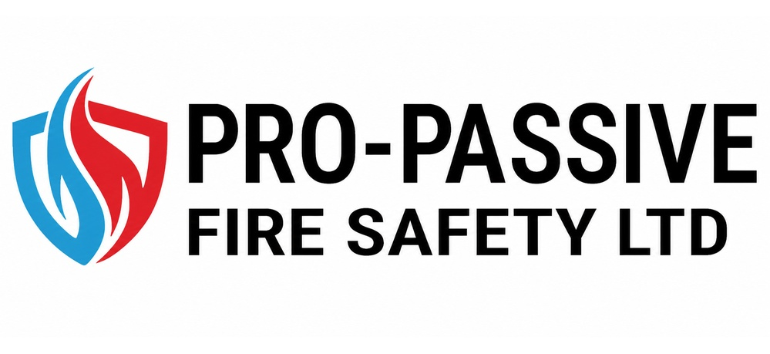 |  | Health & Safety Policy

GENERAL STATEMENT OF INTENT

Pro-Active Fire Safety Ltd believes that excellence in the management of health and safety is an essential element within its overall business plan – a good health and safety record goes hand in hand with high productivity and quality standards.
People are the most important asset to this company, and therefore we are totally committed to ensuring their health, safety and welfare at all times.
From an economic point of view, the company believes that prevention is not only better, but cheaper than cure. There is no necessary conflict between humanitarian and commercial consideration. Profits and safety are not in competition. On the contrary, safety is good business.
From a legal perspective, the company is committed to ensuring that it complies with all relevant health and safety legislation. Where it is reasonably practicable to do so, the company will strive to go beyond the requirements of legislation.
The company is committed to ongoing monitoring and review processes, so that continual improvement in the management of health and safety can be achieved.
Our general intentions are:-
- To provide adequate control of the Health and Safety risks arising from our work activities;
- To consult with our employees on matters affecting their Health & Safety;
- To provide and maintain safe plant and equipment;
- To ensure safe handling and use of substances;
- To provide information, instruction and supervision for employees;
- To ensure all employees are competent to do their tasks, and to give them adequate training;
- To prevent accidents and cases of work-related ill health;
- To maintain safe and healthy working conditions; and
- To review and revise this policy at regular intervals.

Name : Terry James Blaney
Signed: 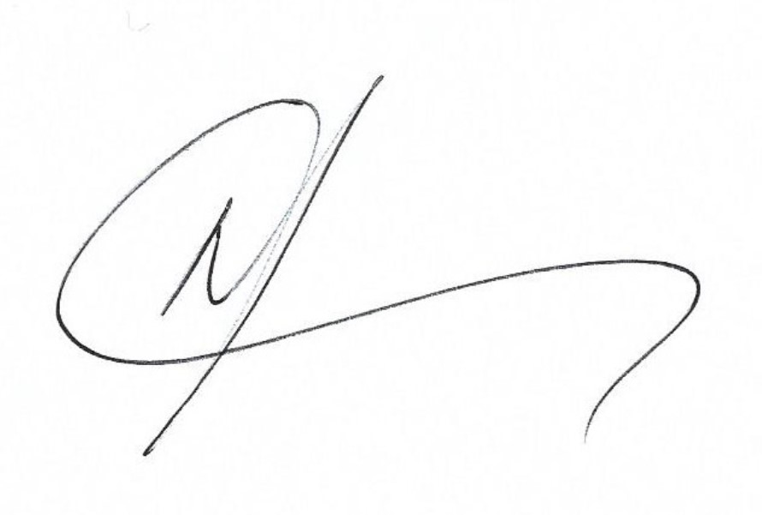
Position : Director
Date: 5/11/25
Review Date: 5/11/26

Organisation
Overall and final responsibility for health and safety is that of:
Terry Blaney– Director
Day-to-day responsibility for ensuring this policy is put into practice is delegated to:
Jason Little – Compliance Manager
Employees’ Duties
All employees are required to:
- Co-operate with supervisors and managers on health and safety matters;
- Not interfere with anything provided to safeguard their health and safety;
- Take reasonable care of the health and safety of themselves and others; and
- Report all health and safety concerns to a responsible person (as detailed in this policy statement).
Non-compliance with health and safety rules and procedures can result in disciplinary action, which may include immediate dismissal if appropriate.
Pro-Active Fire Safety Ltd’s Health and Safety Manual and associated procedures detail the specific procedures in place to ensure compliance with prevailing legislative and regulatory requirements. This Manual is available on the Company PAMS.
Organisation chart (H&S Management)
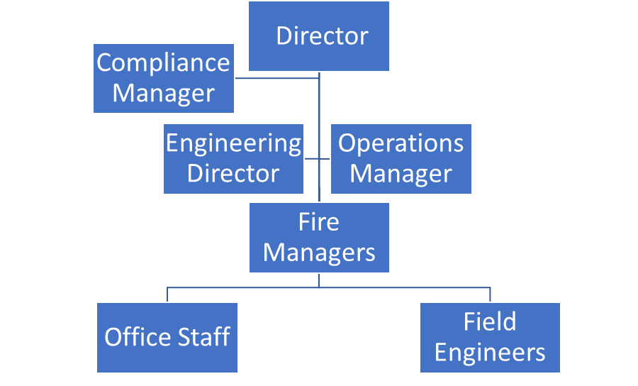

Arrangements for Implementation
All company policies and procedures in relation to health and safety are regarded as supplementary to this policy
Risk Assessment
In accordance with the Management of Health and Safety at Work Regulations 1999, the company will carry out risk assessments of all activities that present a risk to employees or others. These risk assessments will be carried out in line with Health & Safety Executive guidance, and the procedure for doing so is as follows:
- Identify the significant hazards involved in our activity.
- Decide who might be harmed and how.
- Evaluate the level of risk and decide if existing precautions are sufficient, or if more needs to be done.
- Record the significant findings of the assessment.
- Review the assessment when things change, or there is reason to believe that it is no longer valid.
Risk assessments will be undertaken by:
Fire Managers
Approval for the required action to remove or control risks will be given by:
Fire Managers
Health & Safety Management System
The company operates a documented health and safety management system. The system consists of actions for the company to complete and implement and can be viewed on request.
The health and safety management system is the responsibility of:
Jason Little, Compliance Manager

Consultation with Employees
The company will consult with its employees in accordance with the Safety Representative and Safety Committees Regulations 1977 and the Health and Safety (Consultation with Employees) Regulations 1996.
Consultation with employees will be provided by:
Written and Verbal communications
Safe Plant and Equipment
The company will ensure that all plant and equipment is suitable and without risks to health and safety, in accordance with legislation such as the Provision and Use of Work Equipment Regulations 1998, the Lifting Operations and Lifting Equipment Regulations 1998 and the Electricity at Work Regulations 1989.
Responsibility for identifying all plant and equipment needing maintenance is that of:
Operations Manager, Fire Managers and operatives.
Responsibility for ensuring that effective maintenance procedures are drawn up is that of:
Jason Little, Compliance Manager
Responsibility for ensuring that all identified maintenance is implemented is that of:
Fire Managers
Any problems with plant or equipment should be reported to:
Operations Manager or Compliance Manager
Responsibility for checking that new plant and equipment meets health and safety standards before it is purchased is that of:
Operations Manager or Compliance Manager
Safe Handling and Use of Substances
The company will assess and control health risks from exposure to hazardous substances in accordance with the Control of Substances Hazardous to Health Regulations (COSHH) 2002.
Responsibility for identifying all substances that need a COSHH assessment is that of:
Jason Little, Compliance Manager
COSHH assessments will be carried out by:
Jason Little, Compliance Manager
Approval for the required action to remove or control risks will be given by:
Jason Little, Compliance Manager
Construction (Design and Management) Regulations 2015
The company will plan, manage and monitor the construction phase and coordinate matters relating to health and safety during the construction phase to ensure that, so far as is reasonably practicable, construction work is carried out without risks to health and safety.
Responsibility for planning, managing and monitoring construction works is that of:
Jason Little, Compliance Manager

Information, Instruction and Supervision
The Health and Safety Law poster is displayed:
The Kitchen
The company employs Jason Little, Compliance Manager to act as competent advisor on health and safety issues. He can be contacted at any time for advice.
Supervision of young workers/trainees will be arranged/undertaken/monitored by:
Jason Little, Compliance Manager
Responsibility for ensuring that our employees who work at locations under the control of other employers are given relevant health and safety information is that of:
Jason Little, Compliance Manager
Training and Competency
Induction training for all new employees is the responsibility of:
Jason Little, Compliance Manager and Departmental Managers
Job specific training will be provided by:
External training providers, Compliance Manager and Fire Managers
Specific tasks requiring special training are:
External training providers, Compliance Manager and Fire Managers
Training records are kept at/by:
Electronically/Annette Richards
Training will be identified, arranged and monitored by:
Fire Managers and the Compliance Manager

Accidents, First Aid and Work-Related Ill-Health
Health Surveillance is required for employees doing the following jobs:
Using DSE
Health Surveillance will be arranged by:
Jason Little, Compliance Manager
Health Surveillance records will be kept at/by:
Personal files, Director
First aid box(es) is/are kept at/by:
Office and work vans
The appointed person(s)/ first aider(s) is/are:
Mike Richards
All accidents and work-related ill-health are recorded in the accident book, which is kept at/by:
Main office, Tracey Vallis, Finance Director
Responsibility for reporting accidents, diseases and dangerous occurrences to the enforcing authority is that of:
Jason Little, Compliance Manager
Monitoring
To check our working conditions, and ensure our safe working practices are being followed, we will:
Regularly review workplace and risk assessments. Conduct workplace inspections and arrange for an annual Health & Safety audit
Responsibility for investigating near misses and accidents is that of:
Jason Little, Compliance Manager
Responsibility for investigating work-related causes of sickness absence is that of:
Jason Little, Compliance Manager
Responsibility for acting on investigation findings to prevent a recurrence is that of:
Operations Manager and Fire Manager
Emergency Procedures – Fire and Evacuation
Responsibility for ensuring that a suitable and sufficient fire risk assessment is undertaken of Panache’s premises is that of:
Jason Little, Compliance Manager
Escape routes are checked by/every:
Operations Administrator - Daily
Fire extinguishers are maintained and checked by:
Nominated engineers monthly and serviced every 12 months
Emergency evacuation will be tested every:
Six months

