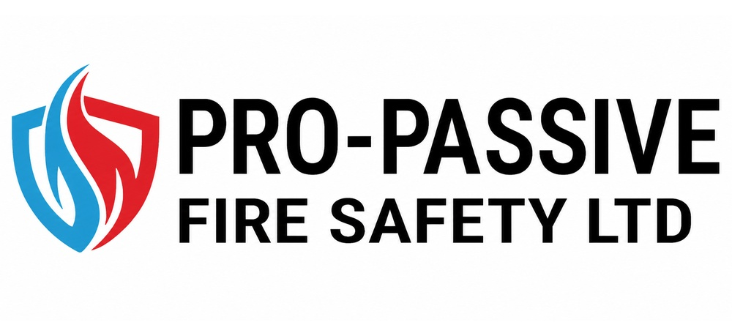 |  | Sustainability Policy

General Statement of Intent
Pro-Active Fire Safety Ltd is committed to promoting sustainability. Concern for the environment and promoting a broader sustainability agenda are integral to Pro-Active Fire Safety Ltd’s professional activities and the management of the organisation. We aim to follow and to promote good sustainability practice, to reduce the environmental impacts of all our activities and to help our clients and partners to do the same.
The company believes that continuous improvement in environmental management is an essential element within its overall business plan – minimising waste, consumption of resources and pollution goes hand in hand with high productivity and quality standards. This policy therefore applies to, and will be integrated with, all business activities, products and services with the potential to adversely affect the environment on a local or global scale.
We recognise and accept our legal duty of care toward the environment and are committed not only to complying with our legal duties and with other requirements to which we subscribe but to exceed these requirements where reasonably practicable.
Energy generation and consumption is a major contributor to the production of greenhouse gases and global warming. Although our use of energy is limited primarily to energy efficient IT equipment we will nevertheless seek to manage our use of energy, reducing consumption and continuously improving efficiency wherever possible.
We will seek to identify all processes that generate waste and will seek to avoid environmentally harmful disposal by eliminating, minimising or reusing waste products wherever reasonably practicable or, where this cannot be achieved, identifying and taking advantage of opportunities for recycling.
The basis of our environmental management system will be an ongoing review of business activities and the identification of aspects of our work that could have an impact upon the environment and the implementation of ongoing steps to eliminate, minimize or manage them so that adverse environmental effects are minimised.
To enable us to measure our environmental performance we will review the suitability of Environmental Policy and the performance of Environmental Management System in order to promote continual improvement year on year in our environmental performance.
Signed: 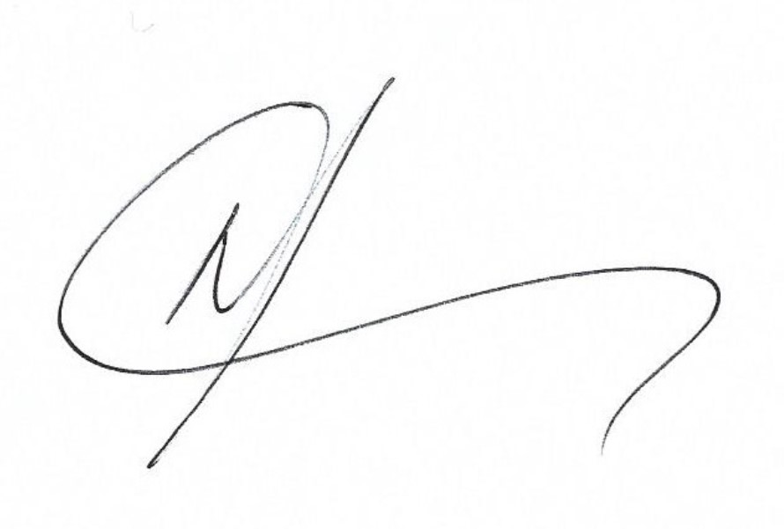
Position: Director
Date: November 2025
Review Date: November 2026

- Scope

The scope of the Sustainability/Environmental Management System extends to all products and services produced by Pro-Active Fire Safety Ltd.
Included within this definition and in addition to planned operating conditions are non-routine activities and foreseeable emergency situations.
The environmental management system will also apply to those aspects of the activities of suppliers and service providers over which we have, or could have an influence and the environmental performance of our business partners.
Our Sustainability Policy is based upon the following principles:
- To comply with legislation, regulations and codes of practice. with, and exceed where practicable, all applicable
- To integrate sustainability considerations into all our business decisions
- To ensure that all staff are fully aware of our Sustainability Policy and are committed to implementing and improving it.
- To minimise the impact on sustainability of all office and transportation activities.
- To make clients and suppliers aware of our Sustainability Policy and encourage them to adopt sound sustainable management practices.
- To review, annually report, and to continually strive to improve our sustainability performance.
- Organisation

The organisation established to implement this Sustainability Policy is:
Overall responsibilities Terry James Blaney Director

Day to day duties Tracey Vallis, Finance Director

- Arrangements

Contents | Page
Legal compliance | 3
Prevention of Pollution | 3
Management of Waste | 3
Carbon Management | 4
Conservation of Water Resources | 4
Sustainability | 4

Legal Compliance
The company is aware that an ever-increasing range of legislation is being introduced both by the UK Government and directly from the European Union intended to protect the local and global environments and to attempt to ensure the sustainable use of the earth’s limited natural resources.
We recognise the importance of compliance with these requirements both to the business itself and to the wider environment and are committed to taking all reasonable steps, on an ongoing basis to identify those legal constraints within which we are required to work and pledge to comply fully with both the letter and spirit of the law as it applies to our activities and those of our partners where we are able to exert a meaningful influence.
We will identify legal requirements relevant to our activities and will ensure that relevant details of such requirements are communicated in an effective manner to our staff. Any actual breaches of our legal responsibilities will be fully investigated and a report submitted for consideration by senior management so that corrective and preventative action may be taken to ensure that no further breaches take place.
Prevention of Pollution
We recognise our fundamental responsibility to prevent pollution of the environment and will identify all environmentally harmful substances, materials and processes used by the company and seek, on an ongoing basis, to replace them with environmentally safe or less harmful alternatives where such alternatives are available at a reasonably practicable cost. We shall further ensure that all environmentally harmful substances and materials are handled safely throughout their storage, use and disposal.
Management of Waste
We recognise the management of waste as a key priority for the business and that eliminating waste at source or minimising that which cannot be eliminated are two of the most effective ways in which we can reduce the impact that our activities have upon the environment.
Where waste is unavoidably produced, we recognise and accept the duty of care in respect of waste placed upon us by Section 34 of the Environmental Protection Act 1990. All contractors employed or used by the company to handle waste that we produce will be required to supply a valid Registration of Carriers Certificate before they are employed by the Company.
We will further ensure that the ultimate destination of our waste is determined and confirm that the site to which it is delivered holds a valid Waste Management License enabling it to lawfully receive and process our waste.
We shall ensure that at all times, waste is held securely to prevent its escape and that where hazardous waste is produced, that this waste is segregated from other waste streams and from other hazardous waste streams with which it may react.
Whenever waste produced as a result of our activities is removed from our site, we will ensure that relevant documentation is prepared and exchanged between ourselves and the contractor to which the waste is being passed. This documentation will then be returned to the company office and retained for the requisite period.
Finally, we will seek, at all relevant levels within the business to minimise the amount of waste sent to landfill, recognising that this is consumes irreplaceable natural resources. Wherever possible, we will seek to eliminate, reduce or re-use waste before considering other options such as recycling or recovery. Land filling shall be considered a last resort.

Carbon Management
We recognise the potentially detrimental effect that certain emissions produced by the company in the delivery of its products and services may have on the global environment and shall seek to reduce emissions of the 6 ‘greenhouse gases’ (GHGs) identified in the Kyoto Protocol as contributing to climate change on an ongoing basis.
The primary source of carbon produced by the company is in our consumption of energy derived from fossil fuels. We will seek, on a continual basis, to identify opportunities to reduce the amount of energy that the business uses through an ongoing program of energy efficiency, recognising the benefits that this action will have both on the environment and on the profitability of the company.
Where energy use is unavoidable, we will encourage our energy provider to consider the viability of supplying energy derived from renewable sources. We commit to considering the environmental cost of energy production alongside and in equal measure, to its financial cost when selecting and reviewing our energy supplies.
Conservation of Water Resources
The company recognises that clean fresh water is a finite resource and that depletion of available fresh water supplies degrades the natural environment. To the extent that we are able, we commit therefore to identifying and implementing effective water conservation practices to ensure that water use is minimised, wherever reasonably practicable.
In making these commitments, we accept that achieving the aims of this policy may require behavioural changes on the part of our employees and commit to providing the resources required to support and achieve this.
Sustainability – Practical Steps
In order to achieve our objectives we will:
Carry out an Impact Assessment on all processes to identify where our services impact on the environment and identify appropriate controls and actions to mitigate the impacts. An annual review of the assessment will be undertaken.
Travel and meetings - Walk, cycle and use public transport to attend local meetings, site visits etc, apart from in exceptional circumstances where the alternatives are impractical and/or cost prohibitive.
Include the full costs of more sustainable forms of transport in our financial proposals, rather than the least cost option which may involve travelling by car or air. Where the only practical alternative is to fly, we will include costs for full air fares rather than budget airlines in our financial proposals.
Avoid physically travelling to meetings etc where alternatives are available and practical, such as using teleconferencing, video conferencing or web cams, and efficient timing of meetings to avoid multiple trips. These options are also often more time efficient, while not sacrificing the benefits of regular contact with clients and partners.
Reduce the need staff to travel by supporting alternative working for arrangements, including home working etc, and promote the use of public transport by locating our offices in accessible locations.
Purchase of equipment and consumption of resources – Look to change vehicle fleet to hybrid/electric. Minimise our use of paper and other office consumables, for example by double-siding all paper used, and identifying opportunities to reduce waste.
As far as possible arrange for the reuse or recycling of office waste, including paper, computer supplies and redundant equipment.
Reduce the energy consumption of office equipment by purchasing energy efficient equipment and good housekeeping.
Supply Chain. We are committed to purchasing timber and timber products from legal sources and seek evidence of compliance from suppliers that they are operating in accordance with the laws of their country.

