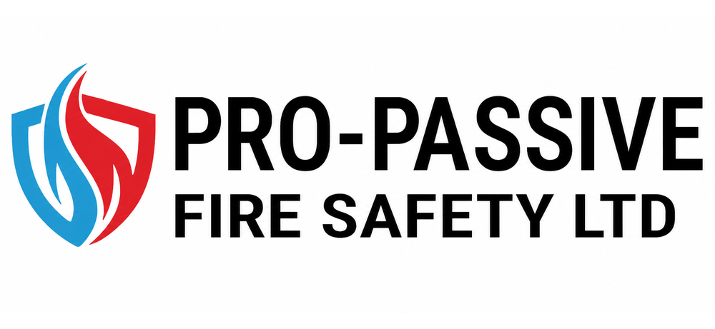 |  | Quality Policy

PRO–ACTIVE Fire Safety Ltd (PAFS) aims to provide high quality active fire protection and associated services for our customers.
The Organisation is accredited to ISO 9001:2015 for the design; Installation; commissioning/handover; maintenance and verification of Fire Detection and Fire Alarm Systems to SP203-1 and BS 5839-1. The supply, installation and maintenance of portable fire extinguishers,
The management is committed to:
- Develop and improve the Quality Management System
- Continually improve the effectiveness of the Quality Management System
- The enhancement of customer satisfaction
The management has a continuing commitment to:
- Ensure that customer needs and expectations are determined and fulfilled with the aim of achieving customer satisfaction.
- Communicate throughout the Organisation the importance of meeting customer needs and legal requirements.
- Establish the Quality Policy and its objectives.
- Conduct Management Reviews of the effectiveness of the implementation of the Quality Management System.
- Ensure the availability of resources.
- Contribute to carbon reduction by reviewing our environmental impact and maintaining and reviewing our policy for carbon reduction.
In addition to all English and EEC commercial legislation and regulations, the Organisation complies with all legislation and regulations specifically related to its business activities including the following:
- Health & Safety at Work Act 1974
- Personal Protective Equipment at Work Regulations 1992
- Management of Health & Safety at Work Regulations 1999
- Manual Handling Operations Regulations 1992
- Provision and Use of Work Equipment Regulations 1998
In order to achieve these objectives PAFS is committed to a system of Total Quality Management, which includes –
- Specifying and auditing the processes required to ensure the delivery of high quality services. PAFS is certified to BS EN IS09001: 2015 and its Quality System has therefore been designed to meet the requirements of this international standard. The Quality Policy Manual and associated operational procedures document the Quality System.
PAFS ensures that the delivery of services complies with agreed procedural requirements which are understood and implemented by all staff. Procedures are developed in line with legislative requirements, national 'good practice' standards and IS09001:2015 standards.
- Monitoring purchaser satisfaction with the services provided.
Key to the delivery of high-quality customer services is ensuring that customer needs and expectations of service delivery are delivered in accordance with required specifications. PAFS monitors customer satisfaction throughout the period of service delivery.
Feedback from purchasers of the service is also sought from a number of forums including –
- Review meetings with purchasers.
- Management and review of informal and formal complaints made by purchasers.
- Surveys for purchasers.
- Enabling staff skill development and assessing consequent performance.
Skill levels and competencies of all staff are developed through focused induction, ongoing and regular supervision and appraisal, and identification and provision of relevant training.
This commitment to Total Quality Management and continual improvement is supported by PAFS’s Management Team and staff. Quality Assurance is achieved by those directly and indirectly working with purchasers and this Quality Policy will therefore be understood and maintained at all levels. This will be achieved through consultation with and training of all staff.

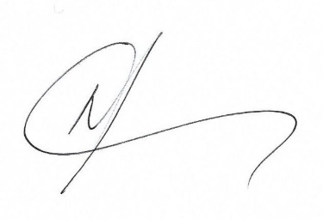
Terry James Blaney
Director

