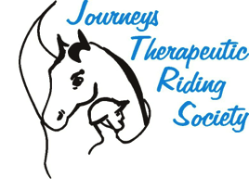
Volunteer Manual
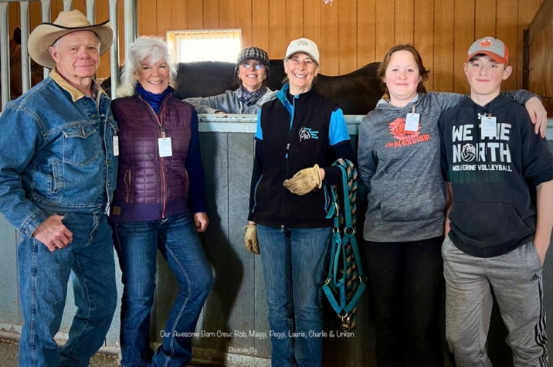

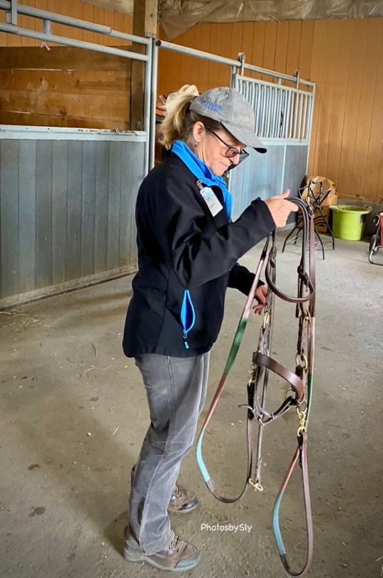

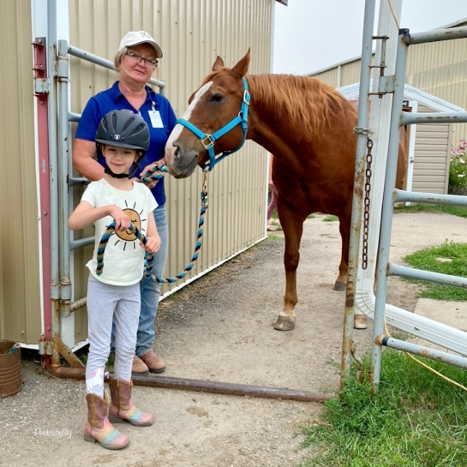
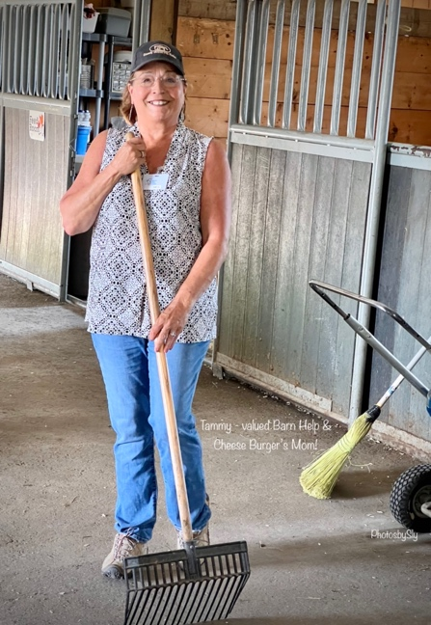
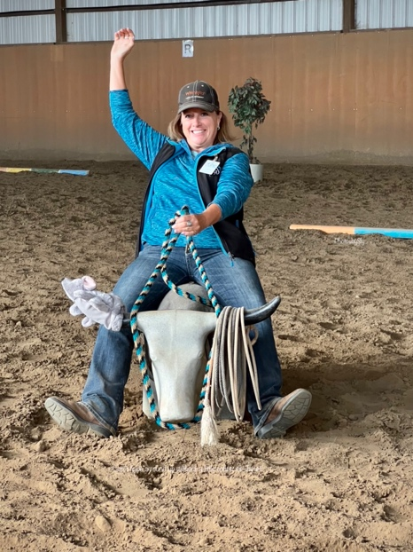
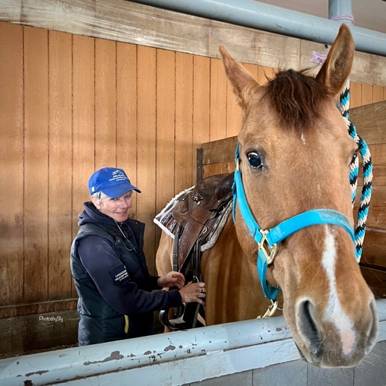
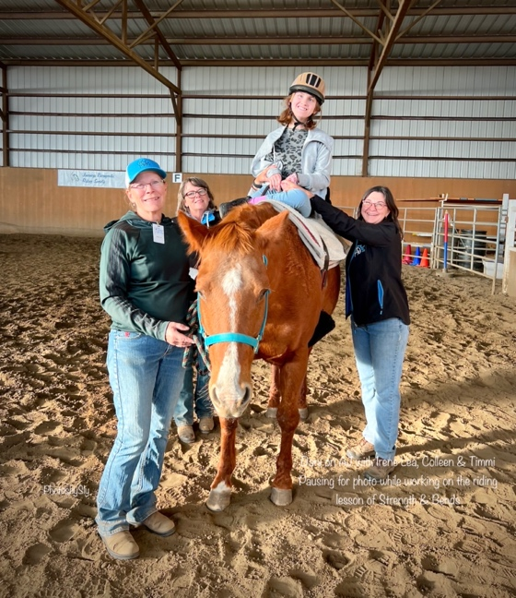

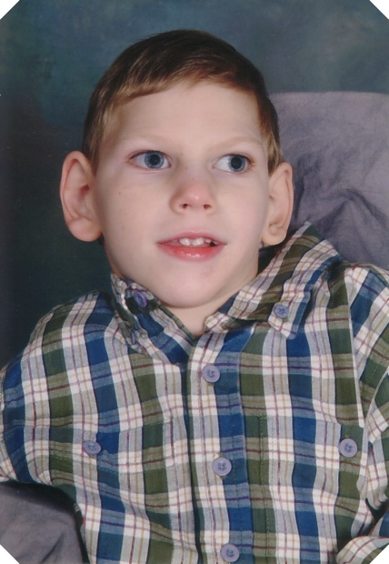
In Lane Holmes memory we believe that…

For every rider there is a horse…
For every horse there is a rider…
And for every horse and rider there is a journey.

Society Founding Donors

B. and K. Holmes
Optimist Club

CONTACT US

Telephone Students: 403-371-9921, Program Director, Laurie Messner
Volunteers: 403-850-6459, Volunteer Coordinator, Robin Beatty

E-mail: joursneystherapeutic@gmail.com
Website: www.jtrs.ca
Location: Winning Strides
Facebook : Journeys Therapeutic Riding Society

INDEX

Topic Page

Welcome to Journeys Therapeutic Riding 4

Working with Individuals with Special Needs 5

Volunteer Duties 6

The Horse Leader 7

The Side-Walker 8

The Assisted Leader 9

Horse Helper/Barn Chore Support 9-10

Procedures 11-12

Some Final Thoughts 13

Our Mission is:

To promote healthy minds, bodies and spirits for children and adults who would benefit from equine supported experiences.

Welcome to Journeys Therapeutic Riding Society
(JTRS)

Volunteer Information

Therapeutic riding is an activity designed to help individuals with special needs to experience physical, psychological, social, and emotional benefits from horseback riding. Riding on a horse gently and rhythmically moves the rider’s trunk and pelvis in a manner like that of the human walk, with resulting improvement on the coordination, balance, flexibility, strength, and control. The relationship with the horse leads to increased confidence, independence, and self-esteem. Contact with volunteers, staff and other riders improves the student’s social skills. “Fun” is a great motivator for all those involved in this dynamic experience!

Riders in our program have a wide range of abilities, skills and needs. Each rider works to learn something different in the arena. We operate on an individual basis, trying to give each rider the best experience possible.

Our program runs with the help of a terrific team of volunteers, instructors, donors, and board members. Without their generous contribution of time, enthusiasm, and energy we would not be able to operate. Being a therapeutic riding volunteer is tremendously satisfying and very worthwhile.

Thank you for volunteering your time to our program. Your energy, enthusiasm and commitment are very much appreciated!

Please be here at least 15 minutes before each class. If for any reason you are not able to attend your scheduled session, please call or text as soon as possible so that we can make alternate arrangements:
- Students, call our Program Director (Laurie Messner) at: 403-371-9921
- Volunteers, call our Volunteer Coordinator (Robin Beatty) at: 403-850-6459

Working with individuals with Special Needs

“To control a horse, one must first lean to control oneself”
Mary Longden, Coaching with Courage.

- Treat each student as an individual.
Everyone has likes and dislikes, hobbies, and activities in which they are interested. Ask about them. Even if the individual is nonverbal, they will appreciate being treated like a person first.

- Promote success.
Encourage the student to complete the tasks asked of them. Being able to groom and tack their horse is a big success, even if it takes some extra time. Memory, coordination, self-esteem, and muscles are built by carrying the blanket, saddle, and reaching to groom, etc.

- Riding is a privilege.
Many of the students that attend therapeutic riding have behavioral problems. When it comes to riding, a student must attempt to do the work in order to ride. It teaches responsibility and self-control, which are part of being safe and socially acceptable. It is not the responsibility of the volunteer to decide if the student should be allowed, or made to ride, or to deal with significant behaviors. These responsibilities fall to the instructor and assistants.

- Students are assisted according to their individual capabilities.
Expectations are established on an individual basis. What is acceptable for one student may not be for another. The instructor will inform you of the behaviors and goals for your student.

- Dress code.
Volunteers MUST be properly attired for an arena/barn environment, (i.e., clothing that is tight/revealing is discouraged); proper footwear for handling horses and walking on uneven ground (only close toed footwear will be permitted); minimal jewelry that is not easily accessible or distractive to students, and no clothing with inappropriate statements.

- Confidentiality.
While volunteering you may gain knowledge about a student that is confidential. It is imperative that students not be discussed outside the program in any way that may break this trust.

- Professionalism.
We are representatives of JTRS, and as such we ask that all individuals act in such a manner that supports our culture, and community reputation in line with our mission.

Volunteer Duties

The JTRS lesson/session team consists of:

- An Instructor (* In concert with Program Director)
        - (*) Selects and prepares horses for the riding season
        - Prepares for and presents at the Annual Orientation (in concert with Program Director and Volunteer Coordinator)
        - Prepares lesson plans and objectives for each class/session
        - Tracks the progress of each rider
        - (*) Monitors the soundness of horses for each class(es)

- Volunteers:
- Arena – Horse Leader (HL)
  - Side Walker(s)
    - Right (RSW)
    - Left (team captain) (LSW)
  - Assisted Leader (AL)
- Barn – Grooming/Tacking and Leading a Horse

Each student will be assessed and assigned a team of volunteers. The JTRS volunteer team in the arena can vary from 1-3 (or more) people depending on the needs of the student.

If more than one volunteer is needed, one will lead the horse and the others will walk on either side.

Everyone needs to listen to and follow directions from the instructor. A smooth-running class depends on everyone listening and following the directions given.

During the lesson, volunteer teams should be attentive to instructor directions and the rider’s needs. Your attention should be focused on safety and NO personal discussions should be held during the session.

Volunteers do not necessarily have the time-
they just have the heart.
Elizabeth Andrew

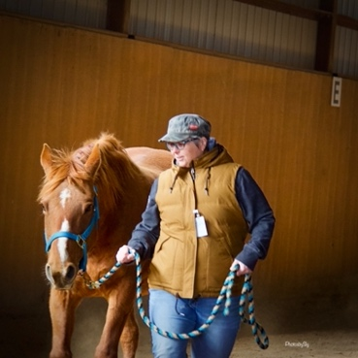
Volunteer Positions

The Horse Leader

The horse leader’s main duty is to ensure the horse is under control at ALL times. The degree of assistance provided will depend on the rider and the horse.

- The horse leader should be someone who is comfortable with horses. Their role is to control the horse, keep it moving at an even pace, and encourage the horse to respond to the aids given by the rider.

- The leader should walk just behind the horse’s head. The right hand should be about 8 inches from the halter with the extra lead rope folded in the left hand.

- Allow the rider to be the first to apply aids. If the aids are not direct or strong enough, then reinforce the rider’s cues by encouraging the horse and applying pressure if need be.

- The leader should be aware of what is going on in the rest of the arena, as well as be attentive to their own rider’s needs.

- When the rider is doing exercises and the horse is stopped, it is the leader’s job to see that the horse stands till and is standing on all four legs evenly. Stand to the left of the horse facing your rider during exercises.

- Horses sometimes have “off” days. Treat them firmly and respectfully. Discourage bad behaviors and habits. After the ride, inform the instructor about any horse’s issues/concerns you might have had, so as to avoid any future problems.

IMPORTANT: In an emergency the horse leader’s responsibility is to control the horse. Bring the horse to a halt immediately. If your rider is down, move the horse a safe distance away and STOP. Allow the instructor and side walkers to attend to the rider.

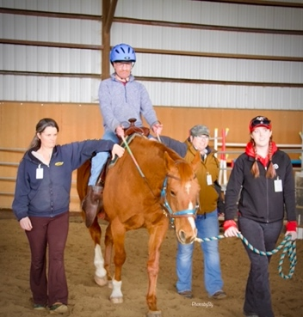
The Side-Walker(s)

The side-walker’s primary responsibility is to ensure the safety of the rider. Side-walkers also assist the instructor in keeping the rider focused on tasks, explaining instructions, and physically assisting the rider (if necessary). The amount of assistance needed will depend on the ability of the rider.

- When there are 2 side-walkers, the left side walker is the designated team captain and will verbally coach the student and reinforce the directions of the instructor.

- Your job may involve both physical and moral support. The instructor may ask you to support the rider’s thigh, heal or trunk depending on the need to keep the student balanced in the saddle.

- When there are 2 side-walkers, both should encourage the rider to use their own balance. If they are sitting crooked, encourage them to correct themselves. If the rider can’t regain balance, the side-walkers should assist in regaining a balanced position.

- The instructor will communicate with the team captain as to how much support the rider needs.

- When the rider is doing exercises or games, the side-walkers should observe the rider’s seat and legs to ensure he does not lose his balance.

- Some riders with a disability are capable of riding without assistance, but they should be closely watched to avoid potential difficulties. Every effort must be made to avoid falls.

- Observe your rider for signs of fatigue. They may perform differently week to week depending on their level of tiredness, excitement, medications, stress, climate, etc.

IMPORTANT: In an emergency the side-walker’s responsibility is to stay with the rider and follow the instructor’s directions.

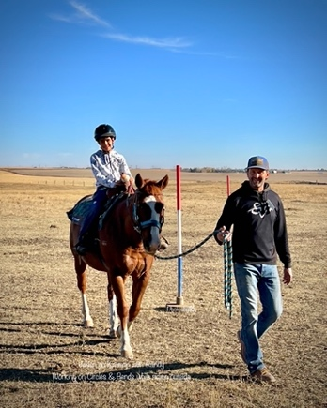
Assisted Leader

- Prior to riding independently, students will first work with an assisted leader. These riders may ride off lead if appropriate. The instructor will make the determination when this is appropriate.

- Your support in this capacity is as essential as the horse leader or side walker.

- The assisted leader should encourage the rider to use their balance and sit tall. If the rider becomes unbalance, they should be encouraged to correct themselves.

- The instructor will communicate with the rider. The assisted leader provides support based on the instruction given.

- Some riders are capable of riding without assistance, but they should be closely observed to avoid potential difficulties. Every effort must be made to avoid falls.

Barn - Grooming/Tacking and Leading a Horse
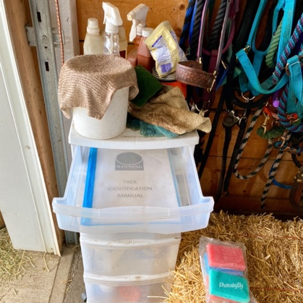
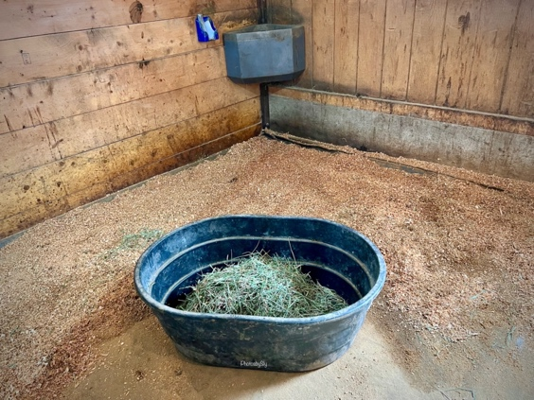
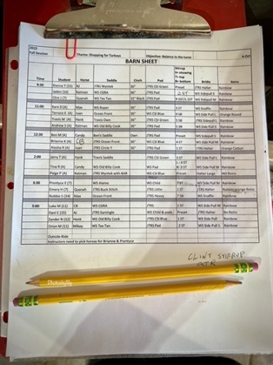

- This role is for someone that has an interest to work more directly with the horses and it is helpful if the individual is comfortable in this setting and has some previous horse experience. However, we will support and train.

- At the direction of the Program Director, the horse helper/barn chore support, will catch and prepare the horse for the upcoming ride, including thoroughly grooming, tidy up the barn area, retrieving the assigned blanket, saddle and bridle and be familiar with tacking up a horse.

- Once checked, the horse helper/barn chore support will deliver the horse to the instruction arena.

- Barn chore support covers all aspects of chores; cleaning up after horses, sweeping the barn, shoveling pens, placing hay and/or feed in pens, emptying manure buckets (barn/arena), and filling water buckets to ensure the wellbeing of the horses.
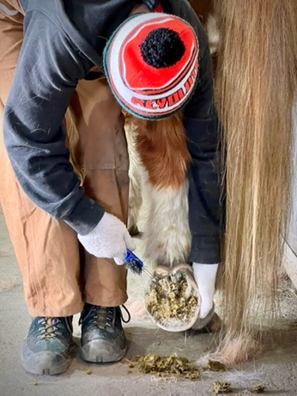
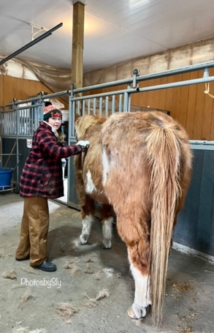

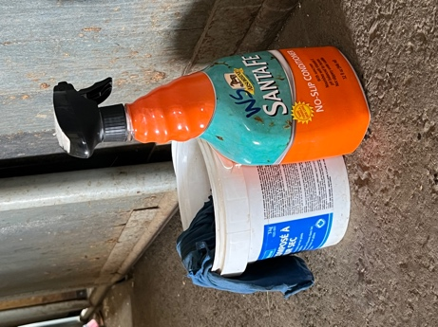

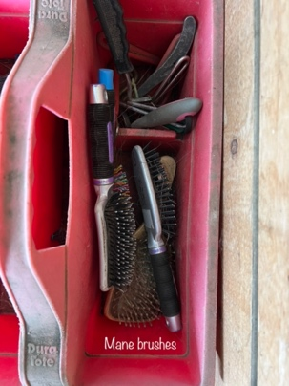
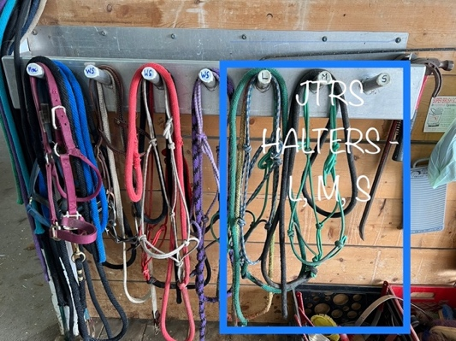
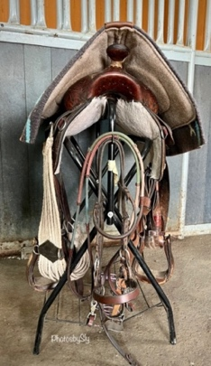

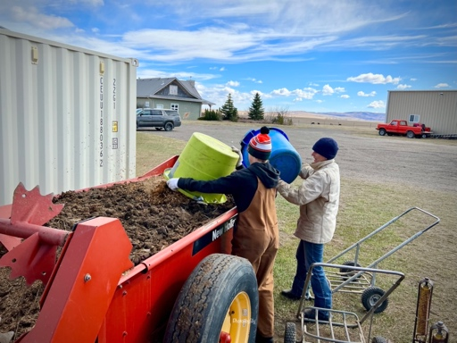
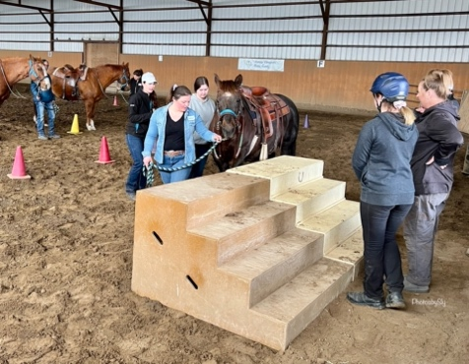
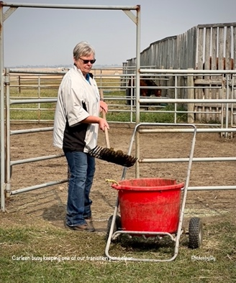

Procedures

Please keep two things in mind:

- Students depend on repetition and consistency to learn
- If there is anything you do not fully understand ask!

Greeting and Safety Equipment

A volunteer will greet and welcome the rider at the best place to support them to begin their class. Riders should be encouraged to get their safety equipment: boots, helmets, etc.

Grooming and Tacking

Pre-Mount:
Horses will be pre-groomed and saddled by volunteers before the students arrive. At the commencement of the class, each rider will have a little time to say hello to their horse, and to visit with their team members for that day. If time permits and it is appropriate for the student, they are encouraged to walk their horses up from the barn with assistance from the volunteer team. Ask for help from the instructor if you are unsure about any part of the procedure.

Post-Dismount:
Give the rider a little time to say thank you to the horse, if time permits the student may assist in unsaddling their horse. Instructors will take off the horse’s bridle/side pull. Students are encouraged to groom their own horse after unsaddling. Time does not always allow for a thorough grooming at the end of the class however any level of grooming is still recommended for the student/team. If time permits and depending on the skills and abilities of the rider, students are encouraged to take their horse back to the barn or corral, with assistance from the volunteer team.

Remember:
- Be aware when walking behind any horse at close range, that the horse knows you are there, and you have their attention. Speak to the horse or place a hand on the horse when behind.
- DO NOT WALK between or under anything the horse is tied too.

Leading

When it is safe to do so, some of the students are encouraged to lead their own horse. The horse will be led from the left side; two hands are used on the lead shank with the right “leading” hand about a forearm’s length from the snap and the remaining rope is folded (not coiled) in the left hand. A support person may walk ahead of, behind or to the left side of the student. Other team members should walk well ahead. Proceed to the riding area, being cautious of other teams. The instructor will tighten the cinch, check stirrups in the arena and assign a volunteer to warm up the horse. Once warm up is completed if all are ready, and the instructor is available to help mount, procced to the mounting stairs, box, or suitable area.

Mounting and dismounting

Requires special attention and is led by the instructor with support from the assistant and trained volunteers.

The ride

The instructor will direct the students as to what activities are to take place throughout the lesson. The volunteer backs up what the instructor is asking the student to do.

Tacking and Untacking

Most of the students are encouraged to groom, tack and untack the horse before and after the ride to the best of their ability (volunteers assist them as needed). During this process encourage the student to thank the horse and say goodbye…verbally or with a rub and/or hug. Have the student put their equipment (boots, helmet, or any other items) that were used away.

Lesson cards

After each ride the instructor writes comments about the student’s progress. Other team members are encouraged to offer insight to be included on the student record through the Volunteer Feedback binder that is located on the Schedule Table.

Things to do in between classes (many hands make light work)

- Pick up manure in the arena and place in the arena buckets, when nearing full - empty buckets into the manure spreader (west of the sea can) using the bucket carts.
- Put away and/or bring to the barn, saddles, pads, halters, reins to/from the JTRS shed/sea can – get guidance from Laurie/Maggie (our tack gurus).
- Dust off, set out helmets and/or riding boots for the next class. Collect used helmets, disinfect (outside arena) and return to shelf.
- Groom horses.

Some Final Thoughts

THE RIDERS ARE OUR REASON FOR BEING HERE.

Let us all remember that our purpose is to “take them from where they are, to where they can go,” in terms of therapy and horsemanship. This takes teamwork, patience, and consistency of routine. We must provide a consistent learning environment.

WE DO WANT FEEDBACK.

We are all learning together in our own journey. If you can see ways that we can improve our service to our riders, please don’t hesitate to share your ideas.

THANK YOU, VOLUNTEERS!

Thank you for donating your time to these very special riders. The success of this whole program totally depends on you and others like you.

It cannot be said often enough “thank you” please know that you are a true treasure in sharing your time and are very much appreciated. You can see it in the progress that the riders are making, in how smoothly the program runs, and the big smiles on the rider’s faces!

QUESTIONS? Please ask…

NOTES

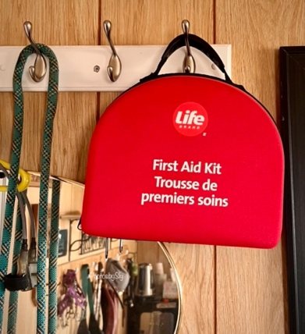
EMERGENCY INFORMATION

The first Aid kit is located in the stable office.

The AED is located in the arena on the table.

9-1-1 CALLS

One person is designated the responsibility to call 9-1-1.

LOCATION
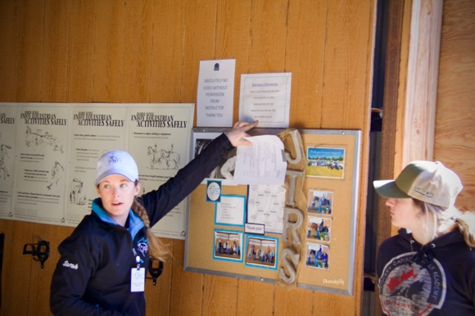
Winning Strides Stable is located at:

MD Rural Address: 285064 Township Road 164
Legal Land Description: SW30-16-28-4

The Winning Strides Location is posted on the notice board inside the barn office and arena.

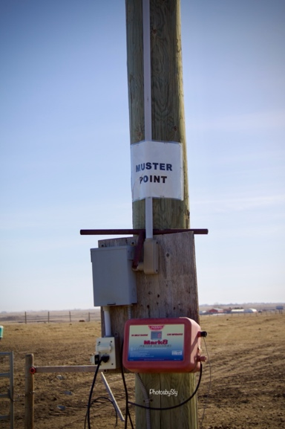
EVACUATION/FIRE PROCEDURE

Follow the instructor’s directions immediately.

The MUSTER point is located at the power pole east of the barn and to the north of the house.

INJURIES TO HORSES

Inform the instructor of any injuries to horses immediately.

