- Go to: https://intermountain.ehr.com/ESS and create an account

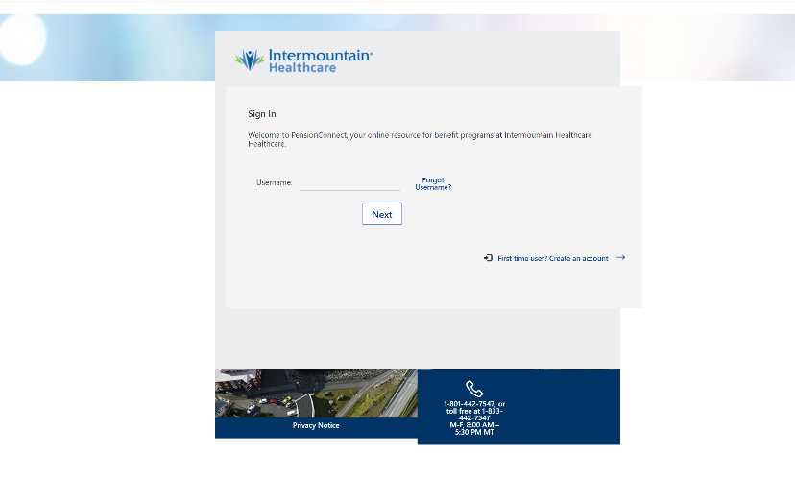

- Very Information. (If the system cannot verify the user, you will get a prompt to call HR. Don’t call HR yet. Just have the retiree select Yes to the question “do you know your SSN?” The system will give them another set of questions to answer. We had to do this three times before my client was verified.
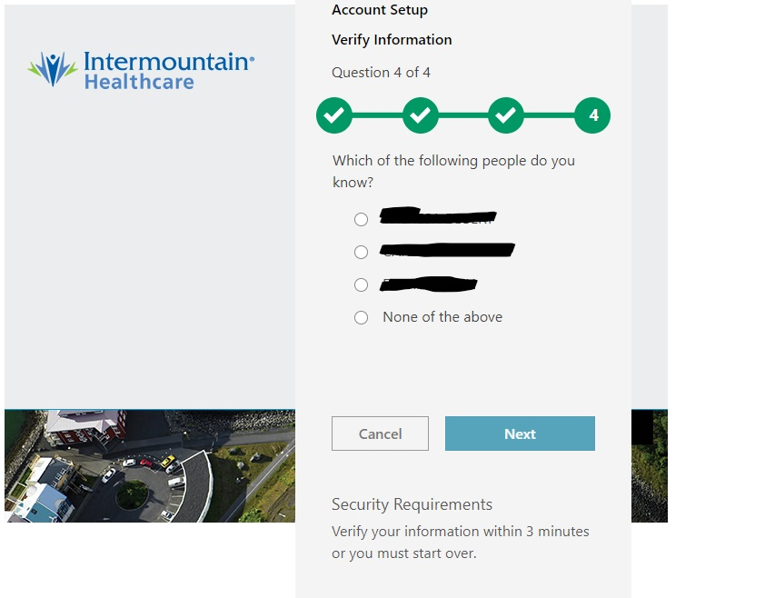
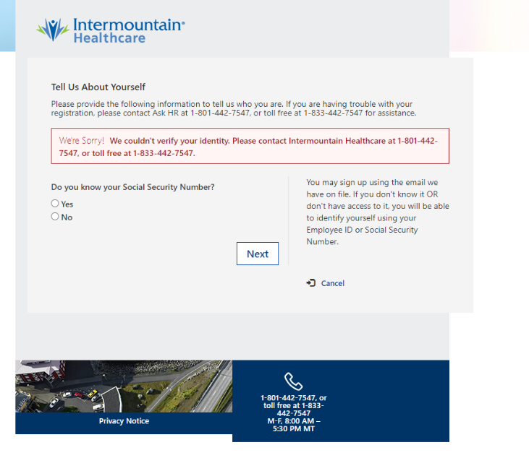

Next couple of steps are intuitive. Just follow the prompts.
- Client will provide their email address and cell phone number for 2-factor authentication.
- Agree to “Online Authorization”..

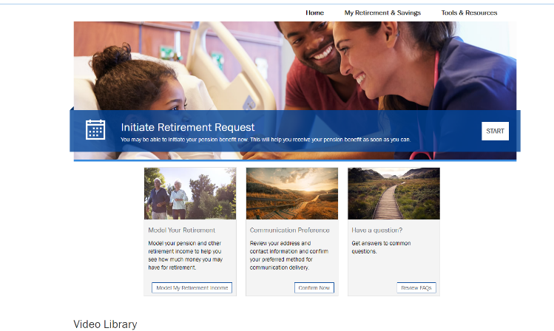
- Initiate Retirement –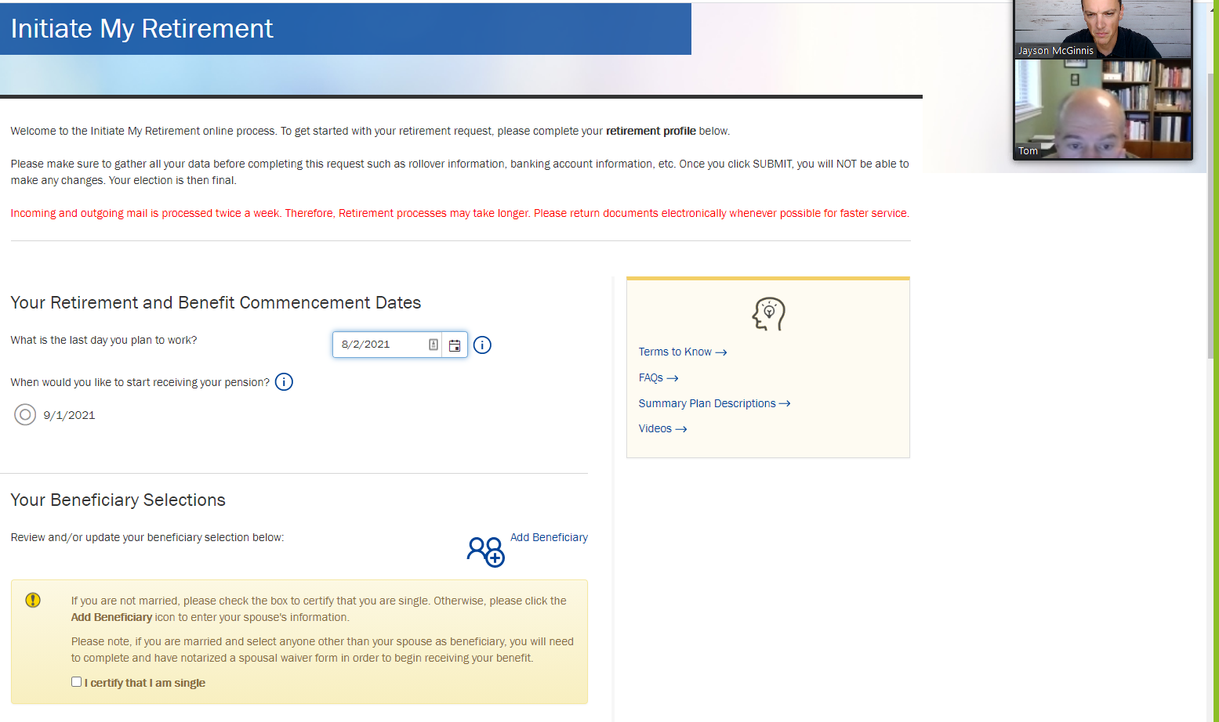

- Payment Election – Add IRA acct info and PO box address
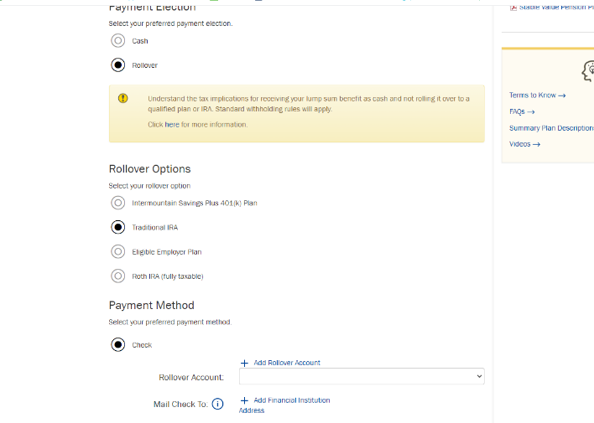
- Review Selections and submit!
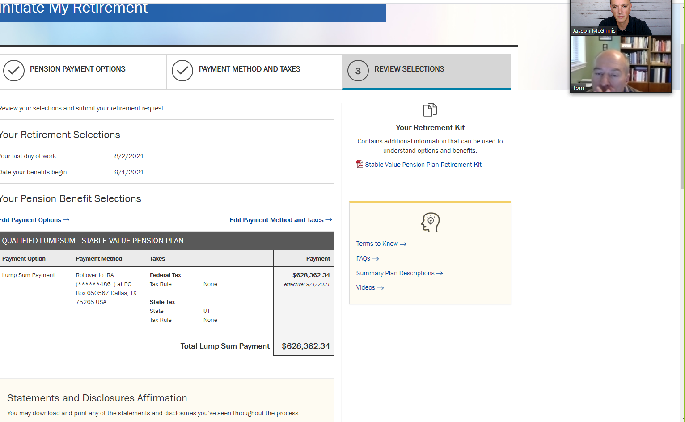

- Print, Scan and upload additional forms needed like PTO rollover, notarized Spousal Waiver, and Legal plan docs. Upload the docs within the messages (envelop icon) in pension path.
