School |  |  |  |  | Location
Activity/PE Lesson |  |  |  |  | Date
Assessor |  |  |  |  | Review Date
Hazard Identified | Who Might Be Harmed |  | Potential Risk/Outcome | Existing Control Measures |  | Likelihood (Low/Med/High) |  | Severity (Low/Med/High) | Risk Rating | Further Action Required
Example: Slips, trips, and falls on hall floor | Pupils, Staff |  | Injury (bruises, sprains) | Floor checked before use, appropriate footwear required |  | Low |  | Medium | Low | Remind pupils of rules before activity
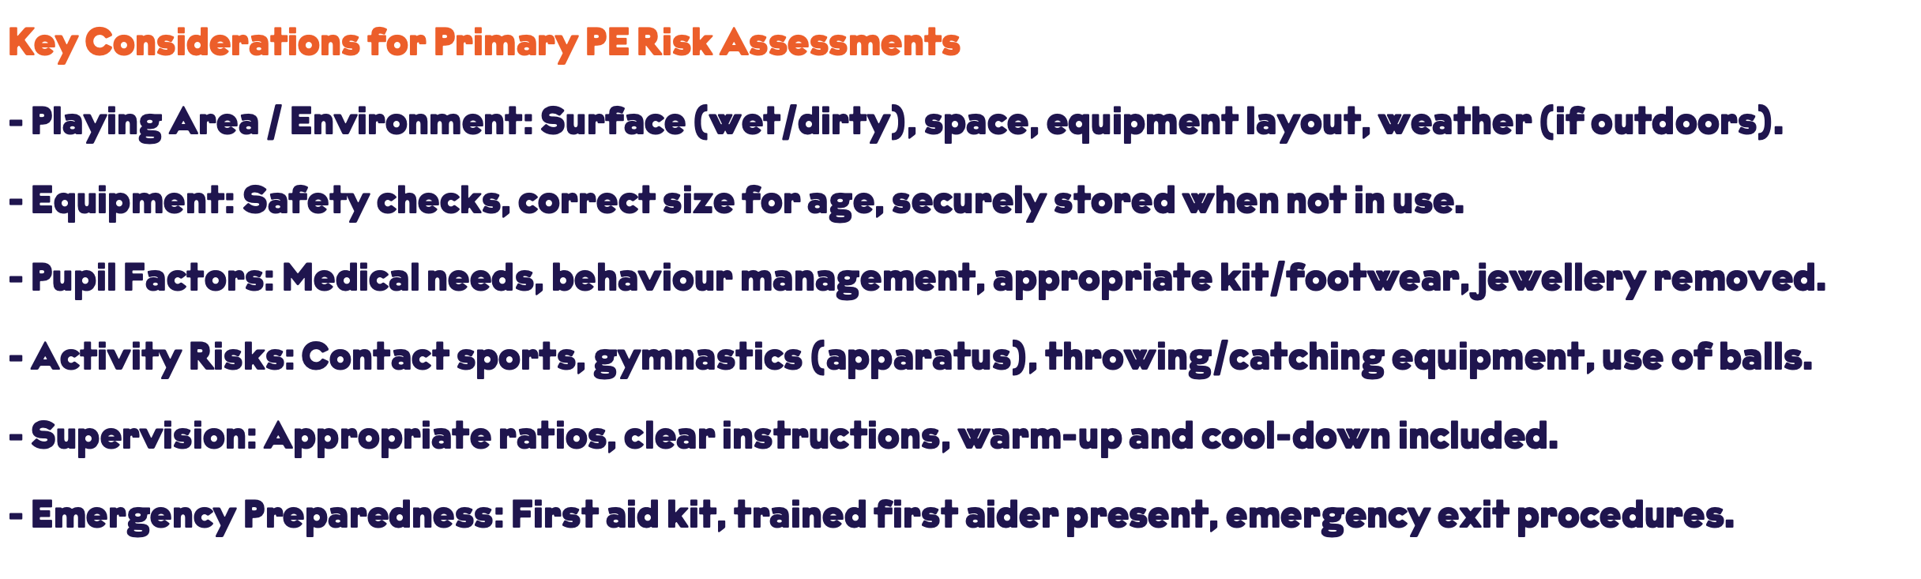

Risk Assessment undertaken by Name: Signed: Date:

Head Name & Signature: Signed: Date:

