SCC – CDs Round Table Notes
August 8, 2024 – Roundtable – Next Roundtable meeting - September 12
Notes by Josh Giuntoli

Welcome and Introduction – Call for CD Topics?
Jean Fike facilitated and welcomed the group.
SCC Leadership Update – James Thompson – jthompson@scc.wa.gov
- Has been out visiting CDs of late – recently Spokane, San Juan, Grays Harbor – upcoming Kitsap
- Closing out fiscal year 24 – preparing for distribution of funds for new FY
- Budget development ongoing – 17 packages
- A lot of new political faces after the November general election
- New SCC staff – Amy Martin (Riparian Grant Program Manager), Jennie Coe (Forest Health)
SCC Program Updates – SCC Staff
CPDS update – Brian Cochrane – bcochrane@scc.wa.gov
- Security Access Washington (SAW) will be the new front to sign into CPDS
- August 28 launch
- You will notice the difference from the CPDS sign-in page – A little different login
- Important that when registering you SAW email that it matches the CPDS user email
- If already have a SAW that doesn’t match let him know and he can give you a new CPDS logon
- Training materials and recorded tutorial coming soon
- If unsure what your CPDS email is, contact Brian Cochrane
Comments/Questions/Discussion
- Map feature search instead of contract number?
  - Can add to the list of possible updates
- Multiple users – security upgrade on how to get to CPDS
- How much money is WSCC investing into CPDS updates annually at this point?
  - At this point, the least amount of money to maintain functionality
  - Investing heavily (Up to $1m over the coming months), to look into current data as well as upcoming migration into new system of our choosing – will look to CDs for input.
- When does the data migration happen – no hard date, expect data to be in a state to migrate sometime around the end of February 2025.
- If you don't have a SAW account do you recommend asking for the CPDS sign in password from Brian, and then setting up a SAW account or the other way around?
  - Contact Brian – could be either way – but reach out to him to know which CPDS account email user
- David Marcell – I would be grateful if SCC consulted with Springbrook in the development and upgrades to their data management systems / strategies. If time allows at the end I would like to dicsuss further.
  - James Thompson - Opportunity around Springbrook
  - Sarah Groth – while a lot of CDs use, Springbrook, we can’t direct CDs to use. If we look to integrate financial components, could be limited due to needing to work with various financial accounting systems in the CD space. Looking at all options for efficiency sake
Irrigation Efficiencies – Jon Culp – jculp@scc.wa.gov
- The IEGP will no longer be accepting applications for financial assistance due to lack of funds available, through June 30, 2025.
- The program may have some remaining or freed up funds as we move through the remainder of the fiscal year and will work with interested districts to allocate those on a case by case basis. As the application link has been deactivated on the program webpage, please email your need and justification to jculp@scc.wa.gov for future consideration.
- Program staff will still be available for in-house technical assistance and you continue to look for viable projects for funding in the coming biennia.
- CTD water resource forum – contact Jon or CTD for information. First Monday of the month at 1pm. For September only, 2nd Monday due to Labor Day.
- Thank you for a job well done and participating in making the Efficiencies program a huge success!
Riparian Grant Program – Amy Martin – amartin@scc.wa.gov
- Outreach and implementation funding available
- Working to gather ideas on improvements on program – contact Amy or Shana (sjoy@scc.wa.gov)
Sustainable Farms and Fields Update – Karen Hills – khills@scc.wa.gov
SFF applications submitted in July totaled $4.1 million for $1.26 million in available funds. We expect to know which projects are moving forward for funding the week of Aug. 19 and all applicants will hear from SCC about their application status after that date. At this point, we don’t expect to have additional SFF funds until summer 2025.
Climate-Smart Livestock Research and Demonstration funding is still available. Next application pull is Sept. 2. More information here: https://www.scc.wa.gov/programs/sff-climate-smart-livestock
Security Warning for CDs – Andrew Phay – see message after section notes
- July 23, Skagit CD had an email account hacked, Message had “(NAME) Invited you to view a file” message was the entrance. Document took staff to a notepad URL – link goes to a site, that asks credentials for Microsoft 365, then hacker uses those credentials to log on maliciously.
- Hacker set up a LinkedIn account – created a CD job announcement, people started replying. Hacker set up for those to go to staff deleted folder. Then, hacker notified applicants they got the job, said they received a certain amount of funding, then gain access to credit card.
- Enduris was contacted – they were able to assist in certain aspects of forensics.
- If your staff didn’t expect a document, contact person outside of the message to confirm.
- Firms exist that for a payment, monitor login attempts.
Comments/Questions/Discussion
- Zorah – Does Microsoft already have this feature built in?
  - Depending on version and licensing, you may have that ability. Some CDs do not.
- Evan - Our IT support can safely open questionable emails/attachments and let us know if they are safe.
MESSAGE FROM ANDREW PHAY
There has been an increase in Phishing attempts that use someone's email account that has been hacked. The account gets hacked and the hacker uses that persons contacts to send out emails to attack more people. Please be on the lookout for emails you get from your contacts that you didn't request or have knowledge of. Examples are Invoices, proposals, requests. They can be very convincing these days. Some of them may take you to a document on the hacked accounts OneDrive/SharePoint/OneNote and then get you to click on another link in that document. Below is one such document with the bad URL in Notepad. Be on the lookout! If you do see anything like this, we would want to let the account holders know so they can shut it down.
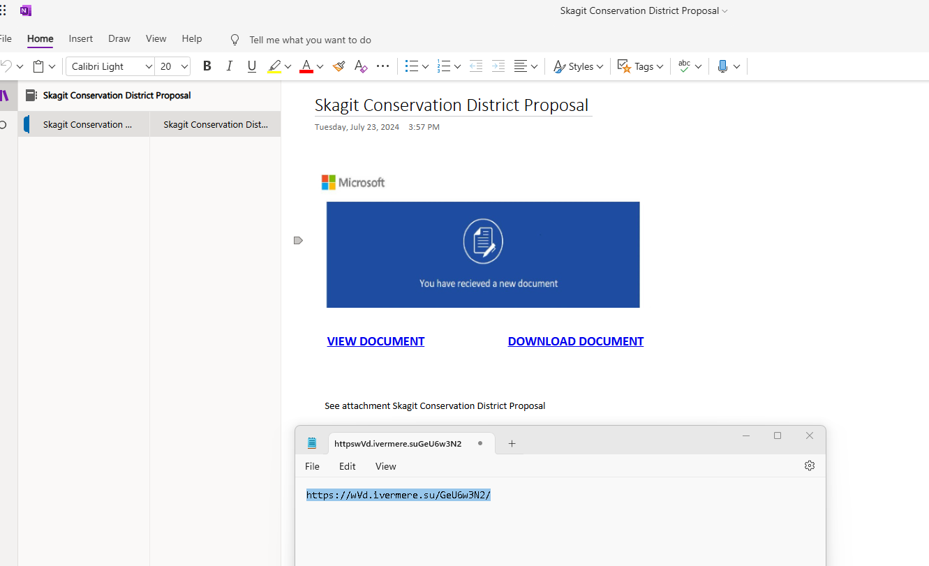
Communications Team Updates
- Just a reminder, send us any annual report stories you want to share!
- https://www.scc.wa.gov/news/please-send-us-your-annual-report-stories
- If you want to make it in the first draft it would be the 16th but please don't let that stop you from sending stuff in. We will still use it.
WACD Update – Tom Salzer, WACD
- Annual meeting conference draft schedule coming to WACD next week
- WACD has been visiting a lot of CDs in June and July, and attending WACD committee meetings
- Published a new pod cast on HUB – looking for candidates to join for a pod cast
- Signed KR strategies contract for outreach materials for new legislators.
- Covid is still with us, friends and associates coming down with new strains
Comments/Questions/Discussion
- Joy Garritone – Where are we at with ECY and CD concerns – has it moved since last we talked?
  - August meeting coming
- Evan met with Gabe Rasso in SW area – good conversation. Let him know some of the CD internal conversations – goal is to come up with a new MOU with ECY as a possible template for others, or possibly work with WACD. Met with non-point staff as they were asking why ECY funding isn’t more utilized. MCD comment asked about site potential tree height, buffer width requirements and they confirmed that is the case. Talked about duplication of efforts (i.e. NEP ag TA outreach) and competing with CDs for those resources.
  - ECY is returning NEP funds – giving the money back. Why? When grant was written, they were in a fiscally challenging situation, now they don’t have those concerns to pay for their staff.
- Brandy – the fact they got the funding in the first place, scope of work driver, could be the funders are not getting the full picture of what CDs can offer.
- Puget Sound Districts to follow up with Puget Sound Partnership and see if the role of CD’s can be reinforced/clarified
Center for Technical Development Update – Jan Thomas, written submission
- Last week’s Riparian Planning Considerations training in Olympia went very well! We had a number of different presentations in the classroom and lots of field time. Our class was a mix of NRCS and District staff, with even a couple of USFWS partners. If you weren’t able to attend this year’s training, look for another opportunity next year in Central WA – and make sure to request it on the FY25 Training Needs Inventory!
- Save the Date for a virtual Cultural Resources training for District staff on September 5th. More details coming soon!
- We are moving forward with purchasing our new online learning platform. Look for more updates on that in next few months.
- If you haven’t already commented, this is your last call for submitting feedback on the WADE conference, including suggestions for next year’s sessions. WADE 2024 Feedback Survey
- Always feel free to reach out with any questions – jan@ucdwa.org or training@wactd.org.
District Topics
- Tom Salzer –FSA CRP signature mess-up.
  - FSA contacted leadership about CDs needing to sign on to contracts for producers with very short notice. CDs had not reviewed the plans
  - Short term solution – work with a small number of CDs to sign as contentious objectors as they were not involved in the plan writing process.
  - Craig Nelson – their CD has never been able to look at any of those documents in the past.
  - Considering WACD session on CD and federal agencies in general.
  - FSA – internal discrepancies about how staff view the policies and procedures
  - Spokane related that they were “asked to sign these last year with an hour notice of our board meeting. Two NRCS people showed up at our meeting with very little notice. We reluctantly did sign, with a hand-written statement on 110 plans stating we had not reviewed them nor participated in writing them. It was very weird and very uncomfortable. We definitely felt we were strong armed into this.”
  - See FSA 2-CRP (Rev. 6) Amend. 1
Next Round Table Meeting
September, 12 2024

