SCC – CDs Round Table Notes
September 12, 2024

Next Roundtable Meeting_ October, 10 9:30am
Notes by Karla Heinitz

Welcome and Introduction – Call for CD Topics?
Josh Giuntoli facilitated and welcomed the group.

Action Items
- SCC ACTION ITEM – Create feedback loop for Riparian Roundtable discussions. Kate & Levi to work with Regional Managers. All interested districts welcome to participate.

SCC Leadership Remarks
Kate Delavan- WSCC recruiting a Legislative Director, please share the announcement.

https://www.governmentjobs.com/careers/SCC Legislative Director

SCC Program Updates – SCC Staff
Policy Update_Kate Delavan__Riparian Roundtable carrying the message to meet landowners where they are.

Tribal conversations—making progress on tribal conversations. Have met with NWIFC and will be working with the Whitner Group to lead us through structured plan for the Riparian Grant program. We are continuing to fund projects through our current funding guidelines. SCC continues to make progress on tribal consultation.

Plauche & Carr - Law firm facilitating the Governor’s Riparian Roundtable June 30 recommendations – were not voted on or put forward by consensus from the Riparian Roundtable.

Evan Bauder_the conversations at the RoundTable are pretty scripted. They are on a different agenda. Need to utilize our funding the best we can make good use.

Brandy Reed__Is it possible to have some conversations between SCC and CDs on what’s happening in the Riparian Roundtable discussions? (Action Follow Up)

SCC Budget Decision Packages are now submitted. Success in the process in the success is important it aligns with the Governor’s Salmon Recovery. GSRO convenes a sub-cabinet around salmon restoration SCC is a part of. Six (6) of our decision packages were included our CTA and NRI. Science Hub, Riparian program, VSP (Cap and Operating) and RPPP. Work plan still in draft available in October or November.

Hilary Aten starting as OFP Coordinator on September 16. Over 20 years of experience in land conservation.

VSP Update_Sarah Wilcox__a new capital round has been announced. Ready to fund projects will be pulled from CPDS on October 29. Still determining the amount of funding remaining. If you have been awarded and forecast you will not use the funding, please return to SCC.

NRCS conservation practices data at HUC12 watershed scale: Overview and training. September 30, 2024, 1:30 – 3:00 pm Online only

Great VSP tours in Columbia and Walla Wall, headed to Okanogan next.

VSP September Newsletter https://content.govdelivery.com/accounts/WASCC/bulletins/3b2cff6

Evan Bauder—will we receive feedback on our monitoring plan with a chance to update before they are updated?

Sarah Wilcox—hoping to get some comments back to you.

Levi Kessler-reviewing and buried. Workplans are all different if there is a need for improvement we will reach out, working on going through plans on who wanted feedback. Getting feedback from agency staff. Mason is one of the 6 plans I’m working on. There is input from agency staff helping right now.

SFF Program Update_ Karen Hills__Notice sent yesterday which was a request for applications for a district(s) around BMP evaluation relevant to aquaculture BMPs. https://www.formstack.com/forms/?5918789-Z1gXYQ3TYx RFA due Oct 11

Zorah-SFF scoring sheets. Can we see all see the scoring sheets?

Karen -Will review and see if that’s possible.

SCC Regional Managers update—Josh Giuntoli--we are hoping to have Thomas Schienbien on a future roundtable call for the SCC IT work that’s happening.

SCC program managers and RMs will be checking in on projects in the next month per our 120-day check-ins.

CD Election Training, September 26 10:00 am webinar it will be recorded.

Irrigation Efficiencies Program__Jon Culp—IE grants program is out of funding for this fiscal year. Still have a small amount of TA funding, pre-project work funding available for entering projects into CPDS. Let me know if you have questions. Guidelines on SCC web page on IE. If a project that has funding to return, please let me know. Projects in CPDS will be good to know for funding for next biennia.

Center for Technical Development (CTD) Update
Training—cultural resources training last week. Posted the sources on the CTD website and the cultural resources for refresher for people.

Update to AgLearn rearrangement to certification on courses completed. Reach out to CTD with questions.

Conservation planning part 2—holding some nationally, Pend Orielle Idaho next month.

CTD also having a conservation planning next spring. Opportunities in early 2025.

Secured our online learning platform.

WACD Update
Heather—thank you to CDs who have timely paid their dues. And thank you to CDs who have submitted their letters of support for SCC budget packages. Send letters of support into OFM this week or next week. Support funding packages that support your district, your district knows best what funding is important to your district. Template letters available contact Heather.

WACD has a meeting this week. Area meetings coming up in October all dates on the HUB.

Tom Salzer_Ryan is at NACD in Alaska right now. Tom heading to Manhattan, Kansas for an Association of Conservation Executive Directors (ACED) board meeting. Tom is the Pacific Region Director.

WACD Virtual office hours yesterday and will announce the next one soon.

WACD Annual meeting is on Monday, Tuesday, Wednesday December 2-4.

Working with KR Strategies on information for CDs for next legislative session. Lots of new Leg members will be elected as well as a new Governor. WACD will have the information once the area meetings happen in October.

Posting resolutions next week, have received very few next so far.

Communications Team Updates
No updates.

District Topics
No topics discussed.

RCO – 2025 SRFB Policy feedback opportunity (Josh Lambert, RCO, Grants Manager - josh.lambert@rco.wa.gov)
Development of Manual 18, Salmon Grants update riparian requirements. Funding report of 2024 grant round. Map of the spread of funding available.

Riparian Grant-funded under CCA, managed by SRFB. There was $28.8 million allocated to salmon regions spread to local lead entities, not less than $300,000 in funding allocated per project. Lots of programs working towards historic funding to meet the needs and scale of the funding. SRFB lead entities can carry forward to 25-27 funding years.

If the CCA funding is repealed the 2025 funding allocated can be carry forward.
69 applications ready to be awarded. At least 8 were stewardship projects. A lot of project types that the Leg wanted to see, mainly on the ground. Limited to only assessments. Increased our deliverables for design for riparian enhancement plans this year. Would love feedback on guidance and where it helped them describe or develop a better project. Did allow some in-stream work needed to deliver and support riparian restoration. Priority for people developing projects for the SRFB.
Map of SRFB funded CD projects.

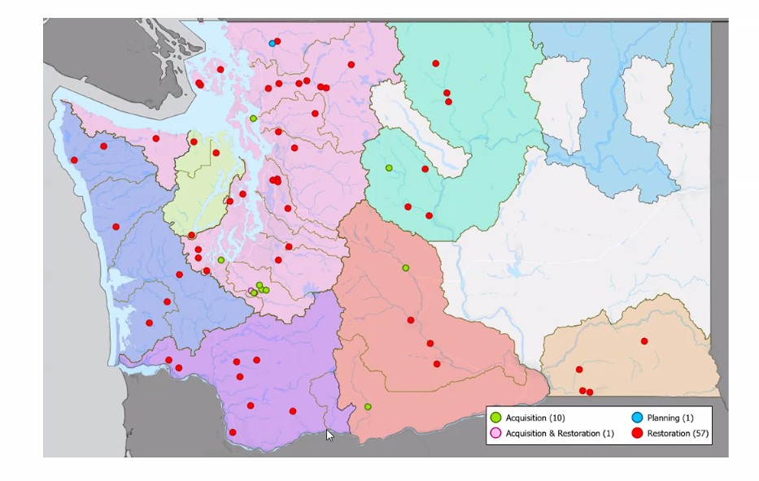

Feedback:
Evan Bauder__Riparian enhancement plans, took a great deal of resources and time to put on paper, huge up front of time and resources. One site ok, but WRIA type more difficult. The review panel was not well equipped to review these new technical type projects. Felt a little clunky along the way.

RCO Response--Panel—went out and reviewed plans. But a lot of paper to review. Panel most interested in the adapted mgmt. development plan. Timing and a lot of information wasn’t there when reviewing. Better align all reviewers on the plan for efficiency’s sake. Make sure they are all reviewing it.

Emmett Skagit—Skagit is different than other CDs who interact with the lead entities. Skagit CD had 18 projects this year, riparian and normal stuff. A lot of delays from RCO in communication. Went through several reiterations, communications difficult, need information to make lead entity decisions.

RCO Response—Riparian funding bridges the funding to SRFB, PSAR and other funding, but yes it was different for each lead entities. Lead entities were able to decide which projects went to which funding source. Good to have a deadline for lead entities. Want to leave as much flexibility as possible for lead entities. Not well for project sponsors in trying to apply for projects. Can get away from the tricky part of the match element, if we can remove match from projects may make things a little smoother. Yes, tried to address those issues early on through the Lean process, but those that are late in the process make it difficult.

Emmett—finding out some information when we were in the lead entity meeting.

How would we find the template for the planning project mentioned in the Nooksack

Rene Hadley--Why can't RCO riparian be a statewide application with a narrow application window? A 10-month application window dealing with a local office with selective priorities is challenging.

RCO—targeted investment an interesting comment. Public comment at SRFB.

Craig Nelson__The RCO application process is so long, tedious, and politicized by our Regional Technical Team who is heavily biased to projects in only three watersheds (and frankly often in reaches they themselves are working) we refuse to even apply for salmon recovery funding. More and more organizations in our county are finding funding elsewhere for the same reason as the only organizations that can put the resources in the process are tribes and state agencies.

RCO—This is a bigger question, gets into the local process that SRFB doesn’t dictate. Grant managers can discuss the project with sponsors. The RTT drive the project lists and technical process.

Evan Bauder—important for us as CDs to keep in mind, a lot of people in the state should not have come to SCC. Be careful how we are pressuring RCO, could lead to some backlash. Lead entity WA way bottoms up salmon model.

Craig--I agree with Evan. There's enough work for all of us to have our roles and processes. Some of our processes work differently and that's a good thing at the end of the day.

RCO—if specifically riparian projects are not making it through the process, even if it’s not riparian but instream.

Kate—Riparian roundtable discussion what is the best mechanism to deploy salmon in the state. There’s a lot of work and lots of different processes. Could be complementary to RCOs SRFB funding. Give James, Kate or Levi a call if you have comments on our seat at the table.

RCO—has someone on the riparian roundtable will connect with that person and tell the comments happening today. Some projects may be difficult to be funded through these SRFB projects, larger projects.

Thanks Josh.

Next Round Table Meeting – TBD
Area meetings coming up RMs will update the next CD Roundtable meeting.

