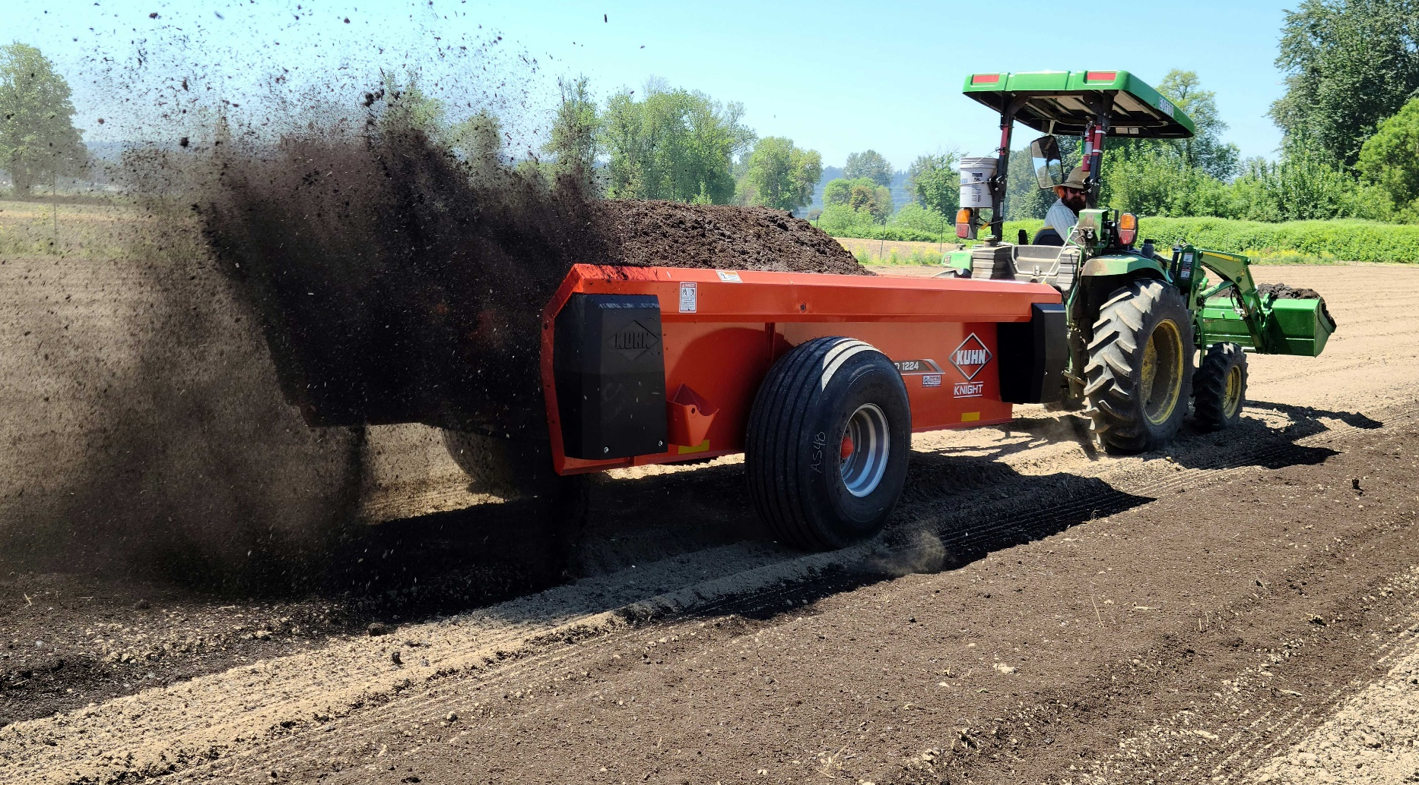
Name of Report
Compost spreader, King County

Report to the Washington State Legislature
Fiscal Year 2022-23
October 15, 2023

Karen Hills​
SFF Program Manager​
khills@scc.wa.gov ​
(564) 669-3292
Alison Halpern, PhD.​
Scientific Policy Advisor / ​
Acting Policy Director​
ahlapern@scc.wa.gov​
(360) 280-5556 ​

Report prepared by:
Your Name​, SCC Program Manager​ | info@scc.wa.gov ​| (123) 456 - 7891
​

Table of Contents

Program Overview 3
Background 3
Program Description 3
Program Accomplishments 3
Testimonials/project examples 3
List of Funded Projects in FY2023 4

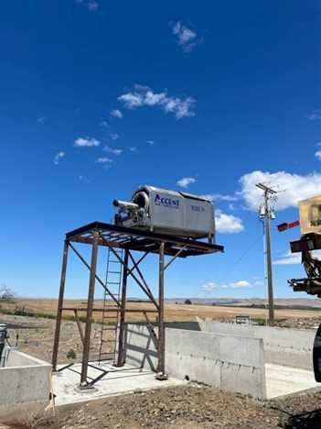
Program Overview

Klingamen manure separator, photo courtesy of Columbia Basin Conservation District
Cost-Share Testimonial or Successful project highlight
“The Columbia Basin is rich in both crops and dairy. This allowed for much larger projects and equipment purchases to further the development on these farms that were not possible in the past with limited cost share funds. Livestock funding has declined, and Columbia Basin Conservation District was only able to fund 1 dairy project per year on average in the past.
Last fiscal year thanks to SFF we were able to help fund 2 separator projects on livestock operations, and 3 reduced tillage drills to help reduce erosion and retain soil carbon. Similarly, the district has a drill for rent to help our smaller producers, made available through the SFF program.”
- Dinah Rouleau, Columbia Basin Conservation District Staff

Background
[What is the program’s background and why do you need to write the report?]
Program Description
[What is the program and what does it do? What is the budget for this program? What page will you have the breakdown of costs?]

Program Accomplishments
What did the program accomplish this year?
Some examples of metrics:
- How many BMPs were implemented?
- How many people were helped?
- How much was spent?

Testimonials/project examples
(It is a great idea to add project testimonials and stories to the report throughout. Below is an example of a way that you can do that within the report without taking away from the overall structure of the report.)

List of Funded Projects in FY2023
Technical Assistance Projects
Recipient Name | Funds Spent
Cascadia Conservation District | $4,331
Clark Conservation District | $37,428
Okanogan Conservation District | $50,000
Pend Oreille Conservation District | $79,350
Pierce Conservation District | $16,497
San Juan Islands Conservation District | $26,260
Spokane Conservation District | $86,399
Stevens County Conservation District | $54,915
Underwood Conservation District | $18,026
Whidbey Island Conservation District | $22,845
Total | $396,051

Equipment Sharing Projects

Recipient Name | Funds Spent | Description | NRCS Practice(s) Supported
Asotin County Conservation District | $187,287 | Purchased equipment for the screening and spreading of manure from beef operations, to aid use of the manure in cropping systems. | Nutrient Management
Columbia Basin Conservation District | $21,109 | Purchased a no-till drill to add to the district’s equipment rental program. | Residue and Tillage Management  -No-Till/Strip-Till/Direct Seed

Cost-Share Projects
Recipient Name | Funds Spent | Description | NRCS Practice(s) Supported
Asotin County Conservation District | $3,647 | Supported cover cropping by producers. | Cover Crop
Asotin County Conservation District | $650 | Supported cover cropping by producers. | Cover Crop
Asotin County Conservation District | $680 | Supported cover cropping by producers. | Cover Crop
Benton Conservation District | $35,000 | Supported the purchase of a no-till drill, allowing expansion of no-till practices by a producer. | No-Till/Strip-Till/Direct Seed

Materials & Supplies Projects
Recipient Name | Funds Spent | Description | NRCS Practice(s) Supported
Central Klickitat Conservation District | $23,320 | Supported cover cropping by a beginning farmer. | Cover Crop
Clark Conservation District | $3,915 | Supported the purchase of cover crop seeds for distribution to producers. | Cover Crop
Eastern Klickitat Conservation District | $28,241 | Supported cover cropping in a dryland grain operation. | Cover Crop
Okanogan Conservation District | $4,694 | This funding purchased enough seed to plant 14 acres of rangeland (using no-till drill funded through SFF). | Range Planting

