

Title (Arial Narrow, 32 pt, R110 G92 B89)
Tips: Only use the title style once and don’t skip heading levels. Manually update the fields highlighted in yellow.

Heading 1 (Arial Narrow, 22 pt., R69 G99 B122)

Heading 2 (Arial, 16 pt., R110 G92 B89)

Heading 3 (Arial, bold,14 pt., R69 G99 B122)

Heading 4 (Arial, bold, 12pt., black)
Tip: Use this heading style instead of bold headers in the body font.
Body (Arial, 11 pt., black)
Quote (Arial, italics, 11pt., black, tabbed)
Link to the website (Arial, bold, 11 pt., R109 G122 B55)

Caption (Arial narrow, italic, 11 pt., R 87 G 94 B 96)

Building blocks
Table of Contents

Heading 1 (Arial Narrow, 22 pt., R69 G99 B122) 1

Heading 2 (Arial, 16 pt., R110 G92 B89) 1

Heading 3 (Arial, bold,14 pt., R69 G99 B122) 1
Heading 4 (Arial, bold, 12pt., black) 1

Table Design

Accessibility Tips:
- Make sure to use the accessibility checker to check that your data does not have split or merged cells.
- Provide alternative text to your table. To do this, right click on the table and choose “table properties” and then the “alternate text” tab and fill in the information.
- Check the reading order by tabbing through your table. It should tab from left to right within each row.
- Also, if the information is in a table primarily for visual reasons, consider not using a table at all.
- Learn more about accessibile tables.

Column 1 | Column 2 | Column 3 | Column 3 | Column 3
Row 1 | Content
Row 2 | Content
Row 3 | Content
Row 4 | Content
Row 5 | Content

Other Accessibility Checks

Title
Make sure to give your document a title. To do this, go to File>Info>and then enter title. Photo showing where this is below.

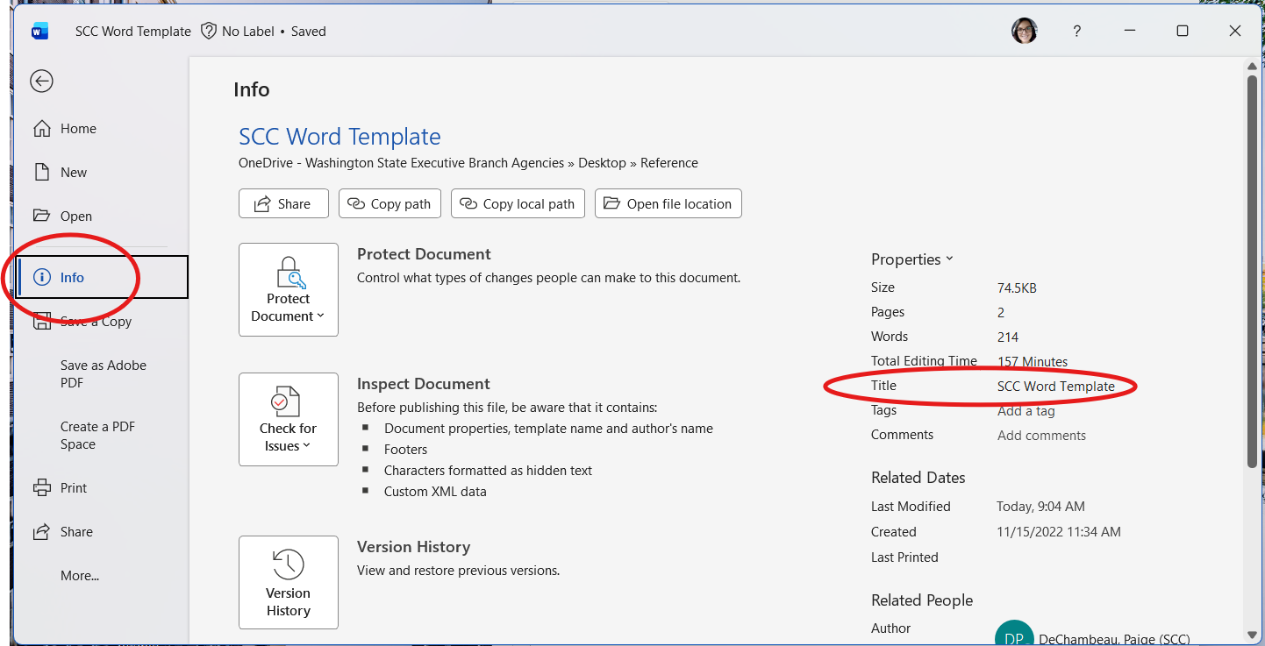

Alternative text
Make sure to add alternative or alt text to any images you add to the document. You can quickly add alt text when using the Accessibility Assistant within Word. Learn more about the Accessibility Assistant.

Saving as a PDF Tip
Currently, the only way to preserve your alternate text when creating a pdf from a Word document is to save it the following way: File > Save as > More options and in the resulting dialog select "PDF" under Save as type.

