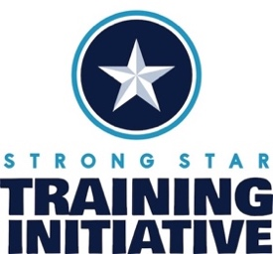

Postvention Immediately After Suicide Death: Emotional Support for Loss Survivors
Target Audience: Veteran connected individuals
Instructional Level: Introductory
Course Description: This course equips participants with practical, evidence-informed postvention strategies to effectively support individuals, families, and communities affected by suicide loss. Participants will build confidence in responding to suicide grief and traumatic loss with empathy, compassion, and a calm presence while developing communication skills that foster trust, connection, and psychological safety through the use of nonjudgmental, supportive language. The course also explores approaches to promoting healing and long-term recovery by encouraging peer support, proactive mental health care, and open conversations about grief, loss, and trauma. By strengthening both personal competency and community response, participants will be better prepared to help stabilize those impacted by suicide and contribute to ongoing suicide prevention and risk reduction.
Learning Objectives:
At the end of this course, participants will be able to:
- Implement practical and deliverable postvention practices to stabilize and support those bereaved by suicide.
- Increase competency in handling suicide grief and traumatic loss with empathy and a calm presence.
- Use of non-judgmental language to provide support and comfort to loss survivors and foster connections that create a safe, supportive environment for those grieving a suicide loss.
- ﻿﻿﻿Encourage Peer support, proactive mental health care, and open communication about grief, loss, and trauma – all aimed at prevention and reducing risk.

Date and Time: September 2, 2026, at 1pm - 2pm ET, 12pm – 1pm CT, 10am – 11am PT
Duration: 1 hours
Where: Zoom
Training Cost: no cost

Meet the Presenter
Carla Stumpf Patton, Ed.D, LMHC, NCC, FT, CCTP

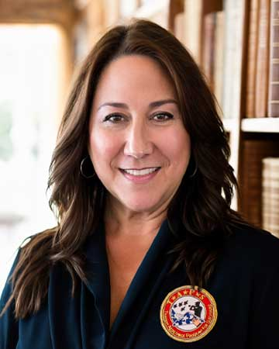
Dr. Carla Stumpf Patton, Ed.D., LMHC, NCC, FT, CCTP, serves as the Senior Director of Suicide Prevention & Postvention at Tragedy Assistance Program for Survivors (TAPS), where she oversees programs and services provided to military community members and families after a suicide loss. She is a suicidologist and subject matter expert in the areas of grief, trauma, and suicide prevention, intervention, and Postvention, is a registered ASIST trainer in suicide first aid, and is trained in Psychological Autopsy Investigations and Crisis Response Planning. Dr. Stumpf Patton holds a B.S. in Psychology, an M.A. in Clinical Mental Health Counseling and School Guidance Counseling, and a Doctorate of Education in Counseling Psychology. Her dissertation research focused on military families bereaved by suicide, and was a key contributor in the development of the TAPS Suicide Prevention Model™. Dr. Stumpf Patton is a Licensed Mental Health Counselor, a Certified Fellow Thanatologist, a National Certified Counselor, a Certified Clinical Trauma Professional, a Florida Qualified Supervisor, and a counseling educator in higher academia. She is the surviving spouse of Sergeant Richard Stumpf, an Active Duty U.S. Marine Corps Drill Instructor and Gulf War Era Combat Veteran who died by suicide in 1994, several days before their only child was born. She is remarried to a retired U.S. Marine, who was also a suicide survivor widower, with whom she shares five children.

Conflict of Interest: Dr. Stumpf Patton has no conflicts of interest.

Special Accommodations
If you require special accommodations due to a disability, please contact the STRONG STAR Training Initiative at admin@strongstartraining.org one week prior to the workshop so that we may provide you with appropriate service.

Continuing Education
The STRONG STAR Training Initiative offers attendees one (1) Continuing Education (CE) Credit for participating in the 1-hour training. Participants who attend are eligible to receive 1 CE Credit.
Our continuing education credits have historically been recognized by most professional state licensing boards. However, this is not guaranteed. Please check with your licensing board for verification.
The University of Texas at San Antonio Health Science Center is approved by the American Psychological Association (APA) to sponsor continuing education for psychologists. The University of Texas Health Science Center at San Antonio maintains responsibility for this program and its content.

