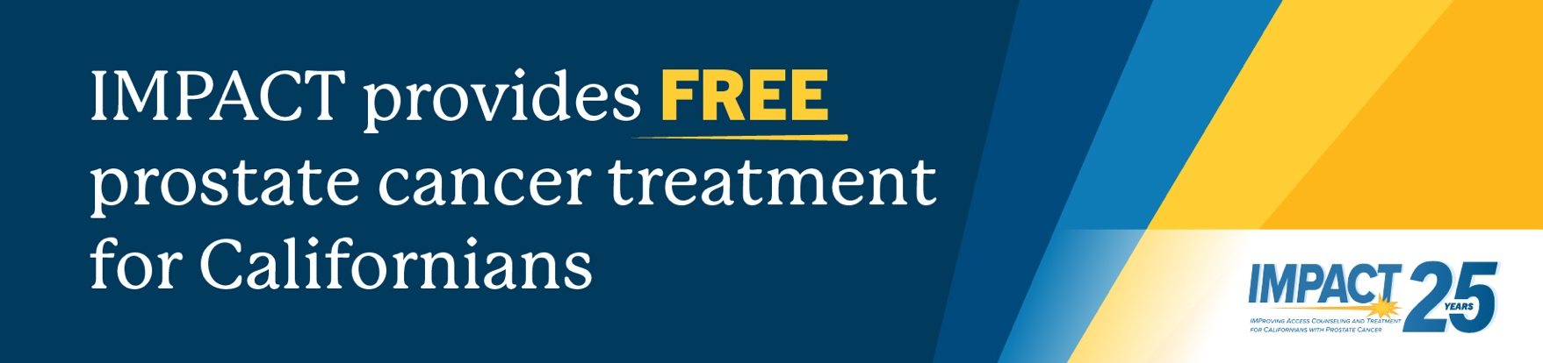

About IMPACT

IMProving Access, Counseling and Treatment for Californians with Prostate Cancer (IMPACT), a partnership between UCLA Urology and California Health and Human Services, is the largest program in the country to support low-income, under and uninsured people with prostate cancer and the only program to offer FREE treatment to eligible California residents.

California residents who have been diagnosed with prostate cancer, are 18 years of age or older and have little to no health insurance with an income at or below 200% of the Federal Poverty Level ($64,300 per year for a family of four) may be eligible to receive free prostate cancer treatment through IMPACT.

Available prostate cancer treatments through IMPACT may include active surveillance, hormone therapy, brachytherapy, chemotherapy, radiation therapy, surgical treatments and nurse case management for all patients. IMPACT makes these treatments possible by partnering with doctors, hospitals, community providers, local health departments and community-based health organizations across the state.

The IMPACT team also provides personalized assistance to help current IMPACT patients who have secured Medi-Cal and need support transitioning to their new coverage. The team also helps connect patients with doctors to ensure they have access to the necessary resources and care for their prostate cancer treatment journey. By offering personalized guidance and support, the IMPACT team empowers patients to make informed decisions about their health and well-being.

For more information about partnering with the program or to enroll, please call 1-800-409-8252 or visit caimpact.org.

