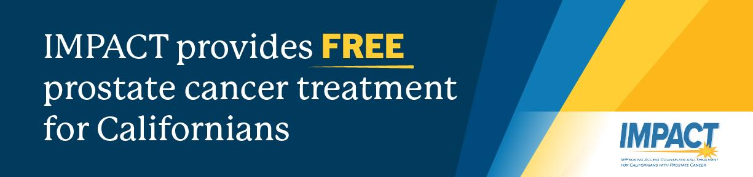

Prostate Cancer Awareness Month
Social Media Promotion Kit

PURPOSE:
To help partners spread the word about free prostate cancer treatment available through the IMPACT program during Prostate Cancer Awareness Month in September.

HOW TO USE THIS KIT:

- Share the message - Copy and paste the sample post text to your organization’s social media pages.
- Add the visuals - Pair each post with your choice of the provided graphics (available in English and Spanish).
- Include the call-to-action - Always add 1-800-409-8252 and caimpact.org on every post so people know where to get help.
- Post widely – Share on Facebook, Instagram, X (Twitter), LinkedIn, and any other channels your organization uses.

Together, we can connect more men to life-saving treatment.

SAMPLE SOCIAL MEDIA POSTS:

- Nearly 30,000 men in California will be diagnosed with prostate cancer this year. If you have prostate cancer and are uninsured, IMPACT can help by providing free, high-quality treatment. Call 1-800-409-8252 or visit caimpact.org today to see if you qualify.

- Prostate Cancer Awareness Month is here - and so is help for those who need it most. The IMPACT program offers FREE prostate cancer treatment for eligible California men. Don’t wait. Treatment saves lives. Call 1-800-409-8252 or visit caimpact.org.

- Did you know? Advanced prostate cancer cases in California are increasing 50% faster than the national average. If you’ve been diagnosed, don’t delay - call IMPACT for free treatment options today. 1-800-409-8252 | caimpact.org

- Prostate cancer is the 2nd most diagnosed cancer in California. The IMPACT program provides free treatment for eligible men, so cost is never a barrier to care. Help us spread the word - it could save a life. Call 1-800-409-8252 or visit caimpact.org.

- If you or someone you love has been diagnosed with prostate cancer and has little or no health insurance, help is available. IMPACT provides free, high-quality treatment to eligible California residents. 1-800-409-8252 | caimpact.org

SUGGESTED HASHTAGS:
#IMPACTCA
#ProstateCancerAwareness
#FREECancerTreatment
#CaliforniaHealth
#MensHealth
#CancerSupport

