Dear
What does a PJ Day mean to kids at school? Probably fun, laughter, and a little extra coziness, right? But for kids with cancer, PJs aren’t just for special days—they’re for every day. My child spent months in their pyjamas during treatment, and I’ll never forget how much that time impacted our family.
That’s why your school’s PJ Day means so much. It’s not just about staying comfy—it’s about support and hope. Support in the form of Childcan’s financial, emotional, and social programs — and hope that the research Childcan funds will lead to better treatments and, one day, a cure.
Every year on February 15—International Childhood Cancer Awareness Day—Childcan asks schools, businesses, and organizations to wear their pyjamas in solidarity with brave kids like mine.
This year, February 15 falls on a Sunday, so let’s wear PJs on Friday, February 13, 2026, and share the love with kids like mine. If that date doesn’t work, you can pick any day in February and let Childcan know by completing the form found here: https://childcan.com/pj-day.
They’ll send you:
💛 Stickers and buttons for participants
💛 A poster to spread the word
💛 A coin box and/or online donation form to make fundraising super simple
When you take part, you’re doing more than having fun—you’re changing lives for families like mine. Childcan doesn’t receive government funding, so every single dollar raised helps provide care, support, and hope to kids with cancer and their families.
I know firsthand the difference your support will make, and I can’t thank you enough for considering this. Let’s make this year’s PJ Day unforgettable—for your kids and for kids like mine.
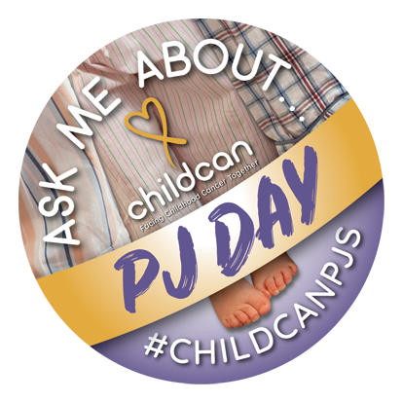
With gratitude,
[Your Name]

