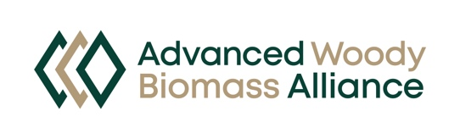
AWBA Newsletter Archive

April 17, 2026
March 20, 2026

