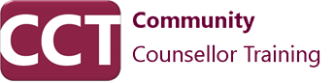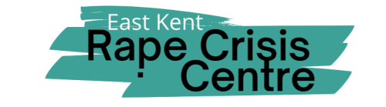
L6 Diploma in Rape & Sexual Assault Counselling
Specialised Therapeutic Training

The L6 Diploma in Rape & Sexual Abuse Counselling is a specialised training programme for counsellors wishing to deepen their expertise enabling them to work with individuals affected by rape, sexual violence, and sexual abuse.
This diploma is offered in collaboration with the East Kent Rape Crisis Centre (EKRCC) and is facilitated by tutor Louise Mackinney.

Course Content
The curriculum includes both theoretical and practical components, focusing on various aspects of trauma and abuse. Key areas covered in the course are:
- Theory and Practice of Working with Rape and Sexual Abuse: Understanding the psychological impact and therapeutic approaches.
- Dissociation: Techniques for recognising and managing dissociative symptoms.
- Shame: Addressing and alleviating feelings of shame in clients.
- Advanced Skills for Working with Sexual Abuse: Enhancing counselling skills specific to sexual abuse survivors.
- Attachment: Exploring attachment theory and its implications in trauma recovery.
- Working with Children: Specialised strategies for counselling child survivors of sexual abuse.
- Trauma-Oriented Theories: Introduction to various trauma-focused therapeutic approaches including:
  - Eye Movement Desensitisation and Reprocessing (EMDR)
  - Sensorimotor Psychotherapy
  - Traumatic Incident Reduction (TIR)
  - Trauma-Focused Cognitive Behavioural Therapy (CBT)
  - Somatic Experiencing

Practical Requirements
Participants are required to complete 50 hours of rape or sexual abuse counselling to gain hands-on experience.

Entry Requirements
To be eligible for this diploma, applicants must have:
- Completed an EKRCC Part 1 training. Details and application for this can be found on the EKRCC website at www.ekrcc.org.uk.
- Submitted an Accreditation of Prior Learning (APL) as part of the application process. Further details on the APL submission will be provided upon application.

