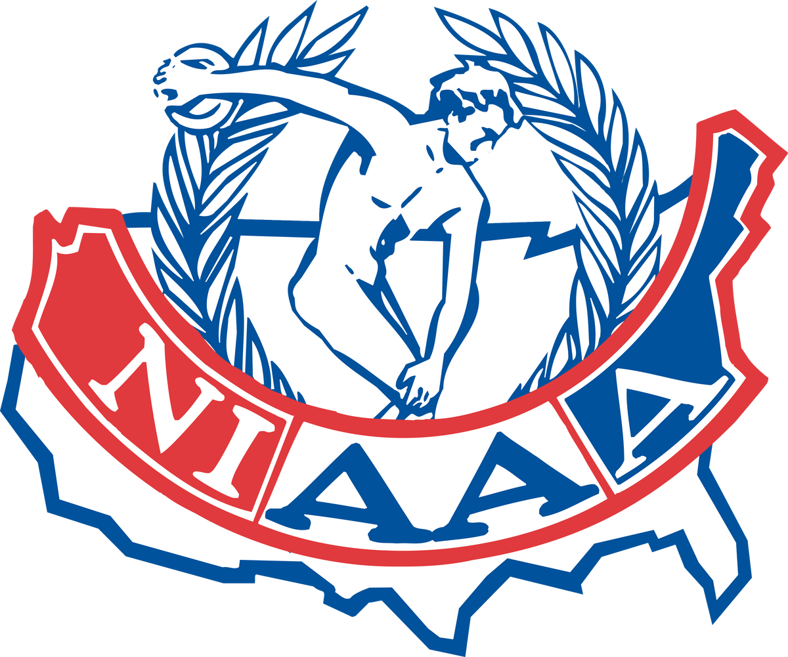

Athletic Administrator Evaluation

PERSONAL INFORMATION:

ATHLETIC ADMINISTRATOR & CERTIFICATION:
DATE OF HIRE:
DATE OF REVIEW:

NAME & CERTIFICATION
DAY
MONTH
YEAR
DAY
MONTH
YEAR

SCHOOL:

NAME
STREET CITY
STATE
ZIP CODE

This evaluation contains six sections. Please review each sections' standards and evaluate by this key: 1- Unacceptable; 2 - Needs Improvement; 3 - Satisfactory; 4 - Excellent.
Space is provided for additional comments and documentation evidence at the end of each section.

SELF EVALUATION |  |  |  | SECTION 1: LEADERSHIP | SUPERVISOR EVALUATION
1       | 2 | 3   | 4 | Emphasizes the physical, mental, emotional, and social benefits of education-based athletics for the student- athlete. | 1 | 2 | 3 | 4
 |  |  |  | Communicates and works collaboratively with coaches, parents, educational leaders, school staff, media, community, booster clubs, and civic groups to develop positive public relationships.
 |  |  |  | Establishes an education-based philosophy for all programs with high academic standards.
 |  |  |  | Seeks to establish high standards of sportsmanship and citizenship for the coaching staff, student athletes, parents, and fans.
 |  |  |  | Displays ethical decision making, character development, personal conduct, and integrity while coaching coaches and mentoring staff.
 |  |  |  | Promotes teamwork among all coaches, making it easier for athletes to play multiple sports.
 |  |  |  | Develops as an athletic administrator by participating in professional growth and development through national and state educational opportunities.
Comments:
info@niaaa.org | 317-587-1450

SELF EVALUATION  1 2 3 4     |  | SECTION 2: SUPERVISION |  | SUPERVISOR EVALUATION
 |  | Sets an expectation for coaches’ direct supervision of facilities and activities related to the sport or activity. | 1 2 3 4
 |  | Directs and coordinates supervision of all home and away events to ensure safety of participants, officials, and fans.
 |  | Provides verification of eligibility of student athletes under the guidance of state and local rules.
 |  | Ensures compliance of Title IX, ADA and for students with special needs to local, state and federal policy.
 |  | Ensures that all appropriate equipment meets the safety standards of the National Operating Committee on Standards for Athletic Equipment (NOCSAE).
 |  | Ensures that all equipment is cleaned, inventoried, and stored properly.
 |  | Oversees the direct supervision of coaches and athletic support staff.
Comments:
SELF EVALUATION |  | SECTION 3: PLANNING & MANAGEMENT |  | SUPERVISOR EVALUATION
1 2 3 4 |  | Plans for scheduling, assessment, maintenance, and improvement of all athletic facilities. | 1 2 3 4
 |  | Organizes and coordinates the utilization of facilities for educational, athletic, and community purposes.
 |  | Plans and directs the creation and annual review of an athletic handbook.
 |  | Plans, directs, and serves as the financial officer for the athletic department budget in all categories of spending and income.
 |  | Plans and schedules the transportation needs for all programs while working with proper district employees.
 |  | Effectively communicates and distributes current job descriptions and sets clear expectations for athletic personnel, including contest officials, workers, and security.
Comments:
info@niaaa.org | 317-587-1450

SELF EVALUATION  1 2 3 4 |  |  | SECTION 4: STRATEGIC PLANNING |  | SUPERVISOR EVALUATION
 |  |  | Conducts pre-season meetings with students, parents, and coaches. | 1 2 3 4
 |  |  | Meets all state association, league, and/or conference deadlines for document submittal.
 |  |  | Attends all appropriate state association, league, and conference meetings.
 |  |  | Facilitates appropriate recognition of all student athletes.
Comments:
 | SELF EVALUATION |  | SECTION 5: HEALTH, WELLNESS & SAFETY |  | SUPERVISOR EVALUATION
1 2 3 4 |  |  | Ensures all student-athletes adhere to required pre- participation health screening. | 1 2 3 4
 |  |  | Ensures all athletic personnel attend required health, wellness, and safety trainings provided by the school/district and state.
 |  |  | Communicates with and instructs students and parents on the inherent risks related to specific sports.
 |  |  | Works with the athletic trainer(s) to promote and communicate a proper system of student athlete well- being and return to play procedures.
 |  |  | Promotes a culture of chemical-free programs through education and prevention.
 |  |  | Promotes good social emotional health awareness for all constituents involved in the athletic department.
 |  |  | Oversees assessment of and adherence to safety protocols and recommendations of medical professionals.
 |  |  | Develops and implements emergency action plans for all contest and practice venues.
 |  |  | Monitors and communicates potential weather hazards that could arise during practices and/or contests.
Comments:
info@niaaa.org | 317-587-1450

SELF EVALUATION  1 2 3 4   | SECTION 6: PERSONNEL |  | SUPERVISOR EVALUATION
 | Adheres to school/district guidelines in hiring all athletic staff personnel. | 1 2 3 4
 | Secures and oversees all needed personnel for the operations of the athletic programs, including but not limited to: coaches, game officials, announcers, timekeepers, ticket sellers, ticket takers, security, event supervisors, custodians, concessions, support personnel, and medical coverage.
 | Cultivates an atmosphere of professional growth for all staff members.
 | Evaluates all coaches and provides feedback pre- season, in-season, and post-season.
 | Works collaboratively with other administrators to advance the school mission.
 | Uses current job descriptions while directing personnel.
Comments:
info@niaaa.org | 317-587-1450

Signature
Date
Title
Employee Name
Employee Notes:
Please attach any additional documentation, evidence or exhibits
to the form. Comments:
Supervisor/Evaluator Notes:
Comments:
Supervisor Name
Title
Date
Signature

info@niaaa.org | 317-587-1450

Employee Final Summary/Remarks (Optional)
Comments:

Name Title Date

Signature

info@niaaa.org | 317-587-1450

