LCGS Summary Data
Data Version: 2025.07.18

Demographics
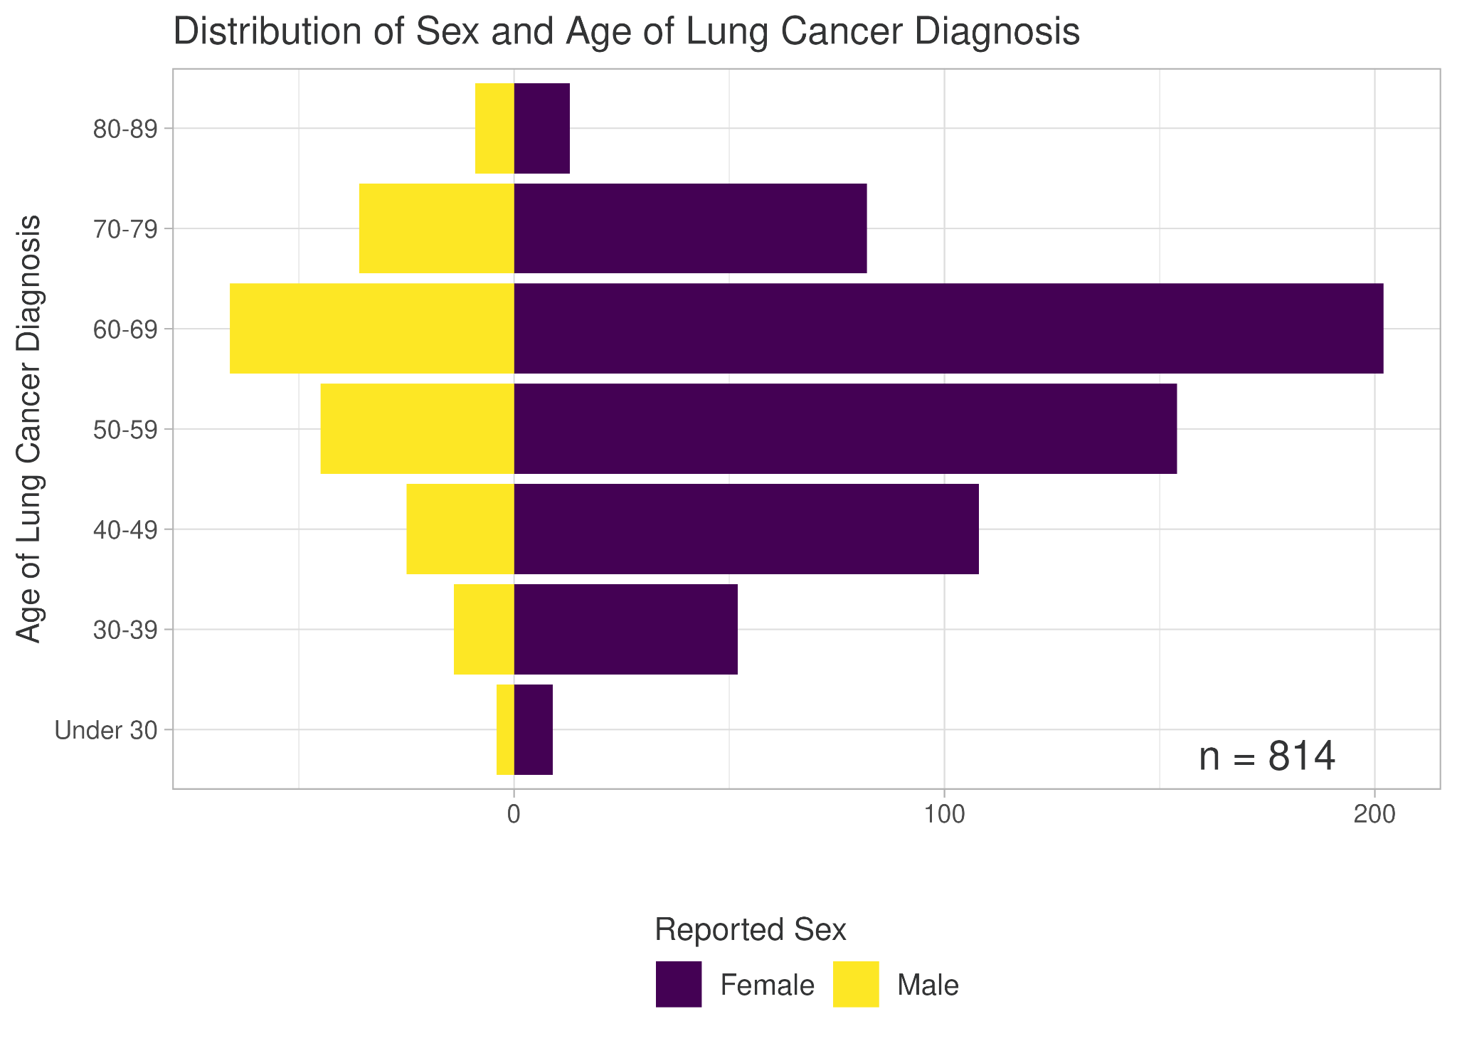

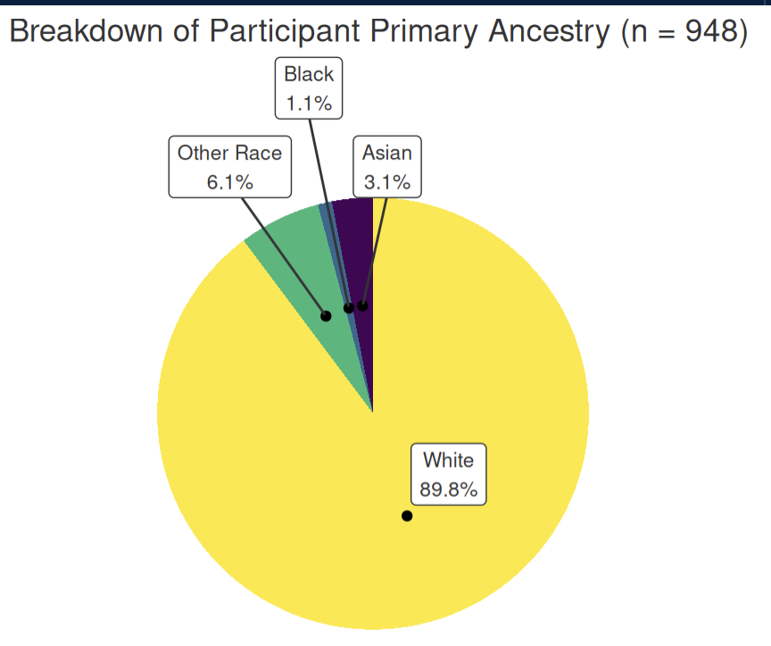

Diagnosis Information
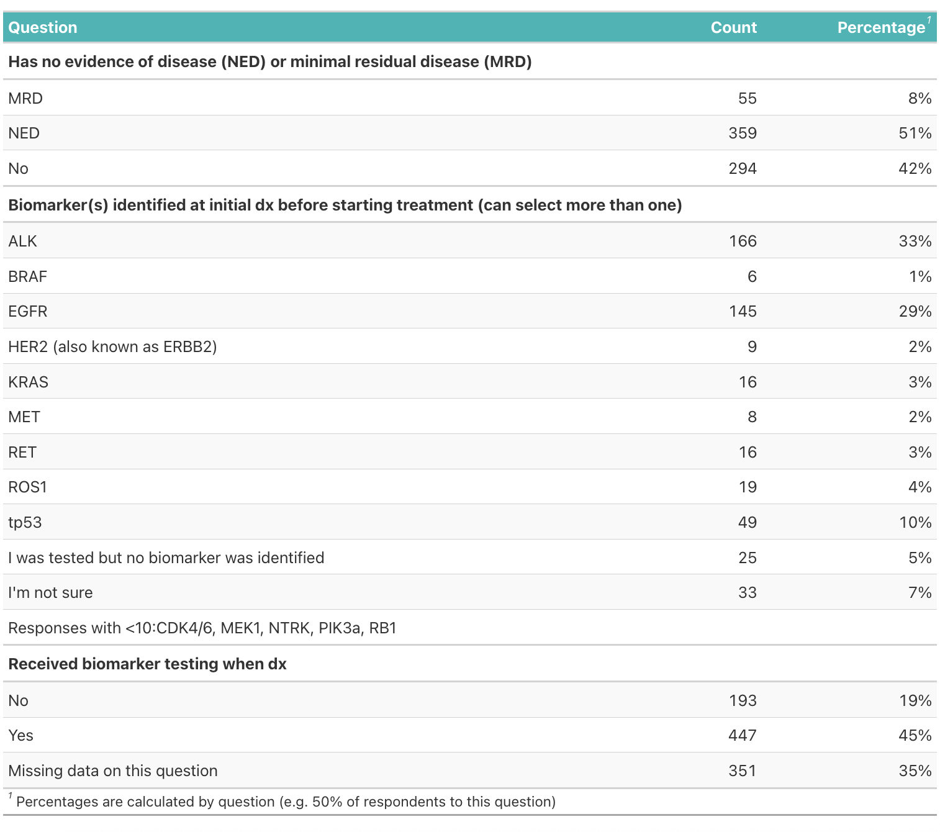

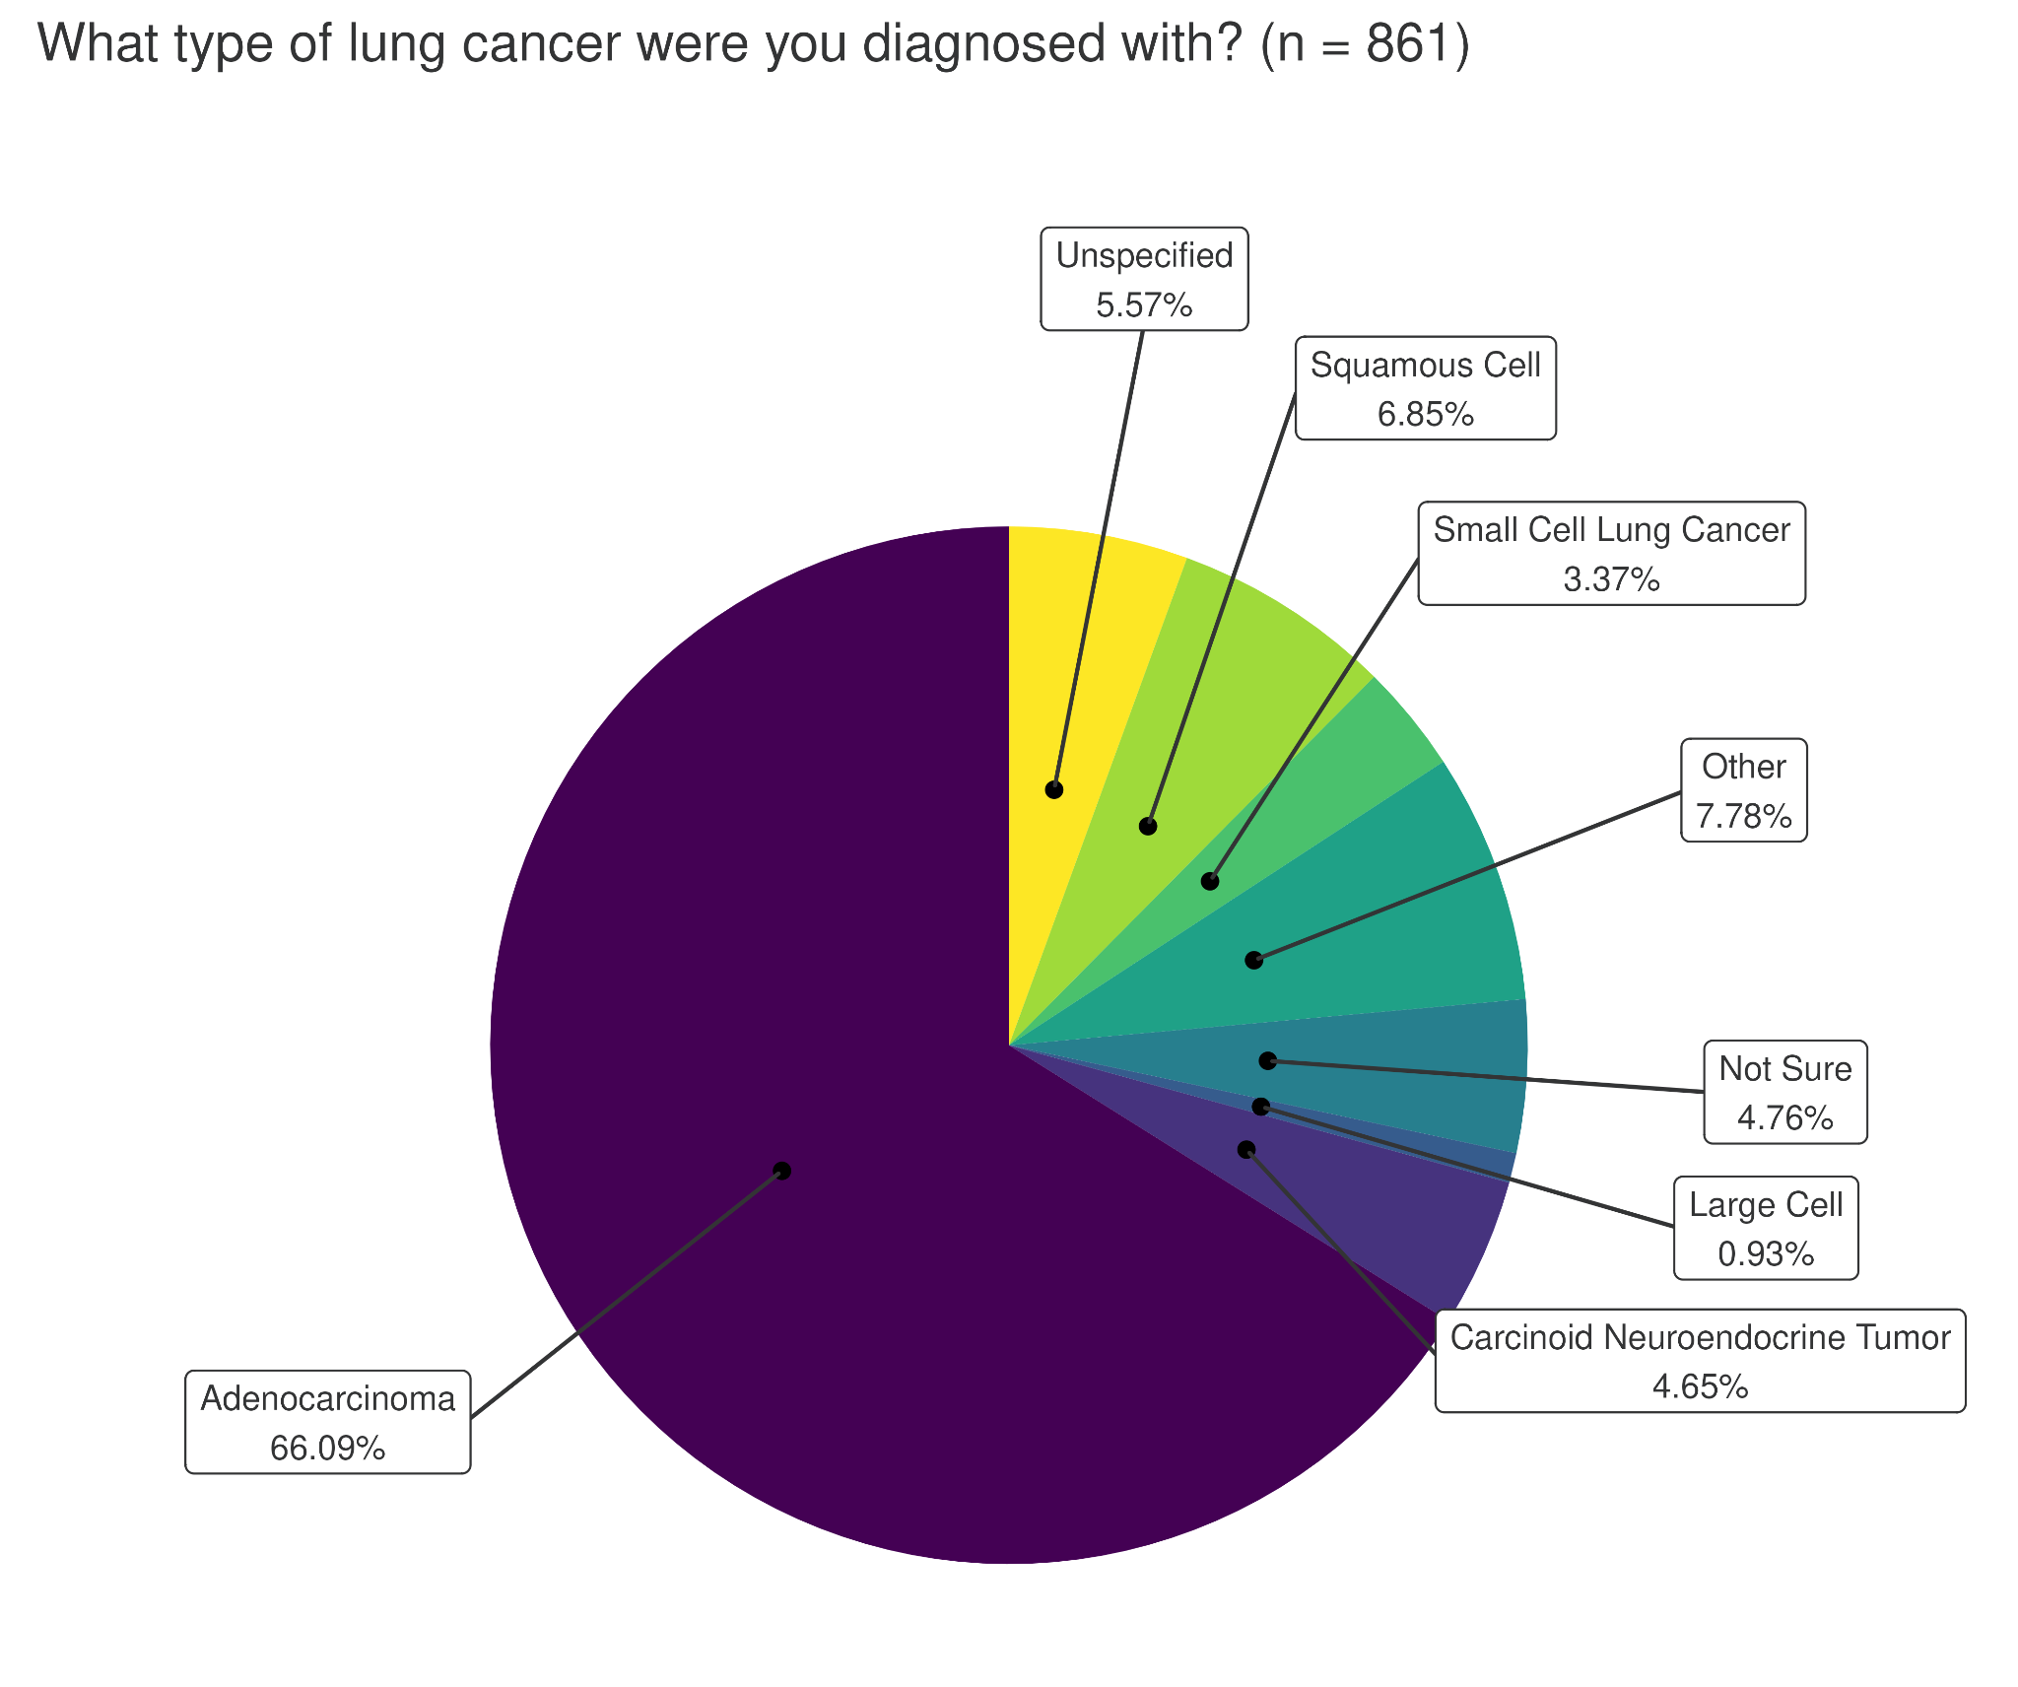
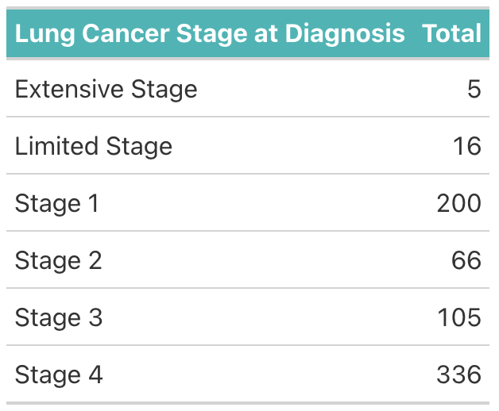

Family History of Cancer
Number of participants with a family history of cancer, by relative and disease type.

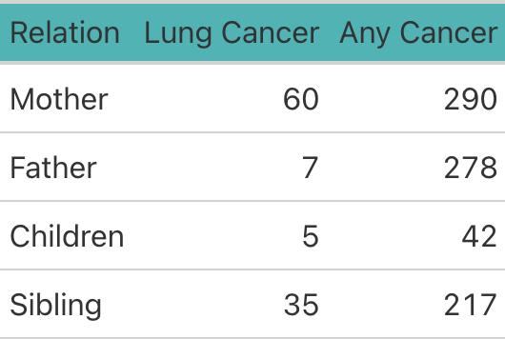

Comorbidities
Oncology comorbidities
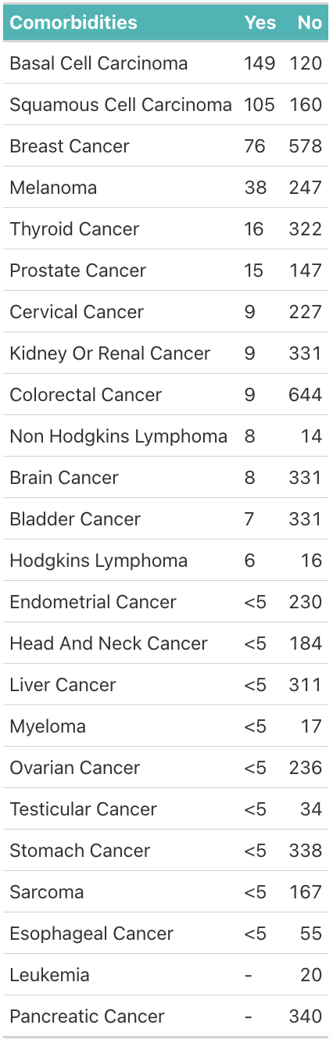

Non-oncology comorbidities

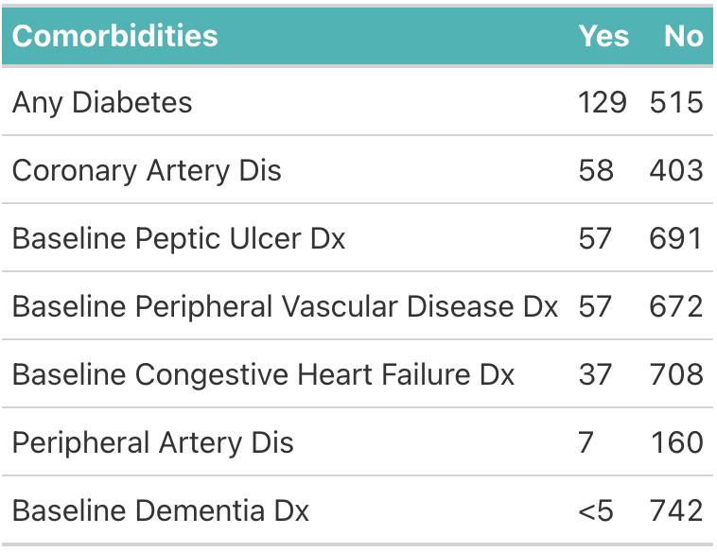

Exposures
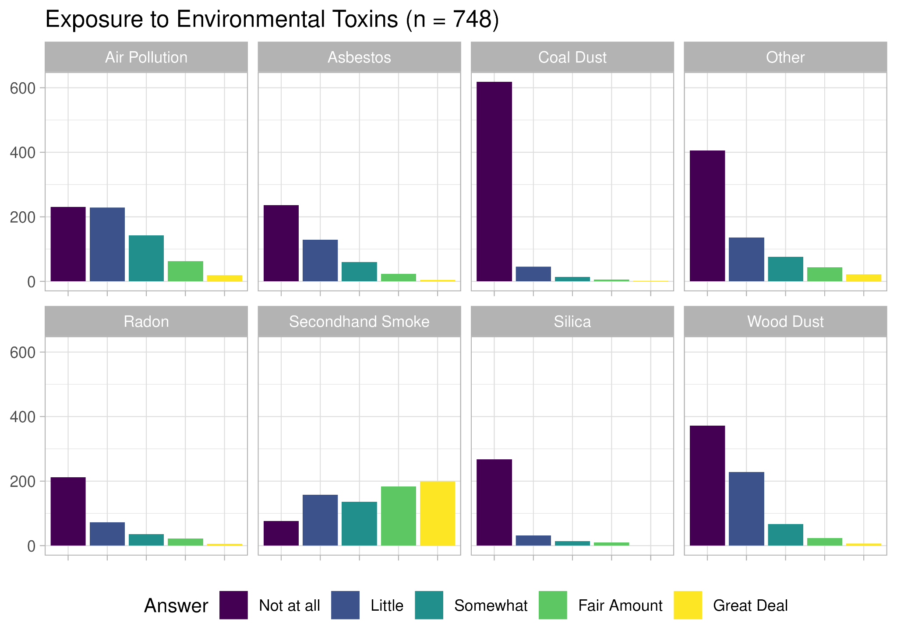

History of Active Exposure to Tobacco Smoke
A) Fraction of participants who have smoked at least one cigarette in their life. B) Among the participants who answered "Yes" to (A), the fraction who have smoked at least 100 cigarettes in their life. C) Among participants who answered "No" to (B), the breakdown of total cigarettes smoked by participant. D) Among participants who answered "Yes" to (B), the frequency of cigarette smoking by participant.
