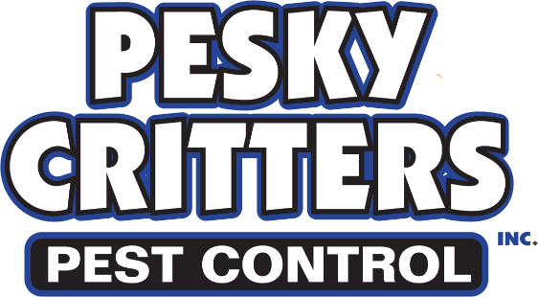
We at Pesky Critters strive to perform the best possible pest treatment on your home. Following this prep sheet will help to speed up control of the targeted pest. Failure to follow the guidelines below will at minimum hinder our ability to treat effectively and, in some cases, prevent control from ever being realized.
Flea Treatment Preparation Sheet

Fleas can be a challenging insect to control. Your cooperation with us will allow our treatment to have the highest success rate for full control. Following the steps outlines below is essential.

Preparing for a Flea Treatment
- Wash pet bedding in hot water or dispose of it in the trash
- Clear the floor of any clothes, boxes, toys, & anything else that prevents us from treating the carpeting or hardwood.
- Remove pets from the home during treatment.
- Pick up pet food and water bowls
- Make sure your pets are on a veterinarian-approved method of flea control BEFORE we treat
- You will need to leave the home for 3 hours during the treatment to allow the chemical to dry

After Treatment

- Vacuum all floors in home daily
- Do not clean carpets or floors with cleaners for at least 2 weeks
- If follow-up treatment is needed complete the initial steps again before the 2nd treatment
- Complete any prep work the tech suggests before the next treatment if necessary.

