FIRST AID KIT - FACT SHEET/GUIDE
We understand that even in the most efficiently supervised environment, children will sustain scrapes, scratches, cuts, or bruises as they explore their environment. It is essential to ensure compliance with Education and Care Services National Regulations 89 and 168, which outline Service’s responsibility in maintaining a fully stocked first aid kit. First Aid Kits are to be accessible at all times during operating hours.
The information below is sourced from ACECQA, Safe Work Australia, and St Johns Ambulance.
TYPE OF FIRST AID KIT
- There are many commercial first aid kits on the market, but a first aid kit can be made from any box or container that keeps contents dust-free, moisture-free, and free of potential contamination.
- First aid kits must be labelled with a sign displaying a white cross on a green background, in compliance with AS 1319: 1994.
- Each first aid kit should also include a list of the contents. A notepad and pencil in each kit can be used as a simple shopping list to keep track of items that are used and need replacing or use an inventory checklist.
LOCATION AND NUMBER OF FIRST AID KITS
While the number of first aid kits is not specified, it will depend on the number of children in attendance, and the layout of the service. A larger service may choose to have a kit in each room, or one kit shared between each two adjoining rooms. Likewise, a smaller service with rooms near may share one kit between two rooms. In multi-story services, it is recommended there should be at least one kit on each floor.
Since first aid kits must be easily and quickly accessible, a kit in a bathroom that offers access to both the classroom and the outdoor environment is recommended. An easy way of deciding where to place the first aid kit/s is to review your Incident, Injury, Trauma and Illness records, as this will determine where most accidents happen, and therefore where a kit should be available.
Safe Work Australia also recommends that the kit is portable, so could be located on a high shelf, rather than wall mounted.

EXPIRY DATES
Many items in a first aid kit have expiration dates, including creams, sprays, antiseptic wipes, irrigation or eyewash solutions, and anything that comes in a single or multi-dose packet, tube, or bottle which management should be familiar with when conducting a first aid kit audit.
There are several items that do not have an expiry date, which includes bandages, dressings, bleeding control pads, gauze pads, rolls of sterile gauze, adhesive strip bandages (band aid), butterfly wound closures, triangular bandages, and adhesive tape.
You may find that non-sterile bandage products have an expiry date, whilst sterile supplies do not. For items without expiry dates, close inspection is required. Look for the following signs to ascertain if items need replacing:
- packaging with faded print, yellowing, water stains, or damage
- clear packaging with stains, yellowing, or condensation on the inside
- broken seals on sterile supplies
- broken seals or damage on packaging
- discolouration or unclean packaging
- adhesive tape that leaves a residue on your fingers when you touch it, or is slimy or sticky

FIRST AID KIT CONTENTS
Whilst the National Regulations require all Services to provide a first aid kit, the contents and other information are not dictated. The first aid kit should be stocked with an appropriate number of items dependant on the number of children within the area each first aid kit is servicing. First aid kits should be equipped to provide basic first aid.

Safe Work Australia's First aid in the workplace Code of Practice provides information to ensure first aid kits include equipment to cover basic first aid applications for the following injuries:
- cuts, scratches, punctures, grazes and splinters
- muscular sprains and strains
- minor burns
- amputations and/or major bleeding wounds
- broken bones
- eye injuries, and
- shock.
The Childcare Centre Desktop First Aid Kit Inventory and Checklist LDC provide examples of the contents of a first aid kit adapted from Safe Work Australia recommendations and customised for early childcare services.
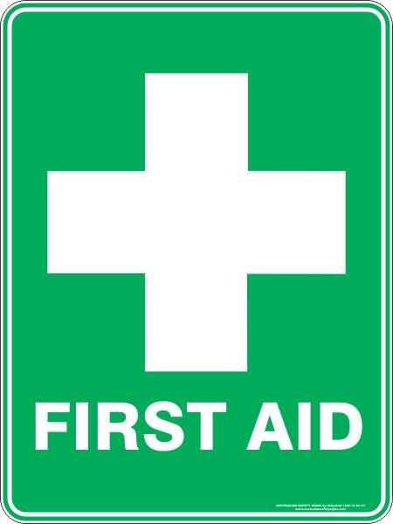
SAFETY DOESN’T HAPPEN BY ACCIDENT

The template above is a guide only and services must edit to reflect practices that are accurate and relevant to their context, statement of philosophy and physical environment.

REVIEW OF GUIDE
Date guide created |  | To be reviewed
Approved by | [name] | Signature
Guide Reviewed Date | Modifications/Changes
APRIL 2022 | Review box added, minor changes regarding formatting

