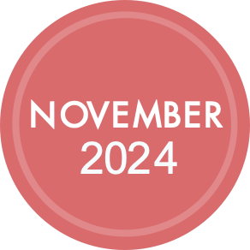

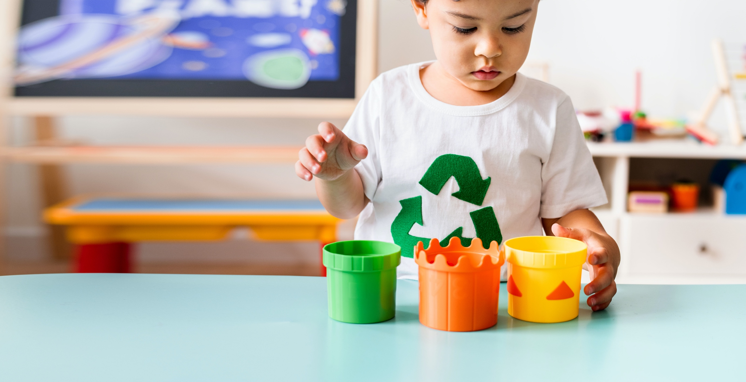

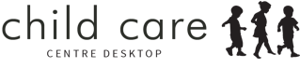
National Recycling Week, established by Planet Ark in 1996, is held every year during the second week of November. This year, National Recycling Week wants you to ‘join the cycle’
Join your community and get involved in resources, tools, and events that will help your sustainable
impact. It's all about quality over quantity, it is not about recycling more but recycling better.
There are many events happening during ‘National Recycling Week’. Find one near you and improve what you do at home to look after our planet.

ADD YOUR PERSONALISED INFORMATION HERE
About the event and if a service-based activity was scheduled, an invitation to parents and family members. Alternatively, it could be a simple message or announcement of the event and its significance.
About the event and if a service-based activity was scheduled, an invitation to parents and family members. Alternatively, it could be a simple message or announcement of the event and its significance.
year? Go to your local council website to find events happening near you.

NATIONAL QUALITY STANDARD | Quality area 3:
PHYSICAL ENVIRONMENT
3.2.3: The service cares for the environment and supports children to become environmentally responsible.
(Ref: National Quality Standard)
year? Go to your local council website to find events happening near you.

EARLY YEARS FRAMEWORK | OUTCOME 2:
CHILDREN ARE CONNECTED WITH AND CONTRIBUTE TO THEIR WORLD
Children become socially responsible and show respect for the environment. This is evident, for example when children: develop an awareness of the impact of human activity on environments and the interdependence of living things.
(Ref: BELONGING, BEING & BECOMING The Early Years Learning Framework for Australia V2.0, 2022)

year? Go to your local council website to find events happening near you.

NOVEMBER 11 - 17
NATIONAL RECYCLING WEEK
SUBMIT THE NAME OF YOUR SERVICE HERE
P: 02 12345678
E: name@here.com

year? Go to your local council website to find events happening near you.

