Alderbrook School
Smartphone Free Policy

To establish clarity around expectations for a Smartphone Free School and to ensure a safe, focused, and conducive learning environment for all students.

- Purpose

  - To establish clarity around expectations for a Smartphone Free Alderbrook and to ensure a safe, focused and conducive learning environment for all students.

- Scope

2.1 This policy applies to all students (Years 7-13) attending Alderbrook School and Sixth Form…

- Aim of the policy

3.1. Maintain the highest standards of education through a distraction and disruption free school environment.
3.2. Ensure the maximum level of safeguarding of students on the Alderbrook site.
3.3. Ensure maximum levels of safeguarding, health and wellbeing of young people in our community.

- Policy Statements for all schools

4.1. We are a Smartphone Free School.
4.2. We make a clear distinction between a simple phone (without the potential for internet access) and a smartphone or any smart device (with internet or potential internet access).
4.3. Students are prohibited from bringing any smartphone or smart devices into school.
4.4. The policy mitigates the safeguarding, health and safety risks related to early access to smart devices and supports the school site being a safe environment for all students.
4.5. The policy supports families to make their own decision about when it is appropriate for their child to have access to smart technology.
4.6. The policy is enforced with significant consequences for students who bring smartphones into school.
4.7. Smartphones and other pocket smart devices that access the internet are prohibited from September 2026. This policy has been introduced to minimise disruption to the school environment and to help tackle cyber bullying, sexting, sharing of indecent images, online grooming and device addiction. The impact of smartphones on children's mental health and development is well documented. Excessive exposure to social media platforms can increase anxiety, depression and even lead to suicidal ideation.
4.8. Please note that throughout this policy, ‘smartphone’ refers to any electronic device with potential access to the internet. This includes kindles, tablets and smart watches.

5.Rationale
5.1. Over the past two years a significant number of studies have been completed providing undisputable evidence of the harm of smartphones on the learning, behaviour, wellbeing and safety of children when provided with access at an early age.

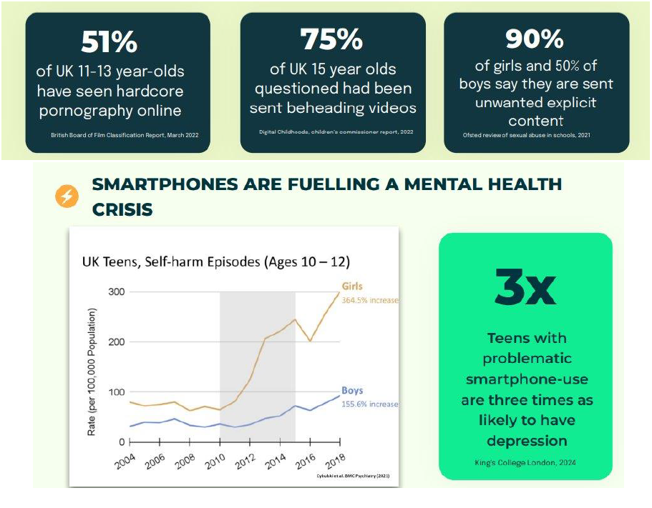

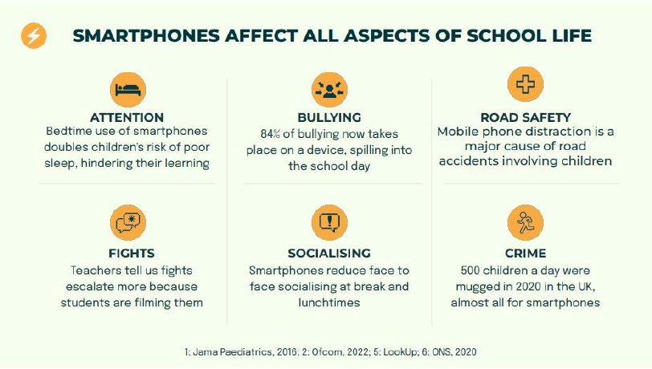

5.2.
The school is responsible for safeguarding students during the school day; this job has become increasingly difficult due to students coming into school with smart devices that potentially have harmful or inappropriate content on them and functions that enable inappropriate behaviour or cyberbullying e.g. access to social media, photo and video capability. Social media is a huge distraction and students increasingly display behaviours indicative of addiction.

- Phones Years 7 -11 Students

6.1. Parents and carers who wish their child to carry a mobile phone to school must adhere to the following policy.
6.2. The phone must be one of the following types: Nokia 105 (approx. £18), Samsung E1200 (approx. £69) or Alcatel 10.16G (approx. £19.99) or other phones that must have:
• No potential to access the internet
• No photo or recording capability
• No access to any apps.

6.3. Any non-approved phone will be classified as a ‘prohibited phone’ and confiscated (see section 10).

6.4. Approved phones:
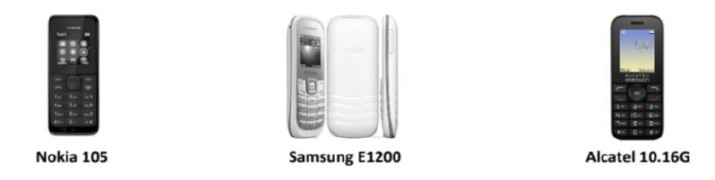

6.5. The phone must be clearly marked with the student’s name.
6.6. The phone must be switched off before the student enters the school site and placed in their school bag.
6.7. The phone must not be brought out of their bag at any point during the school day and should only be used after school when the student is out of sight of the school entrances.
6.8. The phone remains the responsibility of the student at all times and the school will not take action if it is lost or stolen.
6.9. In addition to smartphones, all smart watches and any other pocket-sized devices that can enable a student to access the internet are prohibited. If such devices are discovered or seen, then the same consequence will be given as for a prohibited phone on the school site.
6.10.
Any phone that is seen outside of a school bag or heard during the school day (school approved or otherwise) will automatically be confiscated (see section 10 for information on confiscation periods).
6.11.
Simple GPS trackers such as airtags or the equivalent are permitted if parents and carers want to track their child’s location.

- Phones Sixth Form Students

7.1. Sixth Form students are permitted to have smart technology onsite and on school transport. Students are permitted to use their phones in non-contact time in the Sixth Form building. Phones will not be used in lessons unless directed by their teacher. Sixth Form students will not be permitted to use their phones outside of the Sixth Form Centre, when moving around the site; this includes headphones. If phones are visible outside of the Sixth Form Centre or Sixth Form lessons, then the phone will be confiscated and returned at the end of the day. Repeat behaviour will result in at least a week-long confiscation.

- Reasonable adjustments

8.1. Reasonable adjustments and flexibility will be made for certain disabilities or medical conditions. In each instance this needs to be prearranged with the school and the school will work with parents and carers to determine the specific needs of each student on an individual basis. Only the Principal may exempt a student from this policy.

- Searching for devices

9.1. There may be occasions when a member of staff is required to search a student’s personal belongings to look for a mobile phone or other banned item, if this is deemed necessary in order to maintain high standards of behaviour and a safe environment. Any such search will be conducted in accordance with the DfE guidance on searching and screening.
9.2. If during a search an ‘approved phone’ is found it will not be confiscated provided it does not contain any evidence relating to an investigation AND when it is found it is switched off.
9.3. All prohibited phones and approved phones that are not switched off AND in a school bag will automatically be confiscated as part of a search. This confiscation will follow the consequence process below.
9.4. Students that have previously brought banned items into school may be subject to periodical bag searches

- Consequences

10.1. Any phone that is seen outside of a school bag or heard during the school day (school approved or otherwise) will automatically be confiscated. This includes phones that have been heard from within a student's uniform or bag.
10.2. Any prohibited phone which is seen before or after school, within sight of the school entrances will automatically be confiscated.
10.3. When a phone is confiscated, it will be handed in at reception and locked away.
10.4. When an approved, simple phone is confiscated, it will be securely locked away until collection by the student at the end of the day.
10.5. Prohibited phones will be securely locked away and returned after 4 weeks (of term time).
• If the 4 weeks ends during a school holiday, students receive their phone back on return to school, and not before.
• There will be no option for the SIM card to be removed – it will be confiscated and kept along with the phone.
• If needed, the student will be allowed to use a school phone to contact their parents and carers before they leave the school.
10.6. A student refusing to hand over their phone will be immediately taken to internal exclusion and held for a parent to come into school to support the confiscation of the phone.
10.7. A student that continues to refuse to hand over their phone by the end of the day will be given a 1-day suspension and will have to hand over their smartphone for confiscation on return from the suspension. Failure to do so will result in further suspensions until the phone is handed over.

- Trips and Residentials

11.1. The school's smartphone policy remains the same on all trips and residentials.
11.2. On residentials, students can have access to their non-smartphone during social times. However, family rules apply overnight with all simple phones being handed to the staff member to keep overnight.

Consequences

Student seen with phone in their pocket
Student phone goes off in their bag or pocket
Student is caught checking their phone on or around the school site
A bag search finds a smart phone in a student’s bag
A bag search finds a simple phone turned on in a student’s bag

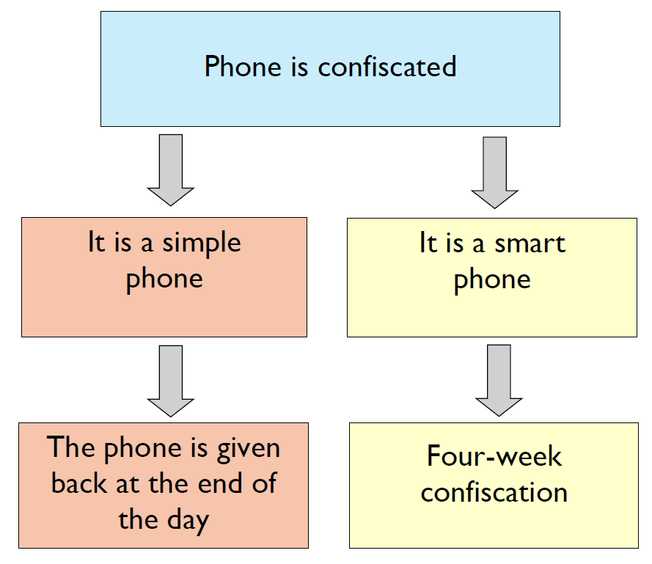

How other schools across the UK have successfully implemented a ‘simple phones only’ policy and addressed common concerns

- Do schools have a legal right to keep a child’s phone?
Yes, the DfE guidance allows schools to confiscate property. As part of the policy development, we have spoken to our local police team and they have confirmed we have a legal right to do so and that they support our right to confiscated property as this is a civil matter and supported by DFE guidance. Ofsted supports schools' rights to confiscation of banned items in line with the DFE guidance.

- How can I contact my child if they do not have a smartphone?
There will be no change during school hours, as students are not permitted to use mobile phones during this time. If communication is required, it should be directed through school reception, as per existing protocols. Importantly, this is not a total ban on mobile phones. If you feel it is necessary for your child to have a means of communication during their journey to and from school, a basic (non-smart) phone enables this while avoiding the risks associated with smartphone use. This approach supports a safer and more focused school environment by reducing exposure to potential harms from both their own and others’ smartphones.

- I want to be able to track my child.
There are basic tracking solutions available that do not involve smartphones. Devices such as Apple AirTags or similar alternatives allow parents and carers to monitor a child's location at school and to and from school without providing internet access, camera facility or social media exposure.

- My child’s smartphone has parental controls—isn’t that safe enough?
While parental controls can be helpful, they are not foolproof. A recent Parentkind poll revealed that 47% of children with parental controls had managed to bypass them. Schools cannot verify or monitor the settings on every student’s device and must consider broader risks, including exposure to inappropriate content via other students’ phones, being photographed or filmed without consent at school and having the content shared or uploaded to the internet. Smartphones are designed to be engaging and, in many cases, addictive. With children receiving hundreds of notifications daily, it is unrealistic to expect parents and carers to monitor all activities. A smartphone-free school environment minimises these risks and helps protect children’s mental well-being and development.

- Do I have to buy a simple phone for my child?
No, there is no obligation to provide your child with any phone. However, if you wish to maintain communication with your child outside school hours, a simple mobile phone is an affordable option. These devices typically cost between £15–£50 new, and under £10 second-hand. Pay-as-you-go SIM cards are often free, and contracts offering unlimited calls and texts can be found for as little as £3–£4 per month. As they do not use mobile data, ongoing costs remain low.

- I want to decide when my child gets a smartphone.
Absolutely. Parents and carers know their children best and should make decisions about smartphone use based on their own judgment. A smartphone-free school policy supports this by maintaining a neutral environment. Parents and carers who feel their child is ready for a smartphone can introduce one at home, while those who feel their child is not yet emotionally prepared can send them to school with the confidence that they won’t be exposed to inappropriate content or peer pressure from other students' devices or be photographed or filmed without consent. This approach not only helps to safeguard children at school, it helps level the playing field, reducing social pressure and preventing any student from feeling excluded—whether they have a smartphone or not.

- My child needs a phone to pay for the bus.
While many people use apps for bus fares, physical smart cards are a widely available and convenient alternative. These cards can be topped up online or directly on the bus. It's worth noting that many schools across major towns and cities have already adopted smartphone-free policies. Students are managing complex journeys using public transport without smartphones, demonstrating that this is entirely achievable.

- My child has a medical condition or special educational need and requires a phone.
If there are exceptional circumstances that necessitate your child having access to a phone during the school day, please contact the school directly to discuss appropriate arrangements.

- Don’t students need smartphones for homelearning?
This is a common misconception. There is no requirement for students to own a smartphone in secondary school. If homelearning requires internet access, parents and carers are free to choose the most appropriate device for home use. This may be a smartphone, tablet, or computer—whichever suits your household best. Students also have access to computers daily before school, break, lunchtime and homework club after school in the library. However, to clarify: no student is required to have a smartphone to complete school work during the school day or on their journey to and from school.

- Why is the policy different for Sixth Form?
We are not anti tech and we believe that Sixth Form students have the maturity to manage the policy differently. It is important that our older students are role models to younger students but also that they show respect. That is why Sixth Form students are not allowed to have their devices visible outside of the Sixth Form Centre.

