INTERNSHIP DETAILS
2024-2025
- Name:Akila.S,Bharath Kumar
Reg.No:71382306002,71382306005
Company Name:BSNL(Bharat Sanchar Nigam Limited)
Domain: Tele Communication

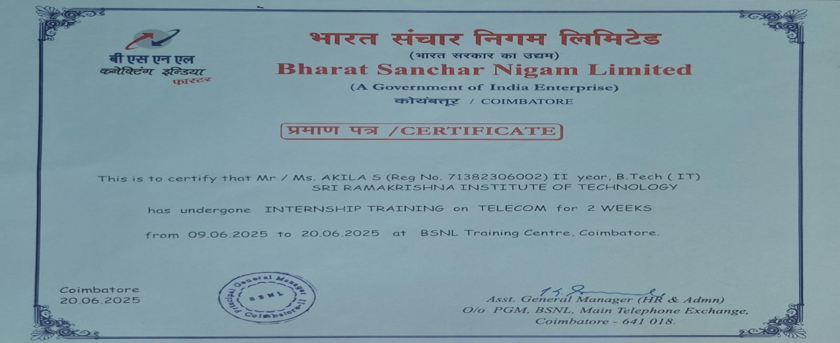
- Name:Janani.R,Selvakani
Reg.No:71382306016,71382306039
Company Name: Layercodes Technologies
Domain: Digital Marketing and Web Development
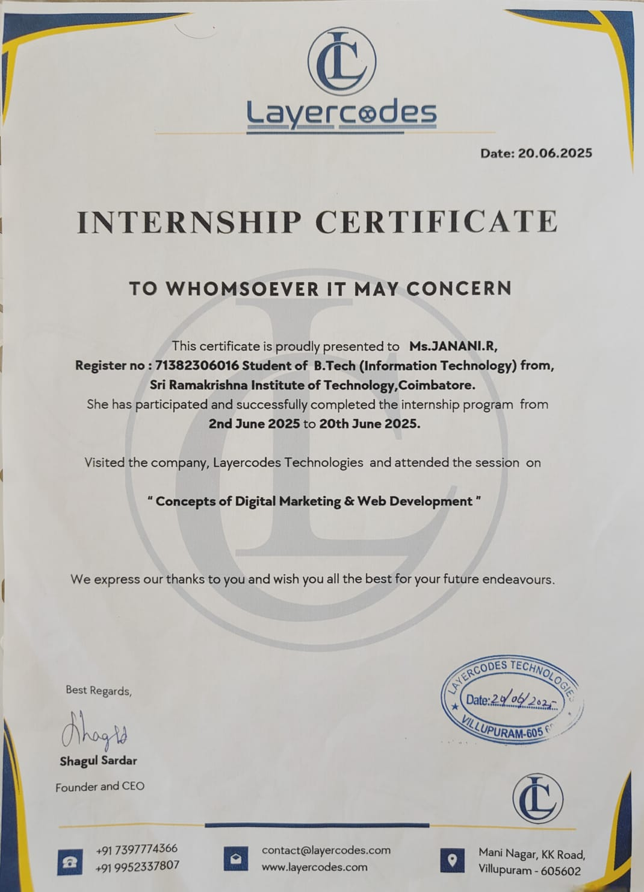

- Name:Loganayagi M,Mahadharshini,Deepana
Reg.No:71382306024, 71382306025, 71382306007
Company Name: Yellow Edusoft
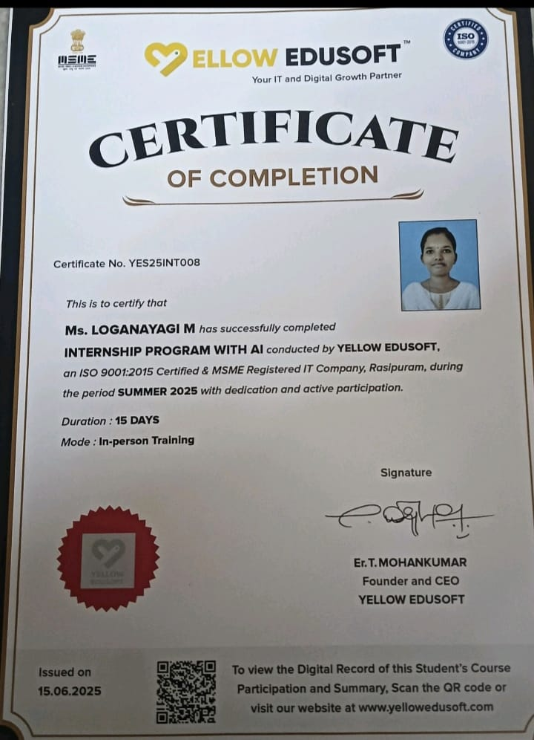
Domain:Internship program with AI

- Name:Sharmila, M,Valarmathi
Reg.No:71382306043, 71382306050
Company Name: Heleyon Technologies
Domain:Web Development

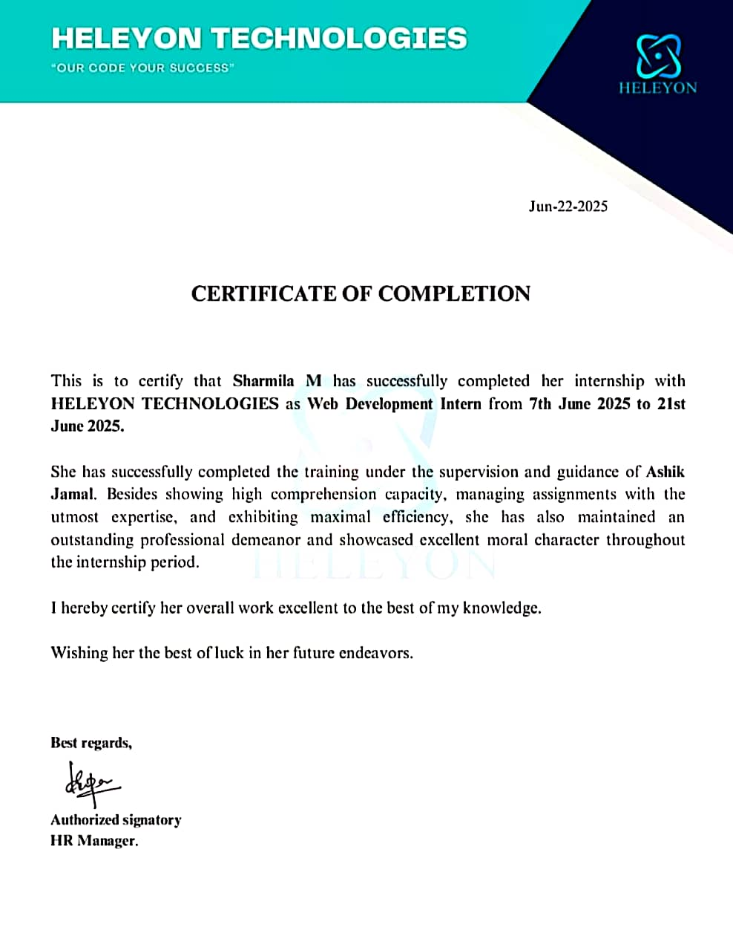

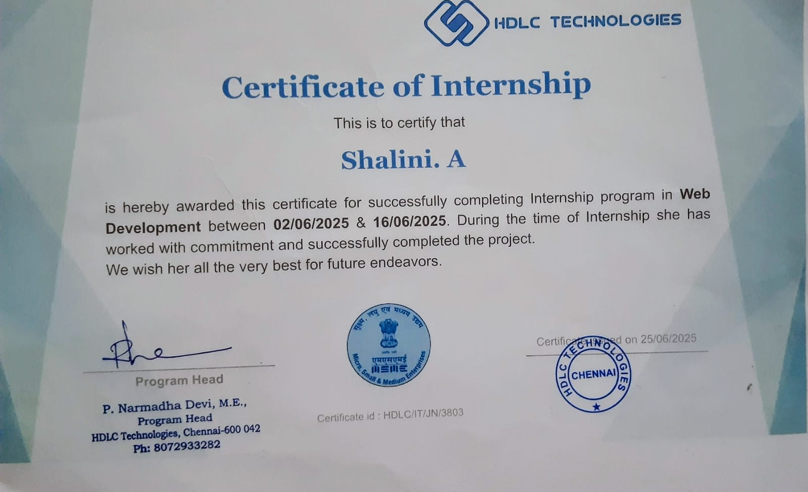
- Name:Shalini.A
Reg.No:71382306041
Company Name: HDLC Technologies
Domain:Web Development

- Name:Priyadharshini T,Manisha Sethu
Reg.No:71382306032, 71382306026
Company Name: IDM Tech park
Domain:Java Programming
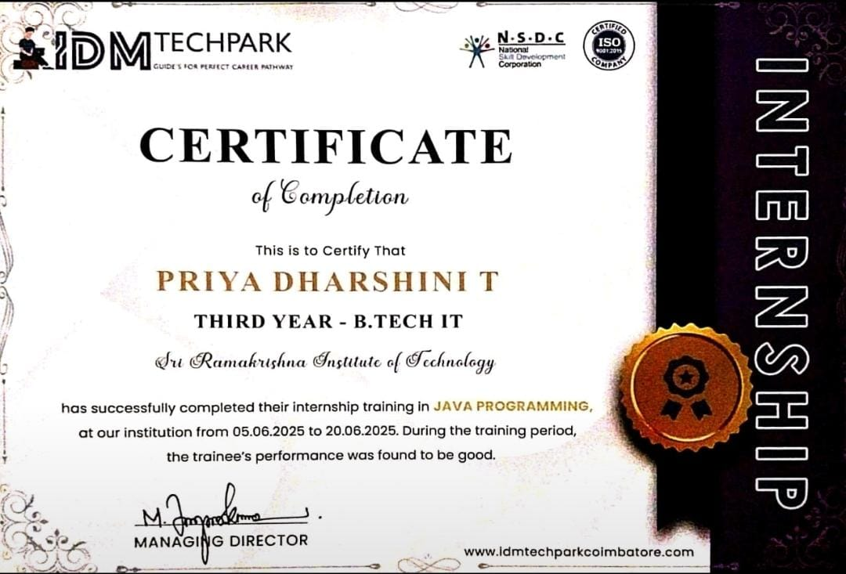
- Name:Priyadharshini.V
Reg.No:71382306033
Company Name: HDLC Technologies
Domain:Cyber Security
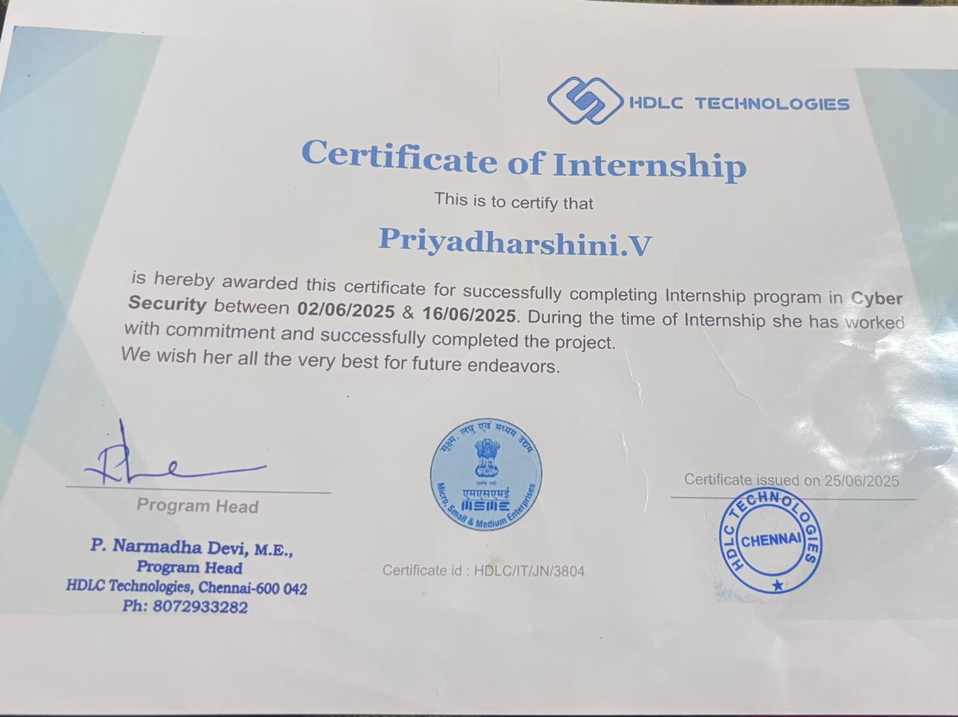
- Name:Yazhini.S,Anusudha
Reg.No:71382306054, 71382306003
Company Name: e-soft IT solutions
Domain:Web Development

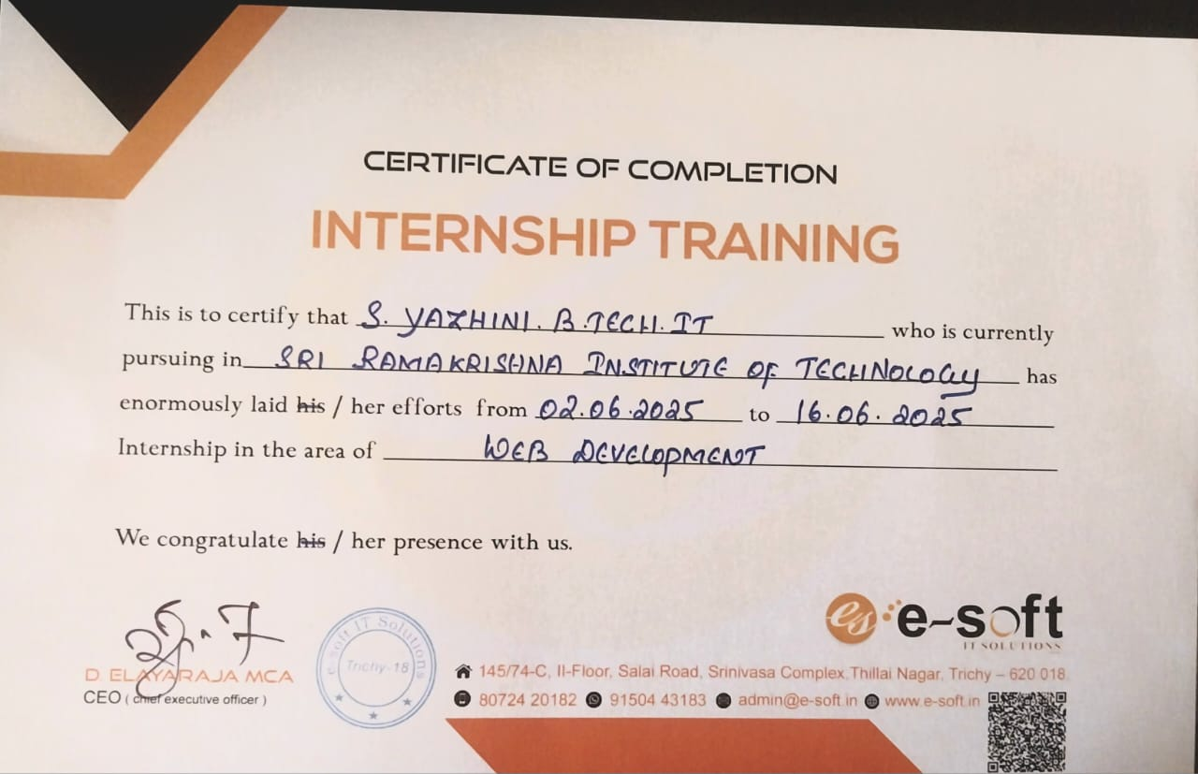

- Name:Swathi.M
Reg.No:71382306049
Company Name: ApexPlanet Software Pvt. Ltd.
Domain:Frontend Web Development
