Gender Equality, DISABILITY and social inclusion Analysis
GOOD PRACTICE NOTE

OVERVIEW
The Australian Government is committed to advancing gender equality, disability equity, and social inclusion through the development program. Australia’s International Development Policy identifies gender equality and disability equity as core issues for action. To achieve effective development outcomes, development and humanitarian investments should be informed by Gender Equality, Disability and Social Inclusion (GEDSI) analysis. GEDSI analysis identifies how social norms, relations and power dynamics are experienced by people as a result of their identities, including gender, age, disability, income, education, faith, race, ethnicity, sexual orientation, and migration status. It recognises that the interaction of impairments (physical, sensory, psychosocial, cognitive) and barriers (physical, social, communication and institutional) has a wide range of effects and explores how these elements intersect to create diverse experiences of exclusion and marginalisation.
DFAT’s International Development Policy’s commitment to gender equality and disability equity and rights are accompanied by a Performance and Delivery Framework that requires annual reporting on disability equity and rights and gender equality. It is a DFAT requirement that Official Development Assistance (ODA) investments valued at $3 million and over include a gender equality objective, aligned with the OECD DAC Gender Equality Policy Marker. These investments must meet the OECD minimum criteria for gender equality, one of which is a requirement for designs to include gender analysis. DFAT also reports to the OECD with the OECD DAC policy marker on the inclusion and empowerment of persons with disabilities, on activities that contribute to disability equity and rights.

A GEDSI analysis is the foundation for ensuring DFAT investments are more effective in reaching socially disadvantaged groups – by preventing unintended harm, exclusion, and further marginalisation, and by promoting their rights, equitable opportunities and benefits. DFAT GEDSI analysis focuses on women, girls, LGBTQIA+ people, and people with disabilities because these groups experience systemic discrimination, resulting in the denial of their rights and lack of access to opportunities.

This Good Practice Note will support DFAT investment managers and development partners to deliver high quality, evidence based GEDSI analysis. It provides a basis for joint planning and decision-making by investment managers and design teams and applies equally to both DFAT-led and Partner-led design pathways. For DFAT-led design pathways, investment managers should share this Good Practice Note with design teams to inform their approach to GEDSI analysis. For Partner-led design pathways, investment managers should share this Good Practice Note with partners to guide their approach to GEDSI analysis, noting that they may have their own established GEDSI analysis methodologies. If using their own GEDSI analysis methodologies, Partner-led analysis must meet the key features of good practice GEDSI analysis, outlined in the checklist below.

This note is aligned with the Gender Equality in Investment Design Good Practice Note, the Gender Equality in Monitoring and Evaluation and Reporting Good Practice Note, the Disability Inclusion in the DFAT Development Program Good Practice Note, and relevant chapters of the Aid Programming Guide. DFAT’s requirement for investment-level gender analysis is aligned with the Commonwealth Government’s introduction of gender responsive budgeting, and a requirement that new policy processes include gender impact assessments.

CHECKLIST – KEY FEATURES OF GOOD PRACTICE GEDSI ANALYSIS
Approach and analytical framework
- Analysis clearly linked to an analytical framework which unpacks gender and social norms, relations, and power dynamics into key dimensions where inequities and discrimination are most prevalent and pervasive.
- Analysis identifies barriers to disability equity with Organisations of People with Disabilities (OPDs), and opportunities to address these through targeted and mainstreamed measures.
- Analysis takes account of intersectionality and considers people’s multiple identities and how these shape their differing experiences, concerns, needs, and capabilities.
Scope
- Analysis draws on both primary and secondary data that is specific to the country, target location, sector, and investment.
- Where analysis relies on secondary data, that data is less than three-years-old, and is specific to the country, target location, sector, and investment.
Methodology
- Analysis involves partners and local organisations, including OPDs and women’s rights organisations (WROs) to better understand specific gender equality, disability, and social inclusion issues, elicit their priorities and suggestions, and ensure they have voice and agency within the analysis process.
- Analysis takes a ‘do no harm’ approach to data collection, storage and usage, considering and minimising potential risks and harm to both participants/ respondents and enumerators/ researchers.
- Analysis combines quantitative and qualitative data collection methods to generate measurable gaps and disparities between diverse groups of people and identify patterns of inequality.
- Analysis uses participatory methods to ensures diverse groups of people participate equally in the research and makes specific effort to engage ‘hard-to-reach’ groups i.e., those who are less visible within their households and communities.
- Analysis has been conducted by specialists in gender equality, disability, and social inclusion. This often requires more than one individual to provide the required knowledge, experience and expertise.
Analysis
- Analysis is disaggregated by sex, age, and disability as a minimum and, where appropriate, gender identity.
- Analysis provides a sufficient level of detail to inform the investment design and identifies: a) where inequalities exist between women, men, girls, boys, gender diverse people and people with disabilities; b) why these disparities exist; c) potential constraints and barriers for women, men, girls, boys, gender diverse people and people with disabilities in accessing and benefitting from the investment; and d) potential solutions to these issues.
- Analysis takes a ‘do no harm’ approach and considers the impact (intended and unintended) that the investment could have on women, men, girls, boys, people of diverse sexual orientation, gender identity, and sex characteristics, and people with disabilities and provides strategies for avoiding or minimising negative impacts on these groups.
Action
- Analysis provides recommendations on where development assistance can be targeted and which gender equality, disability, and social inclusion activities should be included and/or adapted as part the design.

WHY GENDER EQUALITY, DISABILITY AND SOCIAL INCLUSION?

Gender is one way to structure power, but access to power differs depending on a person’s disability status, income, education, faith, race, ethnicity, sexuality, age, migration status, and other social markers. GEDSI analysis recognises that there are particular groups of people (regardless of gender) who experience marginalisation and exclusion. DFAT’s approach to GEDSI analysis specifically includes a focus on people with disabilities, who experience the interaction of disability (physical, sensory, psychosocial, cognitive) and barriers (physical, social, communication, institutional), which impact on their ability to fully and effectively access and participate in society on an equal basis with others. Good GEDSI analysis helps us understand experiences and barriers specific to people with disabilities, ensuring at a minimum the investment does not further entrench exclusion, while driving better outcomes for people with disabilities.

Where possible and appropriate, GEDSI analysis should also include consideration of people of diverse sexual orientation, gender identity, and/or sex characteristics. Given the variation globally in the legal and social status of LGBTQIA+ people, in some circumstances engagement with these communities and/or LGBTQIA+ organisations should be undertaken carefully and with consideration to the risks that may be posed by engagement with them, and by the compilation, circulation and dissemination of data about them.

‘Intersectionality’ is a concept which recognises that an individual’s identity has many layers, and each layer may confer either negative or positive status and may either close or open access to resources and power. Intersectionality does not sideline gender (or disability or LGBTQIA+ persons) but moves away from focussing on single or isolated causes in analysing and explaining the dynamics of power and inequality. Intersectional GEDSI analysis engages communities with lived experience and considers how people’s multiple identities shape their privilege, exclusion, or marginalisation. Figure 1 illustrates the social systems and structures which can combine, overlap and compound to affect an individual’s identity, social position and experience.

Quality GEDSI analysis takes an intersectional approach. GEDSI analysis that recognises people’s different experiences and access to power enables better targeted and more effective programming.

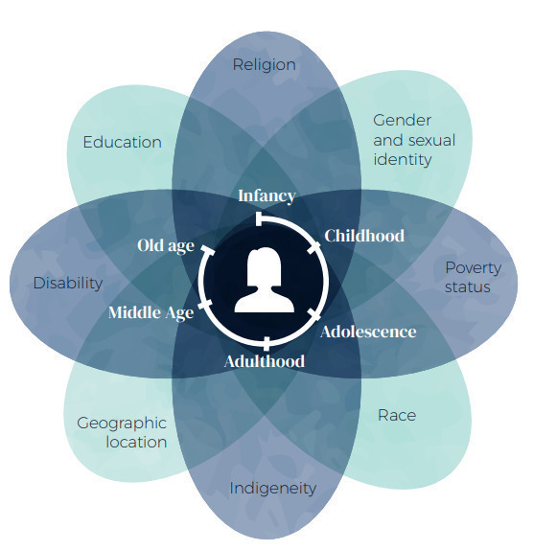
Figure 1. Identity and different forms of discrimination.
RESOURCES
For further information on intersectional approaches see the following:
Gender at Work, Intersectionality Capacity Development Resource Kit: Introduces the concept of intersectionality and supports discussions about intersectionality to identify opportunities, actions and areas for improvement.
UN Women, Intersectionality Resource Guide and Toolkit: Provides a practical framework and tools for reducing inequalities faced by people experiencing diverse and compounded forms of discrimination.
Humanity & Inclusion’s Policy on Disability, Gender and Age: Enables attention to disability, gender and age-based inequalities, identifying factors of exclusion and inequalities in the environment.

DFAT APPROACH TO GEDSI ANALYSIS
Gender equality analytical frameworks unpack gender and social norms, relations, and power dynamics into key dimensions where inequities and discrimination are most prevalent and pervasive. They provide a structured and consistent approach for analysis to inform the design of equitable and inclusive programs.

DFAT uses the Gender at Work Framework to make visible the interlinked dimensions of gender equality, and are using it as a tool to support analysis of disability equity, social inclusion and gender equality (Figure 2). DFAT’s use of the Gender at Work Framework is accompanied by our commitment to rights-based approach to disability inclusion and equity. Quality GEDSI analysis must actively include people with disabilities in each step. DFAT recognises that the interaction of impairments (physical, sensory, psychosocial, cognitive) and barriers (physical, social, communication and institutional) has a wide range of effects. Targeted efforts are required to identify and address barriers experienced by diverse people with disabilities of all genders in engaging in the analysis process, including ensuring accessibility and reasonable accommodations are provided (see page 9).

The Gender at Work Framework explores two primary dimensions: i) individual through to collective or systemic levels across all strata of society, and ii) visible and invisible forms of power, from social norms and exclusionary practices through to formal laws and policies. These two dimensions are divided into four intersecting areas of inquiry. The top two areas of inquiry map the individual, family and community level elements, while the bottom two are systemic and structural. The areas of inquiry on the right map the formal and tangible while the left domains cover the informal, intangible elements. An effective – and intersectional – GEDSI analysis will interrogate the relationships between each of the four areas of inquiry.

The top left area of inquiry considers agency, commitment, knowledge and skills needed for equality. The top right area of inquiry is about access to and control over resources, services and opportunities. The bottom right area of inquiry considers laws, policies, programmes, resource allocation and accountability mechanisms; these are the visible rules that govern changes in terms of equality. The bottom left area of inquiry is often least considered and focuses on the impact of social norms, attitudes, exclusionary practices on equality.

The Gender at Work Framework should be applied in a dynamic way – it must be adapted for socio-cultural, geographic and sectoral differences; and whilst investments should work across both dimensions, not all investments can target all four areas of inquiry or each area of inquiry to the same degree. Figure 3 illustrates how the Gender at Work Framework can be used in identifying GEDSI analysis research questions in a specific sectoral context (for example, a private sector market systems development investment). Sector-specific research questions are needed to inform investment designs. Sector-specific resources are available on the SURGE Knowledge Hub and DID4All website.

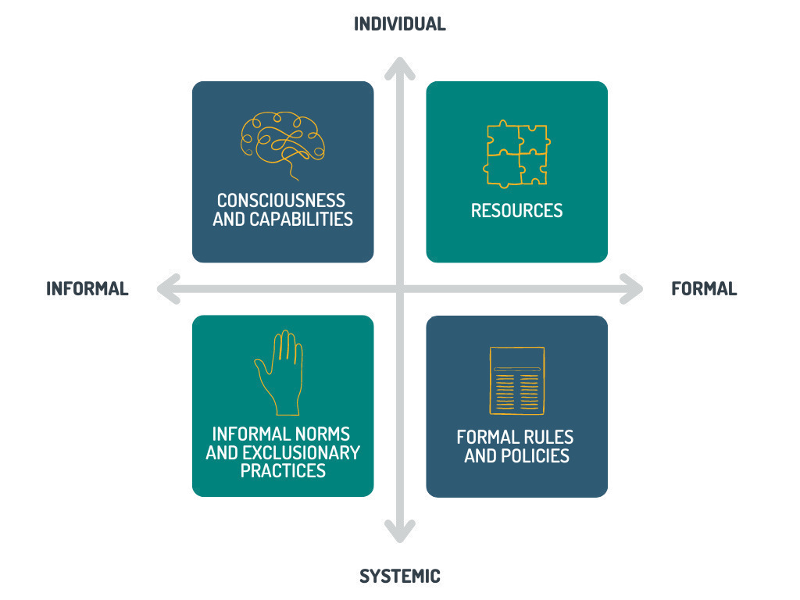
Figure 2. Gender at Work Framework

RESOURCES
For further information on the Gender at Work Framework see the following:
Gender at Work Framework: Explained: Explains the Gender at Work analytical framework and how to use it.

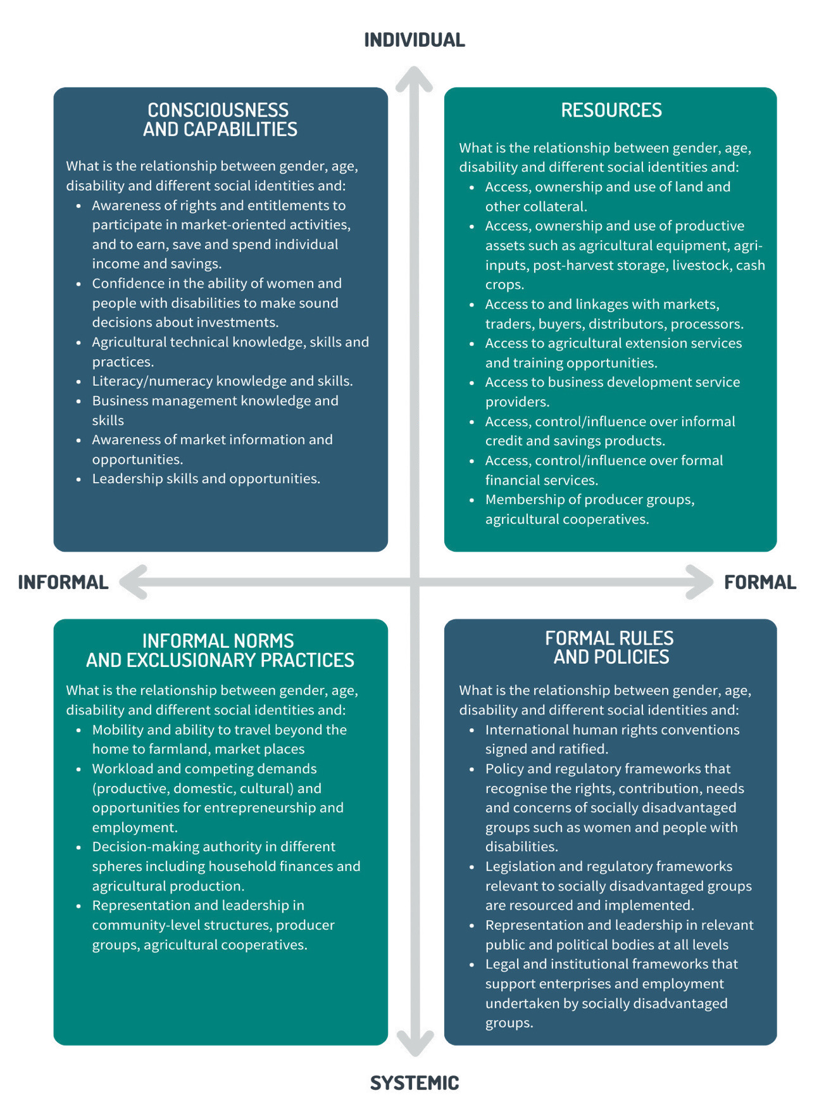

Figure 3. An example of the Gender at Work Framework contextualised for a market systems development investment.

STEP BY STEP – CONDUCTING GEDSI ANALYSIS

STEP 1 – SCOPE
Whilst DFAT investment designs valued at $3 million and over must be informed by gender analysis (preferably GEDSI analysis) the scope of that analysis depends on the availability, currency, and quality of existing gender analyses. GEDSI analysis must be carried out as part of the investment design process to enable an investment to effectively respond to findings. However, time and resource constraints sometimes mean that in-depth analysis will be conducted after the design phase.
If conducting an integrated GEDSI analysis during the design is not possible, the design document must: draw on relevant existing information to clearly articulate the main gender and disability inequities to be addressed by the investment (and attach this as an annex to the design); include disability related barriers and entry points; include a clear time frame and sufficient budget for in-depth analysis to be conducted during the inception phase; and provide flexibility to adapt program outcomes and activities based on the findings of the analysis.
Over time social norms, relations, power dynamics, and barriers change. Events such as a pandemics, conflict, natural disasters or economic crises can cause gender roles, the interaction of impairments and barriers, and access to social participation to change rapidly or dramatically. As such, longer-term programs undertaking a design update or entering a new phase should review and update their GEDSI analysis to identify whether adjustments in implementation approaches are needed.
GEDSI analysis can draw on either secondary data sources (e.g., existing gender and disability analyses and published research and data) or both primary (e.g., key informant interviews, focus group discussions, surveys) and secondary data sources. While quality analysis should use both secondary and primary sources, secondary research is sufficient where existing analysis is: less than three years old; takes an intersectional approach; and explores norms, relations and power dynamics, impairments and barriers within the relevant geographic context and sector. In cases where directly relevant and current GEDSI analysis exists, this can be annexed to the design. However, if secondary data is limited, is older than three years, or was undertaken in a different geographic context or sector, primary research is required to inform program design. If data is only available in relation to gender, rather than disability or other social inequities, this should be noted and addressed.

While humanitarian and disaster assistance investments of less than 12 months duration are exempt from the design gender analysis requirement, GEDSI analysis is required for humanitarian investments of more than 12 months.

The decision tree below guides investment managers on the expected approach to GEDSI analysis.

GEDSI Analysis Decision Tree
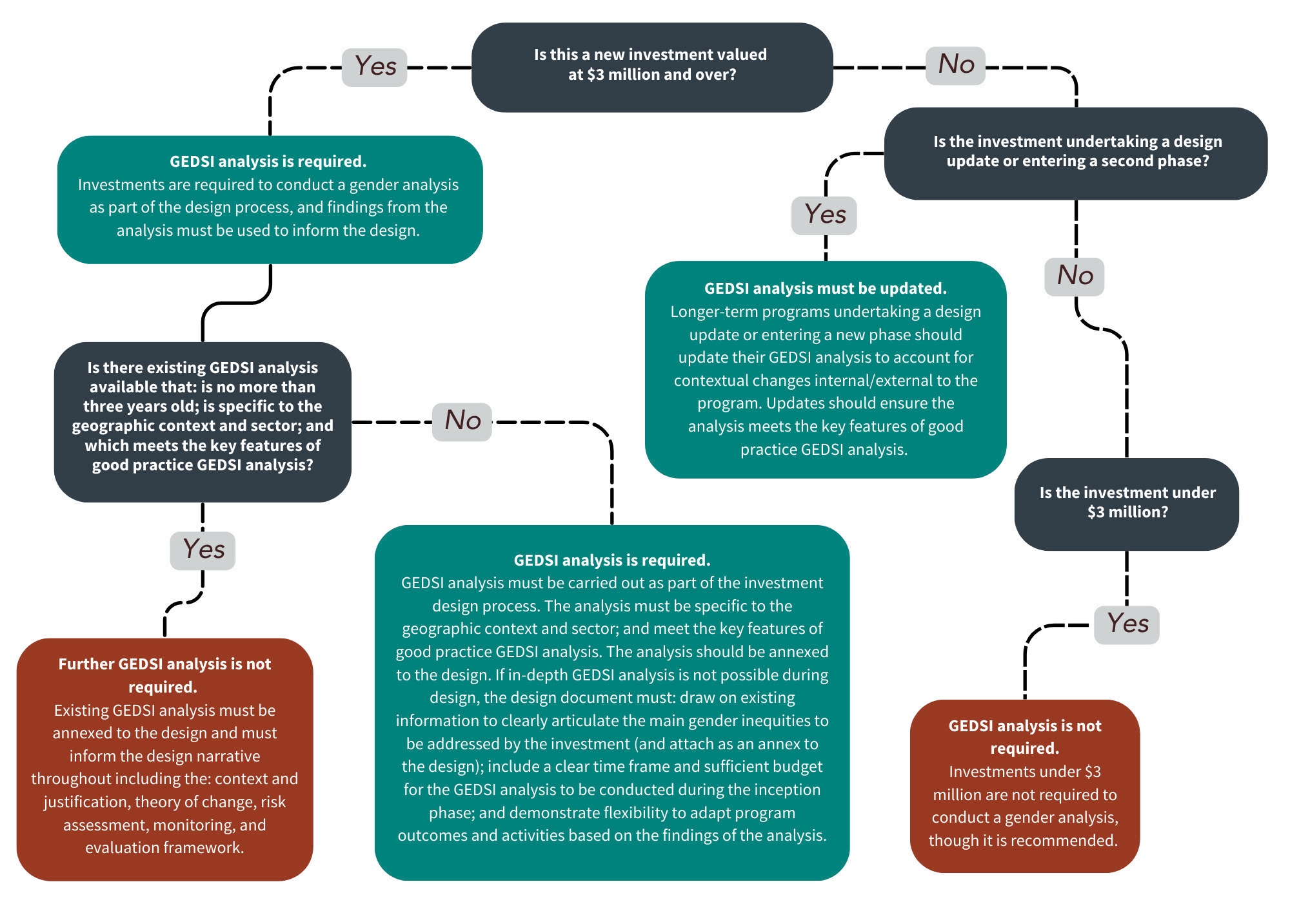

STEP 2 – METHODOLOGY
Although the methodology depends on the scope of the analysis, the below principles ensure that all GEDSI analysis is high quality, evidence-based and sufficiently comprehensive to inform investment design:
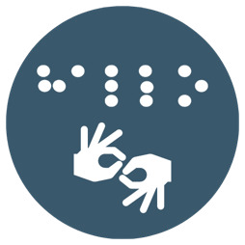
Recognises and provides accessibility and reasonable accommodations. Accessibility refers to measures that aim to target a wide a range of needs. Reasonable accommodation is the tailored provision of support, modifications and/or adjustments that meet the needs of individuals with disabilities to ensure they enjoy and exercise all human rights and fundamental freedoms on an equal basis to others. Good GEDSI analysis seeks to provide accessibility and reasonable accommodations to enable the participation of people with disabilities in consultation to inform analysis and implementation. Accessibility measures include using accessible meeting venues and documents in accessible formats, and reasonable accommodation may include the provision of alternative transportation, support people, and sign-language interpreters.

Makes visible the inequities and identifies opportunities to transform power imbalances. Good GEDSI analysis collects data that highlights how women, men, girls, boys, people with disabilities, gender diverse people negotiate the social norms, relations, barriers and power dynamics that influence their lives. It provides critical analysis across these areas, and highlights: where inequalities exist between different social groups; why these disparities exist; potential barriers for different social groups in benefitting from the investment; and potential solutions to these issues.

Takes a ‘do no harm’ approach. Good GEDSI analysis takes a ‘do no harm’ approach and considers the impact (intended and unintended) an investment could have on different social groups. Addressing marginalisation and stigma can generate backlash, which programs must be designed to manage. It recognises the risks to safety of LGBTQIA+ individuals in countries where they may face additional discrimination and/or lack protections. GEDSI analysis supports social safeguarding by providing an understanding of the specific harms and risks experienced by some social groups. It recognises that for people with disabilities (including cognitive and psychosocial disabilities) there can be additional risks, unintended consequences, and discrimination, including denial of legal capacity, forced sterilisation and institutionalisation. Assessments of risks should consider gender-based violence, child protection risks, sexual exploitation and abuse, and human rights violations and comply with DFAT’s Prevention of Sexual Exploitation, Abuse and Harassment (PSEAH) and Environmental and Social Safeguard and Child Protection Policies.

Goes beyond women, men, girls and boys. Good GEDSI analysis goes beyond a binary understanding of gender. It not only asks which men and which women (which girls and which boys) may face barriers in benefiting from an investment, but also includes gender diverse people and diverse categories of women, men, boys, girls based on other intersecting forms of discrimination. Good GEDSI analysis looks for differences between different social groups, seeks to understand these, and considers how the investment design should respond.

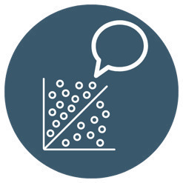
Combines quantitative and qualitative methods. Good GEDSI analysis is based on two types of data: 1) quantitative sex, age and disability-disaggregated data, and 2) qualitative analytical information. Quantitative methods are best suited for generating information on measurable gaps and disparities between different groups of people, and for identifying patterns of inequality. Qualitative methods provide insight into how and why different groups of people have different experiences – and how these affect their capacity to participate in, influence, and benefit from program activities. Combining quantitative and qualitative methods enhances the robustness of findings.

Uses participatory approaches. Good GEDSI analysis requires that different groups of people participate equally in the research. Participatory research methods are essential for engaging with groups directly to understand their needs and identify solutions for their participation in the investment. Participatory methods collect data that is relevant and accurate; it enables those targeted by an investment to share their experiences and provide recommendations for program strategies and activities. Good GEDSI analysis also engages ‘hard-to-reach’ groups. For example, some people with disabilities may be unable to leave their homes or may be purposely hidden due to social stigma, people with communication or cognitive disabilities may face challenges participating in surveys or focus group discussions, and women may face barriers to participation as a result of their heavy workload burdens.

Disaggregates data by sex, age and disability as a minimum and, where safe and appropriate, gender identity. Good GEDSI analysis presents sex, age and disability-disaggregated statistics. First, all analyses should disaggregate by sex as a minimum. However, there are instances where people do not identify with the male/female binary. For example, the Pacific has a number of indigenous alternative expressions of gender, such as fakaleitī (Tonga), fa'afafine (Samoa), vaka sa lewa lewa (Fiji) and pinapinaaine (Kiribati and Tuvalu). In other instances, people may not wish to disclose gender.
The collection of gender-disaggregated data which enables GEDSI analysis participants to identify based on their gender allows for a dignified approach, but can raise concerns about privacy, identity, self-determination, and security. The appropriateness of collecting gender-disaggregated data therefore depends on the context. For example, the decision to collect gender- disaggregated data in countries where same-sex sexual conduct is criminalized or where laws and policies discriminate against LGBTQIA+ persons should be based on an assessment of threats and risks to the safety and rights of those involved in the activity. Consider the degree to which individuals requested to identify their gender may understand and/or react to diverse gender identities. GEDSI analysis must consider potential risks and ‘do-no-harm’ to those conducting and/or participating in the analysis. Safety and confidentiality are a primary concern.
Disaggregation by age is also required. Disaggregation by three age brackets from childhood to adolescence (0-5; 6-12; 13-17) and 10-year age brackets thereafter is the internationally accepted standard. Depending on the type of program or investment, other age groups may be better suited for analysis – for example if designing a nutrition program for children, smaller intervals may be used for those younger than 5 years.
When collecting disability disaggregated data, the focus should be on people’s experience of their individual level of function, which better captures the relationship between their disability, the environment and barriers to participation and the enjoyment of rights. The Washington Group Short Set (WG-SS) of Disability Questions standardises the collection of disability disaggregated data and can be rapidly and easily deployed in a variety of settings. Finally, when data on sex, gender, age or disability are not available, this should be identified as a gap and addressed as an opportunity through the investment monitoring, evaluation and learning system.

What about GEDSI analysis during humanitarian crises?
Humanitarian crises and emergencies affect women and men, girls and boys, gender-diverse people and people with disabilities differently. Pre-existing inequalities are often exacerbated in times of crisis and limit access to the resources and services. This is particularly true for those who experience intersecting and compounding marginalisation including women and girls with disabilities, and people of diverse sexual orientation and gender identity. Conducting GEDSI analysis during an emergency may be challenging but is critical to inform targeted and effective emergency responses that do no harm.
Rapid gender analysis (RGA) is designed for emergency contexts. RGA provides essential information about roles and responsibilities, capacities and vulnerabilities of different groups of people, together with programming recommendations. It can be used in different sectors, include disability inclusion analysis, and can easily be incorporated into existing needs assessment tools and used to monitor and evaluate outcomes. RGAs can also be done progressively as more information becomes available.
CARE’s Gender in Emergencies Guidance Note Preparing a Rapid Gender Analysis and the Interagency Standing Committee’s Gender Handbook for Humanitarian Action provide step by step guidance on how to undertake an RGA. DFAT’s gender equality and disability teams can support with the RGA process.
RESOURCES
For further information on GEDSI analysis tools see:
DFAT Ethical Research and Evaluation Guidance Note: Sets out requirements for ethical research and evaluation. It aligns with DFAT’s policies on program management, conduct and risk management, and safeguarding policies.
ACFID and Research Development for Impact Network Principles and Guidelines for Ethical Research and Evaluation in Development: Provides practical support for the design, implementation and use of research, including GEDSI analysis. An essential resource to ensure research activities ‘do no harm.’
Government of Canada Gender-Based Analysis Plus (GBA+): GBA+ assesses how diverse groups of people experience policies, programs and initiatives. The “plus” in GBA+ acknowledges that GBA goes beyond biological (sex) and socio-cultural (gender) differences.
DFAT and Asian Development Bank Tool Kit on Gender Equality Results and Indicators: Presents a menu of gender equality outcomes, results, and indicators, focusing on the sectors and strategic priorities of the Asian Development Bank (ADB) and Australia's development program.
CBM International Disability and Gender Analysis toolkit: Provides tools for programs to assess knowledge, attitudes and practice to inform situation analysis and design, to create baseline data and/or to improve monitoring, evaluation, accountability and learning.
UN Partnership on the Rights of Persons with Disabilities Guidance for Conducting a Situational Country Analysis of the Rights of Persons with Disabilities: Sets out a framework for analysing the pre-conditions to disability inclusion, level of participation, inclusion of marginalised and under-represented groups, and the rights of women and girls with disabilities.

STEP 3 - ANALYSIS
GEDSI analysis data can be analysed using standard quantitative and qualitative analytical methods and systems. What distinguishes good GEDSI analysis is that it is specific to the proposed investment.
Data analysis should compare information about women, men, girls, boys and gender diverse people, and compare different groups of women, men, girls, boys and gender diverse people (e.g., age, disability, income, education, faith, race, ethnicity and sexual orientation). These comparisons will reveal where there are inequalities that the investment needs to respond to.
The analysis should also provide an understanding of why these gaps and disparities exist and how they affect the opportunities and aspirations of different social groups. It should reveal the strengths of different social groups, and where social norms change is already occurring. Taking a strengths-based approach enables the identification of opportunities and entry points that the program can leverage to transform harmful gender and social norms and address barriers to full and effective access and participation in society. on an equal basis with others. Findings from the analytical process should be used to: ensure that the investment does no harm; identify priority areas of action in the design; and enhance the effectiveness and sustainability of overall program outcomes.

STEP 4 – ACTION
GEDSI analysis is only useful if it provides clear recommendations to inform the investment. Good GEDSI analysis recommendations should build on existing strengths, identify opportunities and entry points, and propose realistic activities and approaches that can be feasibly implemented as part of the investment. Recommendations should identify actions and opportunities to affect positive change that advances gender equality, and disability and social inclusion.
As part of developing recommendations, consider the following questions:
- Have any issues been identified that will impact the ability of the investment to achieve its end-of-program outcomes or intermediate outcomes?
  - If yes, do these issues require that the end-of-investment outcomes or intermediate outcomes be re-phrased or reconceptualised?
- Have any issues been identified that will prevent some social groups from participating in and benefitting equally from the program?
  - If yes, how can the program be amended to ensure that these groups benefit equally?
- What points of entry and opportunities exist for engaging marginalised groups of women, girls, people with disabilities, people of diverse sexual orientation, gender identity, or sex characteristics through the investment?
- Are the needs of any groups of people in relation to this program different enough that a separate program component focusing on that sub-group needs to be created?
- What types of data must be collected to track the impacts of the program on women, girls, people of diverse sexual orientation, gender identity, or sex characteristics, people with disabilities and any other social group?
- Have any potential unintended negative consequences of the investment on different social groups been identified?
  - If yes, following the ‘do no harm’ principle, how can these risks be mitigated against and monitored?
- Has partner capacity been assessed, and what gaps and needs have been identified by partner agencies themselves to implement the actions needed to achieve GEDSI outcomes?
GEDSI analysis should be visible throughout investment design documentation – starting from understanding of the development issue to be addressed, specification of the target group, and design of the investment objective, outcomes, outputs, activities, indicators and budget. See the Gender Equality in Investment Design Good Practice Note, and Gender Equality in Monitoring and Evaluation and Reporting Good Practice Note for further guidance, and the Disability Inclusion in the DFAT Development Program Good Practice Note.

The minimum criteria for an investment to have gender equality as the principal or a significant objective are set by the OECD DAC. Gender equality is considered a ‘significant objective’ where it is an important and deliberate objective, but not the principal reason for undertaking the investment. Gender equality is considered the ‘principal objective’ where gender equality is the main objective of the investment and is fundamental to its design and expected results. The investment would not have been undertaken without this gender equality objective.
UN General Assembly, Convention on the Rights of Persons with Disabilities: resolution / adopted by the General Assembly, 24 January 2007, A/RES/61/106, available at: https://www.refworld.org/docid/45f973632.html [accessed 4 April 2023], Article 1
Adapted from Equality Institute (2019) Identity and different forms of discrimination. Melbourne.
The Gender at Work Framework is not grounded in an understanding of the specific barriers experienced by persons with disabilities – including regarding resourcing to disability-specific supports and services – which is why DFAT encourages further consideration of these priorities.
UN Women, United Nations Entity for Gender Equality and the Empowerment of Women (2022) Intersectionality Resource Guide and Toolkit: An Intersectional Approach to Leave No One Behind. Washington D.C.
Ibid
Documents in accessible formats can include electronic versions that are compatible with screen readers or versions in more simple language and illustrations for people with intellectual disabilities.
Within the Pacific region, these terms refer to people assigned male at birth who live as women according to tradition – in such cases people who have non-heteronormative lifestyles are not always considered minorities.
IFRC (2018) Minimum standards for protection, gender and inclusion in emergencies. Geneva.
Adapted from USAID. (2010) Tips for Conducting a Gender Analysis at the project-level. Washington DC.

