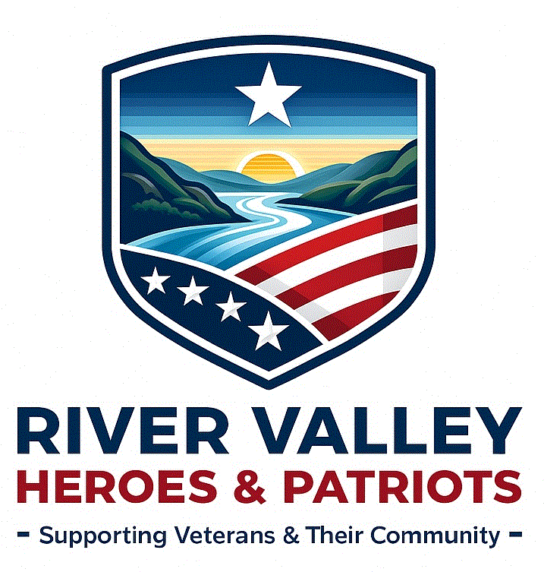
River Valley Heroes & Patriots Application Form
Thank you for your interest in volunteering with River Valley Heroes & Patriots. Our organization encourages the participation of volunteers who support the mission: Provide support and services to veterans and the community; provide a safe, comfortable, and welcoming environment for all members and guests to enjoy; and continue to improve the club’s financial, structural, and operational posture for future generations.

Please complete the following form so we can best match your skills, availability, and interests with our volunteer opportunities.

Personal Information
Full Name: ______________________________________________________________
Address: _______________________________________________________________
City / State / ZIP: _________________________________________________________
Phone Number: __________________________________________________________
Email Address: __________________________________________________________
Preferred Method of Contact: ☐ Phone ☐ Email ☐ Text

Emergency Contact
Name: _________________________________________________________________
Relationship: _______________________ Phone Number: ________________________

Availability
Please indicate when you are generally available to volunteer:
☐ Monday ☐ Tuesday ☐ Wednesday ☐ Thursday ☐ Friday ☐ Saturday ☐ Sunday
Preferred Times: ☐ Morning ☐ Afternoon ☐ Evening
How often are you available?
☐ Weekly ☐ Monthly ☐ Occasionally ☐ For special events only

Areas of Interest in Volunteering
☐ Event setup/cleanup
☐ Community outreach
☐ Veterans assistance
☐ Fundraising/donations
☐ Administrative support
☐ Kitchen/food service
☐ Building maintenance/repairs
☐ Honor guard or ceremonies
☐ Raffles

☐ Other: ___________________________________________

Relevant Experience or Skills (Example: Military service, first aid, administrative skills, carpentry, public relations, people skills, sales abilities, etc.)
__________________________________________________________________________

Have you or a family member served in the military? If so, please list them.

__________________________________________________________________________

Physical Limitations or Medical Conditions
(Please list any limitations or conditions we should be aware of to ensure your safety.)
☐ No known limitations ☐ Yes — please describe briefly: __________________________

Background Check Consent
Some volunteer roles may require a background check.
☐ I consent to a background check if required.

Donation Line (Optional)
If you would like to make a taxable donation to support River Valley Heroes & Patriots programs and events:
Annual Membership $50.00 Donation Amount $ __________________
Total Amount: $______________ ☐ Cash ☐ Check ☐ Other: _________________
Make checks payable to River Valley Heroes & Patriots.

410Declaration and Signature
I certify that the information provided is accurate and understand that volunteering with River Valley Heroes & Patriots may involve certain responsibilities and expectations. As a volunteer of our organization, I agree to abide by the policies and procedures. I agree that all the work I do is on a volunteer basis, and I am not eligible to receive any monetary payment or reward. I do of my own free will and accord, solemnly promise that I will never wrong or defraud this organization nor a member thereof nor permit either to be wronged if in my power to prevent it. I uphold the rules, bylaws, and expectations of the VFW Post 2244.

Signature: ______________________________________ Date: ____________________

Committee Approval: _______________________________ Date: ___________________
Post Approval Date: _______________________

