

Arqiva Group Limited
Registered number 05254001
Using a Capstan Winch

Using a Capstan Winch
This form must be completed when a capstan winch is used on an Arqiva site by an employee, contractor or site sharer or a non Arqiva site by Arqiva employees or contractors. The aim of the form is to show that the work has been properly planned and that the capstan is a suitable tool to undertake the task safely.
Job details
Company name |  |  | Contact name and email
Name of person carrying out assessment
Site name |  |  | Site number
Winch
Winch type (e.g., Leg capstan, Landover capstan, Harken)
Working load limit of winch (marked figure)
Last electrical inspection date
Last LOLER thorough examination date
Load
Description of load (is it being lowered, lifted or both)
Weight of load (kg)
Dimensions of load (maximum load reduction to account for wind loading)
Safe working load applied to winch for proposed specific task
Rigging arrangements
Winch operator (competence)
Details of winch anchor points
Rigging arrangement on structure
Type of bond used
Number of deviations of the lifting rope (has block friction been accounted for when applying SWL to winch)
Height of lift (m)
How will the load be held out from the structure? Will the holding out method put additional strain on the winch?
How will the load be arrested in the event of loss of control of the lift i.e., rope grab fitted?
Supporting information or sketch

Guidance on How to Complete the Form
Requirement | Guidance
Company name, contact name and number | Enter name of the company carrying out the work and a contact if we need to discuss the details of the from with you
Site name | Enter the Arqiva site name where the work is being undertaken
Site number | Enter the Arqiva site number where the work is being undertaken
Working load limit of winch (marked figure) | Capstans are generally not marked with a SWL- the safety factors used to derive the capacity are not known so they should not be used to their limits. 450kg is usually the absolute maximum capacity.
Last inspection date – electrical and LOLER | Enter the date of the last electrical test and independent thorough inspections
Description of load | Enter a brief description of the load e.g., 1.2m dish, steel framework
Weight of load (kg) | Enter the weight of the load
Dimensions of load (maximum load reduction to account for wind loading) | Enter rough dimension specifically if it’s not an antenna and you are lifting steel work
Safe working load applied to winch for proposed specific task | Enter the safe working load of the winch you are working to
Winch operator (competence) | Enter the name and competence of the winch operator
Details of winch anchor points | Detail what the winch will be anchored to Structure legs and purpose made points on vehicles are generally acceptable but cable gantries, fence posts, towbars etc are not. If using a vehicle, the rope must be used in the same direction as the vehicle and not at an angle.
Rigging arrangement on structure | Where and what height will the attachment point be on the structure and what rigging arrangement will be used.
Type of bond used | Detail the type of bond to be used.
Number of deviations of the lifting rope | Has block friction been accounted for when applying SWL to winch.
Height of lift | Enter the height is the load being lifted.
How will the load be held out from the structure? Will the holding out method put additional strain on the winch? | Provide details of how the load will be held out from the structure to avoid damage or the load getting snagged. Also detail where the load will be in relation to the winch operator.
How will the load be arrested in the event of loss of control of the lift i.e., rope grab fitted? | Detail how you will prevent the load falling if control of the load is lost at any point.
Supporting information or sketch | Please provide any other supporting information, photos, or sketches.

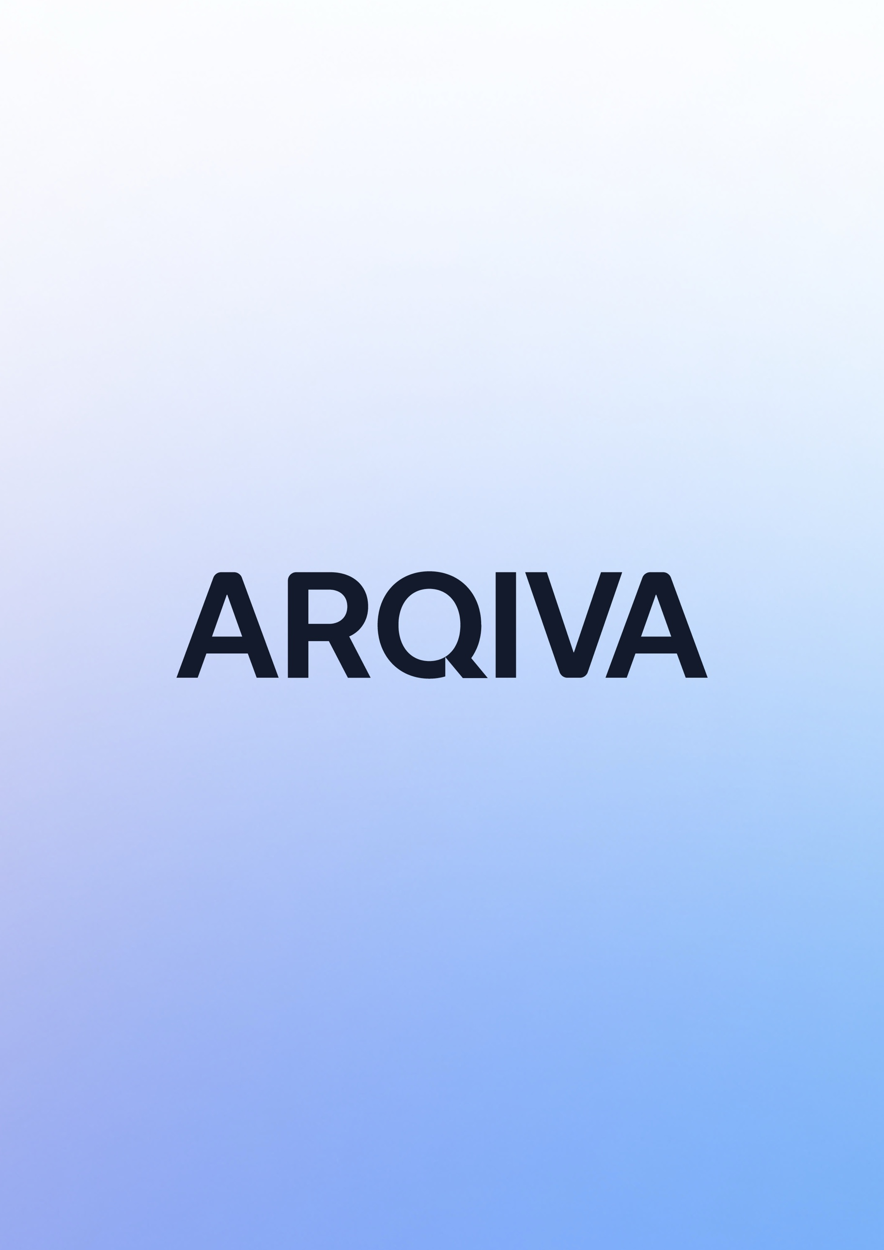

Arqiva Group Limited
Registered number 05254001

SHE-FT-018+Using+a+Capstan+Winch

