Off-Grid Horse & Land Experiences
Scottish Borders, East Berwickshire, Lamberton,Scotland
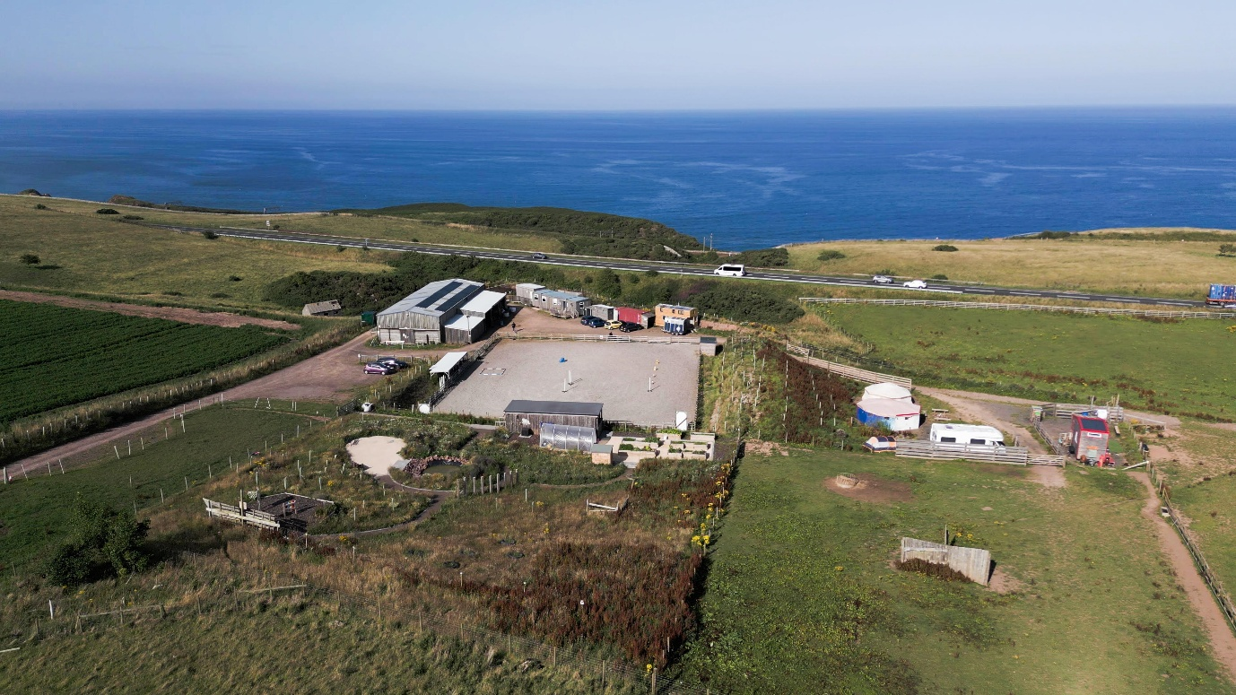

Your Story – Who We Are
Eat Sleep Ride is a unique off-grid equine and nature experience located in the Scottish Borders overlooking the North Sea coast.
Developed on a restored landfill site and powered by the sun, the site combines rescued horses, land restoration and nature-based experiences. Visitors are welcomed into a working rural project where horses, landscape and community come together.
Our experiences focus on connection, wellbeing and authentic rural Scotland rather than traditional equestrian tourism. Guests are invited to slow down, spend time with horses and explore the land while learning about our off-grid project and rural life.
Experiences are designed for small groups and independent travellers (FIT) seeking meaningful, nature-based tourism.

Location
Scottish Borders, Scotland
• 10 minutes from Berwick-upon-Tweed
• 1 hour from Edinburgh and Newcastle
• Located near the A1 coastal route
• Views across the North Sea and located within a recognised Dark Skies area

BOOKABLE EXPERIENCE 1
Off-Grid Horse & Land Experience (Ridden)
Duration
3.5 – 4 hours
Group Size
Minimum 2 | Maximum 12
Rider Weight Limit
Maximum 14 stone
Retail Price
£95 per person
Net Trade Rate
£76 per person
Experience Overview
Guests are welcomed to our off-grid coastal site where rescued horses and land restoration come together. This beginner-friendly riding experience combines horse connection, storytelling and time exploring the land.
The experience focuses on slowing down and connecting with nature rather than technical riding, making it ideal for travellers seeking authentic rural experiences.
What Guests Receive
• Welcome tea or coffee on arrival
• Introduction to the horses and safety briefing
• Ground-based communication with horses
• Supported beginner-friendly riding experience
• Time exploring the land and wildlife areas
• Seasonal refreshments

BOOKABLE EXPERIENCE 2
Horse & Land Connection Experience (Non-Ridden)
Duration
3 hours
Group Size
Minimum 2 | Maximum 16
Retail Price
£75 per person
Net Trade Rate
£60 per person
Experience Overview
A fully ground-based horse and nature experience designed for guests who prefer not to ride or where riding is not suitable.
Guests spend time learning about herd behaviour, horse communication and presence while exploring the land and wildlife areas of our reclaimed off-grid site.
This experience is ideal for wellness travellers, retreat groups and multigenerational visitors.
What Guests Receive
• Welcome tea or coffee
• Guided introduction to herd behaviour
• Facilitated horse interaction
• Nature immersion experience
• Shared storytelling and reflection
• Seasonal refreshments

Enhancement Experiences (Pre-Booked Add-Ons)
These experiences can be added to either programme.
• Fireside horse storytelling experience
• Dark Skies storytelling and stargazing
• Yoga session with Amy (yurt or outdoor setting)
• Local music around the fire
• Farm-to-Fork seasonal lunch using local produce
Enhancements can extend the visit to half-day or retreat-style experiences.

Why Tour Operators Like This Experience
• Unique off-grid horse and nature experience
• Suitable for both riders and non-riders
• Flexible for FIT travellers and small groups
• Easy access from Edinburgh and the A1 coastal route
• Opportunities to add wellbeing, food and storytelling experiences

Terms & Conditions
Advance booking required.
Minimum group size: 2 guests
Maximum group size:
Ridden experience – 12 guests
Non-ridden experience – 16 guests
Riding experiences are weather dependent.
Maximum rider weight: 14 stone
Guests must follow safety guidance when interacting with horses.

Arrival Information
Guests should arrive 15 minutes before the experience begins.
Parking available on site.
Outdoor clothing and closed-toe footwear recommended.

Contact
Eat Sleep Ride
Scottish Borders, Scotland
Email: danielle@eatsleeprides.org
Website: www.eatsleepride.org
Telephone: +44 (0)7516360235

