STRUCTURED TALENT
SAMPLE · PREVIEW
Your Custom EMEA
Outbound Playbook
What you receive — a worked example
Built around your product, your markets, and how each European buyer actually thinks.
Written, not translated. Author-led, not generated.
About this sample
This is a preview built around a fictional example client — “Nordwind Analytics”, a Series A SaaS company expanding into DACH. It shows the structure, depth, and craft of a Structured Talent playbook. A few sections are shown in full so you can judge the quality; others are previewed and completed in your own custom build. Your playbook is written from scratch around your product, your ICP, and your target markets – the Full Playbook has between 40-50 pages.
Fixed €299 · delivered in 7 days · structuredtalent.io

What’s inside your full playbook
Every playbook is a complete operational asset — not a template, not theory. Here is the full table of contents. This sample previews the highlighted sections so you can see the quality before you buy.
# | Section | What it gives your team
1 | Methodology Foundations | The system behind the playbook — shown in this sample
2 | ICP & Persona Matrix | Who to target, who to skip — previewed in this sample
3 | Business Intelligence Snapshot | Your product’s wedge and proof points
4 | Elevator Pitches | Two ready-to-use one-liners — shown in this sample
5 | Market-Native Messaging | Full sequences in every key EMEA language — one shown in full
6 | Call Scripts & Discovery Bank | Openers, SPIN discovery, objection handling
7 | Custom Cadence | The full multi-touch sequence — shown in this sample
8 | Annotated Call Simulation | A coached ‘what good looks like’ call for training
9 | Competitor Battlecard | How to beat the alternatives — previewed in this sample
10 | Low-Hanging Fruit Map | Where to point the team first
11 | AI Prompt Library | Personalise outreach at scale
12 | EMEA Sales-Culture Pages | One page each: Nordics, Benelux, France, Spain, UK/IE
13 | Onboarding 30/60/90 | Ramp a new hire fast
14 | KPIs & Rejection Log | Measure and improve

Sample note: the sections marked “shown” below are presented in full or near-full. The rest are completed in your custom build.

1 — Methodology Foundations
Every playbook runs on the Structured Prospecting Framework: a synthesis of four proven methodologies under one principle — structure creates freedom. Each fixes a specific failure mode, and together they turn outbound from guesswork into a predictable engine.
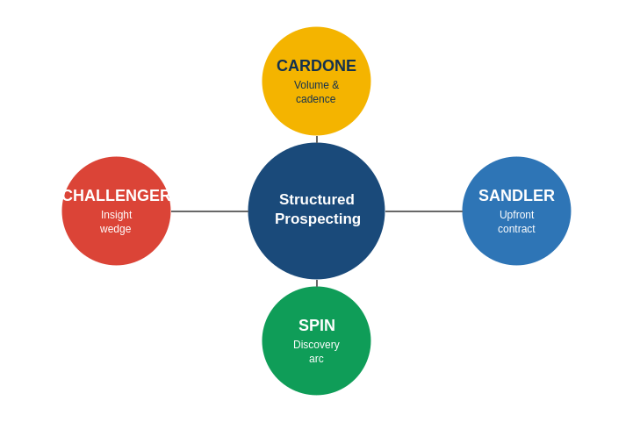
Cardone drives volume and cadence — the discipline of enough relevant activity, never giving up after three touches.
Sandler structures trust — the upfront contract and three-level pain discovery that earns honest conversations.
SPIN gives discovery its arc — Situation, Problem, Implication, Need-payoff — so the buyer talks themselves into urgency.
Challenger provides the edge — a relevant insight that reframes the buyer’s status quo and creates constructive tension around inaction.
In your playbook, every sequence, script and objection response is built on this blend — tailored to your product and market.

2 — ICP & Persona Matrix (preview)
Your playbook opens by defining exactly who to target — and who to walk away from. Here is the example for our fictional client, Nordwind Analytics.
Best-fit trigger we build around: the strongest intent signal is almost always a decision-maker under one year in their role — new leaders review the stack and are mandated to change it. We layer this with smart filters like headcount growth, recent funding, and data/usage growth where they fit your product.

Recommended prospecting filters (example)
Tool | Filter recommendation
LinkedIn Sales Navigator | Industry + geography + function + seniority; “Changed jobs in last 90 days” for the tenure signal; headcount-growth filter
Apollo | Same industry/geo/title; recently-funded filter; headcount band matched to your sweet spot; sort by recently started in role

Target job titles (when not supplied): your playbook always suggests at least four. For Nordwind: VP Sales, Head of Revenue Operations, Head of Data, Director of Growth.
■ ■ ■ Full persona profiles, pain maps & disqualification criteria ■ ■ ■
Included in full in your custom playbook

4 — Elevator Pitches
Your playbook gives two ready-to-use one-liners in 2 languages — one benefit-led, one naming two concrete use cases. Example for Nordwind Analytics:
Version A — the benefit pitch
“We turn the data your team already collects into the one dashboard your board actually trusts — in days, not quarters.”
Version B — the two-use-case pitch
“We help SaaS teams do two things: see which accounts are about to churn before they do, and prove revenue impact to the board without a data team.”
Your version is written around your product and the benefit your buyers care about most.
Version A German — the benefit pitch
„Wir verwandeln die Daten, die Ihr Team bereits sammelt, in das eine Dashboard, dem Ihr Vorstand wirklich vertraut – in Tagen, nicht in Quartalen.“
Version B German — the two-use-case pitch
„Wir helfen SaaS-Teams bei zwei entscheidenden Dingen: zu erkennen, welche Accounts abwanderungsgefährdet sind, bevor es passiert – und dem Board den Umsatz-Impact zu beweisen, ganz ohne Data-Team.“

5 — Market-Native Messaging (sample: German, full)
Your playbook contains full sequences in every key EMEA language you target — German, French, Spanish, Dutch and English — To show the craft, here is a complete German sequence for our example client, in the formal “Sie” form.

Every email is built on the PROOF Method
Each message in your sequence follows one structure — the discipline that separates a localized email from a translated one. It is why these emails earn replies without resorting to the urgency and false familiarity European buyers distrust.
P — Personalise the trigger. A specific, real reason for reaching out — never invented familiarity.
R — Reason / why now. Why this matters to them today, not someday.
O — Observe the implication. Name the cost of the status quo, so the buyer feels it.
O — Offer proof, not pressure. A reference, a figure or a logical mechanism — proof in place of urgency.
F — Finish with a soft ask. An open question, not a hard meeting demand. The PROOF Method sits inside the Structured Prospecting Framework.

E-Mail 1 — Der Einstieg · Hook · Sandler
Betreff: z. Hd. Herrn / Frau - Vorstellung von Nordwind Analytics
Guten Tag [NAME],
die meisten SaaS-Teams sammeln bereits riesige Mengen an Nutzungsdaten – und treffen Entscheidungen trotzdem aus dem Bauch heraus, weil die Auswertung im Tagesgeschäft untergeht.
Nordwind Analytics macht aus genau diesen Daten ein Dashboard, dem Ihr Vorstand vertraut: Churn-Risiken werden sichtbar, bevor ein Kunde kündigt, und der Umsatzbeitrag jedes Segments ist auf einen Blick belegbar – ohne eigenes Data-Team.
Worauf schauen Sie bei [COMPANY] zuerst –
frühzeitige Churn-Signale oder den Umsatzbeitrag je Segment?

Mit freundlichen Grüßen, [SIGN OFF]
E-Mail 2 — Die kurze Erinnerung · Bump · short, no new pitch
Betreff: Re: Vorstellung von Nordwind Analytics
Guten Tag [NAME],
kurz noch einmal hierzu – ist eine der beiden Fragen aus meiner letzten Mail bei Ihnen relevant?
Eine kurze Übersicht sende ich Ihnen gern in jedem Fall zu.
Mit freundlichen Grüßen, [SIGN OFF]

E-Mail 3 — Der Mehrwert · Insight · SPIN Implication
Betreff: z. Hd. Herrn / Frau, Die versteckten Kosten Ihres Reportings
Guten Tag [NAME],

gerne moechte ich Ihnen darstellen,wie im Reporting Kosten verringert werden koennen.
Die unterschätzten Kosten liegen nicht im Tool, sondern im Aufwand:
manuell zusammengetragene Reports, spät erkannte Abwanderung und ein Vorstand, der Zahlen hinterfragt, weil sie aus fünf Quellen stammen. Nordwind führt diese Daten automatisch zusammen – eine verlässliche Quelle, in Tagen statt Quartalen.
Eine kurze Übersicht finden Sie hier: [LINK].
Wann in den kommenden Tagen passt Ihnen ein kurzer Austausch dazu?

Mit freundlichen Grüßen, [SIGN OFF]
E-Mail 4 — Der Abschluss · Break-up · Sandler walk-away
Betreff: RE – Die versteckten Kosten Ihres Reportings
Guten Tag [NAME],
eine letzte Nachricht von mir. Die meisten Verantwortlichen beschäftigt eines von zwei Themen: a) zu spät erkannte Abwanderung oder b) Reporting, das zu viel Zeit kostet und dem der Vorstand nicht vertraut.

Falls eines davon zutrifft, antworten Sie gern mit „Lassen Sie uns sprechen“. Falls nicht, wünsche ich Ihnen in jedem Fall ein erfolgreiches Quartal.

Mit freundlichen Grüßen, [SIGN OFF]
Cadence rule: every sequence starts with an email, contains four emails, and the second is always a short bump. The others are informative — substantial enough to earn the reply, never bloated.
■ ■ ■ Full French, Spanish, Dutch & English sequences + LinkedIn touches ■ ■ ■
Included in full in your custom playbook

7 — Custom Cadence
Your full multi-touch cadence across email, phone and LinkedIn — ready for your team to load into your sequencer. It starts with an email and runs four emails interleaved with calls and a LinkedIn touch.
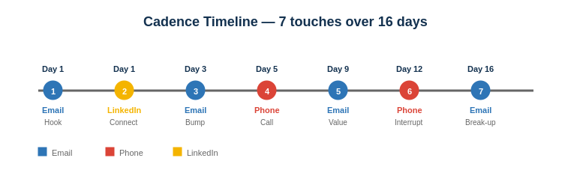
Touch | Day | Channel | Goal
1 | 1 | Email | Hook — brand-led subject line
2 | 1 | LinkedIn | Connection request
3 | 3 | Email | Bump — short nudge
4 | 5 | Phone | Live call — opener from the script bank
5 | 9 | Email | Value-add — insight
6 | 12 | Phone | Pattern interrupt
7 | 16 | Email | Break-up — low-pressure close

9 — Competitor Battlecard (preview)
Your playbook arms the team to beat the real alternatives — never by trashing the competitor, always by reframing the job to be done with a competitor battlecard
When you hear: “We already have a BI tool / we built our own dashboards.”
Acknowledge: “That makes sense — most teams have something in place.”
Reframe: “The question is who maintains it. Home-built dashboards usually mean a data person spends their week rebuilding reports the board still half-trusts. We remove that overhead — one reliable source, maintained for you.”
Redirect: “Worth 20 minutes to see what your team would stop having to do manually?”
■ ■ ■ Full competitor matrix + response cards for key alternatives ■ ■ ■
Included in full in your custom playbook

12 — EMEA Sales-Culture Pages (sample: France)
Your playbook includes a one-page cultural brief for each market you target — Nordics, Benelux, France, Spain, UK/Ireland — Here is the France page as an example.
France expects formal, well-written outreach and respects demonstrated thought leadership. Use vous, and write clean French — avoid Anglicisms where a proper French term exists, as sloppy language signals a sloppy vendor. A reasoned argument beats a one-line hook: the French buyer wants to see you’ve thought the problem through, not that you’ve mastered a punchy subject line. Build the case logically — the problem, why it matters, the considered solution. Relationship and intellectual credibility carry weight, so a well-argued insight email lands better than a volume blast. Patience pays: decisions involve more deliberation, and pushing for urgency reads as pressure, which erodes trust.

Tone & language
Default to a formal register and stay there until the prospect signals otherwise. Open with “Bonjour Madame [NOM]” or “Bonjour Monsieur [NOM]”, never the bare first name, and close with a complete formula such as “Je vous prie d’agréer, Madame, mes salutations distinguées” in a first written approach, softening to “Bien cordialement” once a thread is established. Titles and correct accents matter: a missing accent or a mismatched gender in the greeting is read as carelessness, and carelessness in language is taken as a proxy for carelessness in delivery. If your French is not native, have every first-touch template reviewed by a native speaker — the French buyer notices, and a clean letter buys credibility that no claim about your product can.

How to structure the argument
Lead with the reasoning, not the offer. Where a German email can open with the problem and a Dutch email can get to the point in two lines, the French buyer expects a short, logical case: here is the situation, here is why it carries a cost, here is the considered response. The Challenger insight works well here — provided it is framed as a thoughtful observation rather than a provocation. Avoid hard scarcity and countdown tactics; “limited spots” or “offer ends Friday” reads as manipulation and damages trust with exactly the senior, deliberate buyer you want. Substantiate claims: a named reference, a concrete figure, or a logical mechanism beats superlatives, which are discounted on sight.

Channel & cadence
Email is the credible first channel for a formal approach; the well-argued insight email is your strongest single asset. Cold calling is workable but expects more warmth and context before the pitch than in the UK or US — earn the right to the conversation rather than opening with a script. On LinkedIn, send a connection request with a brief, personalised note rather than a pitch on first contact; the platform is used professionally but a sales message in the first message is poorly received. Keep the overall cadence patient: space touches a little wider than the canonical sequence, and let the value-add email carry the weight rather than frequency.

Timing & the cultural calendar
Respect the French calendar or lose weeks. August is effectively dead for B2B — most decision-makers are away and outreach sent then is forgotten by September. The first two weeks of January and the period around major public holidays (early-May bridges in particular, when a single holiday becomes a long weekend) are similarly weak. Plan your strongest pushes for mid-September through November and from late January into spring. Mid-morning, mid-week sends perform best; avoid Friday afternoons.

Common objections & how they sound
Expect more upfront scrutiny of the vendor than the product. “Qui sont vos clients en France ?” (who are your French references) is asked early and matters — local proof outweighs global logos. Data residency and GDPR posture come up sooner and more pointedly than in other markets, so have a clear, confident answer ready rather than treating it as a late-stage legal detail. “Envoyez-moi une documentation” is often a polite deferral rather than genuine interest; respond with the document and a specific, low-pressure question that keeps the reasoning going, not a push for a meeting.

Quick do / don’t
Do: write in correct, formal French; build a logical case; cite French references and concrete proof; respect the holiday calendar; let patience signal confidence. Don’t: open with a punchy one-line hook; use scarcity or false urgency; pitch in a first LinkedIn message; lead with global logos over local proof; chase with frequency instead of substance.
■ ■ ■ Nordics, Benelux, Spain & UK/Ireland culture pages ■ ■ ■
Included in full in your custom playbook

How your custom playbook is built
This sample shows the structure and quality of some sections. Your playbook is written from scratch around your business.
- Secure checkout (€299, fixed) and a short intake form about your product, ICP and target markets.
- We build your playbook — native-language sequences, scripts, cadence, battlecard, the full asset.
- Delivered within 7 days, ready for your team to deploy.

What makes it different
Author-led, not generated. Written by Harm Linnecke — DACH / EMEA sales expert and author of Structured Prospecting
Written, not translated. Native-language sequences for how each European buyer actually thinks — the gap most teams lose two quarters discovering.
A system, not a template. Built on the Structured Prospecting Framework, customised end to end to your product and markets.

Build my playbook — €299
structuredtalent.io
Harm Linnecke · Founder, Structured Talent ·

