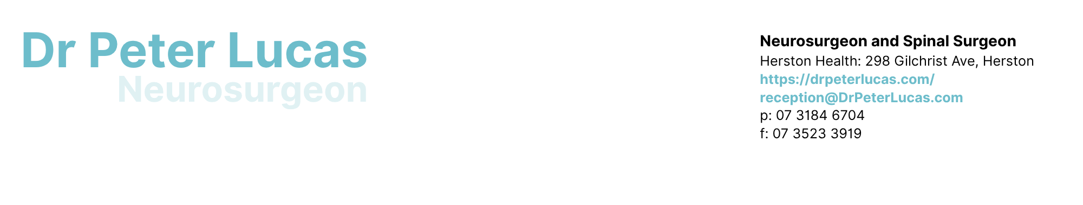

Patient Information Handout: CBD/THC

Important notes regarding your consultation:

- Dr Lucas reviews your pain management generally and in the context of proposed or current CBD/THC prescribing by your primary care clinician (GP).
- Dr Lucas does advise your GP regarding the appropriateness of possible alternative dosages of CBD/THC generally based
on your health and pain, such that if your GP considers it necessary or appropriate to change dosages prescribed there is specialist guidance regarding scope.
- Dr Lucas does not prescribe CBD or THC, advise on the specific current appropriate dose that is relevant for you, endorse a
specific dosage or dosing regimen currently or in the future, nor provide such specific advice to your prescriber.

Patient Information: Risks of CBD and THC Use

What is CBD and THC?

CBD (cannabidiol) and THC (tetrahydrocannabinol) are substances found in cannabis. In Australia, CBD is usually a Schedule 4 (prescription-only) medicine and THC is a Schedule 8 (controlled drug). These products are prescribed under special schemes and are not approved by the TGA (Therapeutic Goods Administration) in the same way standard medicines are for quality, safety, and effectiveness. There may therefore be variability in effectiveness between equal dosages across differing products. Any differences in the effect or the side effects should be reported to your prescribing clinician.

Do not take or cease taking this medication and seek advice from your prescribing clinician if you have adverse effects, are concerned or believe there is an adverse reaction.

It is natural, so is it a medicine or drug?

Yes, both THC and CBD are both medications and drugs. Many medications in common usage are either found naturally or derived from substances found in nature. All compounds whether found directly in nature or not may act as a poison or provide a therapeutic effect depending on dosage. If you are taking supplements, natural or otherwise. Please advise your prescribing clinician.

What are the long-term effects and side effects?

While these medications have been used in many ways historically, medicinal use in Australia and around the world has been relatively recent. Usage outside of controlled medicinal use has many factors of variability including purity and dose (amount of THC, CBD and other cannabinoids) making observations anecdotal regarding long term use. In addition, dose equivalence across brands, preparations and methods of delivery on the market currently have not been studied by the TGA (see above). Therefore, scientifically rigorous data is not yet available regarding long-term usage with currently available preparations.

Real Time Prescribing Monitoring

Note that all jurisdictions in Australia now monitor all prescriptions provided and which prescriptions are filled for all medications for every person. All medical practitioners and pharmacists have access to this record.

Important CBD/THC Medicine Interaction

CBD and THC can interact with other medicines, especially benzodiazepines, gabapentin or pregabalin, and opioid medicines used in pain management. Using these together with CBD &/or THC can cause extreme drowsiness, confusion, poor balance, slowed or dangerous breathing, and overdose. It is advised to discuss with the prescribing clinician if you are using these or any other medications at the same time as using CBD and/or THC

Drowsiness, Thinking, and Mental Health

Cannabinoids, especially THC can affect concentration, memory, and reaction times. In addition, THC may cause anxiety, paranoia, or psychosis and can worsen existing mental health conditions. Always advise your prescribing clinician regarding any mental health diagnoses or concerns. Always advise treating mental health clinicians of the use and dosage of CBD and/or THC medications at your first available opportunity.

Driving and Safety Risks (THC)

THC impairs driving and judgement. Driving with THC in your system is illegal in Australia. Do not drive, operate machinery, climb to unsecured heights, swim alone or engage in any activity where impairment may cause injury to yourself or others after using THC.

Sleep Apnoea (OSA)

CBD and THC may worsen obstructive sleep apnoea by affecting breathing during sleep, leading to increased daytime sleepiness and cardiovascular risk. Always advise your prescriber if you have or feel you may have OSA.

Dependence and Substance Use Risk

THC can be addictive and may increase relapse risk in people with current or past substance use disorders. Always advise your prescriber if you have or feel you may have an addiction to any substance.

Repeated Vomiting

Long-term or heavy THC use can cause cannabinoid hyperemesis syndrome, with severe nausea and vomiting that often resolves only after stopping use. Should vomiting occur, seek advice from your prescriber or if severe attend hospital for urgent medical assessment.

Edible Products

Gummies or pastilles may be mistaken for food and accidentally eaten by others including children. Effects may be delayed and overdosing can occur. Ensure any such prescriptions, if provided, are stored in an appropriate location to avoid such error and clearly mark as medications.

Australian Information Sources

Therapeutic Goods Administration (TGA)
Royal Australian College of General Practitioners (RACGP)
Australian Government Department of Health – Real Time Prescription Monitoring

