
2026/27 Academic Year
Autumn Term
7th September 2026 to 15th December 2026
Half Term: 26th October to 2nd November 2026
INSET Day 28th September 2026,2nd November 2026
Key Dates
17th–19th November 2026: Mock Exams
1st–3rd December 2026: Exams
14th December 2026: AM Group Christmas Breakfast
15th December 2026: PM Group Christmas Lunch

Spring Term
5th January 2027 to 24th April 2027
Half Term: 15th February to 22nd February 27
Key Dates
16th–18th March 2027: Exams
Week Commencing 19th April 2027: Activities Week
1 full day at Hunstanton beach, 1 day in London at museums and ½ day at Ampthill Park
Adapted Timetables – Morning Group will be in all day Monday and Tuesday and usual time Wednesday.
Afternoon group will be in as usual on Wednesday afternoon and then all day Thursday and Friday.

Summer Term
14th April 2027 to 9th July 2027
Half Term: 27th May – 4th June 27
INSET Days 1st & 2nd July 2026
Key Dates
15th–17th June 2027: Exams
21st June 2027: DREAM Points – 2nd Prize Day
23rd June 2027: DREAM Points – 1st Prize Day
29th June 2027: Year 11 Celebration Day (Centre closed to all other students)
30th June 2027: Graduation Day (Centre closed to all other students)
6th July 2027: Year 10 Celebration Day (Centre closed to all other students)
7th July 2027: Post-16 Celebration Day

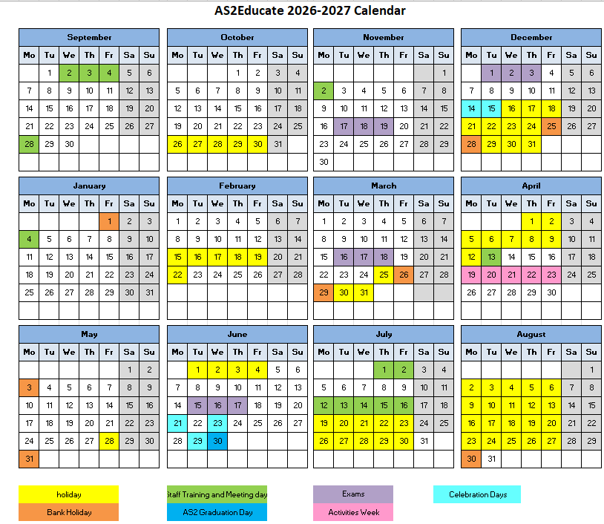
Staff Training Days

