
[Note: This is a template for community housing organisations and should be tailored to the specific needs of the organisation and linked to appropriate policies and procedures.]

Complaints Fact Sheet

How do I make a complaint?
If you are a renter, household member, or applicant, and you have a complaint, you can ask for your complaint to be dealt with under [CHOs] complaints and appeals procedure [link to Complaints Policy].
Complaints can be made by:
- Telephone: [phone number]
- Online: [web address. If CHO has an online complaint form, include instructions on how to access it from the home page]
- Email: [email address]
- Post: [contact name and postal address]
- In person: [office address].
[CHO] is committed to ensuring the complaints process is accessible to everyone. If you have specific communication needs or barriers, please let us know so assistance can be provided by:
- Using an assistance service, such an interpreter or TTY (for free);
- Assistance with reading or writing; and
- Communicating with a support worker or family member on your behalf.

How will I know the outcome of my complaint?
[CHO] will contact you to advise the outcome of your complaint and provide details of:
- Actions taken in response to your complaint;
- The reasons for the decision made;
- Where [CHO] has made an error, the steps that will be taken to fix the situation; and
- Information on options for internal or external review if you are not satisfied with the decision.
A complaint outcome will be made in writing with written reasons.
Below is a flowchart of how complaints are typically handled:
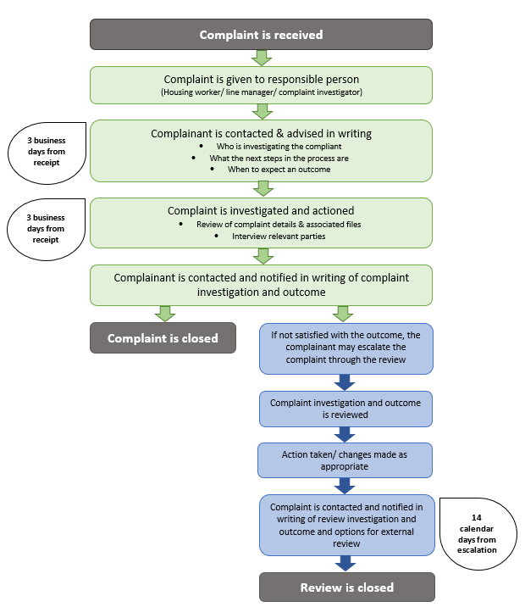

What can I do if I am dissatisfied with the outcome of my complaint?
There may be times where you are dissatisfied with the outcome of your complaint, even after an internal review by [CHO].
The following infographic shows the process for escalating a complaint where you are not satisfied with the process provided by [CHO].
¹ From time to time, it may take longer than 30 days to resolve a complaint; this will be discussed with the complainant.
² In some circumstances it may not be possible to resolve the complaint to the complainants satisfaction, however the reasons for this will be communicated.

Contact details for dispute bodies
Housing Registrar
If [CHO] has not resolved the complaint within 30 days, or the complainant is unsatisfied by the decision made about the complaint, the complainant may contact the Victorian Housing Registrar:
- Telephone: 03 7005 8984
- Online: Making a complaint about community housing
- Post: Housing Registrar, GPO Box 4379, Melbourne VIC 3001
Victorian Ombudsman
If a complainant continues to be dissatisfied after discussing an issue with [CHO] and the Housing Registrar, they can contact the Victorian Ombudsman:
- Telephone: 1800 806 314
- Online: Victorian Ombudsman Complaint form
- Post: Level 2, 570 Bourke Street, Melbourne VIC 3000
Victorian Civil & Administrative Tribunal (VCAT)
A complainant may also have statutory rights of appeal which should be directed to the Victorian Civil and Administrative Tribunal:
- Telephone: 1300 018 228
- Online: Victorian Civil & Administrative Tribunal
- Email: renting@vcat.vic.gov.au

