Parish or LPA Name

Mass of Confirmation 2023

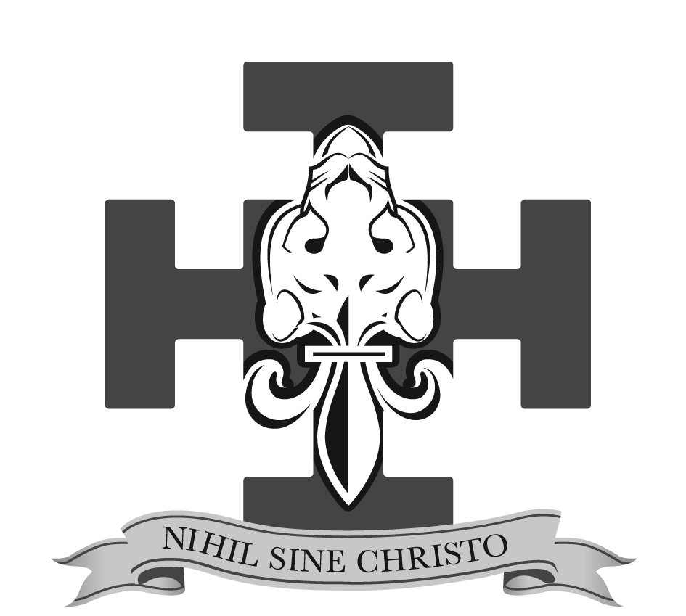

Feast or Date

The Right Reverend Mark Davies
Bishop of Shrewsbury

Welcome!

We hope that you will find God in this holy place and will participate fully in our celebration of Mass today.

Please ensure that your mobile phone is switched off.
We remind you that the use of cameras, video or sound recording
equipment is strictly prohibited during the liturgy.

INTRODUCTORY RITES:

All stand as the Sacristy Bell is rung.

Processional Hymn: please join in singing:

Bishop: In the name of the Father, and of the Son, and of the Holy Spirit.
All: Amen.
Bishop: Peace be with you.
All: And with your spirit.

The Bishop welcomes everyone to the celebration

Penitential Act:
Bishop: Brethren, let us acknowledge our sins, and so prepare ourselves to celebrate the sacred mysteries.

All: I confess to almighty God
and to you, my brothers and sisters,
that I have greatly sinned,
in my thoughts and in my words,
in what I have done and in what I have failed to do,
And, striking their breast, they say:
through my fault, through my fault,
through my most grievous fault;
therefore I ask blessed Mary ever-Virgin,
all the Angels and Saints,
and you, my brothers and sisters,
to pray for me to the Lord our God.

Bishop: May almighty God have mercy on us,
forgive us our sins,
and bring us to everlasting life.
All: Amen.

Bishop: Lord, have mercy. All: Lord, have mercy.
Bishop: Christ, have mercy. All: Christ, have mercy.
Bishop: Lord, have mercy. All: Lord, have mercy.

The Gloria: if necessary

Opening Prayer:
All sit
LITURGY OF THE WORD:

First Reading: Acts 2:1-6. 14. 22-23. 32-33

Psalm: Psalm 103
Response:

Gospel Acclamation: Please stand and join in singing the Alleluia.

Gospel: John 14:15-17
Deacon: The Lord be with you
All: and with your Spirit
Deacon: A reading from the holy Gospel according to John
All: Glory to you, O Lord.

Deacon: The Gospel of the Lord
All: Praise to you, Lord Jesus Christ.

All be seated
RITE OF CONFIRMATION:

Priest: Candidates for Confirmation please stand.
Right Reverend Father on behalf of the parishes of N and N, I present to you these candidates for the Sacrament of Confirmation.

The Candidates sit

Homily: The Right Reverend Mark Davies

Renewal of Baptismal Promises:
Bishop: And now, before you receive the Spirit, call to mind the faith which you professed in Baptism or which your parents and godparents professed with the Church.

Bishop: Do you renounce Satan, and all his works and empty promises?
Candidates: I do.
Bishop: Do you believe in God, the Father almighty, Creator of heaven and earth?
Candidates: I do.
Bishop: Do you believe in Jesus Christ, his only Son, our Lord, who was born of the Virgin Mary, suffered death and was buried, rose from the dead and is seated at the right hand of the Father?
Candidates: I do.
Bishop: Do you believe in the Holy Spirit, the Lord, the giver of life, who today through the Sacrament of Confirmation is given to you in a special way just as he was given to the Apostles on the day of Pentecost?
Candidates: I do.
Bishop: Do you believe in the holy Catholic Church, the communion of saints, the forgiveness of sins, the resurrection of the body, and life everlasting?
Candidates: I do.

Bishop: This is our faith. This is the faith of the Church. We are proud to profess it in Christ Jesus our Lord.
Congregation: Amen.

The Laying on of Hands:

Bishop: Dearly beloved, Let us pray to God the almighty Father, for these, his adopted sons and daughters, already born again to eternal life in Baptism, that he will graciously pour out the Holy Spirit upon them to confirm them with his abundant gifts, and through his anointing conform them more fully to Christ, the Son of God.

All pray in silence for a brief period.

The Bishop lays hands upon all the candidates by extending his hands over them.

Then the Bishop alone says:
Bishop: Almighty God, Father of our Lord Jesus Christ, who brought these your servants to new birth by water and the Holy Spirit,
freeing them from sin: send upon them, O Lord, the Holy Spirit, the Paraclete; give them the spirit of wisdom and understanding, the spirit of counsel and fortitude, the spirit of knowledge and piety; fill them with the spirit of the fear of the Lord. Through Christ our Lord.
All: Amen.

The Anointing with Sacred Chrism:
Please follow the directions of the catechists.
Candidates come forward with their Sponsor and kneel in front of the Bishop.

The Sponsor places their hand on the candidates shoulder and says:
Sponsor: I present (Confirmation Name) for Confirmation.

Bishop: Be sealed with the Gift of the Holy Spirit
Newly Confirmed: Amen

Bishop: Peace be with you.
Newly Confirmed: And with your Spirit.

During this time please join in singing:

Universal Prayer: read by the Deacon

All sit

LITURGY OF THE EUCHARIST:
As the Altar is prepared, and the gifts are brought forward please join in singing:

Bishop: Pray, brethren (brothers and sisters), that my sacrifice and yours may be acceptable to God, the almighty Father.

All rise and reply.
All: May the Lord accept the sacrifice at your hands for the praise and glory of his name, for our good, and the good of all his holy Church.

The Bishop prays the Prayer over the Offerings.
All: Amen.

Bishop: The Lord be with you.
All: And with your spirit.
Bishop: Lift up your hearts.
All: We lift them up to the Lord.
Bishop: Let us give thanks to the Lord our God.
All: It is right and just.

The Bishop prays the Preface, at the end of which all acclaim:

All kneel
Bishop: The mystery of faith.
All: We proclaim your death, O Lord, and profess your resurrection until you come again.

The Bishop concludes the Eucharistic Prayer with the Doxology.
Bishop: Through him, and with him, and in him, O God, almighty Father,
in the unity of the Holy Spirit, all glory and honour is yours, for ever and ever.

The people respond: Amen

All stand

COMMUNION RITE:

Bishop: At the Saviour’s command and formed by divine teaching, we dare to say:
All: Our Father, who art in heaven ...

Bishop: Deliver us, Lord, we pray, … our Saviour, Jesus Christ.
All: For the kingdom, the power and the glory are yours now and for ever.

Bishop: Lord Jesus Christ, who said to your Apostles: … Who live and reign for ever and ever.
All: Amen.

Bishop: The peace of the Lord be with you always.
All: And with your spirit.
Deacon: Let us offer each other the sign of peace.

The Bishop begins the fraction. Please join in singing:

All kneel.

Bishop: Behold the Lamb of God, behold him who takes away the sins of the world. Blessed are those called to the supper of the Lamb.

All: Lord, I am not worthy that you should enter under my roof, but only say the word and my soul shall be healed.

If you are not in Communion with the Catholic Church,
or cannot receive Holy Communion for any reason,
you are warmly invited to come forward to receive a blessing.
Please indicate your intention by crossing your arms across your chest.

During the distribution of Holy Communion please join in singing:

Prayer after Communion: All stand

CONCLUDING RITES:

Bishop: The Lord be with you.
All: And with your spirit.

Bishop: May almighty God bless you, the Father, + and the Son, + and the Holy + Spirit.
All: Amen.

Deacon: Go in peace glorifying the Lord by your life.
All: Thanks be to God.

Recessional Hymn: please join in singing:

© 2023 Shrewsbury Diocese
CCLI No. replace with parish license number One License No. replace with parish license number
Excerpts from the English translation of the Roman Missal
© Copyright 2011, International Committee on English in the Liturgy, Inc. All rights reserved
Excerpts from the English translation of The Order of Confirmation
© Copyright 2013, International Committee on English in the Liturgy (ICEL) All rights reserved

